|  |  |
| --- | --- |
|  | **MINISTRY OF EDUCATION AND TRAINING** |

|  |
| --- |
| **FPT UNIVERSITY** |
| Capstone Project Document |
| **FPT Lecturer Scheduler** |

|  |  |
| --- | --- |
| **GFA22SE49** | |
| **Group Members** | Vũ Minh Đăng - Leader - SE63447  Nguyễn Quốc Bảo - Member - SE140824  Hồng Đại Dương - Member - SE140501  Đỗ Thế Dương - Member - SE141129  Trần Tuấn Minh - Member - SE140690 |
| **Supervisor** | Mr. Lâm Hữu Khánh Phương |
| **Ext Supervisor** |  |
| **Capstone Project code** | FA22SE62 |

- Ho Chi Minh, December 2022 -

# Table of Contents

Table of Contents 2

List of Tables 5

List of Figures 9

Acknowledgements 14

Definition and Acronyms 15

I. Project Introduction 16

1. Overview 16

1.1 Project Information 16

1.2 Project Team 16

2. Product Background 16

3. Existing Systems 16

3.1 FAP 16

4. Business Opportunity 16

5. Software Product Vision 16

6. Project Scope & Limitations 17

6.1 Major Features 17

6.2 Limitations & Exclusions 19

II. Project Management Plan 19

1. Overview 19

1.1 Scope & Estimation 19

1.2 Project Objectives 20

1.3 Project Risks 20

2. Management Approach 22

2.1 Project Process 22

2.2 Quality Management 23

2.3 Training Plan 23

3. Project Deliverables 23

4. Responsibility Assignments 24

4.1 Team & Structures 24

4.2 Roles & Responsibilities 24

5. Project Communications 24

5.1 Communication Plan 24

5.2 External Interface 25

6. Configuration Management 25

6.1 Document Management 25

6.2 Source Code Management 25

6.3 Tools & Infrastructures 26

III. Software Requirements Specification 26

1. Product Overview 26

1.1 Unauthenticated User Requirements 26

1.2 Authenticated User Requirements 26

2. User Requirements 27

2.1 Actors 27

2.2 Use Cases 28

3. Functional Requirements 31

3.1 System Functional Overview 31

3.2 Member Features 38

3.3 Admin Features 41

3.4 Department Manager Features 47

3.5 Lecturer Features 66

4. Non-Functional Requirements 73

4.1 External Interfaces 73

4.2 Quality Attributes 74

5. Requirement Appendix 75

5.1 Business Rules 75

5.2 Application Messages List 77

6. Solution 77

6.1 Ant colony optimization algorithms 77

6.2 Ant colony optimization for teacher scheduling problem 78

IV. Software Design Description 83

1. System Design 83

1.1 Overall Architecture 83

1.2 System Architecture 84

1.3 Package Diagram 86

2. Database Design 90

2.1 Table Descriptions 90

3. Detailed Design 98

3.1 Class Diagram 98

3.2 Sequence Diagrams 106

3.3 Activity Diagrams 128

3.4 State Machine Diagram 142

V. Software Testing Documentation 143

1. Scope of Testing 143

1.1 Test model 143

1.2 Scope 144

2. Test Strategy 144

2.1 Testing Types 144

2.2 Test Levels 144

3. Test Plan 145

3.1 Human Resources 145

3.2 Test Environment 145

3.3 Test Milestones 145

4. Test Cases 145

5. Test Reports 146

VI. Release Package & User Guides 146

1. Deliverable Package 146

1.1 Source codes & documents 146

1.2 Known Issues, Limitations & Restrictions 146

2. Installation Guides 146

2.1 System Requirements 146

2.2 Setup file 147

2.3 Installation Instruction 147

3. User Manual 149

3.1 Terms and definitions 149

3.2 System Requirements 149

3.3 Application Usage 150

VII. Appendix 197

1. References 197

# List of Tables

Table 1. Major Features 19

Table 2. Scope & Estimation 20

Table 3. Project Objectives 20

Table 4. Project Risks 21

Table 5. Quality Management 23

Table 6. Training Plan 23

Table 7. Project Deliverables 24

Table 8. Team & Structures 24

Table 9. Roles & Responsibilities 24

Table 10. Communication Plan 25

Table 11. External Interface 25

Table 12. Tools & Infrastructures 26

Table 13. System actor 27

Table 14. Use case descriptions 31

Table 15. Screens Descriptions - Admin 34

Table 16. Screens Descriptions - Department manager 36

Table 17. Screens Descriptions - Lecturer 36

Table 18. Screen Authorization 37

Table 19. Entities Description 38

Table 20. Member Features - Login 38

Table 21. Member Features - View personal profile 39

Table 22. Member Features - Edit profile 40

Table 23. Member Features - Logout 41

Table 24. Admin Features - Manage semesters 41

Table 25. Admin Features - Manage courses 42

Table 26. Admin Features - Manage departments 43

Table 27. Admin Features - Manage subjects 44

Table 28. Admin Features - Manage lecturer accounts 45

Table 29. Admin Features - Generate schedule in semester 47

Table 30. Department Manager Features - View all lecturers 47

Table 31. Department Manager Features - View lecturer information 48

Table 32. Department Manager Features - View all subjects 48

Table 33. Department Manager Features - View all departments 49

Table 34. Department Manager Features - View all schedules of lecturers in semester 50

Table 35. Department Manager Features - View all semesters 50

Table 36. Department Manager Features - View all semester details 51

Table 37. Department Manager Features - View all assigned courses 52

Table 38. Department Manager Features - View all subjects in department 53

Table 39. Department Manager Features - View all requests from lecturers 54

Table 40. Department Manager Features - Response all requests from lecturers 54

Table 41. Department Manager Features - Manage assigned course of lecturer 55

Table 42. Department Manager Features - Assign course for lecturer 56

Table 43. Department Manager Features - Manage priority course of lecturer 57

Table 44. Department Manager Features - Add priority courses for lecturers 58

Table 45. Department Manager Features - Delete priority courses for lecturers 59

Table 46. Department Manager Features - Manage subject evaluation points of lecturer 60

Table 47. Department Manager Features - Manage Preference slot 61

Table 48. Department Manager Features - Manage min max course of lecturer in semester 62

Table 49. Department Manager Features - Swap courses in schedule of a lecturer 63

Table 50. Department Manager Features - View course to swap between two lecturers 64

Table 51. Department Manager Features - Swap between two lecturers in department 65

Table 52. Lecturer Features - View all semesters 66

Table 53. Lecturer Features - View detail of the semester 67

Table 54. Lecturer Features - View schedule in semester 67

Table 55. Lecturer Features - View all slots in semester 68

Table 56. Lecturer Features - View all departments 69

Table 57. Lecturer Features - View all subjects 69

Table 58. Lecturer Features - Rate grades for his/her assigned subjects in department 70

Table 59. Lecturer Features - Rate favourite slot time 71

Table 60. Lecturer Features - Disable registration subjects in the department 72

Table 61. Lecturer Features - Send requests to teach more subjects out the department 73

Table 62. Lecturer Features - View all requested subjects out the department 73

Table 63. Business Rules 77

Table 64. Application Messages 77

Table 65. Package Descriptions - Back-end 86

Table 66. Package Descriptions - Front-end 87

Table 67. Package Descriptions - WinForms 89

Table 68. Package Descriptions - Mobile 90

Table 69. Database design - User 91

Table 70. Database design - Course 91

Table 71. Database design - CourseAssign 91

Table 72. Database design - CourseGroupItem 92

Table 73. Database design - Department 92

Table 74. Database design - DepartmentGroup 92

Table 75. Database design - LecturerCourseGroup 93

Table 76. Database design - LecturerSlotConfig 93

Table 77. Database design - Request 94

Table 78. Database design - RoomSemester 94

Table 79. Database design - RoomType 94

Table 80. Database design - Schedule 95

Table 81. Database design - Semester 95

Table 82. Database design - SlotType 95

Table 83. Database design - Subject 96

Table 84. Database design - SubjectOfLecturer 96

Table 85. Database design - UserAndRole 96

Table 86. Database design - Role 97

Table 87. Database design - RefreshToken 97

Table 88. Class Specification - User 99

Table 89. User Method 99

Table 90. Class Specification - Course 99

Table 91. Course Method 99

Table 92. Class Specification - CourseAssign 99

Table 93. CourseAssign Method 100

Table 94. Class Specification - CourseGroupItem 100

Table 95. CourseGroupItem Method 100

Table 96. Class Specification – Department 100

Table 97. Department Method 100

Table 98. Class Specification – DepartmentGroup 101

Table 99. DepartmentGroup Method 101

Table 100. Class Specification – LecturerCourseGroup 101

Table 101. LecturerCourseGroup Method 101

Table 102. Class Specification – LecturerSlotConfig 101

Table 103. LecturerSlotConfig Method 102

Table 104. Class Specification – Request 102

Table 105. Request Method 102

Table 106. Class Specification – RoomSemester 102

Table 107. RoomSemester Method 103

Table 108. Class Specification - RoomType 103

Table 109. RoomType Method 103

Table 110. Class Specification – Schedule 103

Table 111. Schedule Method 103

Table 112. Class Specification – Semester 104

Table 113. Semester Method 104

Table 114. Class Specification – SlotType 104

Table 115. SlotType Method 104

Table 116. Class Specification – Subject 104

Table 117. Subject Method 105

Table 118. Class Specification - SubjectOfLecturer 105

Table 119. SubjectOfLecturer Method 105

Table 120. Class Specification- UserAndRole 105

Table 121. UserAndRole Method 105

Table 122. Class Specification- Role 106

Table 123. Role Method 106

Table 124. Class Specification- RefreshToken 106

Table 125. RefreshToken Method 106

Table 126. State Machine Diagram Description 143

Table 127. Human Resources 145

Table 128. Test Environment 145

Table 129. Test Milestones 145

Table 130. Source code & documents 146

Table 131. System Requirements- Hardware Requirements for Mobile 147

Table 132. System Requirements- Hardware Requirements For PC 147

Table 133. User Manual - Hardware Requirements For PC 149

Table 134. User Manual- Hardware Requirements for Android Devices 149

Table 135. User Manual - Software Requirements For PC 149

Table 136. Brief Description - Login 150

Table 137. Brief Description- View Profile 150

Table 138. Brief Description- Update Profile 151

Table 139. Brief Description- Admin Function 152

Table 140. Brief Description- View Semester 152

Table 141. Brief Description- Create Semester 152

Table 142. Brief Description- Delete Semester 153

Table 143. Brief Description- Update Semester 154

Table 144. Brief Description - Update state of Semester 155

Table 145. Brief Description - Update state of Semester 156

Table 146. Brief Description- Create course 156

Table 147. Brief Description- Import course 157

Table 148. Brief Description- Update course 157

Table 149. Brief Description- Delete course 158

Table 150. Brief Description- View Schedule 158

Table 151. Brief Description- View Lecturer 159

Table 152. Brief Description- View Department 160

Table 153. Brief Description- Create Department 161

Table 154. Brief Description- Update Department 161

Table 155. Brief Description- Delete Department 162

Table 156. Brief Description- View Subject 162

Table 157. Brief Description- Create Subject 163

Table 158. Brief Description- Update Subject 163

Table 159. Brief Description- Delete Subject 163

Table 160. Brief Description- View Slot 164

Table 161. Brief Description-View Home of Department Manager 164

Table 162. Brief Description- View Assign course 165

Table 163. Brief Description- Assign course 166

Table 164. Brief Description- Add Priority Course in Department 167

Table 165. Brief Description- Add Priority Course Out Department 168

Table 166. Brief Description- Delete Course Group Item 169

Table 167. Brief Description- Manager Request 169

Table 168. Brief Description- Response Request 170

Table 169. Brief Description- View Response Request 171

Table 170. Brief Description- Edit Min Max Course of Lecturer 171

Table 171. Brief Description- View Subject of Lecturer 172

Table 172. Brief Description- Update Evaluation Point of Subject 172

Table 173. Brief Description- Update the Maximum Number of Subject 173

Table 174. Brief Description- Manager Lecturer Slot Config 175

Table 175. Brief Description - Department Manager Swap assigned courses in schedule of a lecturer 175

Table 176. Brief Description - Department Manager Swap assigned courses in schedule between lecturers 176

Table 177. Brief Description- View Schedule 177

Table 178. Brief Description- View Semester 177

Table 179. Brief Description- View Semester Details 178

Table 180. Brief Description- View Schedule 178

Table 181. Brief Description- View Subject Rating 179

Table 182. Brief Description- Rating favourite Subjects 180

Table 183. Brief Description- Send Request 181

Table 184. Brief Description- View Requests 182

Table 185. Brief Description- Preference Slots 183

Table 186. Brief Description- View Department 183

Table 187. Brief Description- View Subject 183

Table 188. Brief Description- Login 184

Table 189. Brief Description- View Schedule 185

Table 190. Brief Description- View Semester 186

Table 191. Brief Description- View Semester Detail 188

Table 192. Brief Description- View Registered Subjects 189

Table 193. Brief Description- View Request 190

Table 194. Brief Description- View Department 191

Table 195. Brief Description- View Subject 192

Table 196. Brief Description- View Profile 193

Table 197. Brief Description- Update Profile 194

Table 198. Brief Description- Admin login WinForms 195

Table 199. Admin generates schedule 197

# List of Figures

Figure 1. Project Process 22

Figure 2. Use case diagram 28

Figure 3. Screens Flow - Admin 31

Figure 4. Screens Flow - Department manager 32

Figure 5. Screens Flow - Lecturer 32

Figure 6. Entity Relationship Diagram 37

Figure 7. Member Features - Login 38

Figure 8. Member Features - View personal profile 39

Figure 9. Member Features - Edit profile 40

Figure 10. Member Features - Logout 40

Figure 11. Admin Features - Manage semesters 41

Figure 12. Admin Features - Manage courses 42

Figure 13. Admin Features - Manage departments 43

Figure 14. Admin Features - Manage subjects 44

Figure 15. Admin Features - Manage lecturer accounts 45

Figure 16. Admin Features - Generate schedule in semester 46

Figure 17. Department Manager Features - View all lecturers 47

Figure 18. Department Manager Features - View lecturer information 47

Figure 19. Department Manager Features - View all subjects 48

Figure 20. Department Manager Features - View all departments 49

Figure 21. Department Manager Features - View all schedules of lecturers in semester 49

Figure 22. Department Manager Features - View all semesters 50

Figure 23. Department Manager Features - View all semester details 51

Figure 24. Department Manager Features - View all assigned courses 52

Figure 25. Department Manager Features - View all subjects in department 52

Figure 26. Department Manager Features - View all requests from lecturers 53

Figure 27. Department Manager Features - Response all requests from lecturers 54

Figure 28. Department Manager Features - Manage assigned course of lecturer 55

Figure 29. Department Manager Features - Assign course for lecturer 56

Figure 30. Department Manager Features - Manage priority course of lecturer 57

Figure 31. Department Manager Features - Add priority courses for lecturers 58

Figure 32. Department Manager Features - Delete priority courses for lecturers 59

Figure 33. Department Manager Features - Manage subject evaluation points of lecturer 60

Figure 34. Department Manager Features - Manage Preference slot 61

Figure 35. Department Manager Features - Manage min max course of lecturer in semester 62

Figure 36. Department Manager Features - Swap courses in schedule of a lecturer 63

Figure 37. Department Manager Features - View course to swap between two lecturers 64

Figure 38. Department Manager Features - Swap between two lecturers in department 65

Figure 39. Lecturer Features - View all semesters 66

Figure 40. Lecturer Features - View detail of the semester 66

Figure 41. Lecturer Features - View schedule in semester 67

Figure 42. Lecturer Features - View all slots in semester 68

Figure 43. Lecturer Features - View all departments 68

Figure 44. Lecturer Features - View all subjects 69

Figure 45. Lecturer Features - Rate grades for his/her assigned subjects in department 70

Figure 46. Lecturer Features - Rate favourite slot time 71

Figure 47. Lecturer Features - Disable registration subjects in the department 72

Figure 48. Lecturer Features - Send requests to teach more subjects out the department 72

Figure 49. Lecturer Features - View all requested subjects out the department 73

Figure 50. Pheromones matrix of 5 Lecturers with 12 courses 79

Figure 51. Choose the cell with the highest score, 10-point cells are courses that are fixed 79

Figure 52. Update the Pheromones matrix with the hard constraints 80

Figure 53. Lecturer 1 with max course can teach is 3 in semester will disable all column 1 when assigned 3 courses 80

Figure 54. List slot types 81

Figure 55. Lecturer 1 with 3 assigned courses and 12 slot types 81

Figure 56. Choose the cell with the highest score, update the Pheromones matrix with the hard constraints 82

Figure 57. Repeat the steps until there are no more assignable slots 82

Figure 58. Optimal score 83

Figure 59. Overall Architecture 83

Figure 60. System Architecture - Server 84

Figure 61. System Architecture - Web Application 84

Figure 62. System Architecture - Windows Form Application 85

Figure 63. System Architecture - Mobile Application 85

Figure 64. Package diagram - Back-end 86

Figure 65. Package diagram - Front-end 87

Figure 66. Package diagram - WinForms 88

Figure 67. Package diagram - Mobile 89

Figure 68. Database diagram 90

Figure 69. Class Diagram 98

Figure 70. Sequence Diagram - Member Login 106

Figure 71. Sequence Diagram - Admin View all semesters 107

Figure 72. Sequence Diagram - Admin View semester detail 107

Figure 73. Sequence Diagram - Admin Create semester 108

Figure 74. Sequence Diagram - Admin Edit semester 108

Figure 75. Sequence Diagram - Admin Delete semester 109

Figure 76. Sequence Diagram - Admin Import semester course list 109

Figure 77. Sequence Diagram - Create course 110

Figure 78. Sequence Diagram - Update course 110

Figure 79. Sequence Diagram - Admin Delete course 111

Figure 80. Sequence Diagram - Admin View all courses 111

Figure 81. Sequence Diagram - Admin View all slot type in semester 112

Figure 82. Sequence Diagram - Admin View all lecturers 112

Figure 83. Sequence Diagram - Admin View lecturer detail 113

Figure 84. Sequence Diagram - Admin View all schedule of lecturers in semester 113

Figure 85. Sequence Diagram - Admin Create department 114

Figure 86. Sequence Diagram - Admin Update department 114

Figure 87. Sequence Diagram - Admin Delete department 115

Figure 88. Sequence Diagram - Admin all departments 115

Figure 89. Sequence Diagram - Admin Create subject 116

Figure 90. Sequence Diagram - Admin Update subject 116

Figure 91. Sequence Diagram - Admin Delete subject 117

Figure 92. Sequence Diagram - Admin View all subjects 117

Figure 93. Sequence Diagram - Admin View all assigned courses in semester 118

Figure 94. Sequence Diagram - Admin Assign courses for lecturers 118

Figure 95. Sequence Diagram - Department manager Disable courses assign for lecturer 119

Figure 96. Sequence Diagram - Department manager Add priority courses for lecturers 119

Figure 97. Sequence Diagram - Department manager Assess subject evaluation points for lecturers with subjects 120

Figure 98. Sequence Diagram - Department manager Disable subjects of lecturer 120

Figure 99. Sequence Diagram - Department manager Disable slots of lecturer 121

Figure 100. Sequence Diagram - Department manager Update min max courses number in semester of lecturer 121

Figure 101. Sequence Diagram - Department manager View all request from lecturers in semester 122

Figure 102. Sequence Diagram - Department manager Response requests from lecturers 122

Figure 103. Sequence Diagram - Department manager Swap assigned courses in schedule of a lecturer 123

Figure 104. Sequence Diagram - Department manager Swap assigned courses in schedule between lecturers 124

Figure 105. Sequence Diagram - Lecturer View all semesters 124

Figure 106. Sequence Diagram - Lecturer View schedule in semester 125

Figure 107. Sequence Diagram - Lecturer Rate grades for his/her assigned subjects in the department 126

Figure 108. Sequence Diagram - Lecturer Rate favourite slots time 127

Figure 109. Sequence Diagrams - Lecturer Send requests to teach more subjects out the department 128

Figure 110. Activity Diagrams - Member Login 128

Figure 111. Activity Diagrams - Member View profile 129

Figure 112. Activity Diagrams - Member Update personal profile 129

Figure 113. Activity Diagrams - Admin View all list semesters 130

Figure 114. Activity Diagrams - Admin Create semester 130

Figure 115. Activity Diagrams - Admin Import data courses list 131

Figure 116. Activity Diagrams - Admin Update state of semester 131

Figure 117. Activity Diagrams - Admin Delete semester 132

Figure 118. Activity Diagrams - Admin Generate schedule 133

Figure 119. Activity Diagrams - Department Manager Assign courses for lecturers 134

Figure 120. Activity Diagrams - Department Manager Add priority courses for lecturers 135

Figure 121. Activity Diagrams - Department Manager View all request from lecturers in semester 136

Figure 122. Activity Diagrams - Department Manager Response requests from lecturers 137

Figure 123. Activity Diagrams - Department Manager Swap assigned courses in schedule of a lecturer 138

Figure 124. Activity Diagrams - Department Manager Swap assigned courses in schedule between lecturers 139

Figure 125. Activity Diagrams - Lecturer Send requests to teach more subjects out the department 140

Figure 126. Activity Diagrams - Lecturer Rate Reference Slot 140

Figure 127. Activity Diagrams - Lecturer Rate grades for his/her subjects in the department 141

Figure 128. Activity Diagrams - Lecturer View schedule in semester on Mobile Application 141

Figure 129. Activity Diagrams - Lecturer View all assigned courses in semester 142

Figure 130. State Machine Diagram 142

Figure 131. Agile Testing 143

Figure 132. Test case list 144

Figure 133. Test Reports 146

Figure 134. Set up local backend API 147

Figure 135. Swagger API 148

Figure 136. Login WinForms Application 148

Figure 137. Login 150

Figure 138. View Profile 150

Figure 139. Update Profile 151

Figure 140. View Home 151

Figure 141. View semester 152

Figure 142. Create semester 152

Figure 143. Delete semester 153

Figure 144. Edit semester 154

Figure 145. State of Semester 155

Figure 146. Update state of Semester 155

Figure 147. View Course 155

Figure 148. Create Course 156

Figure 149. Choose file to import Course 156

Figure 150. Import Course 157

Figure 151. Update Course 157

Figure 152. Delete course 158

Figure 153. View Schedule 158

Figure 154. View Schedule Detail of Lecturer 159

Figure 155. View Lecturer 159

Figure 156. View Lecturer Detail 160

Figure 157. View Department 160

Figure 158. Create Department 160

Figure 159. Update Department 161

Figure 160. Delete Department 161

Figure 161. View Subject 162

Figure 162. Create Subject 162

Figure 163. Update Subject 163

Figure 164. Delete Subject 163

Figure 165. View Slot 164

Figure 166. View Home of Department Manager 164

Figure 167. View Lecturer to assign course 165

Figure 168. View Assign Course 165

Figure 169. Assign course 166

Figure 170. Add Priority Course in Department 167

Figure 171. Add Priority Course Out Department 168

Figure 172. Delete Course Group Item 169

Figure 173. Manager Request 169

Figure 174. Response Request 170

Figure 175. View Response Request 170

Figure 176. Edit Min Max Course of Lecturer 171

Figure 177. View Subject of Lecturer 171

Figure 178. Update Evaluation Point of Subject 172

Figure 179. Update The Maximum Number of Subject 173

Figure 180. Disable Teachers from Teaching That Subject 174

Figure 181. Manager Lecturer Slot Config 174

Figure 182. Department Manager Swap assigned courses in schedule of a lecturer 175

Figure 183. Department Manager Get list empty slots 176

Figure 184. Department Manager Swap assigned courses in schedule between lecturers 176

Figure 185. View Schedule 177

Figure 186. View Semester 177

Figure 187. View Semester Details 178

Figure 188. View Schedule 178

Figure 189. View Rating favourite Subjects 179

Figure 190. Rating favourite Subjects 180

Figure 191. Send Request 181

Figure 192. View Requests 182

Figure 193. Preference Slots 182

Figure 194. View Department 183

Figure 195. View Subject 183

Figure 196. Login 184

Figure 197. View Schedule 185

Figure 198. View Semester 186

Figure 199. View Semester Detail 188

Figure 200. View Registered Subjects 189

Figure 201. View Requests 190

Figure 202. View Department 191

Figure 203. View Subject 192

Figure 204. View Profile 193

Figure 205. Update Profile 194

Figure 206. Admin login WinForms 195

Figure 207. Admin load data in semester 195

Figure 208. Admin configures the coefficients 196

Figure 209. Admin name the schedule 196

Figure 210. Admin send the schedule to the server 197

# Acknowledgements

First of all, we would like to express our special gratitude and thanks to our supervisors, Mr. Lam Huu Khanh Phuong, who has been an attentive mentor for us throughout the last 4 months. Every instruction, situation, mistakes you pointed out, they do not only help us recognize our shortcomings in projects, but also help us grow up to be real developers in our future career path. They are priceless advice you gave to us, without them, it is so hard for us to keep going and complete this capstone project. We also give special thanks to Mr. Nguyen The Hoang, Mr. Do Tan Nhan, Mr. Tran Thanh Nguyen and Ms. Nguyen Thi Cam Huong, who has helped us review and give us a lot of detailed advice to make our project done successfully.

Besides that, we also give many special thanks to each individual member in our team. It is marvellous when we meet and go together until now. We know that doing a capstone project is not easy, but all efforts that we have tried are valuable, they include knowledge, time or even money. Special thanks to our leader, Vu Minh Dang, he always helps the team connect easily, arranges documents and clarify main ideas to our mentor. A lot of appreciation to Tran Tuan Minh for his competent technical skills. Great thanks to Do The Duong, he always completes tasks on time and helps other members if they are in trouble. Many thanks to Nguyen Quoc Bao for his responsibility, he always does as perfectly as he can. And big applause to Hong Dai Duong, who is a really hard-working member, he also encourages the team when we are under pressure. Sometimes we have arguments because of miscommunication, but all serve the goal of completing this capstone project successfully. Thank you very much for all our contribution and being a part of the team.

We cannot forget to give a lot of great thanks to our family who always support us from behind and expect us to have a good result. They are also important people who give us motivation to go to the end of the hard capstone project process. Finally, thanks to FPT University and all the lecturers for teaching and giving us a lot of experiences on our future career path.

Sincerely,

FLS team.

# Definition and Acronyms

|  |  |
| --- | --- |
| **Acronym** | **Definition** |
| API | Application Program Interface |
| BR | Business Rule |
| ERD | Entity Relationship Diagram |
| FLS | FPT Lecturer Scheduler |
| FPTU | FPT University |
| FAP | FPT University Academic Portal |
| GUI | Graphical User Interface |
| PM | Project Manager |
| SDD | Software Design Description |
| SRS | Software Requirement Specification |
| UC | Use Case |
| UI | User Interface |

# I. Project Introduction

## 1. Overview

### 1.1 Project Information

* Project name: FPT Lecturer Scheduler.
* Project code: FA22SE62.
* Group name: GFA22SE49.
* Software type: Web, Mobile App, WinForms App.

### 1.2 Project Team

|  |  |  |  |
| --- | --- | --- | --- |
| **Full Name** | **Role** | **Email** | **Mobile** |
| Lâm Hữu Khánh Phương | Mentor | phuonglhk@fpt.edu.vn | 0915 353 001 |
| Vũ Minh Đăng | Leader | dangvmse63447@fpt.edu.vn | 0977 527 371 |
| Hồng Đại Dương | Member | duonghdse140501@fpt.edu.vn | 0342 791 949 |
| Trần Tuấn Minh | Member | minhttse140690@fpt.edu.vn | 0965 826 260 |
| Đỗ Thế Dương | Member | duongdtse141129@fpt.edu.vn | 0972 297 498 |
| Nguyễn Quốc Bảo | Member | baonqse140824@fpt.edu.vn | 0377 943 234 |

## 2. Product Background

* Currently, the scheduling system for lecturers at FPT University (FAP) is working with the flow is:
* At the beginning of the semester, the lecturer will be received the first schedule with some information about times, slots, subjects, classes… have to teach with this and the problems here is something in their schedule the must teach some subject they don’t want or it’s not their forte and they have to teach in any slot time they do not want.
* The lecturer scheduling system (FLS) is designed to solve this problem. Specifically, it collects information about each lecturer's interests, teaching strengths, and slot time in each subject, thereby optimizing the lecturer's teaching schedule.

## 3. Existing Systems

### 3.1 FAP

* FAP Systems is an application for FPT University to generate a scheduler for lecturers. At the beginning of a semester, a small schedule from FPT University Ha Noi will be sent to FPT University HCM with Courses, Subjects, and Slots. A complete schedule will be generated after Department Manager arranges the Courses with Lecturers. With that method, it makes the lecturer will be passive and they cannot choose a subject which they love.

## 4. Business Opportunity

* FLS (FPT Lecturer Scheduler) help Department managers manage priority with each other lecturer, help lecturers choose love subjects, slot time they want to teach to suitable with their schedule, more personality, easier to use, more beautiful and more user-friendly.

## 5. Software Product Vision

* In the future, FLS Application can arrange slot time, and courses. In the course, we have two types to be distinguished are practical subjects and theoretical subjects, with theoretical subjects that will be added from Monday to Friday and practical subjects add to Saturday. FLS can generate a schedule with a room number, and manager room type. Plan subject for Coursera at the beginning of a semester.

## 6. Project Scope & Limitations

### 6.1 Major Features

|  |  |  |
| --- | --- | --- |
| Actor | ID | Features description |
| Admin | FE-01 | Allow Admin to login by mail FPT. |
| FE-02 | Allow Admin to log out. |
| FE-03 | Allow Admin to manage Lecturers. |
| FE-04 | Allow Admin to manage the course amount. |
| FE-05 | Allow Admin to manage priority for Lecturers. |
| FE-06 | Allow Admin to create the schedule for all Lecturers. |
| FE-07 | Allow Admin to view the schedule of each Lecturer. |
| FE-08 | Allow Admin to create semesters. |
| FE-09 | Allow Admin to create departments. |
| FE-10 | Allow Admin to create subjects. |
| FE-11 | Allow Admin to create courses. |
| FE-12 | Allow Admin to change config before creating the schedule. |
| Department Manager | FE-13 | Allow Department Manager to login by mail FPT. |
| FE-14 | Allow Department Manager to log out. |
| FE-15 | Allow Department Manager to give rating points to subjects of lecturers. |
| FE-16 | Allow Department Manager to assign one course for one Lecturer. |
| FE-17 | Allow Department Manager to add priority courses for Lecturers. |
| FE-18 | Allow Department Manager to view the schedule of Lecturers in the department. |
| FE-19 | Allow Department Manager to view all semesters. |
| FE-20 | Allow Department Manager to view the detailed semester. |
| FE-21 | Allow Department Manager to manage Lecturers in the department. |
| FE-22 | Allow Department Manager to manage subjects in the department. |
| FE-23 | Allow Department Manager to manage courses of subjects in the department. |
| FE-24 | Allow Department Manager to send a request to Lecturers to suggest subjects. |
| FE-25 | Allow Department Manager to respond to a request from Lecturers. |
| Lecturer | FE-26 | Allow Lecturer to login by mail FPT. |
| FE-27 | Allow Lecturer to logout. |
| FE-28 | Allow Lecturer to view their schedule. |
| FE-29 | Allow Lecturer to rate grades for their assigned subjects. |
| FE-30 | Allow Lecturer to choose favourite slot time. |
| FE-31 | Allow Lecturer to view their profile. |
| FE-32 | Allow Lecturer to edit their profile. |
| FE-33 | Allow Lecturer to view all semesters. |
| FE-34 | Allow Lecturer to view all departments. |
| FE-35 | Allow Lecturer to view all subjects. |
| FE-36 | Allow Lecturer to view all courses of department. |
| FE-37 | Allow Lecturer to view detail of slot type. |
| FE-38 | Allow Lecturer to send requests to teach more subjects. |
| FE-39 | Allow Lecturers to view all their requests. |
| FE-40 | Allow Lecturers to receive requests from the department manager. |
| FE-41 | Allow Lecturers to respond to requests from the department manager. |

Table . Major Features

### 6.2 Limitations & Exclusions

Limitations:

LI-1: The mobile application only supports Android OS.

LI-2: The mobile application is only for viewing information mainly.

LI-3: The system is not the best and most optimal solution.

Exclusions:

EX-1: The system doesn’t manage Coursera courses.

EX-2: The system does not stack and manage rooms.

EX-3: The system does not assign and manage students.

EX-4: The system does not arrange and manage slots in the evening.

# II. Project Management Plan

## 1. Overview

### 1.1 Scope & Estimation

|  |  |  |  |
| --- | --- | --- | --- |
| **#** | **WBS Item** | **Complexity** | **Est. Effort**  **(man-days)** |
| ***1*** | ***Initiating*** |  |  |
| 1.1 | Collect requirement | Medium | 21 |
| 1.2 | Come up with ideas | Medium | 14 |
| ***2*** | ***Planning*** |  |  |
| 2.1 | Create plan for capstone project | Simple | 5 |
| ***3*** | ***Executing*** |  |  |
| 3.1 | Data |  |  |
| 3.1.1 | Crawl data from FAP | Simple | 7 |
| 3.1.2 | Filling and edit data | Medium | 7 |
| 3.2 | Analysis |  |  |
| 3.2.2 | Analysis requirement | Complex | 21 |
| 3.3 | Design |  |  |
| 3.3.1 | Draw and design Lecturer’s display | Complex | 24 |
| 3.3.2 | Draw and design Department Manager’s display | Complex | 24 |
| 3.3.3 | Draw and design Admin’s display | Complex | 24 |
| 3.3.2 | Design Mobile Application | Complex | 14 |
| 3.3.3 | Design ERD | Complex | 14 |
| 3.3.4 | Design database | Complex | 14 |
| 3.3.5 | Create RESTful API | Complex | 14 |
| 3.3.6 | Design WinForms Application | Complex | 10 |
| 3.4 | Algorithm |  |  |
| 3.4.1 | Ant colony Algorithm | Complex | 21 |
| ***4*** | ***Monitoring and controlling*** |  |  |
| 4.1 | Control the process | Complex |  |
| ***5*** | ***Closing*** |  |  |
| 5.1 | Report final | Complex | 12 |
| ***Total Estimated Effort (man-days)*** | | | ***182*** |
|  | | |  |

Table . Scope & Estimation

### 1.2 Project Objectives

|  |  |  |  |  |
| --- | --- | --- | --- | --- |
| **#** | **Testing Stage** | **No. of Defects** | **% of Defect** | **Notes** |
| 1 | Reviewing | 8 | 33.33% |  |
| 2 | Unit Test | 6 | 25% |  |
| 3 | Integration Test | 2 | 8.33% |  |
| 4 | System Test | 5 | 20.83% |  |
| 5 | Acceptance Test | 3 | 12.5% |  |

Table . Project Objectives

### 1.3 Project Risks

|  |  |  |  |  |
| --- | --- | --- | --- | --- |
| **#** | **Risk Description** | **Impact** | **Possibility** | **Response Plans** |
| 1 | Far from University | Serious | High | 2 times offline per week. |
| 2 | Conflicts between team members | Medium | High | Make clarify the problem and focus on target. |
| 3 | Poor experience | Medium | Medium | All members should support the leader to handle the project process. |
| 4 | Framework technical knowledge | High | High | The team should take the time to research the framework. |
| 5 | Algorithm knowledge | High | High | Team research knowledge about Algorithm. |
| 6 | Not understanding requirements | High | Low | Meeting with mentor 2 times a week. |
| 7 | The working process is delayed because of power-off | Medium | Medium | Overtime every date. |
| 8 | Unrealistic project schedule | Serious | Medium | The team must meet, and everyone needs to review the schedule. |

Table . Project Risks

## 2. Management Approach

### 2.1 Project Process

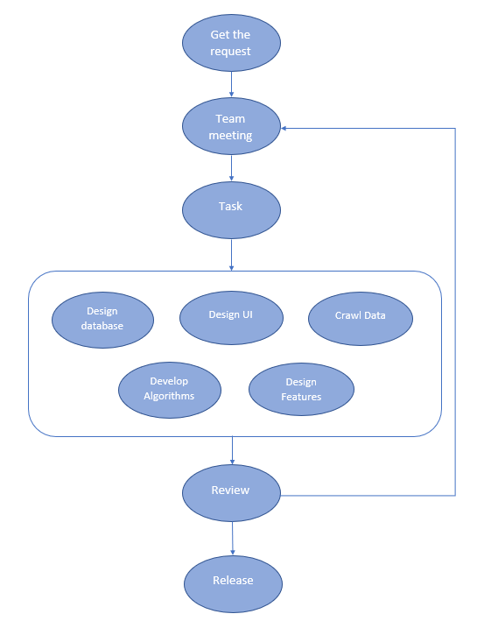

Figure . Project Process

The FLS (FPT Lecturer Scheduler) uses the Scrum of Agile Software Development Model. We choose this model because of some reasons:

* Scrum can help teams complete project deliverables quickly and efficiently.
* Developments are coded and tested during the sprint review.
* Short sprints enable changes based on feedback a lot more easily.
* The individual effort of each team member is visible during daily scrum meetings.
* Because our supervisors review our project every week, Scrum is the most reasonable approach for us to show them.

### 2.2 Quality Management

|  |  |  |  |
| --- | --- | --- | --- |
| **Approach** | **Description** | **When** | **Waiver Criteria** |
| Defect prevention | Implement and follow verified coding convention | Before starting each coding phase | Mandatory |
| Self-review using integrated Visual Code and Visual Studio | Before committing | Mandatory |
| Review | Cross-review before pushing code to master branch | After a member finishes assigned tasks | Mandatory |
| Testing | Unit testing | After a member finishes modules related to a specific feature and all of code is reviewed | Mandatory |
| Integration testing | After all modules are integrated and unit test cases are passed | Mandatory |

Table . Quality Management

### 2.3 Training Plan

|  |  |  |  |
| --- | --- | --- | --- |
| **Training Area** | **Participants** | **When, Duration** | **Waiver Criteria** |
| ASP .Net Core | MinhTT, DuongDT | Start on 5/9/2022, 2 weeks | Mandatory |
| ReactJS | DuongHD, DangVM | Start on 5/9/2022, 2 weeks | Mandatory |
| Flutter | BaoNQ | Start on 5/9/2022, 2 weeks | Mandatory |
| Git, GitHub | MinhTT, DuongDT, DuongHD, DangVM, BaoNQ | Start on 5/9/2022, 2 weeks | Mandatory |

Table . Training Plan

## 3. Project Deliverables

|  |  |  |  |
| --- | --- | --- | --- |
| **#** | **Deliverable** | **Due Date** | **Notes** |
| 1 | Project Plan | 12/09/2022 | Schedule plan, Scope, WBS |
| 2 | SRS | 19/09/2022 | Use case, Use case description |
| 3 | Design | 30/09/2022 | Architecture Design, ERD Design, Database, UI |
| 4 | Lecturer functions development | 10/10/2022 | Code & Unit test, System test cases |
| 5 | Contract Lecturer functions development | 20/10/2022 | Code & Unit test, System test cases |
| 6 | Admin functions development | 30/10/2022 | Code & Unit test, System test cases |
| 7 | Department Manager functions development | 13/11/2022 | Code & Unit test, System test cases |
| 8 | Feedback functions | 20/11/2022 | Code & Unit test, System test cases |
| 9 | Test | 30/11/2022 | Codes, System test reports |
| 10 | Final Package | 04/12/2022 | Final Codes & documents, User manual |

Table . Project Deliverables

## 4. Responsibility Assignments

### 4.1 Team & Structures

|  |  |
| --- | --- |
| **Role** | **Full Name** |
| Scrum master | Vũ Minh Đăng |
| Development team | Hồng Đại Dương  Trần Tuấn Minh  Đỗ Thế Dương  Nguyễn Quốc Bảo |
| Cross-functional team | Vũ Minh Đăng  Đỗ Thế Dương |

Table . Team & Structures

### 4.2 Roles & Responsibilities

|  |  |
| --- | --- |
| **Role** | **Responsibility** |
| Scrum master | * Ensuring that all Scrum events take place and are positive, productive, and kept within the timebox. * Removing impediments to the Scrum Team’s progress. * Helping the Scrum Team focus on creating high-value Increments that meet the Definition of Done. * Implement Project Management. * Assist the Product Owner with the Product Backlog. |
| Development team | * Team will directly produce product. * Team will help Product Owner maintain Product Backlog. For instance, some request of new technology. |
| Cross-functional member | * Scrum master and Cross-functional member can participate in development team to produce product. |

Table . Roles & Responsibilities

## 5. Project Communications

## 5.1 Communication Plan

|  |  |  |  |  |
| --- | --- | --- | --- | --- |
| **Communication Item** | **Who/ Target** | **Purpose** | **When, Frequency** | **Type, Tool, Method(s)** |
| Offline | Team members & Supervisor | Task reports, Q&A | 3 day/week | FPT University Campus Ho Chi Minh |
| Online | Team member | Discussion  Working together | 6 days/week | Google Meet |
| Offline | Team member | Discussion | 2 days/week | FPT University Campus Ho Chi Minh |

Table . Communication Plan

### 5.2 External Interface

|  |  |  |  |
| --- | --- | --- | --- |
| Function | Contact Person | Contact address | Responsibility |
| Supervisor | Lâm Hữu Khánh Phương | phuonglhk@fpt.edu.vn  0915 353 001 | - Provide document template  - Give instruction to project team  - Review deliverables  - Supervise project status  - Provide document template  - Receive report project  - Answer questions about the project |

Table . External Interface

## 6. Configuration Management

### 6.1 Document Management

We use Google Drive to manage the process of documents

Reference: [Documents Report](https://drive.google.com/drive/folders/14jPRH1RrfKm0c7CpbMvR2tHB03pay9Gd?usp=sharing)

### 6.2 Source Code Management

We use GitHub to manage the process of code

Reference: Main Source Code

Front-End: [Front-end Source Code](https://github.com/duongse141129/FLSCapstone/tree/Frontend)

Mobile: [Mobile Source Code](https://github.com/duongse141129/FLSCapstone/tree/Mobile)

Back-End: [Back-end Source Code](https://github.com/duongse141129/FLSCapstone/tree/Backend)

WinForms App: [WinForms Source Code](https://github.com/duongse141129/FLSCapstone/tree/Scheduler)

### 6.3 Tools & Infrastructures

|  |  |
| --- | --- |
| **Category** | **Tools / Infrastructure** |
| **Technology** | ReactJS (Frontend), Flutter (Mobile App), C# .NET Core (Backend) |
| **Database** | Microsoft SQL Server |
| **IDEs/Editors** | Visual Studio Code, Visual Studio |
| **Diagramming** | Star UML, Draw.io |
| **Documentation** | Ms Office, Google Docs/Sheets/Slides |
| **Version Control** | GitHub (Source Codes), Google Drive (Documents) |
| **Deployment server** | Microsoft Azure |
| **Project management** | Trello |

Table . Tools & Infrastructures

# III. Software Requirements Specification

## 1. Product Overview

The FPT Lecturer Scheduler (FLS) is an application that helps owners generate schedules for FPT University with some inputs about courses, slot type, lecturers, and rating point… and manage department managers and lecturers. With the Department managers, this app helps to assign a course for the lecturer, give some rating points for the lecturer, and enable or disable subjects with lecturers. With Lecturers, this app helps them to give rating points and request subjects they want to teach.

### 1.1 Unauthenticated User Requirements

Unauthenticated User is the person who has not been identified by the FLS. Unauthenticated User has limited access to the system with the following feature:

* Log in
* Log out

### 1.2 Authenticated User Requirements

Authenticated User is the person who has been identified by the FLS System. Authenticated User has access to system with the following feature:

#### 1.2.1 Admin

* Import courses
* Manage semesters
* Manage courses
* Manage subjects
* Manage department
* Generate schedule
* Update state
* View all schedule
* View all lecturer

#### 1.2.2 Manager

* Add priority courses
* Assign courses
* Update min max courses number
* Update subject evaluation
* Update requests
* Swap assign courses
* Update profile

#### 1.2.3 Lecturer

* View all department
* View all subjects
* Rate preference slots
* Rate favourite subjects
* Disable registration subjects
* Update profile

## 2. User Requirements

### 2.1 Actors

|  |  |  |
| --- | --- | --- |
| **#** | **Actor** | **Description** |
| 1 | Member | Member is the person who has an account to access the system. |
| 2 | Admin | Admin is a person who has login to FLS, manage information about slots time, courses, subjects, lecturer, department manager and generate schedule |
| 3 | Department Manager | Department Manager is a person who has login to FLS manager all lecturer in their department he/she manage, assign course for a lecturer and view schedule |
| 4 | Lecturer | Lecturer is a person who has login to FLS, rate subjects want to teach, request teaching for subject want to teach and pick favourite slot time |

Table . System actor

### 2.2 Use Cases

#### 2.2.1 Diagram

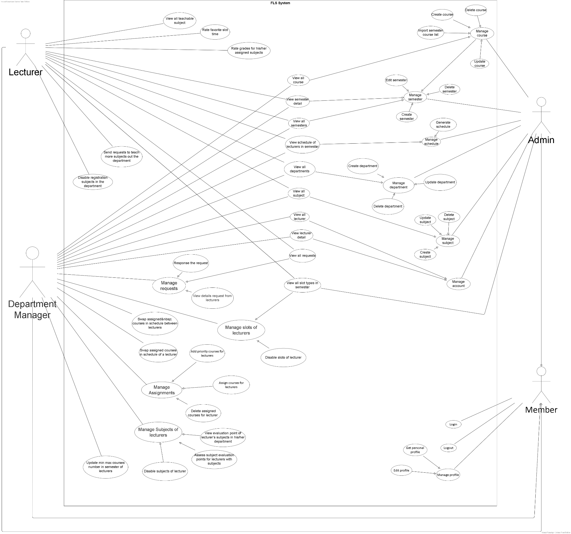

Figure . Use case diagram

#### 2.2.2 Descriptions

|  |  |  |
| --- | --- | --- |
| *ID* | *Use case* | *Actor* |
| 1 | Login | Member |
| 2 | Logout | Member |
| 3 | View personal profile | Member |
| 4 | Edit profile | Member |
| 5 | View all semesters | Admin |
| 6 | View semester detail | Admin |
| 7 | Create semester | Admin |
| 8 | Edit semester | Admin |
| 9 | Delete semester | Admin |
| 10 | Import semester course list | Admin |
| 11 | Create course | Admin |
| 12 | Update course | Admin |
| 13 | Delete course | Admin |
| 14 | View all courses | Admin |
| 15 | View all slot type in semester | Admin |
| 16 | View all lecturers | Admin |
| 17 | View lecturer detail | Admin |
| 18 | Generate schedule | Admin |
| 19 | View all schedule of lecturers in semester | Admin |
| 20 | Create department | Admin |
| 21 | Update department | Admin |
| 22 | Delete department | Admin |
| 23 | View all departments | Admin |
| 24 | Create subject | Admin |
| 25 | Update subject | Admin |
| 26 | Delete subject | Admin |
| 27 | View all subjects | Admin |
| 28 | View all lecturers | Department Manager |
| 29 | View all subjects | Department Manager |
| 30 | View all courses list | Department Manager |
| 31 | View evaluation point of lecturer’s subjects in his/her department | Department Manager |
| 32 | View all schedule of lecturers in semester | Department Manager |
| 33 | View lecturer detail | Department Manager |
| 34 | View all departments | Department Manager |
| 35 | View semester | Department Manager |
| 36 | View semester detail | Department Manager |
| 37 | Add priority courses for lecturers | Department Manager |
| 38 | Assign courses for lecturers | Department Manager |
| 39 | Delete assigned courses for lecturer after pick course assign | Department Manager |
| 40 | Assess subject evaluation points for lecturers with subjects | Department Manager |
| 41 | Update min max courses number in semester of lecturers | Department Manager |
| 42 | View all request from lecturers | Department Manager |
| 43 | View request detail from lecturers | Department Manager |
| 44 | Response requests from lecturers | Department Manager |
| 45 | Disable slots of lecturer | Department Manager |
| 46 | Disable subjects of lecturer | Department Manager |
| 47 | Swap assigned courses in schedule between lecturers | Department Manager |
| 48 | Swap assigned courses in schedule of a lecturer | Department Manager |
| 49 | View all semesters | Lecturer |
| 50 | View detail of the semester | Lecturer |
| 51 | View schedule in semester | Lecturer |
| 52 | View all slots in semester | Lecturer |
| 53 | View all departments | Lecturer |
| 54 | View all subjects | Lecturer |
| 55 | View all teachable subjects | Lecturer |
| 56 | Rate grades for his/her assigned subjects in the department | Lecturer |
| 57 | Rate favourite slot time | Lecturer |
| 58 | Disable registration subjects in the department | Lecturer |
| 59 | Send requests to teach more subjects out the department | Lecturer |
| 60 | View all requested subjects out the department | Lecturer |

Table . Use case descriptions

## 3. Functional Requirements

### 3.1 System Functional Overview

#### 3.1.1 Screens Flow

##### a. Screen Admin Web Application Flow

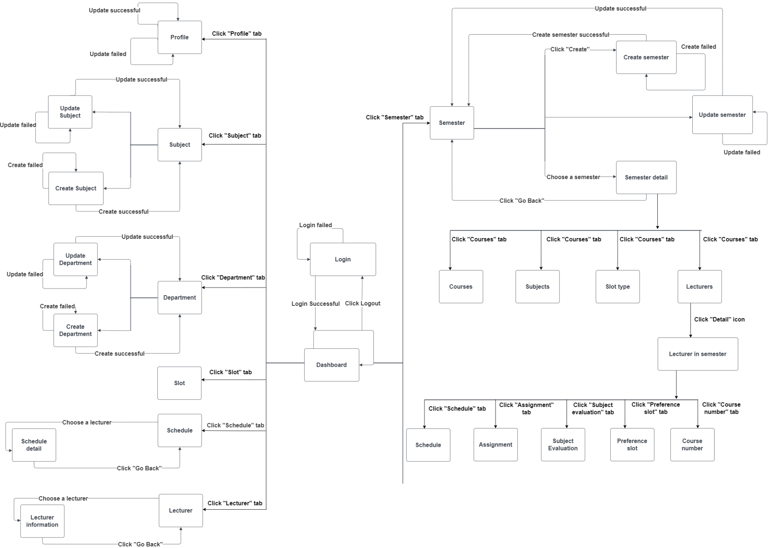

Figure . Screens Flow - Admin

##### b. Screen Department Manager Web Application Flow

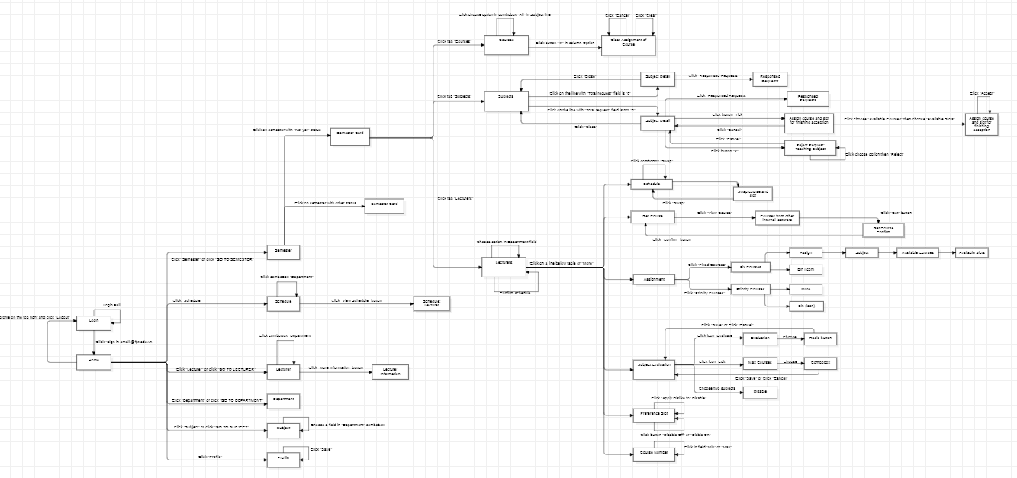

Figure . Screens Flow - Department manager

##### c. Screen Lecturer Web Application Flow

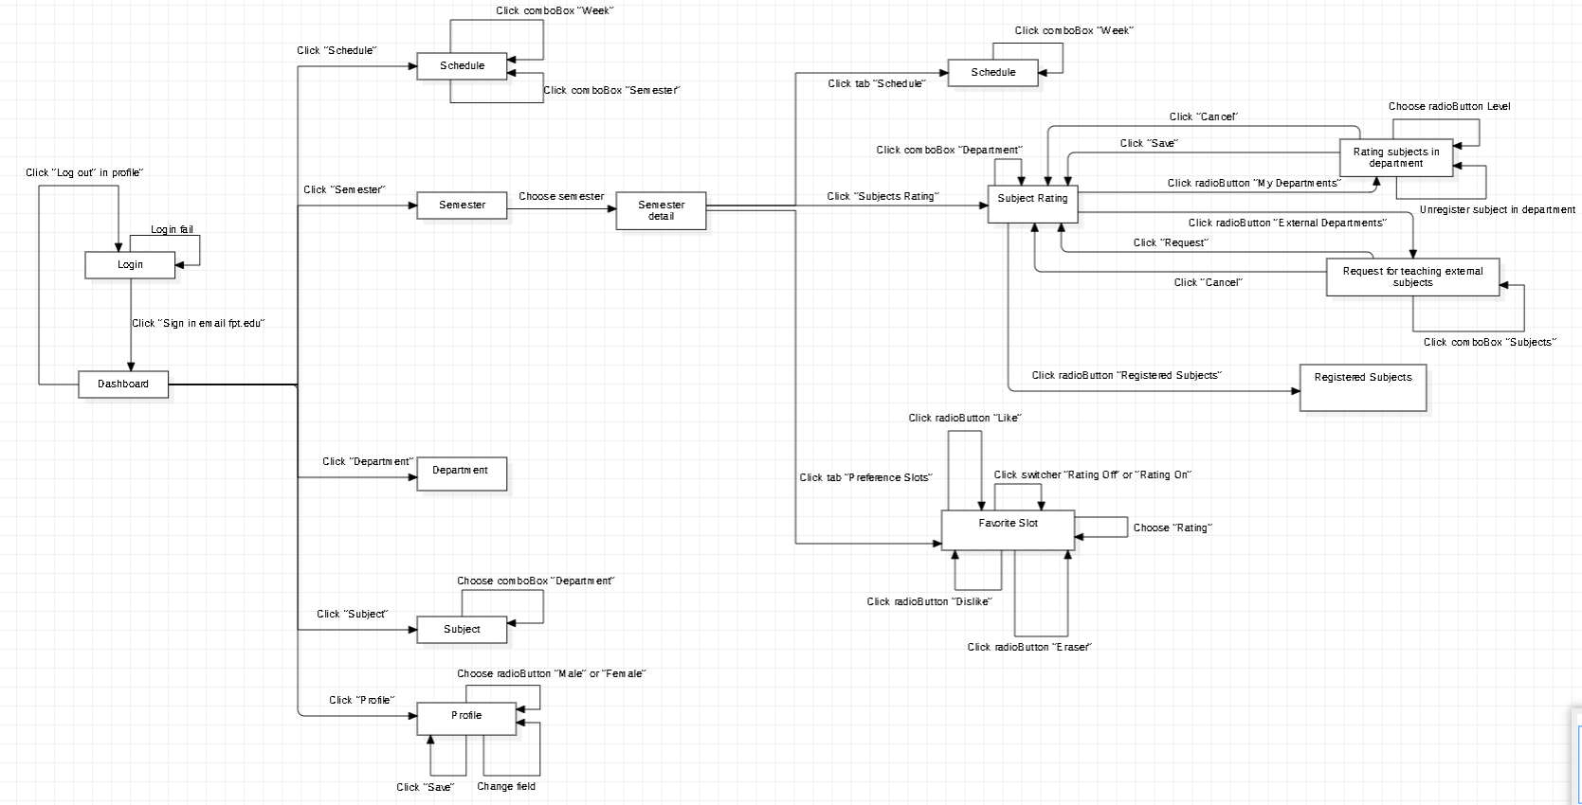

Figure . Screens Flow - Lecturer

#### 3.1.2 Screen Descriptions

##### **a. Screen Admin Web Application Details**

|  |  |  |  |
| --- | --- | --- | --- |
| **Id** | **Feature** | **Screen** | **Description** |
| 01 | Authenticate User | Login | This screen allow user to login to system with the username and password |
| 02 | Display dashboard | Dashboard | This screen display dashboard screen |
| 03 | Display list of slots | Slot | This screen allows the user to view all slots in semester |
| 04 | Display list of departments | Department | This screen allows the user to view all departments |
| 05 | Create new department | Create department | This screen allows the user to create new department |
| 06 | Update department | Update department | This screen allows the user to update detail of department |
|  | Disable department | Department | This screen allows the user to disable department |
| 07 | Display list of subjects | Subject | This screen allows the user to view all subjects |
| 08 | Create new subject | Create subject | This screen allows the user to create new subject |
| 09 | Update subject | Update subject | This screen allows the user to update detail of subject |
| 10 | Disable subject | Subject | This screen allows the user to disable subject |
| 11 | Display all information of user | Profile | This screen allows the user to view all information of user |
| 12 | Update profile | Profile | This screen allows the user to update information of user |
| 13 | Display list of lecturers | Schedule | This screen allows the user to view all lecturers |
| 14 | Display a schedule in semester of lecturer | Schedule detail | This screen allows the user to view a schedule in semester of lecturer |
| 15 | Display list of lecturers | Lecturer | This screen allows the user to view all lecturers |
| 16 | Display all information of lecturer | Lecturer detail | This screen allows the user to view all information of lecturer |
| 17 | Display list of semesters | Semester | This screen allows the user to view all semesters |
| 18 | Create new semester | Create Semester | This screen allows the user to create new semester |
| 19 | Update semester | Update Semester | This screen allows the user to update detail of semester |
| 20 | Disable semester | Semester | This screen allows the user to disable semester |
| 21 | Display semester detail | Semester detail | This screen allows the user view detail of semester |
| 22 | Display list of course in the semester | Course | This screen allows the user to view all courses in the semester |
| 23 | Display list of subjects in semester | Subjects | This screen allows the user to view subjects in semester |
| 24 | Display list of slots in semester | Slot type | This screen allows the user to view slots in semester |
| 25 | Display list of lecturers in semester | Lecturers | This screen allows the user to view lecturers in semester |
| 26 | Display semester and lecturer detail | Lecturer In Semester | This screen allows the user to view semester and lecturer detail |
| 27 | Display a schedule of the lecturer in the semester | Schedule | This screen allows the user to view a schedule of the lecturer in the semester |
| 28 | Display fixed courses and priority courses in semester | Assignment | This screen allows the user to view |
| 29 | Display list of fixed courses in the semester | Fixed courses | This screen allows the user to view list of fixed courses in the semester |
| 30 | Display list of priority courses in the semester | Priority courses | This screen allows the user to view list priority courses in the semester |
| 31 | Display list of the rating for the subject of lecturer in the department in the semester | Subject Evaluation | This screen allows the user to view the rating for subjects of lecturer in the department in the semester |
| 32 | Display list of the rating for slots of lecturer in the department in the semester | Preference Slot | This screen allows the user to view Display list of the rating for slots of lecturer in the department in the semester |
| 33 | Display min and max courses of lecturer in the semester | Course Number | This screen allows the user to view mix max courses of lecturer in the semester |

Table . Screens Descriptions - Admin

##### **b. Screen Department Manager Web Application Details**

|  |  |  |  |
| --- | --- | --- | --- |
| **#** | **Feature** | **Screen** | **Description** |
| 01 | Authenticate User | Login | This screen allows the user to log in to the system with the username and password. |
| 02 | Display Home Screen | Home | This screen display information about Semester |
| 03 | Display Semester Screen | Semester | This screen allows the user to view all semester |
| 04 | Display Semester Detail Screen | Semester Detail | This screen allows the user to view the state of the semester |
| 05 | Display Courses Screen | Semester Detail | This screen allows the user to fix course for lecturers |
| 06 | Display Subjects Screen | Semester Detail | This screen allows the user to view total courses, total assigned courses, total requests and response request |
| 07 | Display Lecturers Screen | Semester Detail | This screen allows the user to view lecturers, view schedule of lecturer, assign courses, give subject evaluation points, disable slot and edit min max course for lecturer |
| 08 | Display Schedule Screen | Semester Detail | This screen allows the user to view schedule of a lecturer |
| 09 | Display Assignment Screen | Semester Detail | This screen allows the user to assign courses for a lecturer |
| 10 | Display Subject Evaluation | Semester Detail | This screen allows the user to give Subject Evaluation and max courses for a lecturer |
| 11 | Display Preference Slot | Semester Detail | This screen allows the user to disable slot’s lecturer |
| 12 | Display Course Number | Semester Detail | This screen allows the user to edit min and mix course of lecturer |
| 13 | Display Schedule Screen | Schedule | This screen allows the user view schedule of a lecturers |
| 14 | Display Lecturer Screen | Lecturer | This screen allows the user view all lecturers in/out department |
| 15 | Display Lecturer Information | Lecturer Information | This screen allows the user to view profile a lecturer |
| 16 | Display Department Screen | Department | This screen allows the user to view all departments |
| 17 | Display list of Subject | Subject | This screen allows the user to view all subject in/out departments |
| 18 | Display Profile | Profile | This screen allows the user to view and edit profile |

Table . Screens Descriptions - Department manager

##### **c. Screen Lecturer Web Application Details**

|  |  |  |  |
| --- | --- | --- | --- |
| **#** | **Feature** | **Screen** | **Description** |
| 01 | Authenticate User | Login | This screen allows the user to login to the system with the username and password. |
| 02 | Display Schedule Screen | Schedule | This screen allows the user to view schedule in semester on going |
| 03 | Display Semester Screen | Semester | This screen allows the user to view semester and do features |
| 04 | Display Schedule Screen | Semester Detail | This screen allows the user to view schedule |
| 05 | Display Subjects Rating | Semester Detail | This screen allows the user to give favourite points and request teachable for subjects |
| 06 | Display Preference Slots | Semester Detail | This screen allows the user to choose preference slots |
| 07 | Display Department Screen | Department | This screen allows the user to view all departments |
| 08 | Display Subject | Subjects | This screen allows the user to view all subjects in/out department |
| 09 | Display Profile | Profile | This screen allows the user to edit and view profile |

Table . Screens Descriptions - Lecturer

#### 3.1.3 Screen Authorization

|  |  |  |  |  |
| --- | --- | --- | --- | --- |
| **Screen** | **Member** | **Lecturer** | **Department Manager** | **Admin** |
| Login | X | X | X | X |
| Home |  | X | X | X |
| Schedule |  | X | X | X |
| Semester |  | X | X | X |
| Department |  | X | X | X |
| Subject |  | X | X | X |
| Profile |  | X | X | X |
| Lecturer |  | X | X |  |
| Assignment |  |  | X |  |
| Priority |  |  | X |  |
| Rating |  |  | X |  |
| Request |  | X | X |  |
| View Request |  | X | X |  |

Table . Screen Authorization

#### 3.1.4 Entity Relationship Diagram

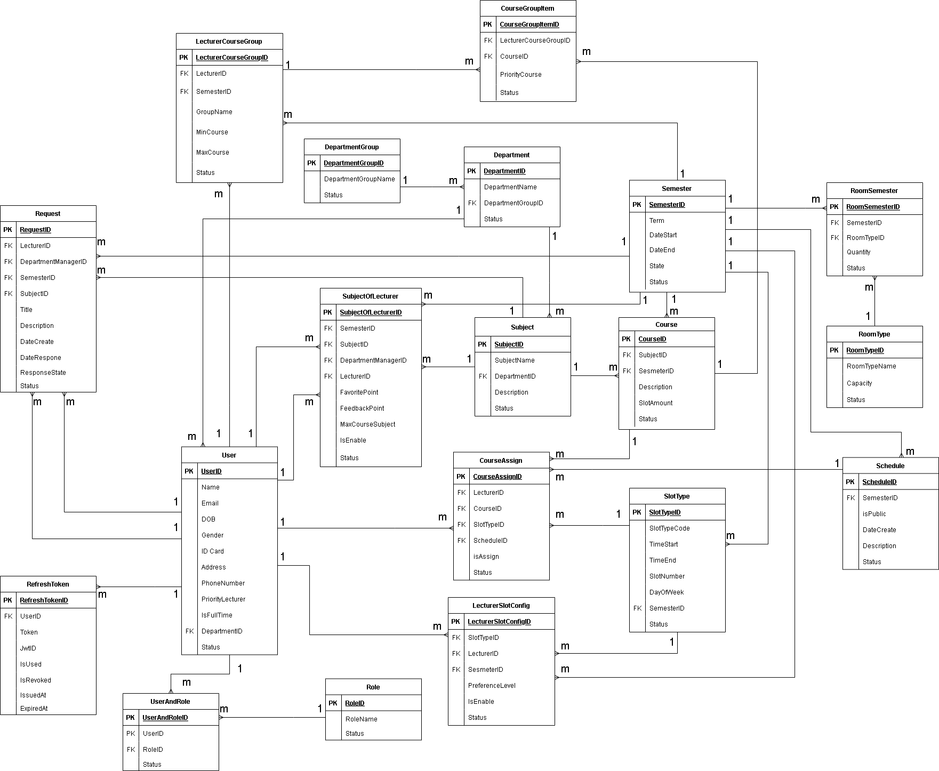

Figure . Entity Relationship Diagram

**Entities Description**

|  |  |  |
| --- | --- | --- |
| **#** | **Entity** | **Description** |
| 1 | LecturerCourseGroup | Information about amount courses of Lecturer teach in semester |
| 2 | CourseGroupItem | Information about priority courses of Lecturer in semester |
| 3 | User | Information about user |
| 4 | UserAndRole | Information about user role |
| 5 | Role | Information about role |
| 5 | DepartmentGroup | Information about relate department of lecturer |
| 6 | Department | Information about department |
| 7 | Semester | Information about semester |
| 8 | RomSemster | Information about amount rooms in semester |
| 9 | RoomType | Information about room |
| 10 | Request | Information about request |
| 12 | SubjectOfLecturer | Information about subject of lecturer can teach |
| 13 | Subject | Information about subject in department |
| 14 | Course | Information about course of subject |
| 15 | CourseAssgin | Information about courses is assigned for lecturer |
| 16 | Schedule | Information about schedule of semester |
| 17 | LecturerSlotCofig | Information about slot of lecturer teach in semester |
| 18 | SlotType | Information about slot |
| 19 | RefreshToken | Information about token |

Table . Entities Description

### 3.2 Member Features

#### 3.2.1 Login

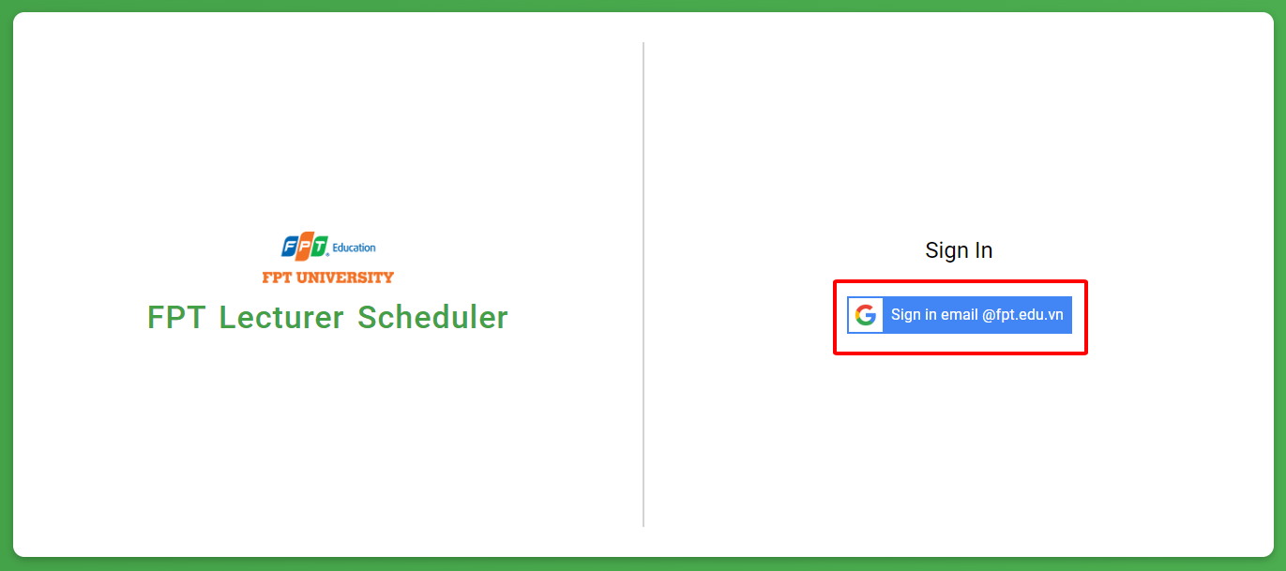

Figure . Member Features - Login

|  |  |  |
| --- | --- | --- |
| Function trigger | **Login page -> Sign in email @fpt.edu.vn** | |
| Function description | Actor | Member |
| Purpose | Login to FLS System |
| Function Details | Validation | Login by email @fpt account which registered in FLS system |
| Business rules | BR-03: Members must log in with the FPT email registered in the system's data.  BR-04: Gmail is unique for each lecturer. |
| Functionalities | In login page, Member click “Sign in email @fpt.edu.vn” and use @fpt email to login FLS system |

Table . Member Features - Login

#### 3.2.2 View personal profile

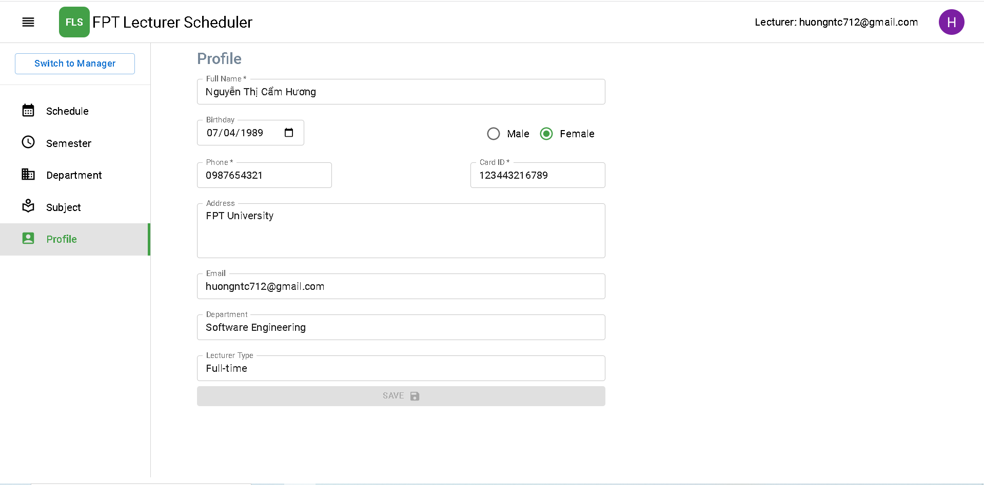

Figure . Member Features - View personal profile

|  |  |  |
| --- | --- | --- |
| Function trigger | **Home page -> Profile tab** | |
| Function description | Actor | Member |
| Purpose | View personal information of member |
| Function Details | Validation | Login by email @fpt account which registered in FLS system |
| Business rules |  |
| Functionalities | Member chooses “Profile” tab to view personal information. |

Table . Member Features - View personal profile

#### 3.2.3 Edit profile

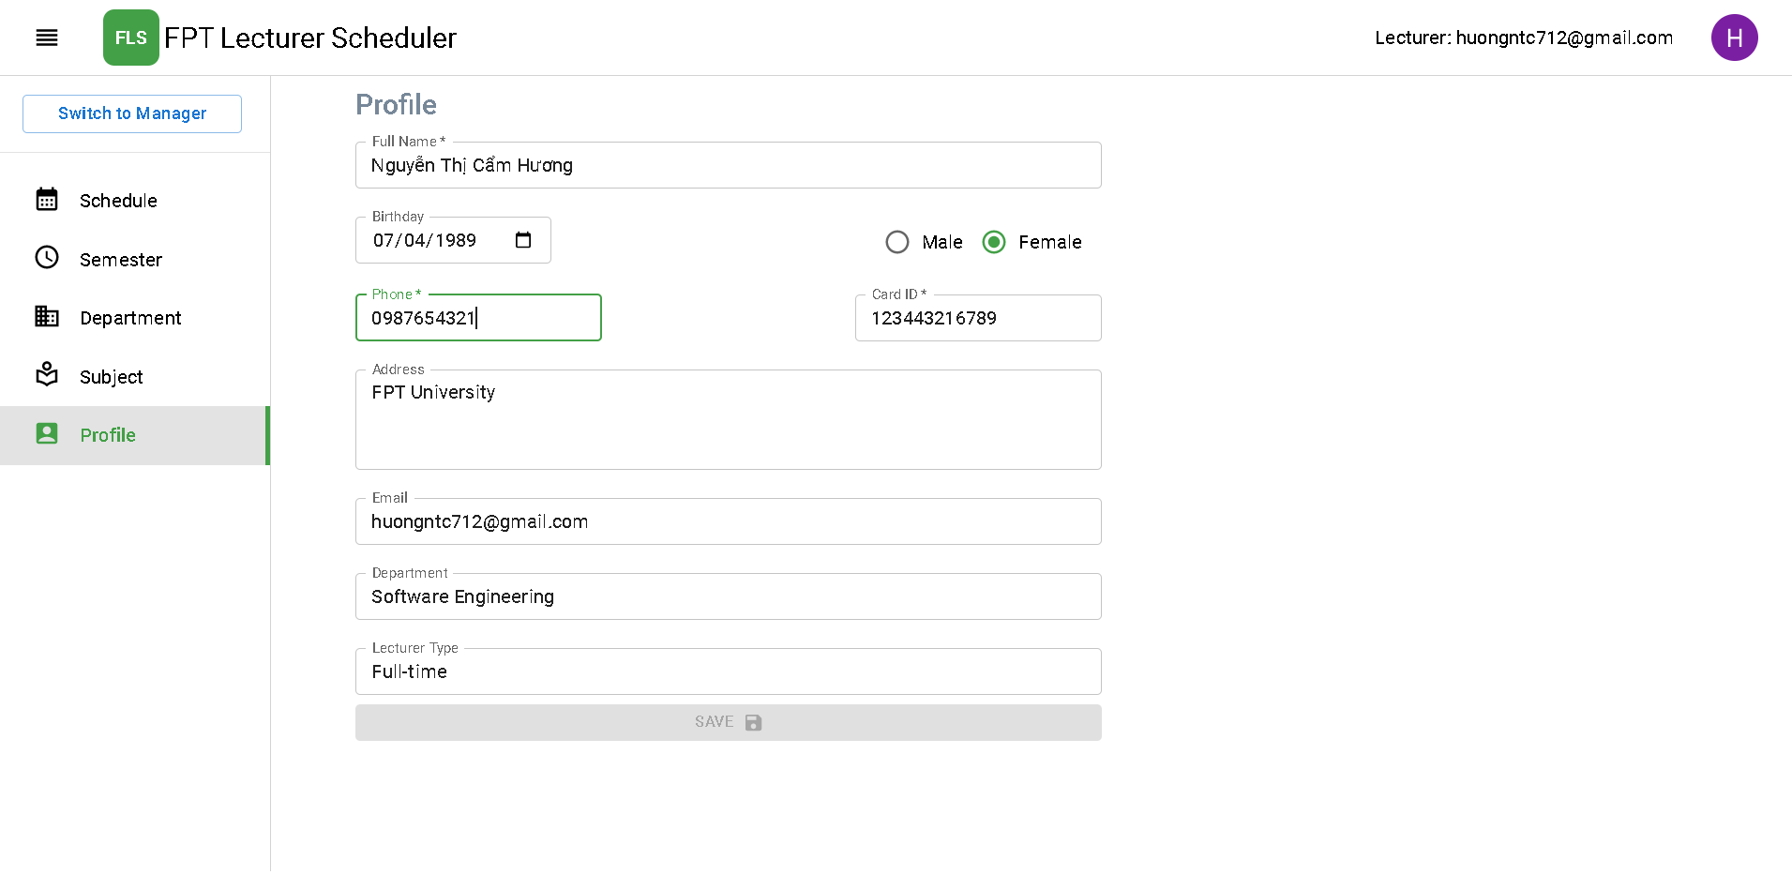

Figure . Member Features - Edit profile

|  |  |  |
| --- | --- | --- |
| Function trigger | **Home page -> Profile tab** | |
| Function description | Actor | Member |
| Purpose | Member edits personal information:   * Full name * Date of birth * Gender * Phone * Card ID * Address |
| Function Details | Validation | Login by email @fpt account which registered in FLS system |
| Business rules |  |
| Functionalities | Member edits personal information and clicks “Save” button. |

Table . Member Features - Edit profile

#### 3.2.4 Logout

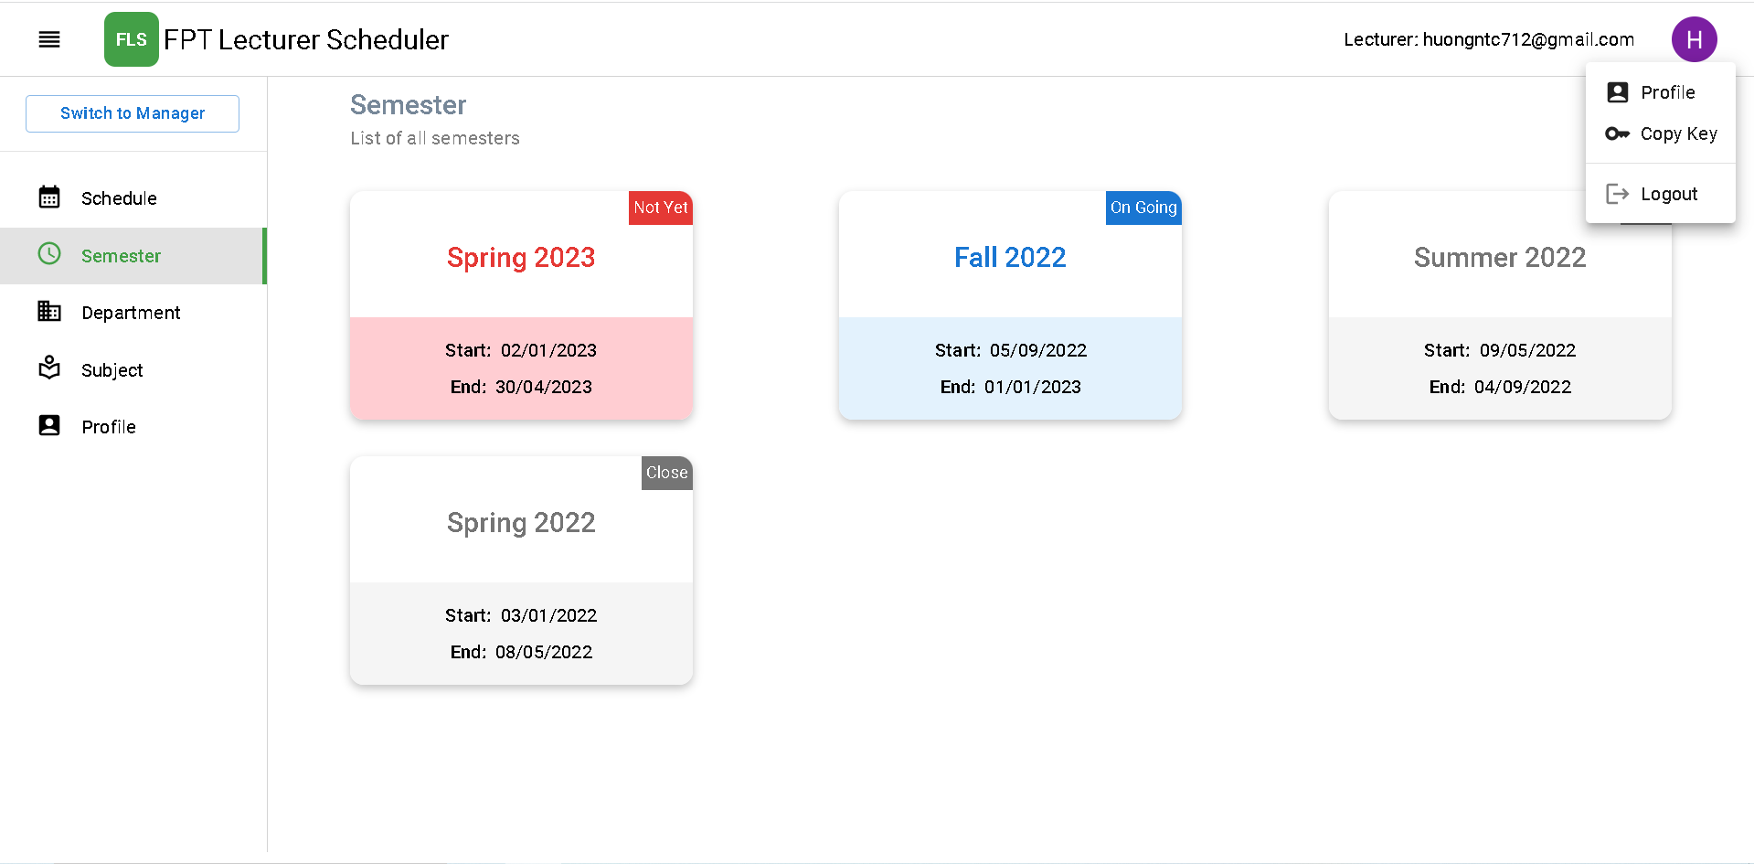

Figure . Member Features - Logout

|  |  |  |
| --- | --- | --- |
| Function trigger | **Home page -> click Avatar -> Logout** | |
| Function description | Actor | Member |
| Purpose | Logout of FLS System |
| Function Details | Validation | Member logged in FLS system |
| Business rules | BR-02: Clear session when account logout. |
| Functionalities | Member clicks Avatar and click “Logout” to log out of FLS system |

Table . Member Features - Logout

### 3.3 Admin Features

#### 3.3.1 Manage semesters

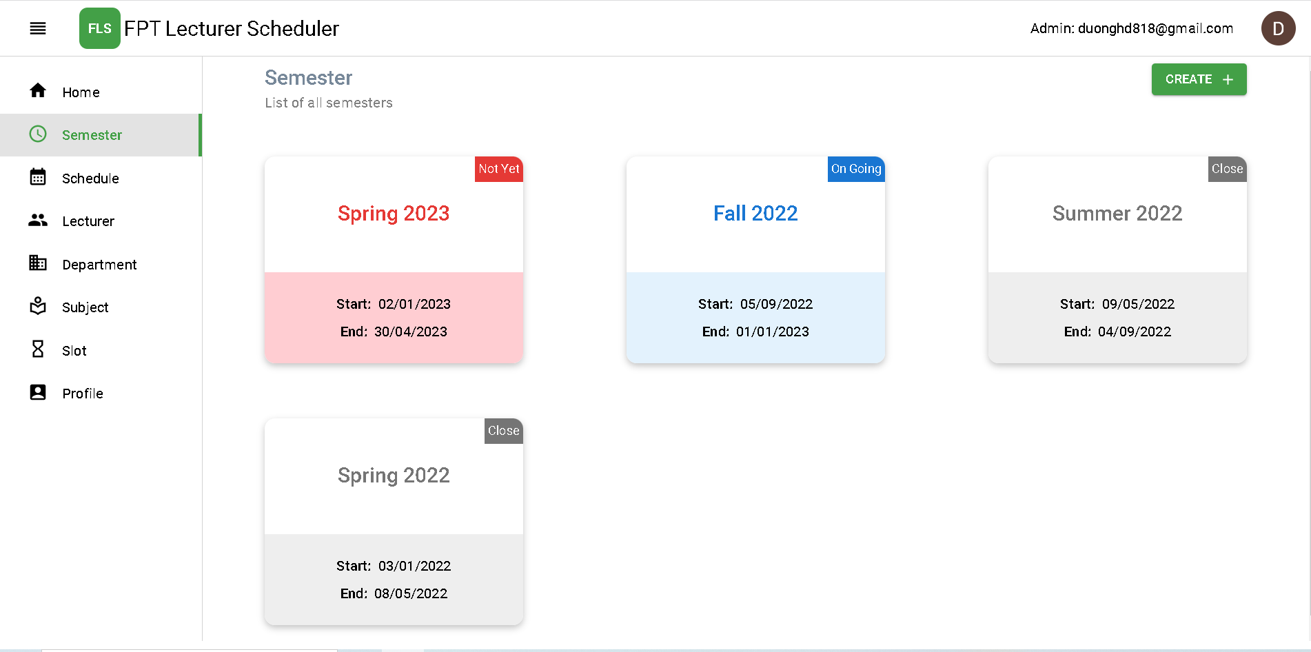

Figure . Admin Features - Manage semesters

|  |  |  |
| --- | --- | --- |
| Function trigger | **Admin Home Page -> Semester Page** | |
| Function description | Actor | Admin |
| Purpose | Manage all semesters.   * View all semesters: List all semesters * View semester detail: Courses, subjects, slot types, lecturers, schedules * Create semester: Create new a semester * Update semester: Update state of the semester * Delete semester: Disable semester |
| Function Details | Validation | Login by email account with role admin. |
| Business rules | BR-05: Only the Admin role can create a new semester.  BR-06: Only the Admin role can modify the state of the semester.  BR-07: Only the Admin role can delete semester. |
| Functionalities | Admin chooses “Semester” tab to manage and view all list semesters, admin clicks on semester to view detail. |

Table . Admin Features - Manage semesters

#### 3.3.2 Manage courses

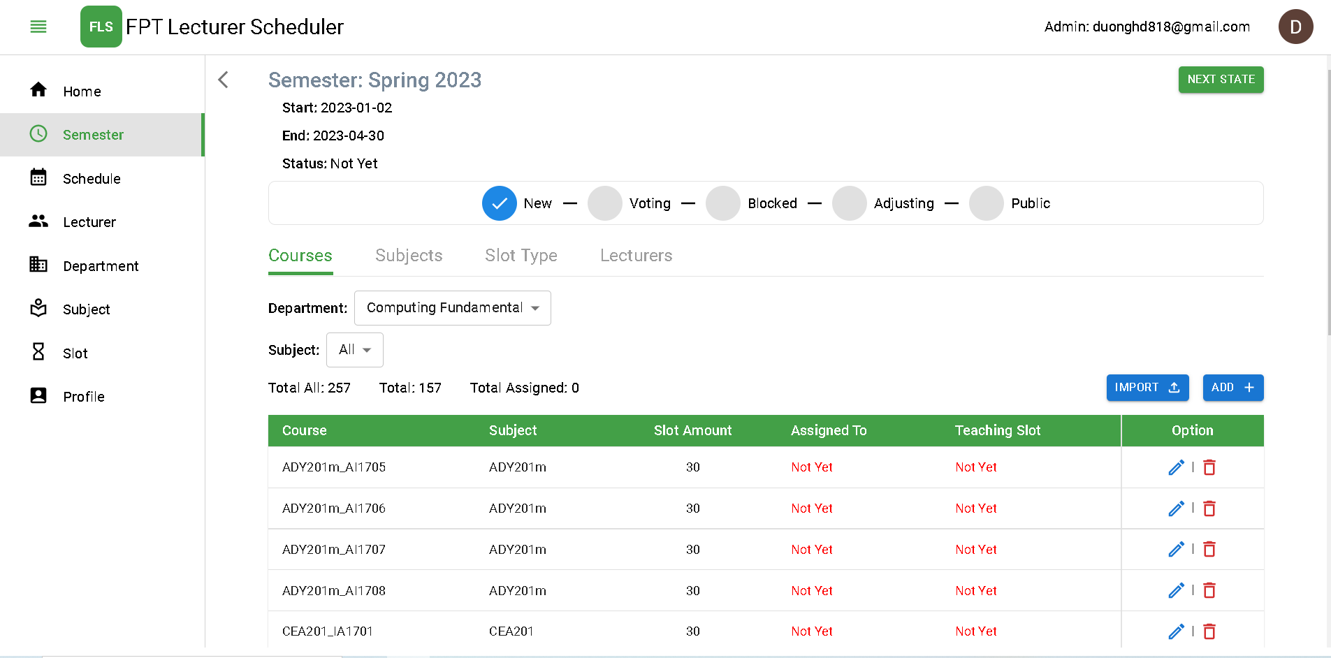

Figure . Admin Features - Manage courses

|  |  |  |
| --- | --- | --- |
| Function trigger | **Admin Home Page -> Semester Page -> Choose the semester -> Course tab** | |
| Function description | Actor | Admin |
| Purpose | Manage all courses.   * View all courses: List all courses in semester * Import semester course list: From data excel * Create course: Create new a course * Update course: Update course detail * Delete course: Disable course |
| Function Details | Validation | Login by email account with role admin. |
| Business rules | BR-11: Only the Admin role can add data courses for the semester.  BR-12: Only the Admin role can delete data courses for the semester.  BR-46: Admin can only manage course when state of semester is new |
| Functionalities | Admin clicks on semester to manage courses in the semester. |

Table . Admin Features - Manage courses

#### 3.3.3 Manage departments

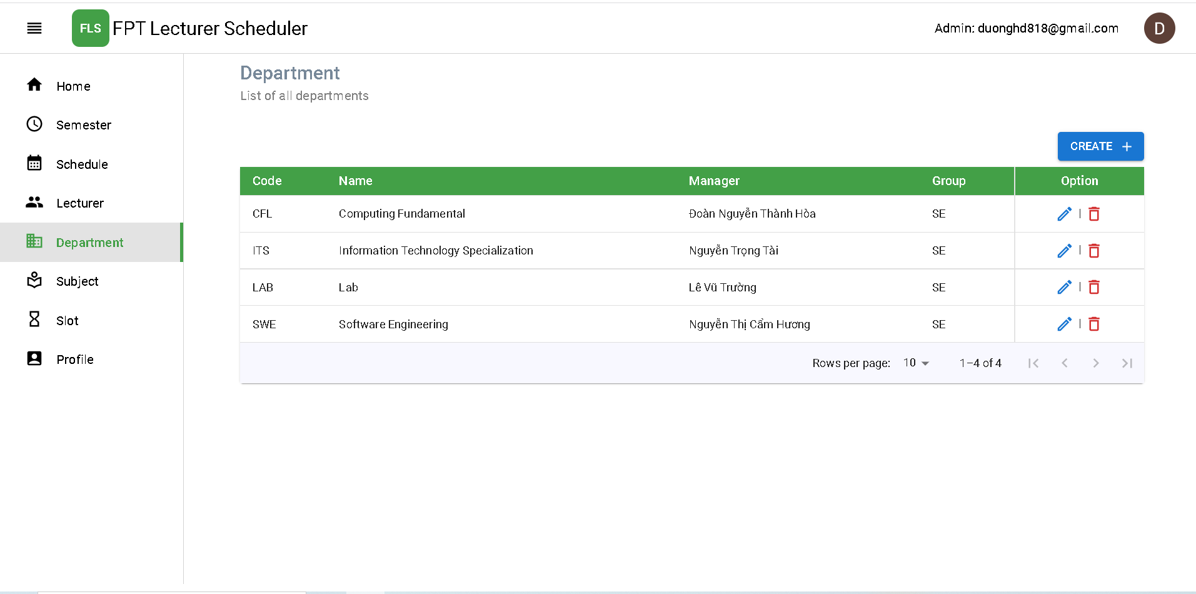

Figure . Admin Features - Manage departments

|  |  |  |
| --- | --- | --- |
| Function trigger | **Admin Home Page -> Department Page** | |
| Function description | Actor | Admin |
| Purpose | Manage all departments.   * View all departments: List all departments * Create department: Create new a department * Update department: Update information of the department * Delete department: Disable department |
| Function Details | Validation | Login by email account with role admin. |
| Business rules | N/A |
| Functionalities | Admin chooses “Department” tab to manage and view all list departments. |

Table . Admin Features - Manage departments

#### 3.3.4 Manage subjects

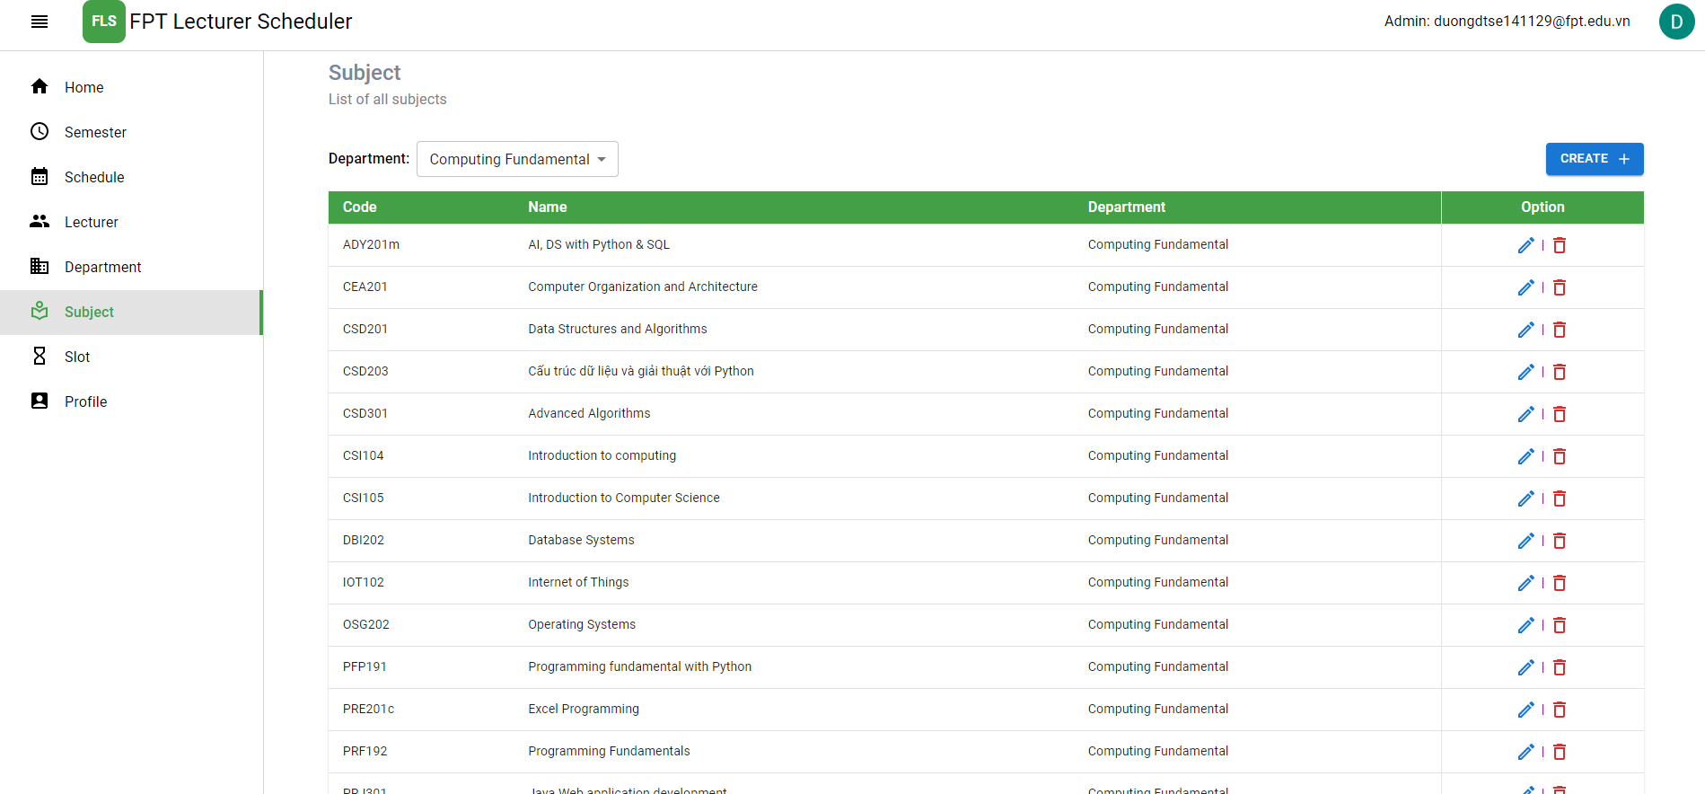

Figure . Admin Features - Manage subjects

|  |  |  |
| --- | --- | --- |
| Function trigger | **Admin Home Page -> Subject Page** | |
| Function description | Actor | Admin |
| Purpose | Manage all subjects.   * View all subjects: List all subjects * Create subject: Create new a subject * Update subject: Update information of the subject * Delete subject: Disable subject |
| Function Details | Validation | Login by email account with role admin. |
| Business rules | N/A |
| Functionalities | Admin chooses “Subject” tab to manage and view all list subjects. |

Table . Admin Features - Manage subjects

#### 3.3.5 Manage lecturer accounts

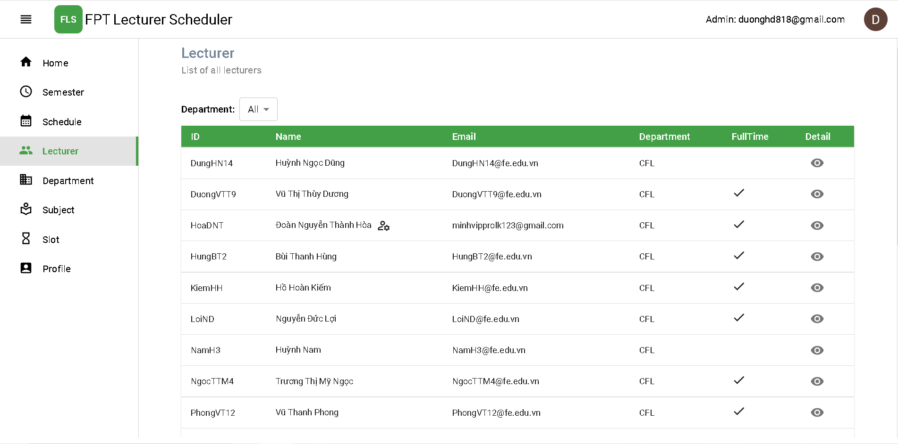

Figure . Admin Features - Manage lecturer accounts

|  |  |  |
| --- | --- | --- |
| Function trigger | **Admin Home Page -> Lecturer Page** | |
| Function description | Actor | Admin |
| Purpose | Manage all lecturer accounts.   * View all lecturers: List all lecturers * View lecturer detail: View lecturer information |
| Function Details | Validation | Login by email account with role admin. |
| Business rules | N/A |
| Functionalities | Admin chooses “Lecturer” tab to view all list lecturers. |

Table . Admin Features - Manage lecturer accounts

#### 3.3.6 Generate schedule in semester

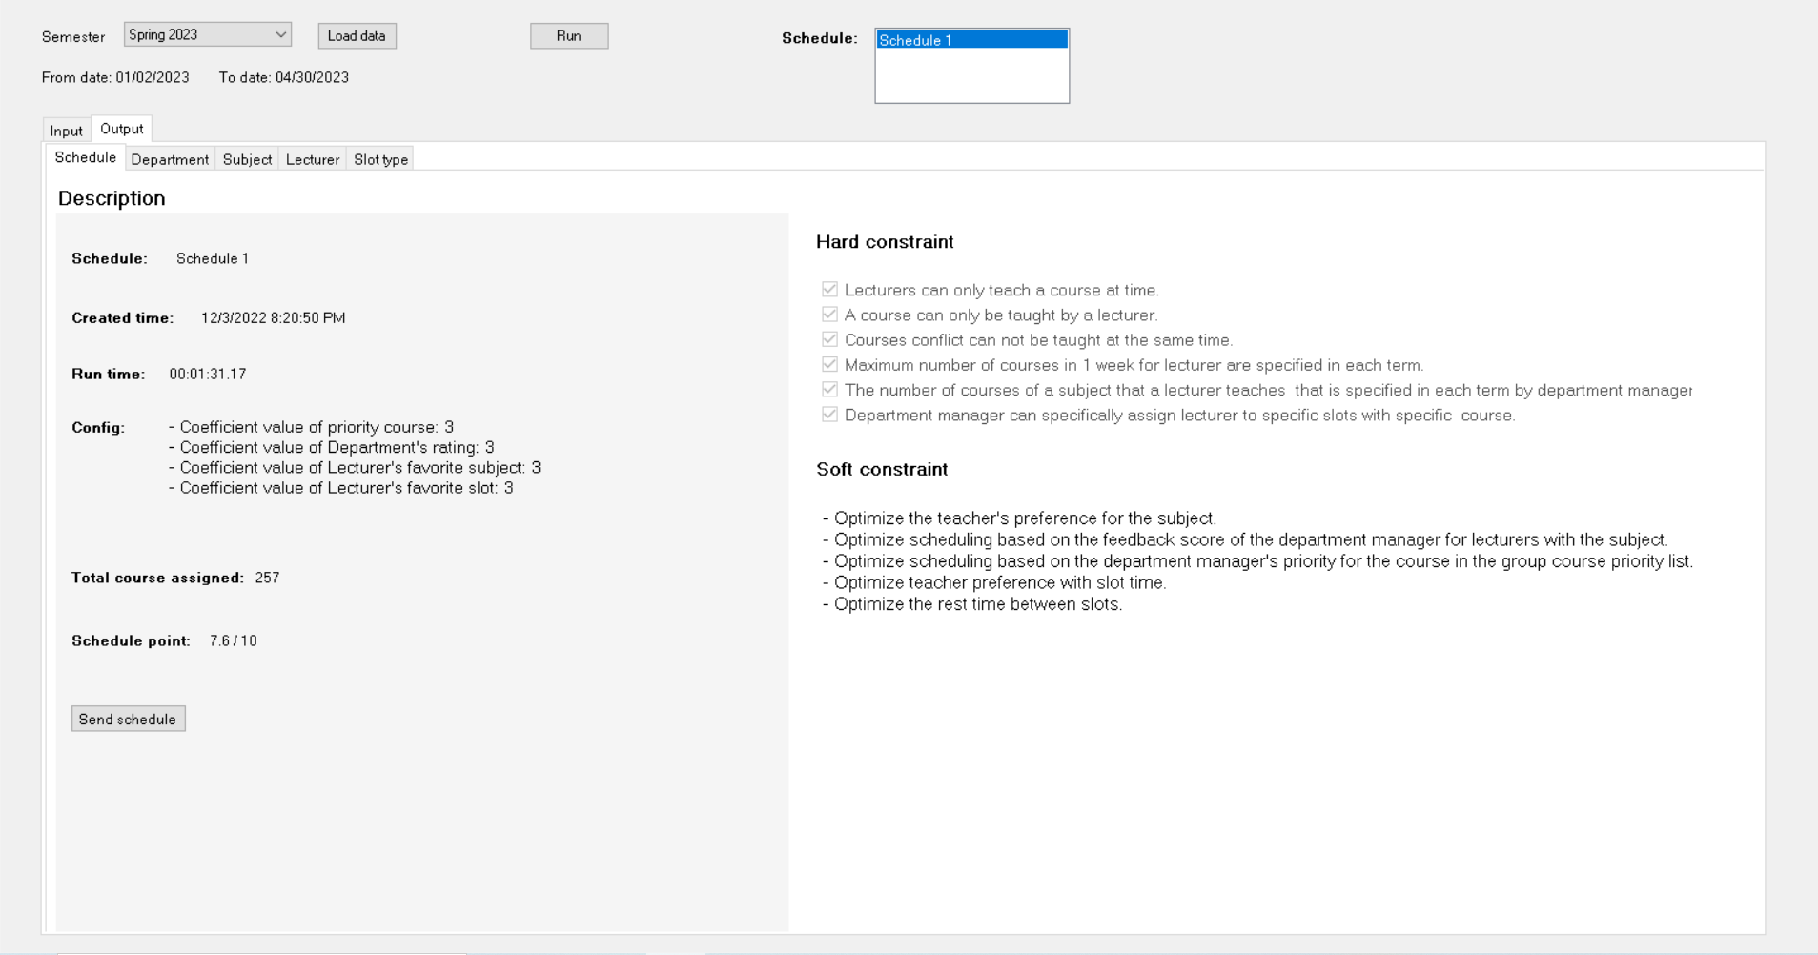

Figure . Admin Features - Generate schedule in semester

|  |  |  |
| --- | --- | --- |
| Function trigger | **WinForms App login -> Load data semester -> Run -> Schedule tab** | |
| Function description | Actor | Admin |
| Purpose | Generate schedule in semester   * Load data semester: Choose semester want generate schedule to load data * Run algorithm WinForms to generate schedule * View the generated schedule detail |
| Function Details | Validation | Login WinForms by token with role admin. |
| Business rules | BR-24: Lecturers can only teach one course at a time.  BR-25: A Course can only be taught by a lecturer.  BR-26: Courses which conflict cannot be taught at the same time.  BR-30: Lecturers can teach other subjects but only within the department group.  BR-35: Optimize lecturer preference with slot time.  BR-36: Optimize the lecturer's preference for the subject.  BR-37: Optimize the rest time between slots.  BR-38: Optimize scheduling based on the feedback score of the department manager for lecturers with the subject.  BR-39: Optimize scheduling based on the department manager's priority for the course in the group course priority list. |
| Functionalities | Admin logins window form app to generate schedules, After choosing schedule, admin click “Send schedule” button to send schedule to server. |

Table . Admin Features - Generate schedule in semester

### 3.4 Department Manager Features

#### 3.4.1 View all lecturers

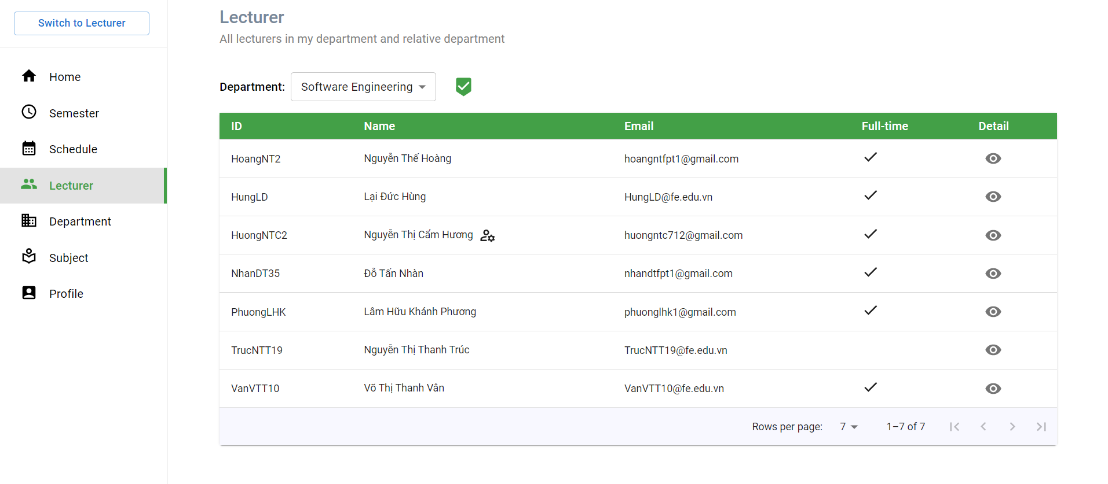

Figure . Department Manager Features - View all lecturers

|  |  |  |
| --- | --- | --- |
| Function trigger | **“Home” on navigation bar -> “Lecturer” on navigation bar** | |
| Function description | Actor | Department Manager |
| Purpose | View all lecturers in department and relative departments |
| Function Details | Validation | Login by email account with role department Manager |
| Business rules | N/A |
| Functionalities | The Department Manager choose in the selection: “Department” to select the department.  The Department Manager clicks the “Eye” icon to view lecturer detail. |

Table . Department Manager Features - View all lecturers

#### 3.4.2 View lecturer information

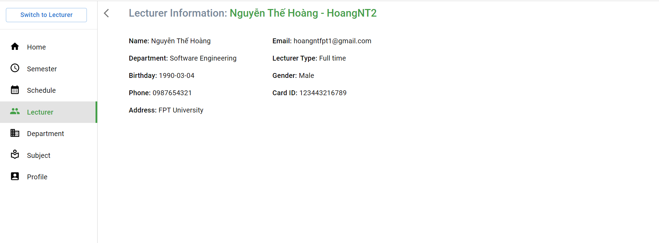

Figure . Department Manager Features - View lecturer information

|  |  |  |
| --- | --- | --- |
| Function trigger | **“Home” on navigation bar -> “Lecturer” on navigation bar** | |
| Function description | Actor | Department Manager |
| Purpose | View lecturer information |
| Function Details | Validation | Login by email account with the role department Manager |
| Business rules | N/A |
| Functionalities | List all information of the lecturer |

Table . Department Manager Features - View lecturer information

#### 3.4.3 View all subjects

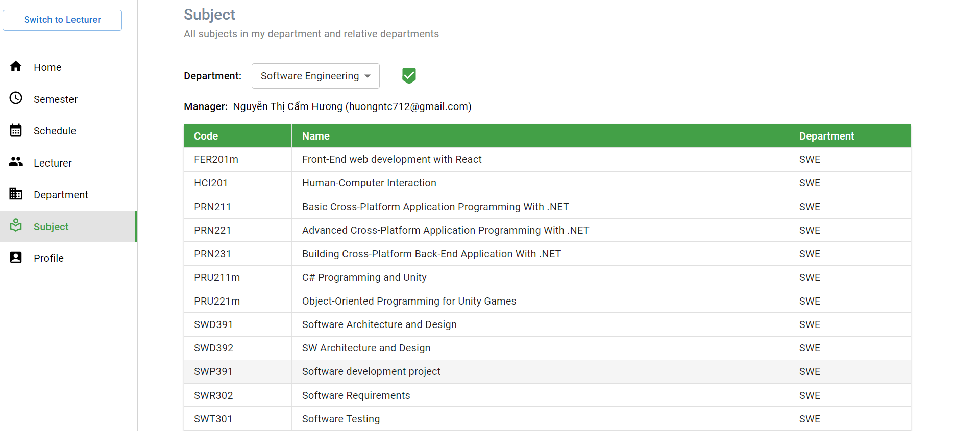

Figure . Department Manager Features - View all subjects

|  |  |  |
| --- | --- | --- |
| Function trigger | **“Home” on navigation bar -> “Subject” on navigation bar** | |
| Function description | Actor | Department Manager |
| Purpose | View all subjects |
| Function Details | Validation | Login by email account with the role department Manager |
| Business rules | N/A |
| Functionalities | The Department Manager choose in the selection: “Department” to select the department. |

Table . Department Manager Features - View all subjects

#### 3.4.4 View all departments

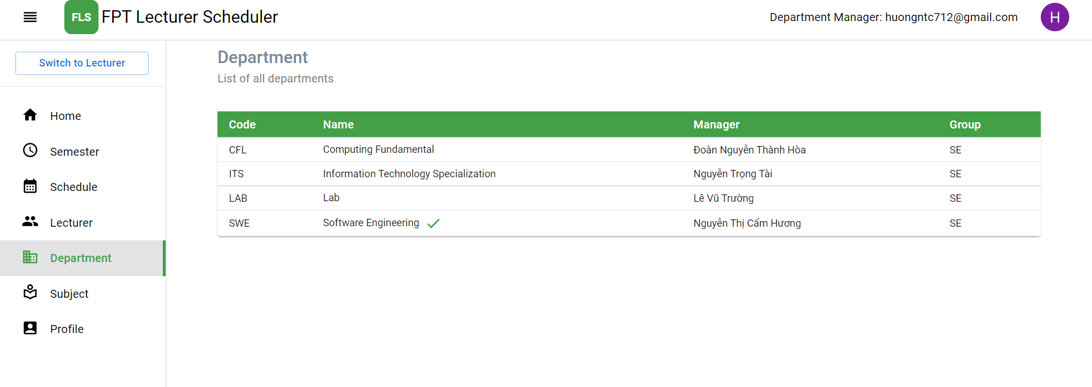

Figure . Department Manager Features - View all departments

|  |  |  |
| --- | --- | --- |
| Function trigger | **“Home” on navigation bar -> “Department” on navigation bar** | |
| Function description | Actor | Department Manager |
| Purpose | View all departments |
| Function Details | Validation | Login by email account with the role department Manager. |
| Business rules | N/A |
| Functionalities | List all departments. |

Table . Department Manager Features - View all departments

#### 3.4.5 View all schedules of lecturers in semester

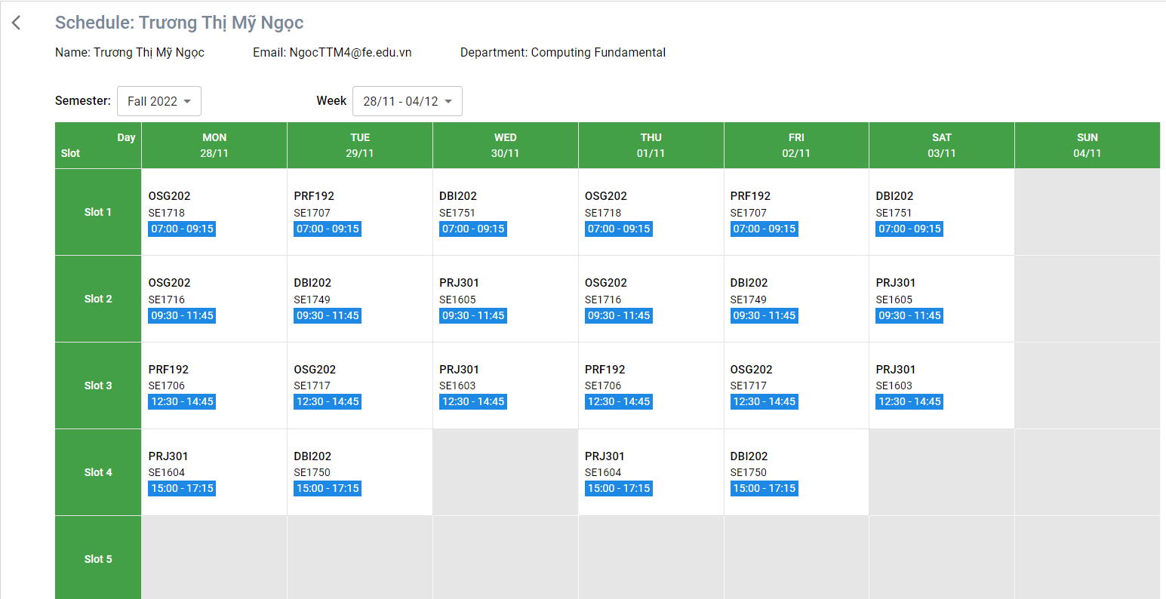

Figure . Department Manager Features - View all schedules of lecturers in semester

|  |  |  |
| --- | --- | --- |
| Function trigger | **“Home” on navigation bar -> “Schedule” on navigation bar** | |
| Function description | Actor | Department Manager |
| Purpose | View schedule details of lecturer |
| Function Details | Validation | Login by email account with role department Manager |
| Business rules | N/A |
| Functionalities | The Department Manager chooses in the selection: “Semester” to select the semester.  The Department Manager chooses in the selection: “Week” to select the week. |

Table . Department Manager Features - View all schedules of lecturers in semester

#### 3.4.6 View all semesters

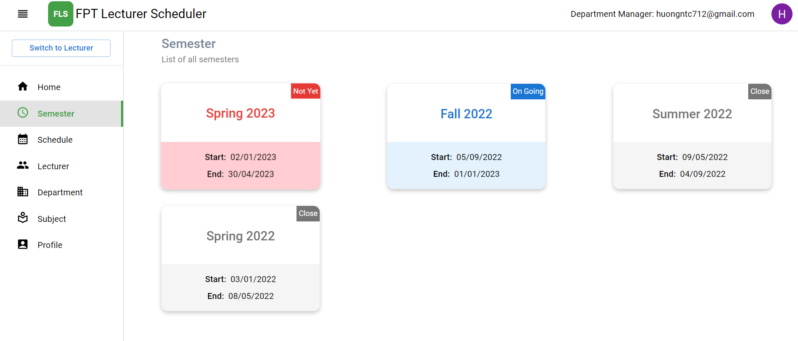

Figure . Department Manager Features - View all semesters

|  |  |  |
| --- | --- | --- |
| Function trigger | **“Home” on navigation bar -> “Semester” on navigation bar** | |
| Function description | Actor | Department Manager |
| Purpose | View semester |
| Function Details | Validation | Login by email account with role department Manager |
| Business rules | N/A |
| Functionalities | List all semesters  The Department Manager clicks on any semester card to view semester details. |

Table . Department Manager Features - View all semesters

#### 3.4.7 View semester details

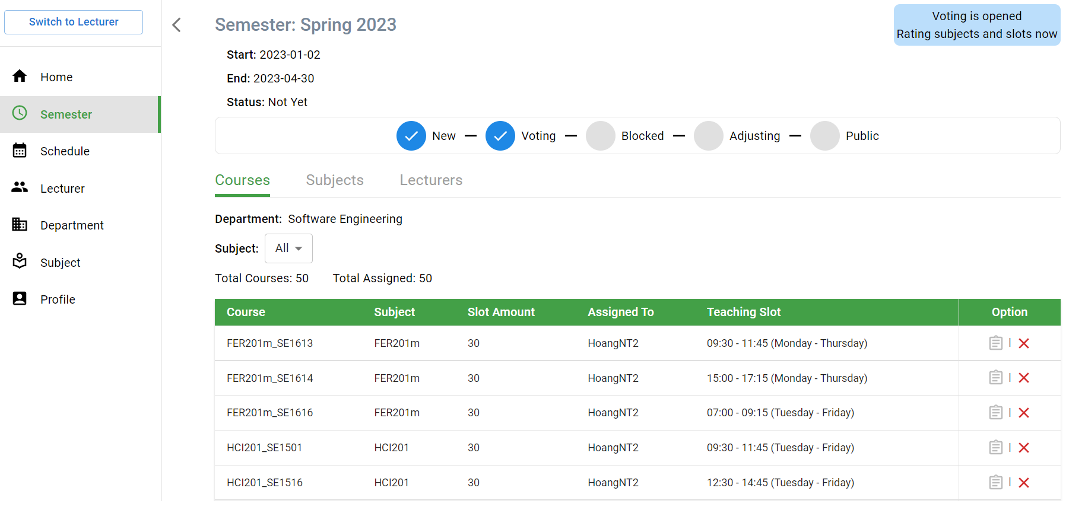

Figure . Department Manager Features - View all semester details

|  |  |  |
| --- | --- | --- |
| Function trigger | **“Home” on navigation bar -> “Semester” on navigation bar** | |
| Function description | Actor | Department Manager |
| Purpose | View semester details. |
| Function Details | Validation | Login by email account with role department Manager |
| Business rules | N/A |
| Functionalities | The Department Manager clicks on “Course” to view all assigned courses list.  The Department Manager clicks on “Subject” to view all subjects in the department.  The Department Manager clicks on “Lecturer” to view all lecturers in the department. |

Table . Department Manager Features - View all semester details

#### 3.4.8 View all assigned courses

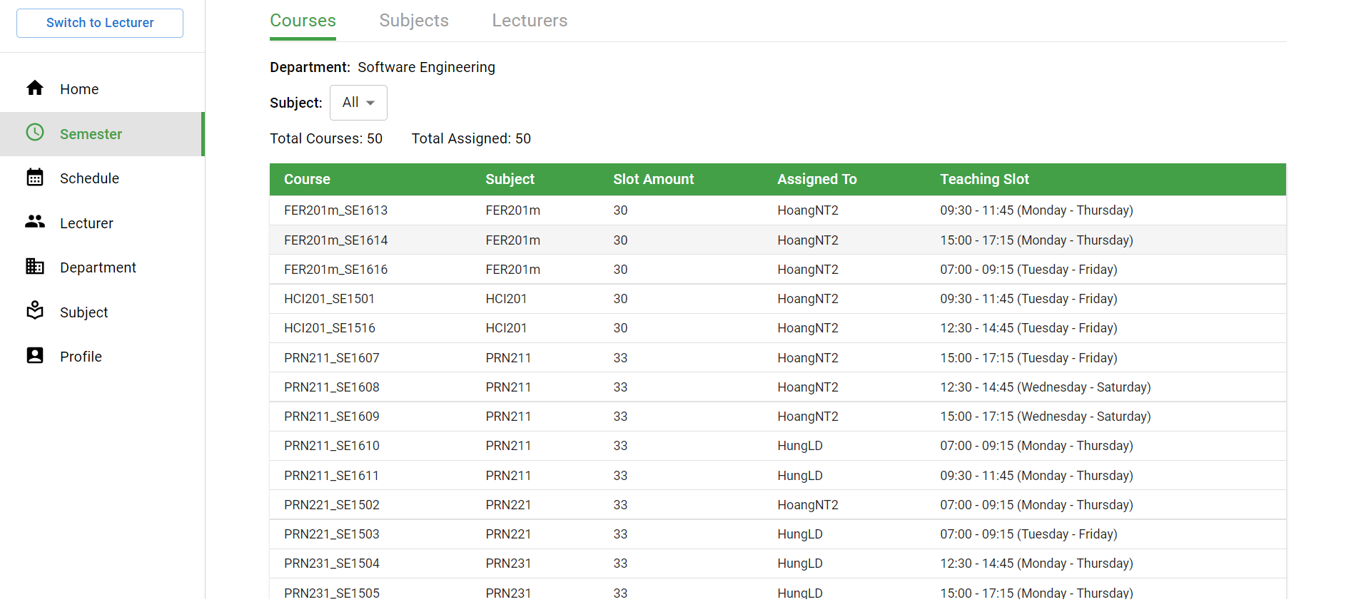

Figure . Department Manager Features - View all assigned courses

|  |  |  |
| --- | --- | --- |
| Function trigger | **“Home” on navigation bar -> “Semester” on navigation bar ->Semester Detail page -> “Course” tab** | |
| Function description | Actor | Department Manager |
| Purpose | View all assigned courses of the subject.   * View all courses: List all courses * View all assigned courses: List all assigned courses |
| Function Details | Validation | Login by email account with role department Manager |
| Business rules | N/A |
| Functionalities | The Department Manager chooses in the selection: “Subject” to select the subject. |

Table . Department Manager Features - View all assigned courses

#### 3.4.9 View all subjects in department

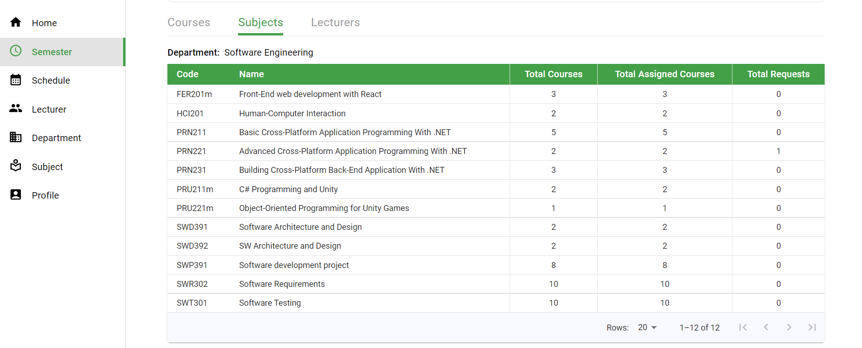

Figure . Department Manager Features - View all subjects in department

|  |  |  |
| --- | --- | --- |
| Function trigger | **“Home” on navigation bar -> “Semester” on navigation bar ->Semester Detail page -> “Subject” tab** | |
| Function description | Actor | Department Manager |
| Purpose | View all subjects in the department.   * View all subjects: List all subjects * View total courses of the subject * View total assigned courses of the subject * View subject details |
| Function Details | Validation | Login by email account with the role department Manager |
| Business rules | N/A |
| Functionalities | The Department Manager clicks on the row subject to view subject details. |

Table . Department Manager Features - View all subjects in department

#### 3.4.10 View all requests from lecturers

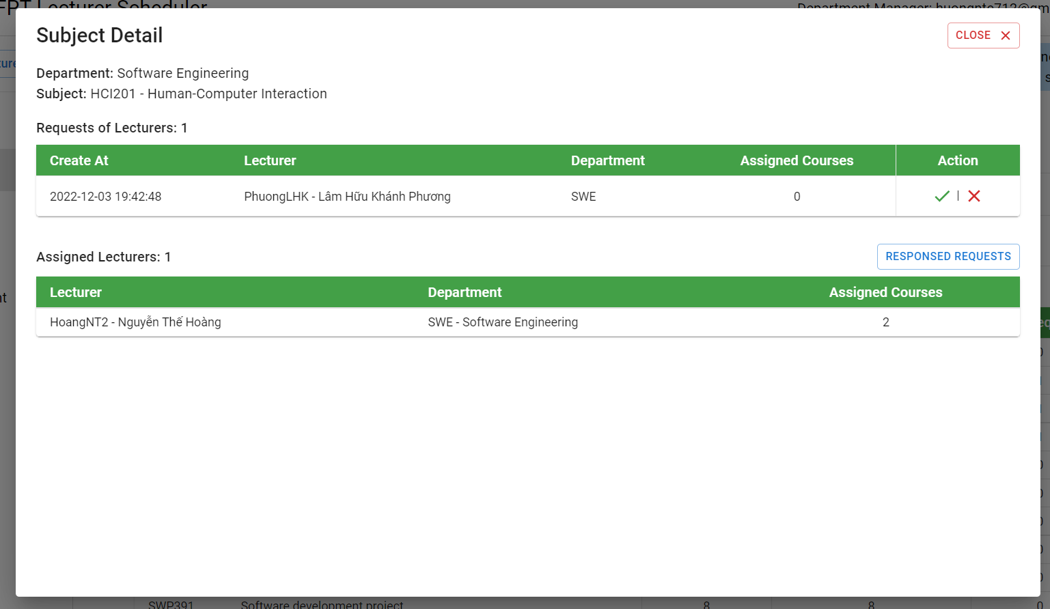

Figure . Department Manager Features - View all requests from lecturers

|  |  |  |
| --- | --- | --- |
| Function trigger | **“Home” on navigation bar -> “Semester” on navigation bar ->Semester Detail page -> “Subject” tab-> Subject Detail** | |
| Function description | Actor | Department Manager |
| Purpose | View all requests from the lecturer.   * View all requests: list requests * Response requests from lecturer |
| Function Details | Validation | Login by email account with the role department Manager |
| Business rules | N/A |
| Functionalities | List all requests to teach more subjects out of the department from the lecturer. |

Table . Department Manager Features - View all requests from lecturers

#### 3.4.11 Response all requests from lecturers



Figure . Department Manager Features - Response all requests from lecturers

|  |  |  |
| --- | --- | --- |
| Function trigger | **“Home” on navigation bar -> “Semester” on navigation bar ->Semester Detail page -> “Subject” tab-> Subject Detail** | |
| Function description | Actor | Department Manager |
| Purpose | Response requests from lecturers. |
| Function Details | Validation | Login by email account with the role department Manager |
| Business rules | BR-58: Only Department manager can accept the lecturer’s request to teach more subjects.  BR-59: Only Department manager can deny the lecturer’s request. |
| Functionalities | The Department Manager clicks on the “Ticks” icon to respond to accept.  The Department Manager clicks on the “X” icon to respond to rejection. |

Table . Department Manager Features - Response all requests from lecturers

#### 3.4.12 Manage assigned course of lecturer

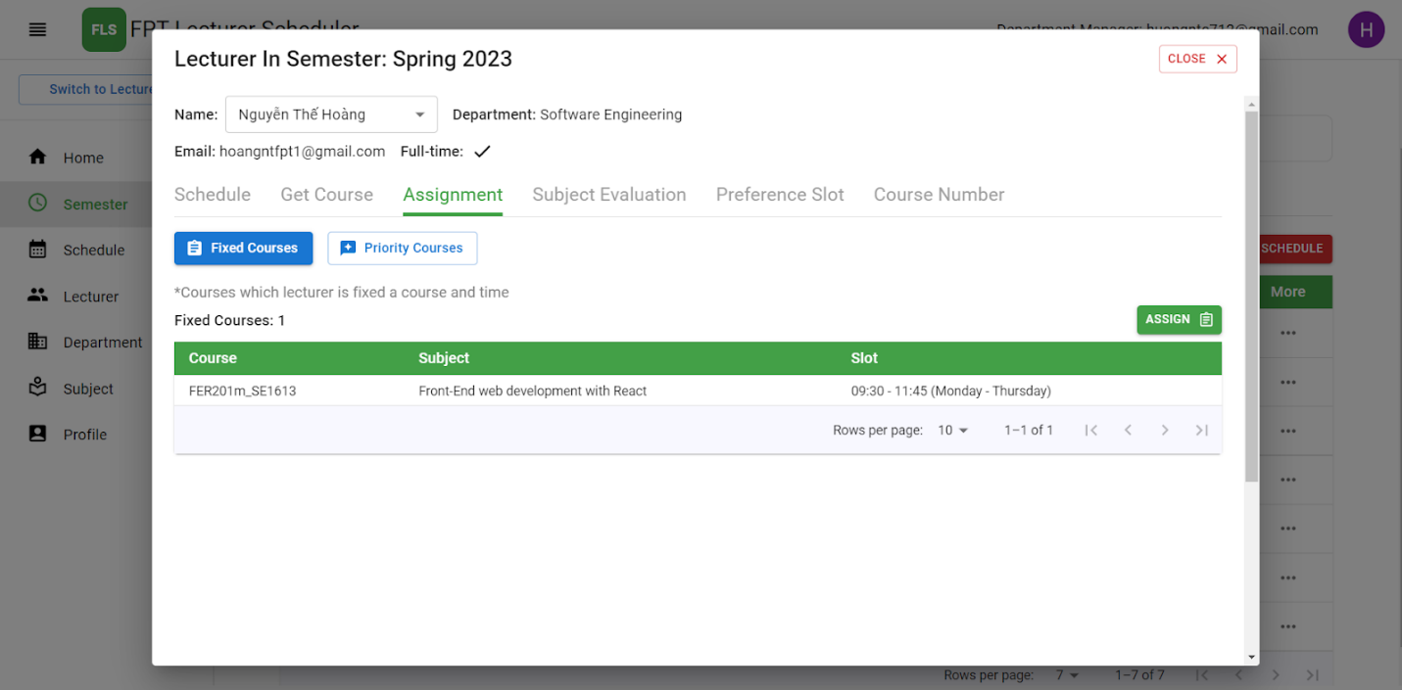

Figure . Department Manager Features - Manage assigned course of lecturer

|  |  |  |
| --- | --- | --- |
| Function trigger | **“Home” on navigation bar -> “Semester” on navigation bar ->Semester Detail page -> “Lecturer” tab -> Lecturer Detail -> Assignment** | |
| Function description | Actor | Department Manager |
| Purpose | Manage assigned courses.   * Assign courses for lecturer * Delete courses assign for lecturer after pick course assign * Add priority courses for lecturers |
| Function Details | Validation | Login by email account with the role department Manager |
| Business rules | BR-14: Only Department manager role can assign courses for lecturers in semester  BR-17: Only Department manager role can edit courses assign for lecturer after pick course assign  BR-52: Department manager can only assign courses for the lecturer when the state of the semester is Evaluating. |
| Functionalities | The Department Manager clicks on the “Assign” button to assign a course for the lecturer.  The Department Manager clicks on the “Bin” icon to delete the assigned course for the lecturer. |

Table . Department Manager Features - Manage assigned course of lecturer

#### 3.4.13 Assign course for lecturer

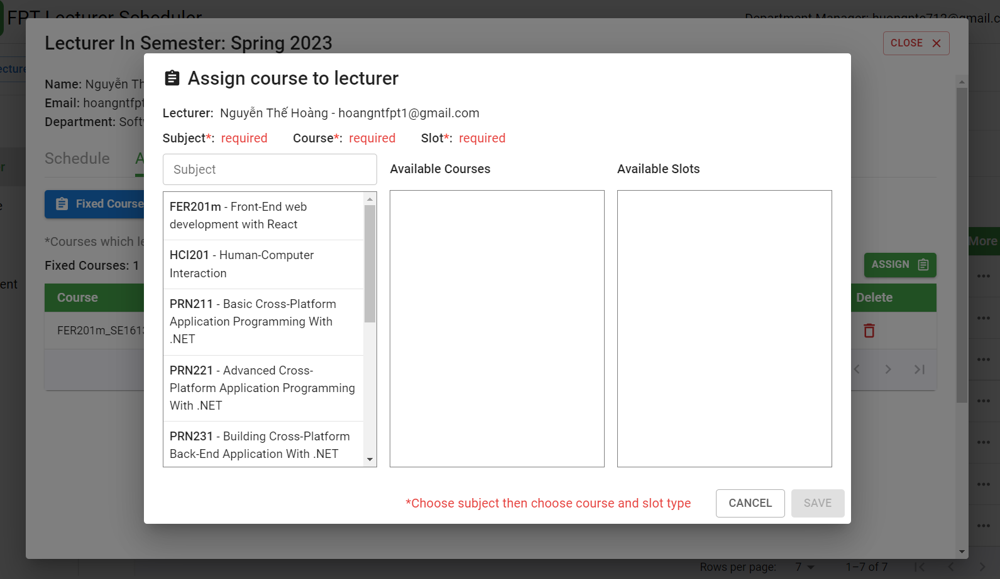

Figure . Department Manager Features - Assign course for lecturer

|  |  |  |
| --- | --- | --- |
| Function trigger | **“Home” on navigation bar -> “Semester” on navigation bar ->Semester Detail page -> “Lecturer” tab -> Lecturer Detail page -> Assignment tab -> “ASSIGN button** | |
| Function description | Actor | Department Manager |
| Purpose | Assign courses for lecturer.   * Search subject |
| Function Details | Validation | Login by email account with the role department Manager |
| Business rules | BR-14: Only Department manager role can assign courses for lecturers in semester  BR-17: Only Department manager role can edit courses assign for lecturer after pick course assign  BR-52: Department manager can only assign courses for the lecturer when the state of the semester is Evaluating. |
| Functionalities | The Department Manager searches for the subject.  The Department Manager chooses the subject.  The Department Manager chooses the course of the subject.  The Department Manager chooses available slots.  The Department Manager clicks on the “Save” button to save. |

Table . Department Manager Features - Assign course for lecturer

#### 3.4.14 Manage priority course of lecturer

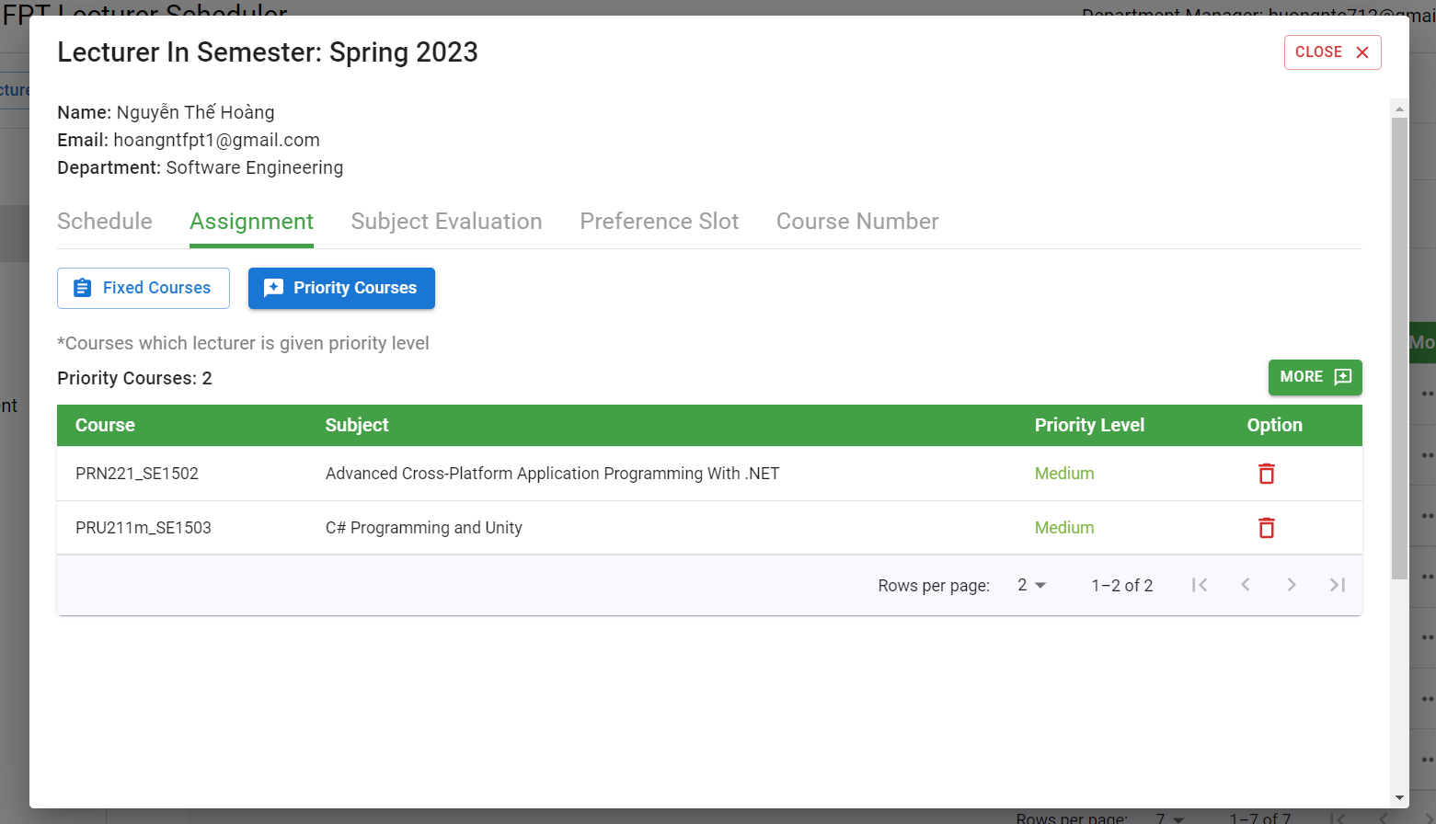

Figure . Department Manager Features - Manage priority course of lecturer

|  |  |  |
| --- | --- | --- |
| Function trigger | **“Home” on navigation bar -> “Semester” on navigation bar ->Semester Detail page -> “Lecturer” tab -> Lecturer Detail -> Assignment -> “Priority Course” button** | |
| Function description | Actor | Department Manager |
| Purpose | Manager priority courses for lecturer.   * Add priority courses for lecturers * Delete priority courses for lecturers |
| Function Details | Validation | Login by email account with the role department Manager |
| Business rules | BR-15: Only Department manager role can give priority course for lecturers in his/her department in semester |
| Functionalities | The Department Manager clicks on the “More” button to add priority courses for the lecturer.  The Department Manager clicks on the “Bin” icon to delete the priority course for the lecturer. |

Table . Department Manager Features - Manage priority course of lecturer

#### 3.4.15 Add priority courses for lecturers

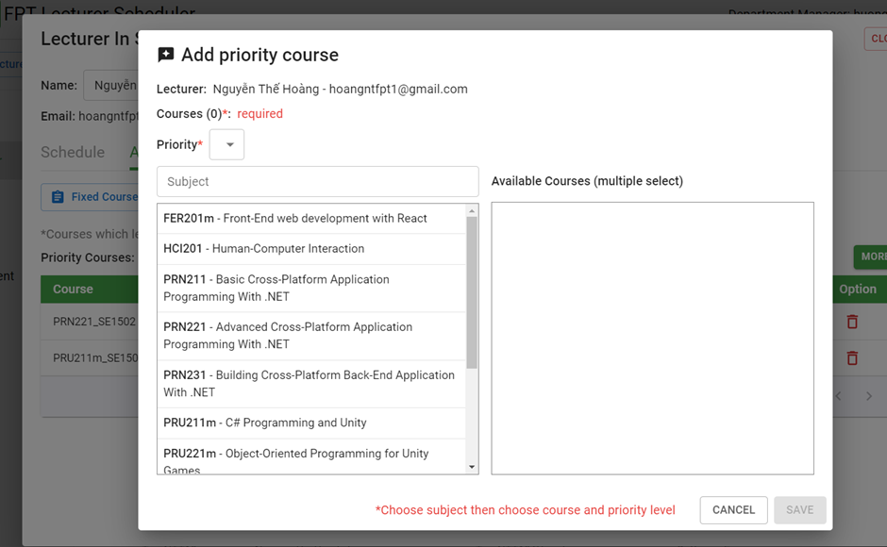

Figure . Department Manager Features - Add priority courses for lecturers

|  |  |  |
| --- | --- | --- |
| Function trigger | **“Home” on navigation bar -> “Semester” on navigation bar ->Semester Detail page -> “Lecturer” tab -> Lecturer Detail -> Assignment -> “Priority Course” button-> “More” button.** | |
| Function description | Actor | Department Manager |
| Purpose | Manager priority courses for lecturer.   * Add priority courses for lecturers * Delete priority courses for lecturers |
| Function Details | Validation | Login by email account with the role department Manager |
| Business rules | BR-15: Only Department manager role can give priority course for lecturers in his/her department in semester |
| Functionalities | The Department Manager chooses in the selection: “Subject” to select the subject.  The Department Manager chooses the subject.  The Department Manager chooses the course of the subject.  The Department Manager clicks on the “Save” button to save. |

Table . Department Manager Features - Add priority courses for lecturers

#### 3.4.16 Delete priority courses for lecturers



Figure . Department Manager Features - Delete priority courses for lecturers

|  |  |  |
| --- | --- | --- |
| Function trigger | **“Home” on navigation bar -> “Semester” on navigation bar ->Semester Detail page -> “Lecturer” tab -> Lecturer Detail -> Assignment -> “Priority Course” button** | |
| Function description | Actor | Department Manager |
| Purpose | Manager priority courses for lecturer.   * Add priority courses for lecturers * Delete priority courses for lecturers |
| Function Details | Validation | Login by email account with the role department Manager |
| Business rules | BR-15: Only Department manager role can give priority course for lecturers in his/her department in semester |
| Functionalities | The Department Manager clicks on the “Bin” icon to delete. |

Table . Department Manager Features - Delete priority courses for lecturers

#### 3.4.17 Manage subject evaluation points of lecturer

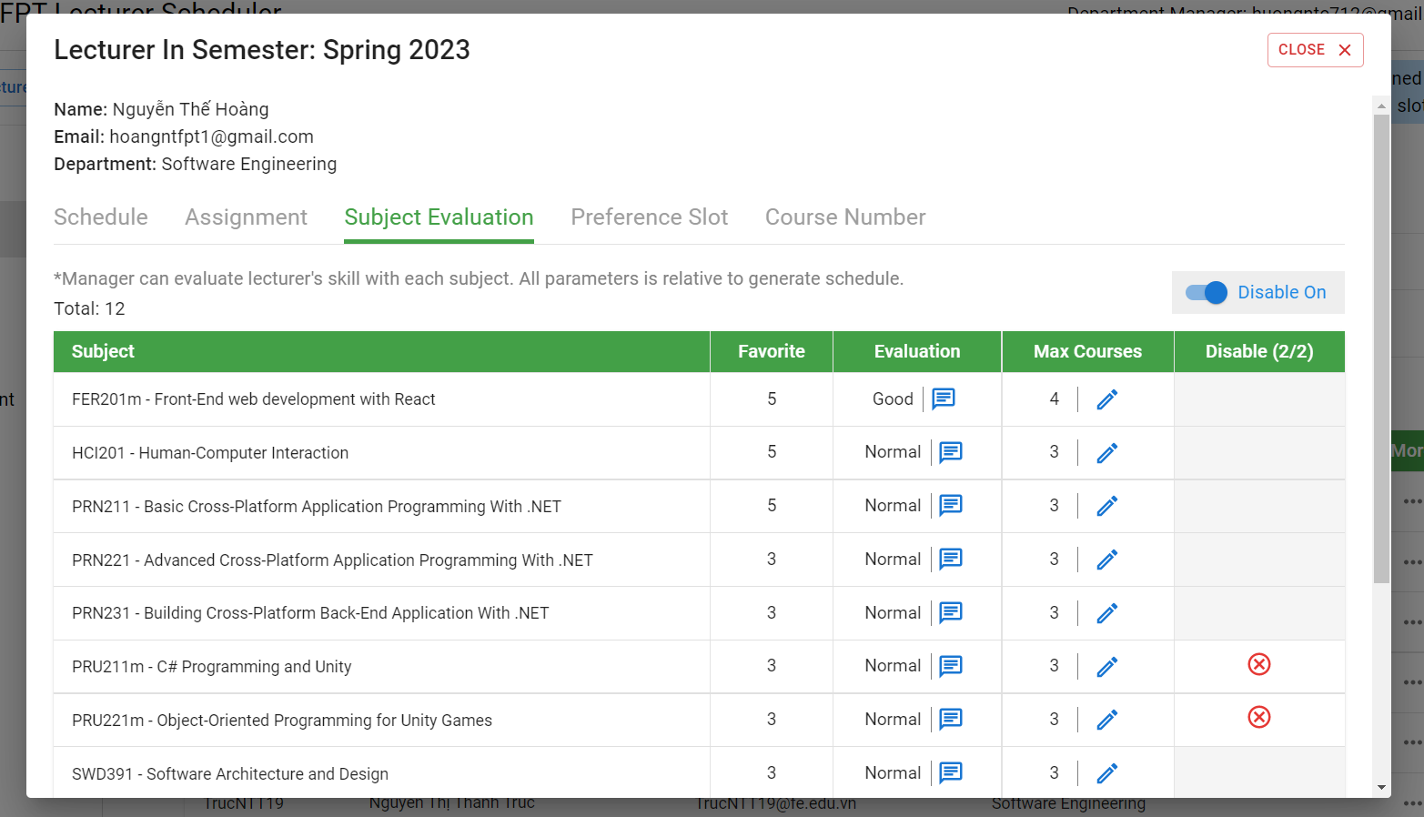

Figure . Department Manager Features - Manage subject evaluation points of lecturer

|  |  |  |
| --- | --- | --- |
| Function trigger | **“Home” on navigation bar -> “Semester” on navigation bar ->Semester Detail page -> “Lecturer” tab -> Lecturer Detail -> Subject Evaluation tab** | |
| Function description | Actor | Department Manager |
| Purpose | Manage subject evaluation points for lecturers with subjects. |
| Function Details | Validation | Login by email account with the role department Manager |
| Business rules | BR-16: Only Department manager role can edit Subject Evaluation point for lecturers after give Subject Evaluation point  BR-31: The department manager assesses the scores of the lecturers of the subjects in his/her department  BR-50: Department manager can only rating subject of lecturer when the state of the semester is Evaluating  BR-53: Department manager can only edit Course Number for lecturer when the state of semester is Evaluating. |
| Functionalities | Assess subject evaluation points for lecturers with subjects  Update max courses number in semester of subject  Disable subjects of lecturer |

Table . Department Manager Features - Manage subject evaluation points of lecturer

#### 3.4.18 Manage Preference slot

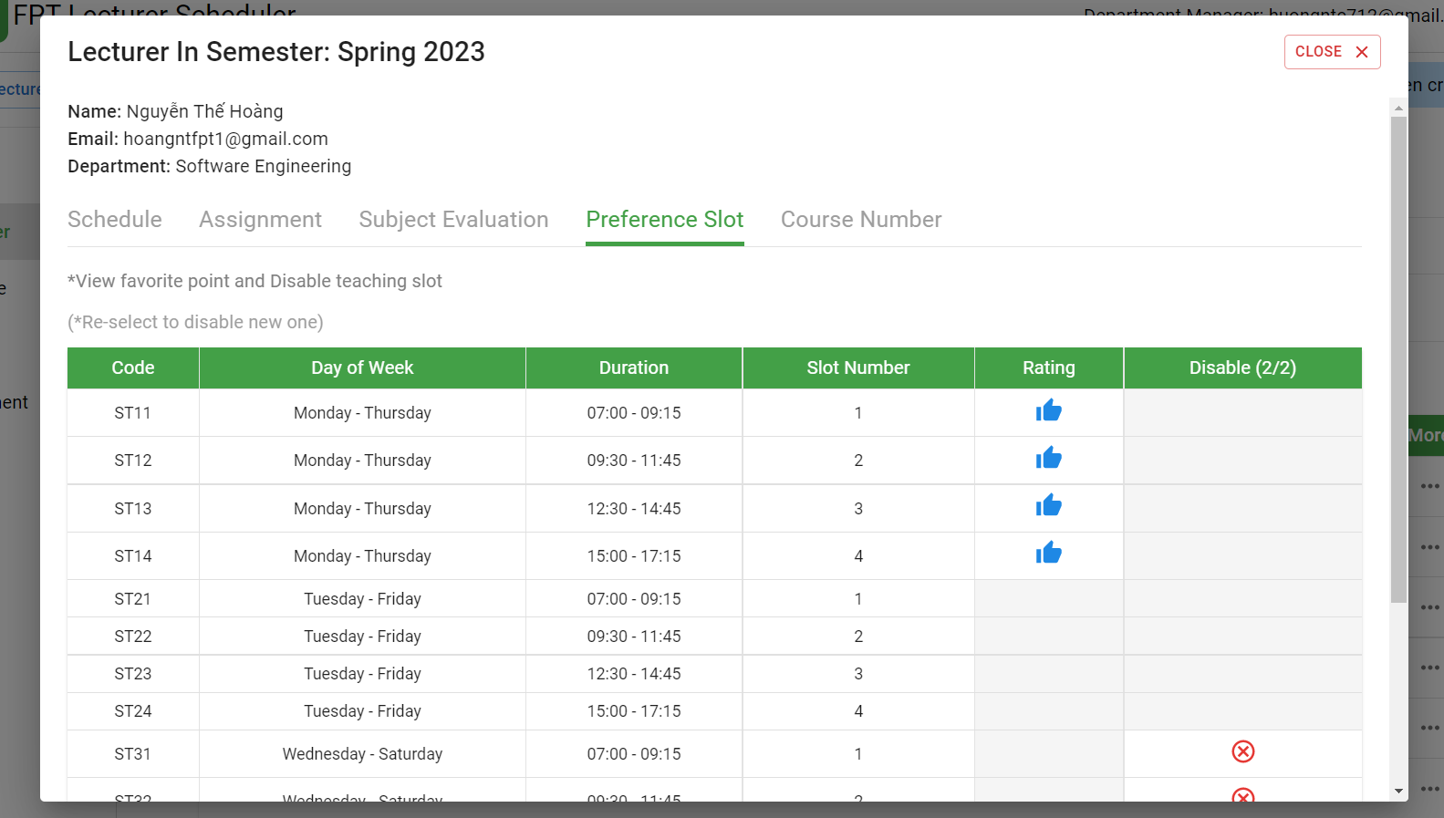

Figure . Department Manager Features - Manage Preference slot

|  |  |  |
| --- | --- | --- |
| Function trigger | **“Home” on navigation bar -> “Semester” on navigation bar ->Semester Detail page -> “Lecturer” tab -> Lecturer Detail -> Preference Slot tab** | |
| Function description | Actor | Department Manager |
| Purpose | Manage preference slots of lecturers. |
| Function Details | Validation | Login by email account with the role department Manager |
| Business rules | BR-32: The Department Manager can specifically assign teachers to specific slots.  BR-51: Department manager can only disable slots of lecturer when the state of the semester is Evaluating |
| Functionalities | View all preference slot of lecturer  Disable slots of lecturer |

Table . Department Manager Features - Manage Preference slot

#### 3.4.19 Manage min max course of lecturer in semester

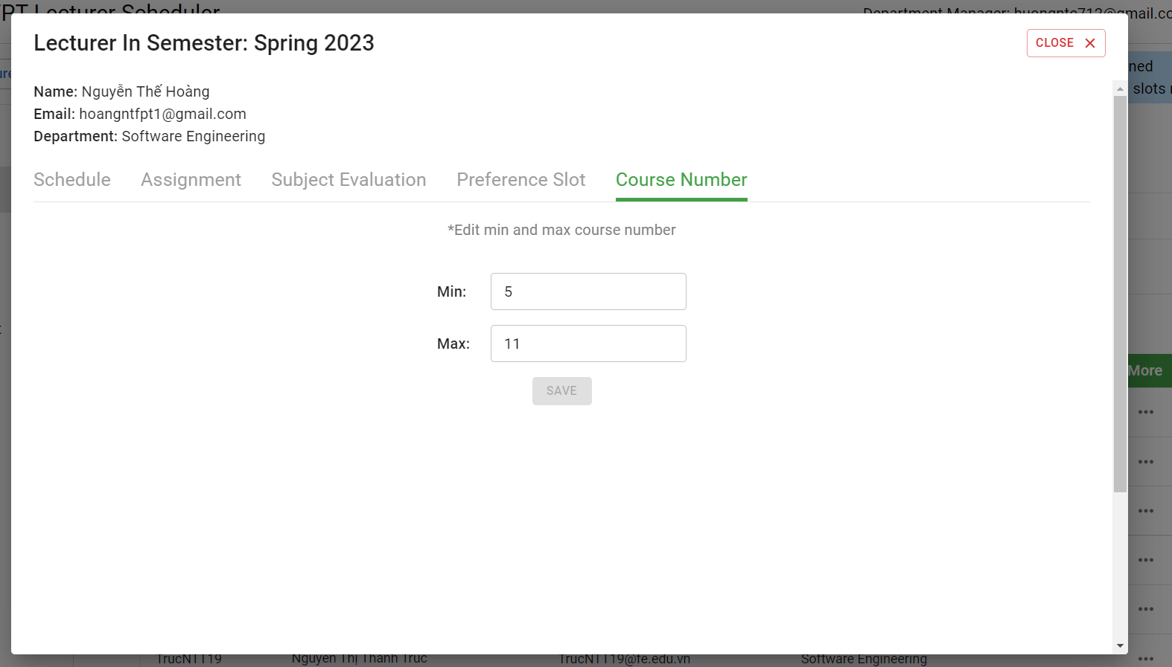

Figure . Department Manager Features - Manage min max course of lecturer in semester

|  |  |  |
| --- | --- | --- |
| Function trigger | **“Home” on navigation bar -> “Semester” on navigation bar ->Semester Detail page -> Lecturer tab -> Lecturer Detail -> Course Number tab** | |
| Function description | Actor | Department Manager |
| Purpose | Update min max courses number in semester of lecturer |
| Function Details | Validation | Login by email account with the role department Manager |
| Business rules | BR-29: Min course of lecturer full time is 5.  BR-53: Department manager can only edit Course Number for lecturer when the state of semester is Evaluating. |
| Functionalities | Edit min course number in semester of lecturer  Edit max course number in semester of lecturer |

Table . Department Manager Features - Manage min max course of lecturer in semester

#### 3.4.20 Swap courses in schedule of a lecturer

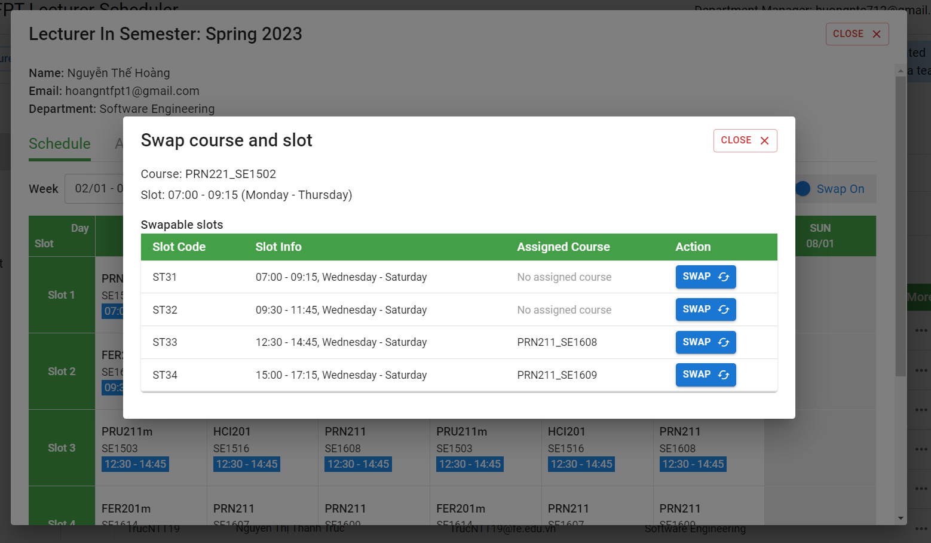

Figure . Department Manager Features - Swap courses in schedule of a lecturer

|  |  |  |
| --- | --- | --- |
| Function trigger | **“Home” on navigation bar -> “Semester” on navigation bar ->Semester Detail page -> Lecturer tab -> Lecturer Detail page -> Schedule tab** | |
| Function description | Actor | Department Manager |
| Purpose | Swap courses in the schedule of a lecturer. |
| Function Details | Validation | Login by email account with the role department Manager |
| Business rules | BR-54: Department manager can only swap courses when the state of the semester is adjusted.  BR-60: Only Department managers can swap assigned courses in lecturer's schedule in his/her department |
| Functionalities | Swap courses |

Table . Department Manager Features - Swap courses in schedule of a lecturer

#### 3.4.21 View Course to swap between two lecturers

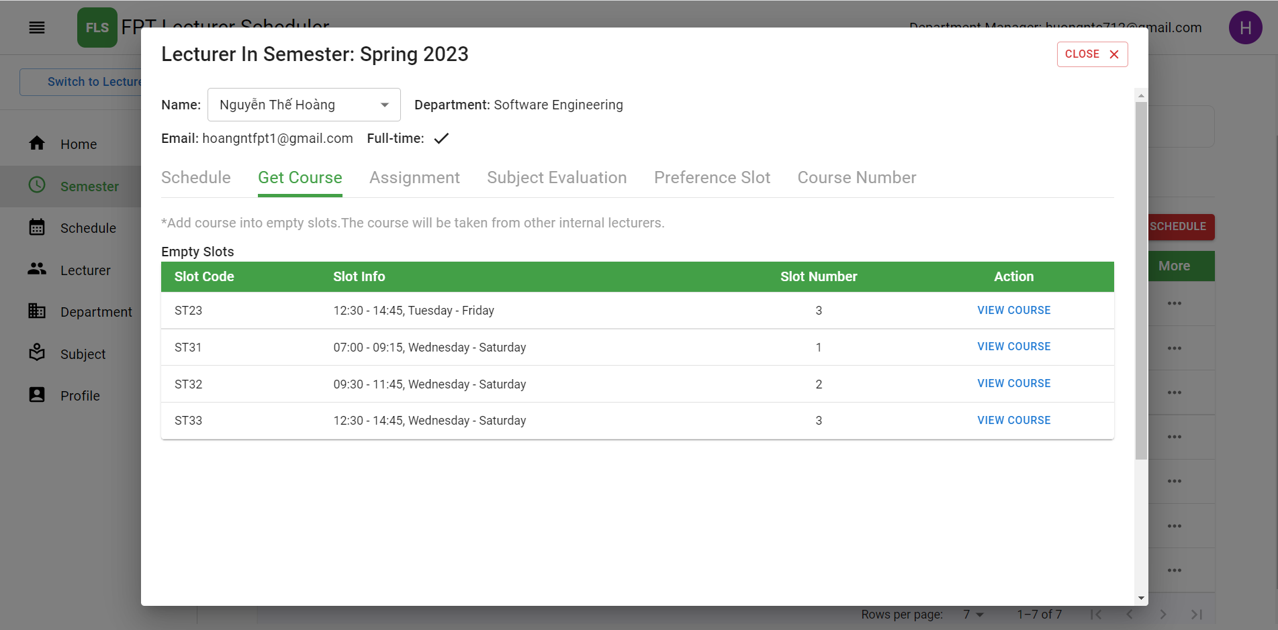

Figure . Department Manager Features - View course to swap between two lecturers

|  |  |  |
| --- | --- | --- |
| Function trigger | **“Home” on navigation bar -> “Semester” on navigation bar ->Semester Detail page -> Lecturer tab -> Lecturer Detail -> “View Course” Button** | |
| Function description | Actor | Admin |
| Purpose | View Course to swap between two lecturers.   * View all courses: List all courses * Swap course between two lecturers. |
| Function Details | Validation | Login by email account with role admin. |
| Business rules | BR-54: Department Manager can only swap courses when the state of the semester is adjusted.  BR-60: Only Department managers can swap assigned courses in lecturer's schedule in his/her department |
| Functionalities | The Department Manager clicks on the “View Course ” button to view courses. |

Table . Department Manager Features - View course to swap between two lecturers

#### 3.4.22 Swap between two lecturers in department

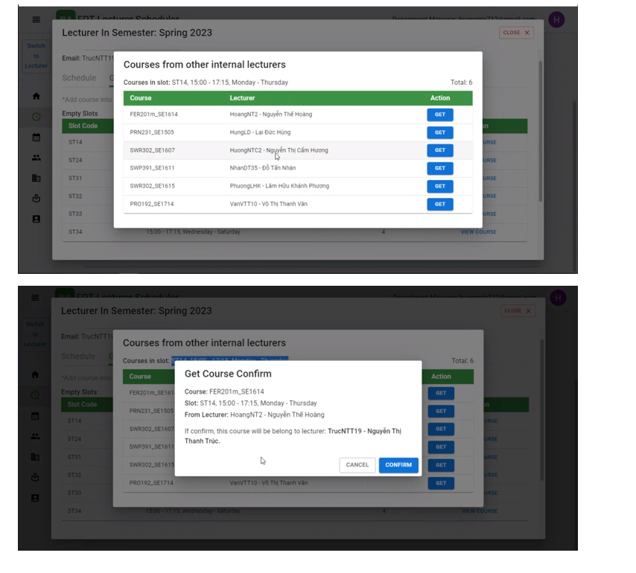

Figure . Department Manager Features - Swap between two lecturers in department

|  |  |  |
| --- | --- | --- |
| Function trigger | **“Home” on navigation bar -> “Semester” on navigation bar ->Semester Detail page -> Lecturer tab -> Lecturer Detail -> Course Number tab -> “View Course” button -> “Get” button** | |
| Function description | Actor | Admin |
| Purpose | Swap course between two lecturers in the department. |
| Function Details | Validation | Login by email account with role admin. |
| Business rules | BR-54: Department Manager can only swap courses when the state of the semester is adjusted.  BR-60: Only Department managers can swap assigned courses in lecturer's schedule in his/her department |
| Functionalities | The Department Manager clicks on the “Get” button to choose the course to swap  The Department Manager clicks on the “Confirm” button to swap courses between two lecturers. |

Table . Department Manager Features - Swap between two lecturers in department

### 3.5 Lecturer Features

#### 3.5.1 View all semesters

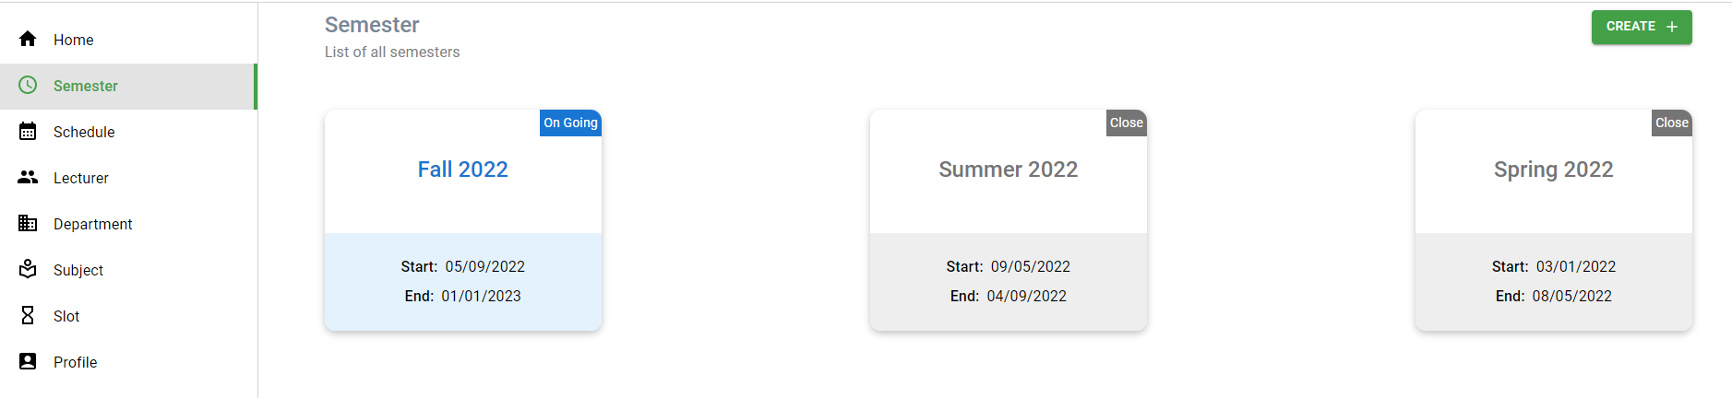

Figure . Lecturer Features - View all semesters

|  |  |  |
| --- | --- | --- |
| Function trigger | **Home Page -> Semester Page** | |
| Function description | Actor | Lecturer |
| Purpose | View all semesters |
| Function Details | Validation | Login by email account with the role lecturer |
| Business rules | N/A |
| Functionalities | List all semesters |

Table . Lecturer Features - View all semesters

#### 3.5.2 View detail of the semester

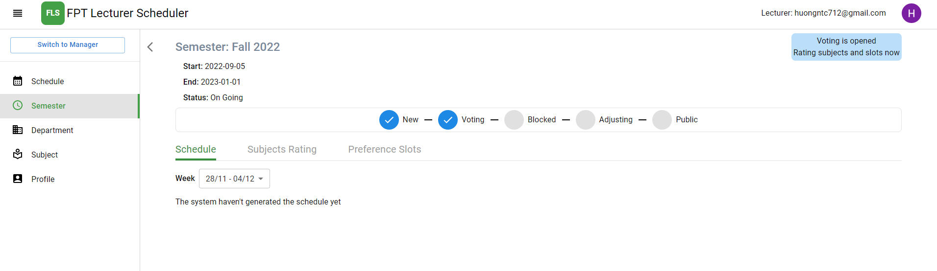

Figure . Lecturer Features - View detail of the semester

|  |  |  |
| --- | --- | --- |
| Function trigger | **Home Page -> Semester Page -> Semester detail page** | |
| Function description | Actor | Lecturer |
| Purpose | View all information of the semester. |
| Function Details | Validation | Login by email account with the role lecturer |
| Business rules | N/A |
| Functionalities | View the state of the semester to know when to implement the functions:   * Rate grades for his/her assigned subjects in department * Rate favourite slot time * View schedule in semester |

Table . Lecturer Features - View detail of the semester

#### 3.5.3 View schedule in semester



Figure . Lecturer Features - View schedule in semester

|  |  |  |
| --- | --- | --- |
| Function trigger | **Home Page** | |
| Function description | Actor | Lecturer |
| Purpose | View schedule in semester |
| Function Details | Validation | Login by email account with the role lecturer |
| Business rules | BR-23 Lecturers can only view their Schedule.  BR-24 Lecturers can only teach one course at a time.  BR-25 A Course can only be taught by a lecturer.  BR-26 Courses which conflict cannot be taught at the same time.  BR-27 Limits on the minimum and maximum number of courses in 1 week for lecturers are specified in each term. |
| Functionalities | List all assigned courses and slots in semester. |

Table . Lecturer Features - View schedule in semester

#### 3.5.4 View all slots in semester

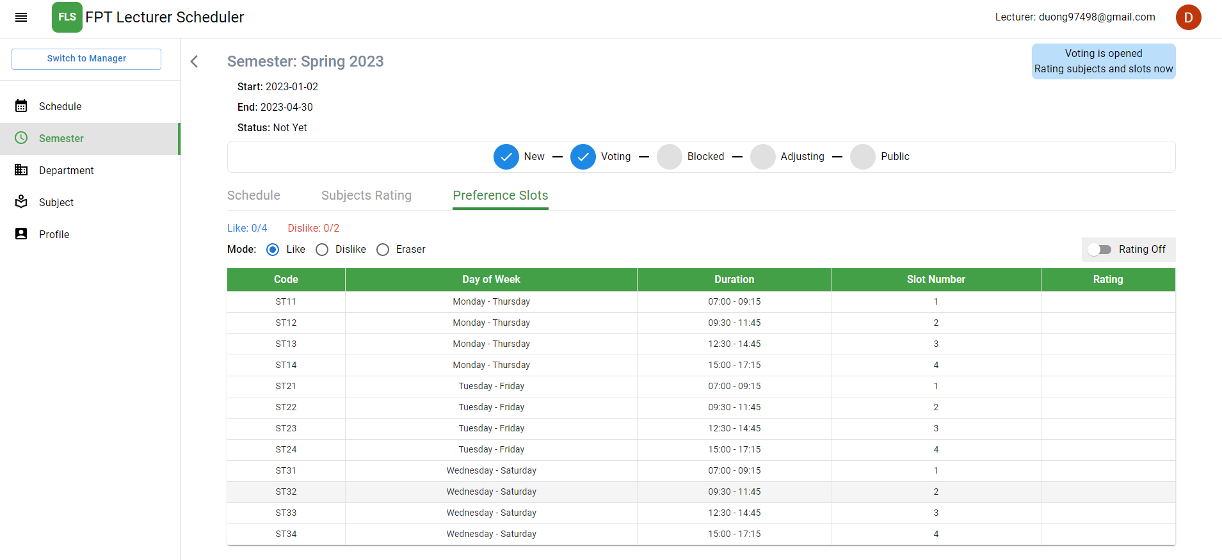

Figure . Lecturer Features - View all slots in semester

|  |  |  |
| --- | --- | --- |
| Function trigger | **Home Page -> Semester Page -> Semester Detail Page -> Preference Slots Tab** | |
| Function description | Actor | Lecturer |
| Purpose | View all slots in semester |
| Function Details | Validation | Login by email account with the role lecturer |
| Business rules | BR-42: The maximum number of like slots is 6  BR-43: The maximum number of dislike slots is 3 |
| Functionalities | List all slots in the semester.  Show all information of slot (Duration, Day of week, slot number) |

Table . Lecturer Features - View all slots in semester

#### 3.5.5 View all departments

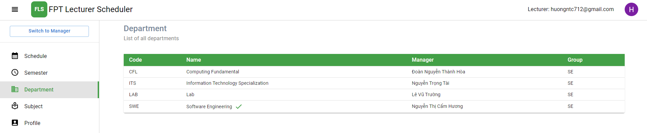

Figure . Lecturer Features - View all departments

|  |  |  |
| --- | --- | --- |
| Function trigger | **Home Page -> Department Page** | |
| Function description | Actor | Lecturer |
| Purpose | View all departments |
| Function Details | Validation | Login by email account with the role lecturer |
| Business rules | N/A |
| Functionalities | List all departments and information about the department. |

Table . Lecturer Features - View all departments

#### 3.5.6 View all subjects

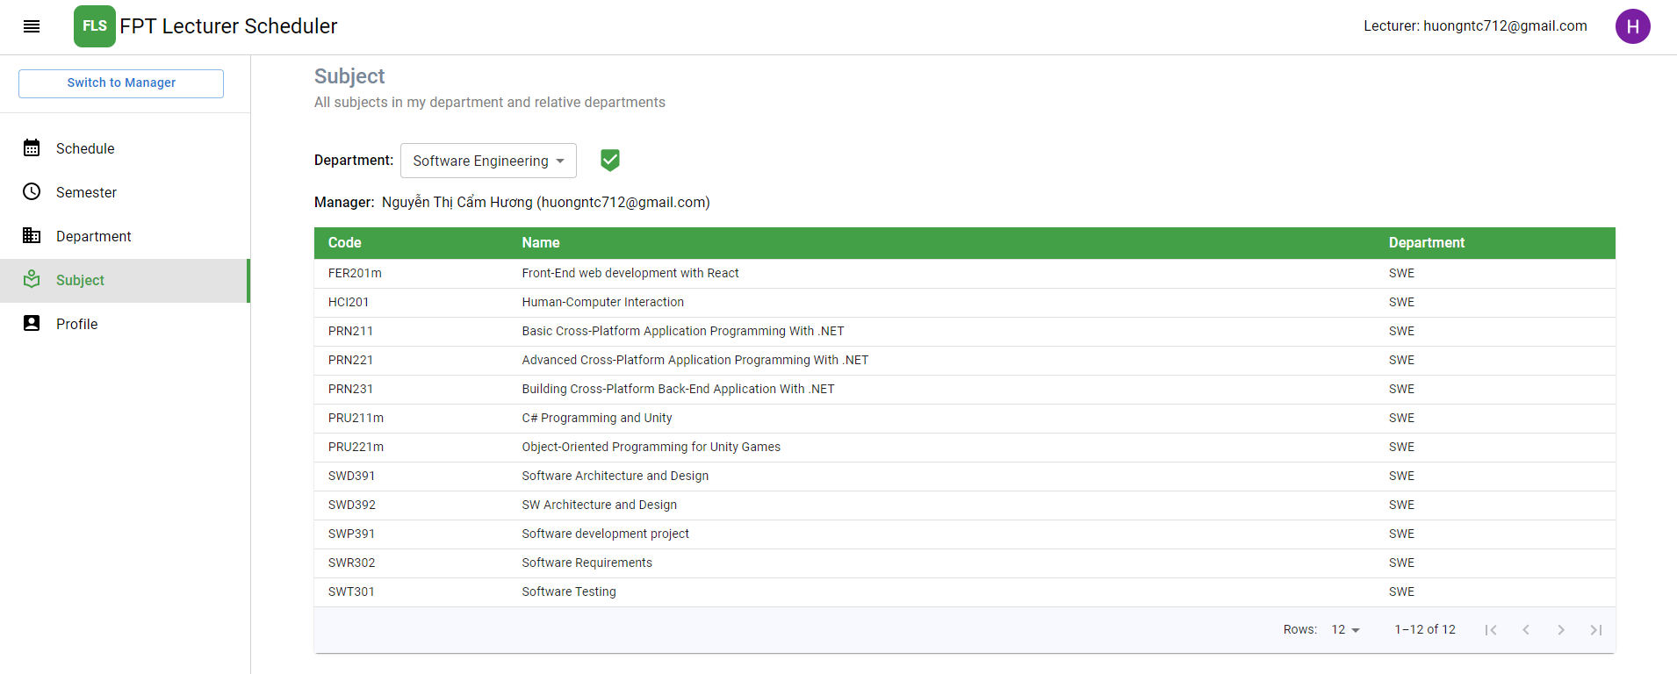

Figure . Lecturer Features - View all subjects

|  |  |  |
| --- | --- | --- |
| Function trigger | **Home Page -> Subject Page** | |
| Function description | Actor | Lecturer |
| Purpose | View all subjects |
| Function Details | Validation | Login by email account with the role lecturer |
| Business rules | N/A |
| Functionalities | List of subjects and information about the subject. |

Table . Lecturer Features - View all subjects

#### 3.5.7 Rate grades for his/her assigned subjects in department

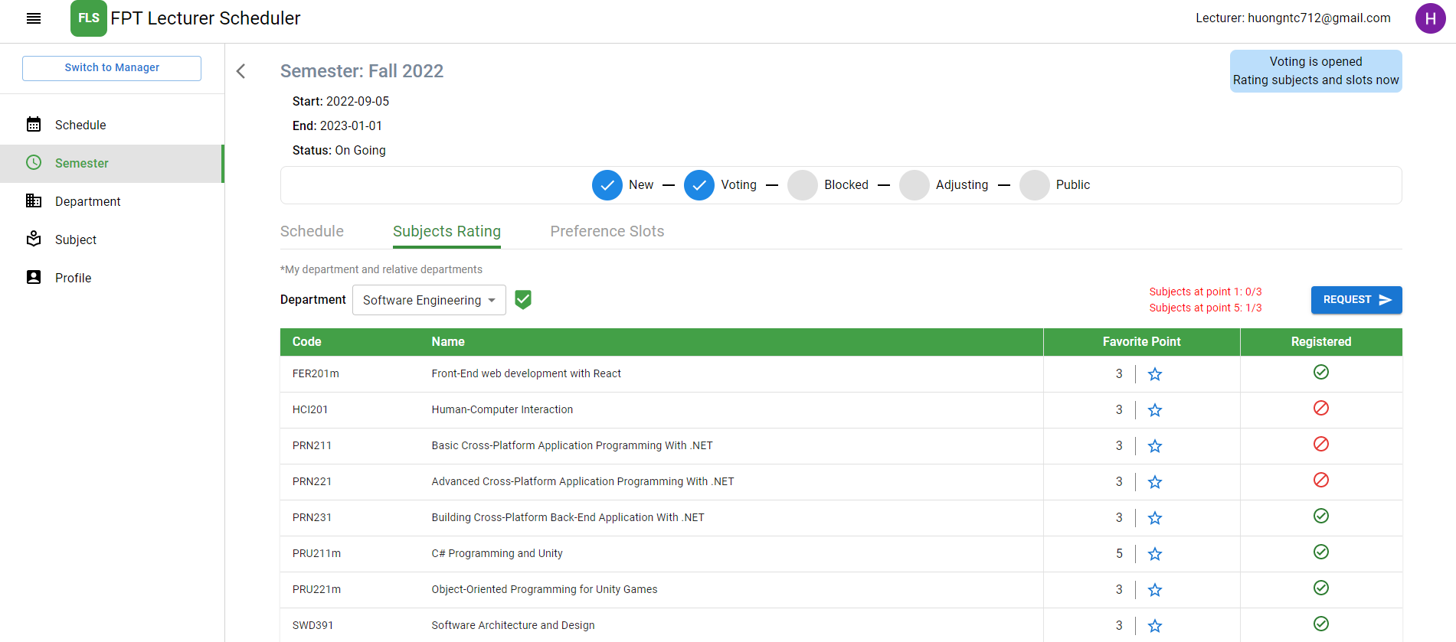

Figure . Lecturer Features - Rate grades for his/her assigned subjects in department

|  |  |  |
| --- | --- | --- |
| Function trigger | **Home Page -> Semester Page -> Semester Detail Page -> Subjects Rating Tab** | |
| Function description | Actor | Lecturer |
| Purpose | Rate points based on favourite in the subject of lecturer |
| Function Details | Validation | Login by email account with the role lecturer |
| Business rules | BR-18 Only Lecturers can rate grades for their assigned subjects in his/her department in the semester.  BR-19 Lecturer's favourite scores for subjects in their department range from 1 to 5  BR-20 By default, the Lecturer's favourite point for a subject in their department is 3.  BR-21 Lecturers evaluate grades for subjects belonging to the same department.  BR-40 The maximum number of Subjects Rating (level 5) in one term is 3.  BR-41 The maximum number of Subjects Rating (level 1) in one term is 3.  BR-47 Lecturer can only vote favourite subject when state of semester is lecturer voting |
| Functionalities | Provide information about the Lecturer's preference for the subject so that the system generates the schedule |

Table . Lecturer Features - Rate grades for his/her assigned subjects in department

#### 3.5.8 Rate favourite slot time

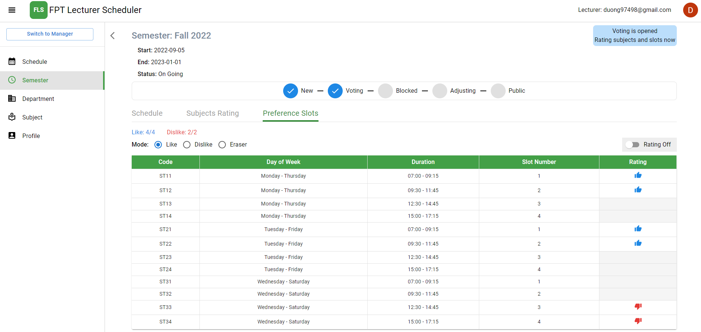

Figure . Lecturer Features - Rate favourite slot time

|  |  |  |
| --- | --- | --- |
| Function trigger | **Home Page -> Semester Page -> Semester Detail Page -> Preference Slots Tab** | |
| Function description | Actor | Lecturer |
| Purpose | Rate points based on favourite in the slot of lecturer |
| Function Details | Validation | Login by email account with the role lecturer |
| Business rules | BR-22 Only Lecturers can choose their favourite slot time.  BR-42 The maximum number of like slots is 6  BR-43 The maximum number of dislike slots is 3  BR-48 Lecturer can only vote favourite slots when state of semester is lecturer voting |
| Functionalities | Provide information about the Lecturer's preference for the slot so that the system generates the schedule |

Table . Lecturer Features - Rate favourite slot time

#### 3.5.9 Disable registration subjects in the department

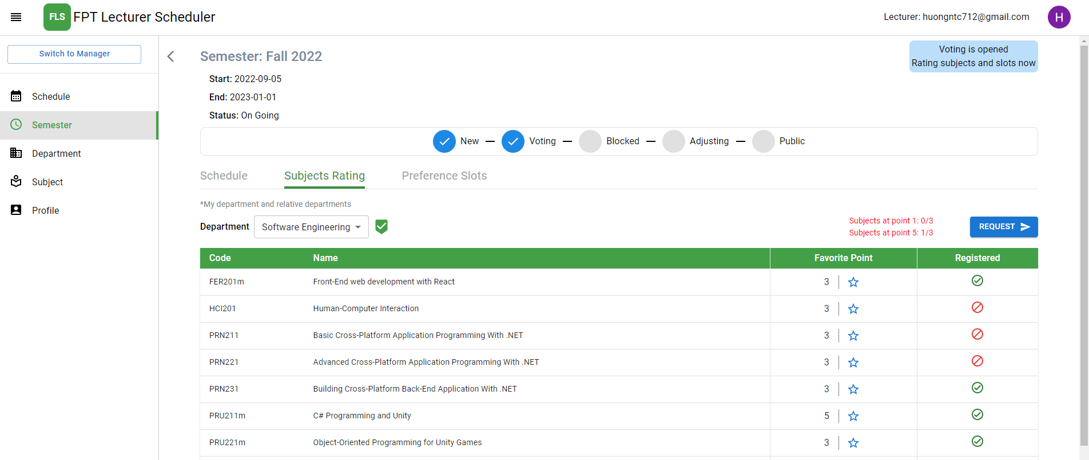

Figure . Lecturer Features - Disable registration subjects in the department

|  |  |  |
| --- | --- | --- |
| Function trigger | **Home Page -> Semester Page -> Semester Detail Page -> Subjects Rating Tab** | |
| Function description | Actor | Lecturer |
| Purpose | The teacher wants to disable the registration subject. |
| Function Details | Validation | Login by email account with the role lecturer |
| Business rules | BR-56 Lecturers can disable subject registration in his/her department as specified. |
| Functionalities | The system will not schedule that subject for the teacher in semester |

Table . Lecturer Features - Disable registration subjects in the department

#### 3.5.10 Send requests to teach more subjects out the department

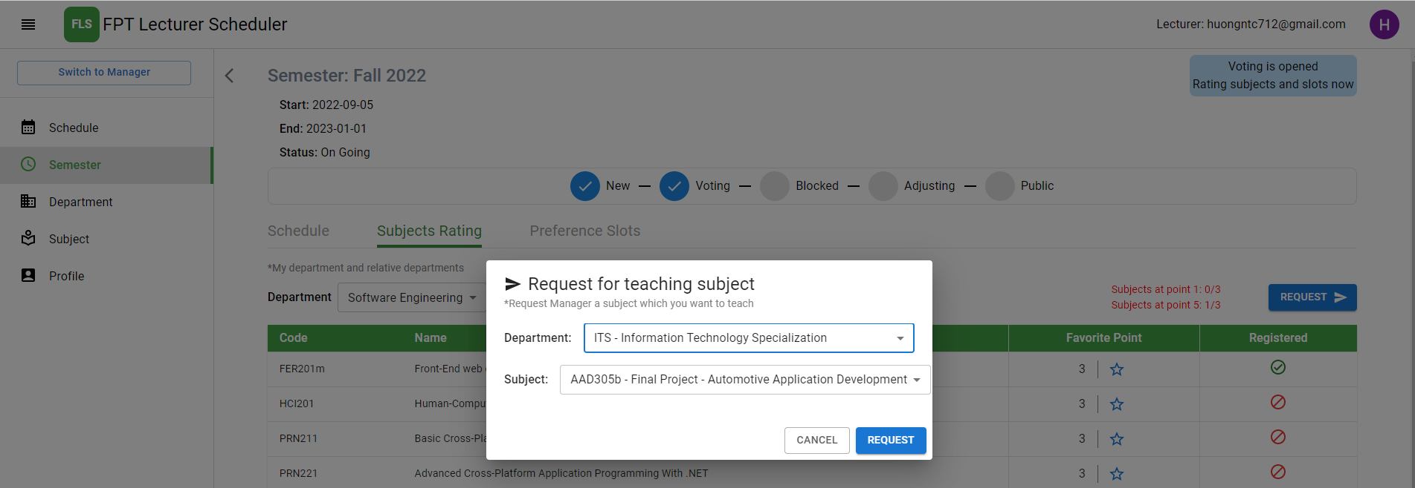

Figure . Lecturer Features - Send requests to teach more subjects out the department

|  |  |  |
| --- | --- | --- |
| Function trigger | **Home Page -> Semester Page -> Semester Detail Page -> Subjects Rating Tab**  **-> Request Pop Up** | |
| Function description | Actor | Lecturer |
| Purpose | Lecturers registered to teach more subjects out the department |
| Function Details | Validation | Login by email account with the role lecturer |
| Business rules | BR-49 Lecturer can only request to teach more subject when state of semester is lecturer voting  BR-57 Only Lecturers can request to teach more subjects out of his/her department as specified. |
| Functionalities | The system will not schedule that subject for the teacher in semester |

Table . Lecturer Features - Send requests to teach more subjects out the department

#### 3.5.11 View all requested subjects out the department

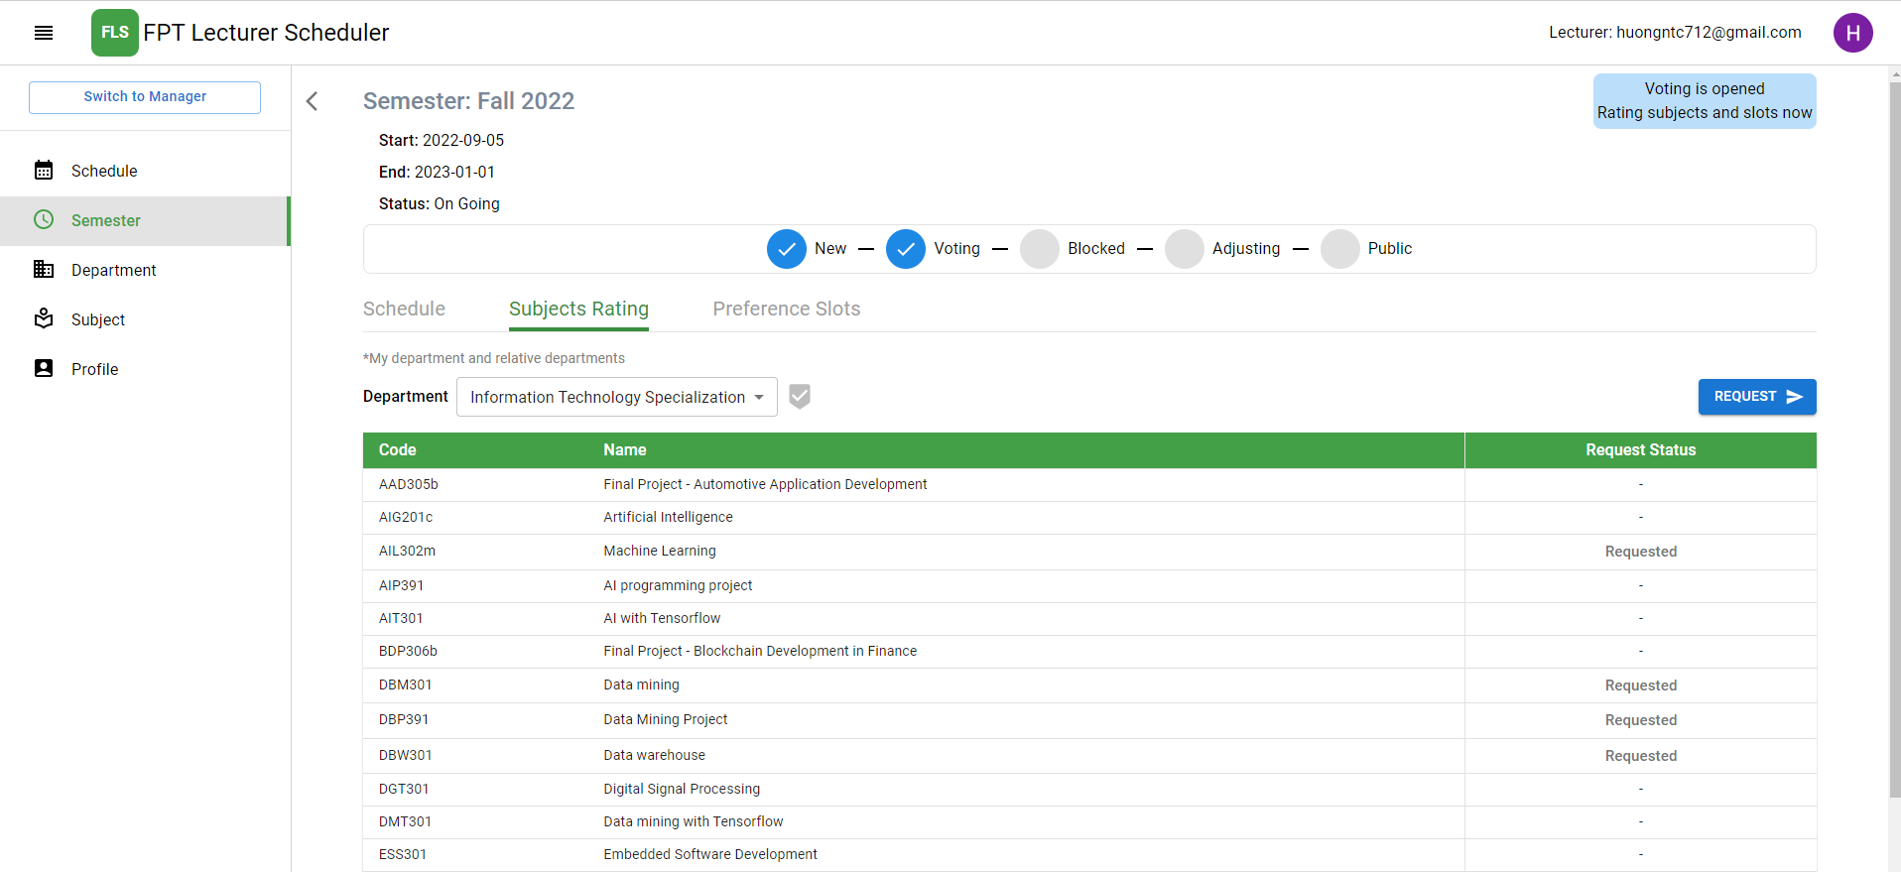

Figure . Lecturer Features - View all requested subjects out the department

|  |  |  |
| --- | --- | --- |
| Function trigger | **Home Page -> Semester Page -> Semester Detail Page -> Subjects Rating Tab** | |
| Function description | Actor | Lecturer |
| Purpose | View all requested subjects out of the department. |
| Function Details | Validation | Login by email account with the role lecturer |
| Business rules | N/A |
| Functionalities | List the subjects registered to teach out of the department. |

Table . Lecturer Features - View all requested subjects out the department

## 4. Non-Functional Requirements

### 4.1 External Interfaces

#### 4.1.1 User Interfaces

* UI-1: GUI must be simple, friendly to use.
* UI-2: When updating any information, the changes should be reflected on the screen when the user confirms the changes.
* UI-3: Icons used must be easy to recognize.
* UI-4: Web applications follow Material-UI design.

#### 4.1.2 Software Interfaces

* SI-1: Web application: Google Chrome browser and Firefox browser.
* SI-2: Mobile application: Android version 12.0 or higher.
* SI-3: Window form application: C# .NET 5 or higher.

#### 4.1.3 Hardware Interfaces

* FLS just requires basic devices for input, output as a personal computer or laptop and smartphone. All the devices must have internet permission.

#### 4.1.4 Communications Interfaces

* FPT Lecturer Scheduler communication interfaces depend on sending and retrieving data through the online protocol HTTP and through the form of RESTFUL Web API to connect between applications.

### 4.2 Quality Attributes

#### 4.2.1 Usability

* Mobile Application and WinForms Application is friendly with users
* Web Application follows Material Design which is clear and easy to use
* FLS Admin and FLS manager can use FLS with less than two days of guidance
* Users do not require technical knowledge before using.

#### 4.2.2 Reliability

* The information stored in the database is permanent.
* The likelihood of the system failure is less than 10%.

#### 4.2.3 Performance

* All common response time is under 10 seconds.

#### 4.2.4 Dependability

##### **a. Security**

* JWT is used for authentication and authorization.
* Each role can only access its own functions.
* All data must be validated before saving to the database.

#### 4.2.5 Supportability

* FLS is available for both Web Application and Mobile Application.
* System is modularized to support maintenance and further development.

#### 4.2.6 Design Constraints

* Language used for Web Application and Mobile Application is English.
* Using technologies:
  + Mobile Application: Flutter, Dart,
  + Web Application: ReactJS library
  + Server: .NET Core, repository pattern
  + WinForms Application: C#
  + Database management system: MSSQL Server

#### 4.2.7 Support Documents

* User Guides are provided for guiding to assist users using the FPT Lecturer Scheduler, written in step-by-step, with visual content, including images, annotated screenshots, graphics.
* Documenting the requirement specification, system design, and testing to support maintenance and further development.

## 5. Requirement Appendix

### 5.1 Business Rules

|  |  |
| --- | --- |
| **ID** | **Rule Definition** |
| BR-01 | If the account is correct, system redirect users to corresponding home page:   * User logs in as role “admin”, the system will display admin home page * User logs in as role “department manager”, the system will display manager home page * User logs in as role “lecturer”, the system will display lecturer home page |
| BR-02 | Clear session when account logout. |
| BR-03 | Members must log in with the FPT email registered in the system's data. |
| BR-04 | Gmail is unique for each lecturer. |
| BR-05 | Only the Admin role can create a new semester. |
| BR-06 | Only the Admin role can modify the state of the semester. |
| BR-07 | Only the Admin role can delete semester. |
| BR-08 | Only the Admin role can generate schedules. |
| BR-09 | Only the Admin role can block semester. |
| BR-10 | Admin role can view schedules of all lecturers. |
| BR-11 | Only the Admin role can add data courses for the semester. |
| BR-12 | Only the Admin role can delete data courses for the semester. |
| BR-13 | Slot types have max course amount which can teach in same time |
| BR-14 | Only Department manager role can assign courses for lecturers in semester |
| BR-15 | Only Department manager role can give priority course for lecturers in his/her department in semester |
| BR-16 | Only Department manager role can edit Subject Evaluation point for lecturers after give Subject Evaluation point |
| BR-17 | Only Department manager role can edit courses assign for lecturer after pick course assign |
| BR-18 | Only Lecturers can rate grades for their assigned subjects in his/her department in the semester. |
| BR-19 | Lecturer's favourite scores for subjects in their department range from 1 to 5 |
| BR-20 | By default, the Lecturer's favourite point for a subject in their department is 3. |
| BR-21 | Lecturers evaluate grades for subjects belonging to the same department. |
| BR-22 | Only Lecturers can choose their favourite slot time. |
| BR-23 | Lecturers can only view their Schedule. |
| BR-24 | Lecturers can only teach one course at a time. |
| BR-25 | A Course can only be taught by a lecturer. |
| BR-26 | Courses which conflict cannot be taught at the same time. |
| BR-27 | Limits on the minimum and maximum number of courses in 1 week for lecturers are specified in each term. |
| BR-28 | The lecturer can be the Department manager. |
| BR-29 | Min course of lecturer full time is 5. |
| BR-30 | Lecturers can teach other subjects but only within the department group. |
| BR-31 | The department manager assesses the scores of the lecturers of the subjects in his/her department. |
| BR-32 | The Department Manager can specifically assign teachers to specific slots. |
| BR-33 | Each lecturer has their priority to prioritize the schedule. |
| BR-34 | Schedule faculty based on priority courses, departmental courses and assigned courses. |
| BR-35 | Optimize teacher preference with slot time. |
| BR-36 | Optimize the teacher's preference for the subject. |
| BR-37 | Optimize the rest time between slots. |
| BR-38 | Optimize scheduling based on the feedback score of the department manager for lecturers with the subject. |
| BR-39 | Optimize scheduling based on the department manager's priority for the course in the group course priority list. |
| BR-40 | The maximum number of Subjects Rating (level 5) in one term is 3. |
| BR-41 | The maximum number of Subjects Rating (level 1) in one term is 3. |
| BR-42 | The maximum number of like slots is 6 |
| BR-43 | The maximum number of dislike slots is 3 |
| BR-44 | The maximum number of subjects the department manager can disable from a lecturer in semester is 3 |
| BR-45 | The maximum number of courses in a subject that an lecturer can teach is specified |
| BR-46 | Admin can only manage course when state of semester is new |
| BR-47 | Lecturer can only vote favourite subject when state of semester is lecturer voting |
| BR-48 | Lecturer can only vote favourite slots when state of semester is lecturer voting |
| BR-49 | Lecturer can only request to teach more subject when state of semester is lecturer voting |
| BR-50 | Department manager can only rating subject of lecturer when the state of the semester is Evaluating |
| BR-51 | Department manager can only disable slots of lecturer when the state of the semester is Evaluating |
| BR-52 | Department manager can only assign courses for the lecturer when the state of the semester is Evaluating. |
| BR-53 | Department manager can only edit Course Number for lecturer when the state of semester is Evaluating. |
| BR-54 | Department manager can only swap courses when the state of the semester is adjusted. |
| BR-55 | When the state of the semester is Public, the schedule cannot be modified. |
| BR-56 | Lecturers can disable subject registration in his/her department as specified. |
| BR-57 | Only Lecturers can request to teach more subjects out of his/her department as specified. |
| BR-58 | Only Department manager can accept the lecturer’s request to teach more subjects. |
| BR-59 | Only Department manager can deny the lecturer’s request. |
| BR-60 | Only Department managers can swap assigned courses in lecturer's schedule in his/her department |

Table . Business Rules

### 5.2 Application Messages List

|  |  |  |  |  |
| --- | --- | --- | --- | --- |
| **#** | **Message code** | **Message Type** | **Context** | **Content** |
| 1 | MSG01 | In line | There is not any search result | No search results. |
| 2 | MSG02 | Toast message | Updating information of asset(s) successfully | Update successfully. |
| 3 | MSG03 | Toast message | Creating new asset(s) successfully | Create successfully. |
| 4 | MSG04 | Toast message | Delete asset(s) successfully | Delete successfully |
| 5 | MSG05 | In red, under the text box | Input-required fields are empty | The field is required. |
| 6 | MSG06 | In red, under the text box | Input value condition | The value must meet the condition |
| 7 | MSG07 | Confirm message | Confirmation from user | Do you want to do this action?  This action can’t be reverted. |

Table . Application Messages

## 6. Solution

### 6.1 Ant colony optimization algorithms

* In computer science and operations research, the ant colony optimization algorithm (ACO) is a probabilistic technique for solving computational problems which can be reduced to finding good paths through graphs. Artificial ants stand for multi-agent methods inspired by the behaviour of real ants. The pheromone-based communication of biological ants is often the predominant paradigm used e.g., vehicle routing and assignment problem.
* Ant colony optimization is a class of optimization algorithms modelled on the actions of an ant colony. Artificial 'ants' (e.g., simulation agents) locate optimal solutions by moving through a parameter space representing all possible solutions. Real ants lay down pheromones directing each other to resources while exploring their environment. The simulated 'ants' similarly record their positions and the quality of their solutions, so that in later simulation iterations more ants locate better solutions.

### 6.2 Ant colony optimization for teacher scheduling problem

#### 6.2.1 Input

##### **a. Variables and Domains**

* List lecturers in semester
* List courses in semester
* List slot types in semester
* Config of department manager in semester:
* With lecturer and subjects
* With lecturers and slots
* With hard assign courses (pick a course with a slot and lecturer in schedule)
* Group priority lecturer’s course
* Config of lecturer in semester:
* With subjects
* With slots

##### **b. Constraints**

* Hard constraints
* A lecturer can only teach a course at time.
* A course can only be taught by a lecturer.
* Courses conflict cannot be taught at the same time.
* Maximum number of courses in 1 week for lecturer are specified in each term.
* The number of courses of a subject that a lecturer teaches that is specified in each term by department manager.
* Department manager can specifically assign lecturer to specific slot with specific course.
* Soft constraints
* Optimize the teacher's preference for the subject.
* Optimize scheduling based on the rating score of the department manager for lecturers with the subject.
* Optimize scheduling based on the department manager's priority for the course in the group course priority.
* Optimize teacher preference with slots time.
* Optimize the rest time between slots.

##### **c. General Algorithm Description**

* Pheromones matrix initialization
* Columns: List lecturers in semester
* Rows: List courses in semester
* Cells: Optimal score between lecturer and courses, if violate hard constraint, the cell will be disabled

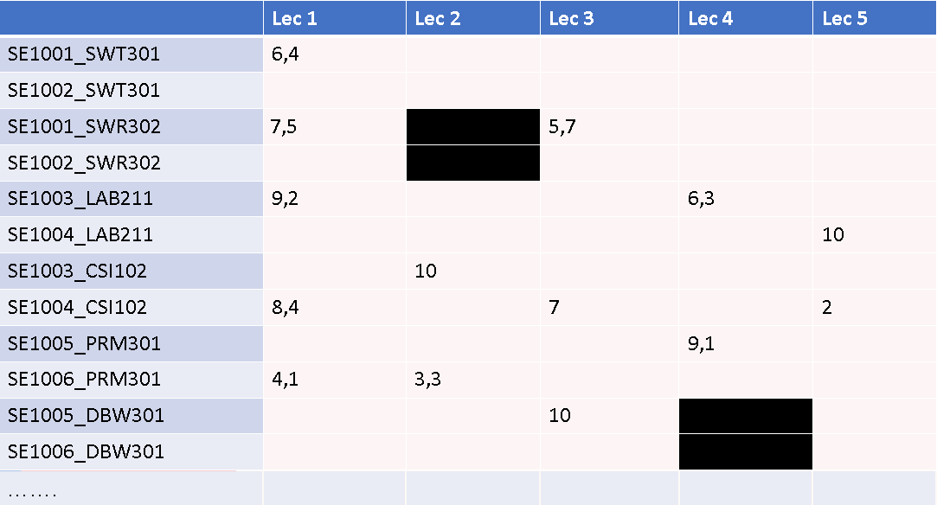

Figure . Pheromones matrix of 5 Lecturers with 12 courses

* Ants build solutions
* Ants choose the most optimal path, here are the cells with high Optimal scores

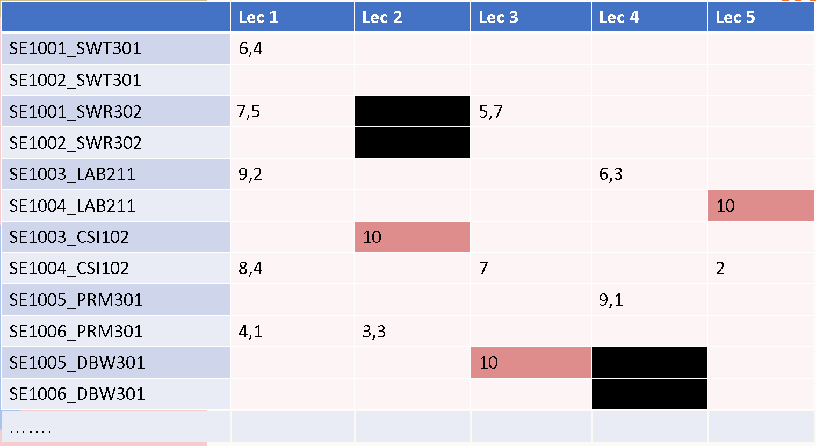

Figure . Choose the cell with the highest score, 10-point cells are courses that are fixed

* After selecting the cell with the highest score, update the Pheromones matrix with the hard constraints

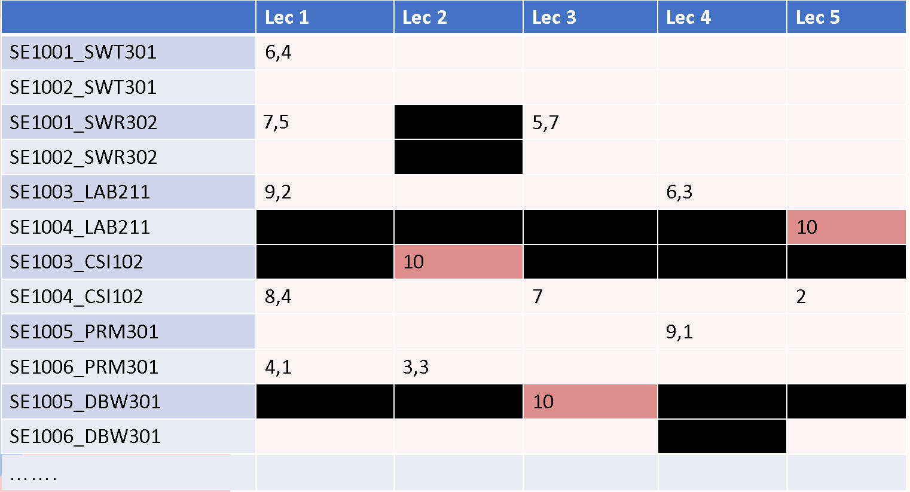

Figure . Update the Pheromones matrix with the hard constraints

* Repeat the steps until there are no more assignable courses

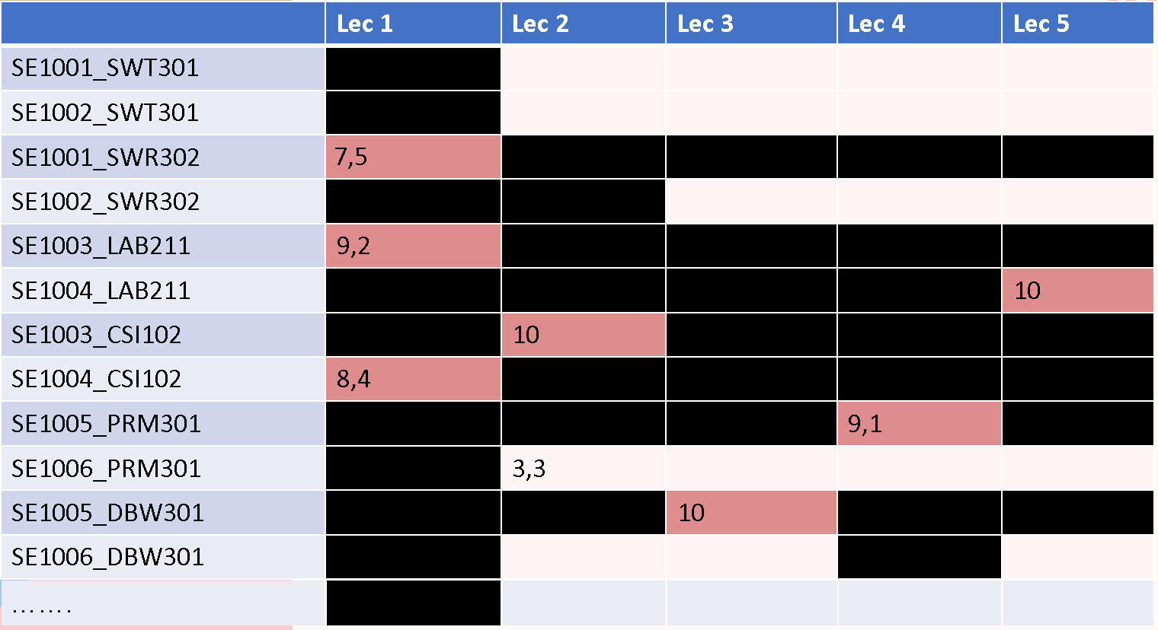

Figure . Lecturer 1 with max course can teach is 3 in semester will disable all column 1 when assigned 3 courses

* Like when assigning slot for lecturer-courses, cells is optimal score between lecturer and slots, if violate hard constraint, the cell will be disabled

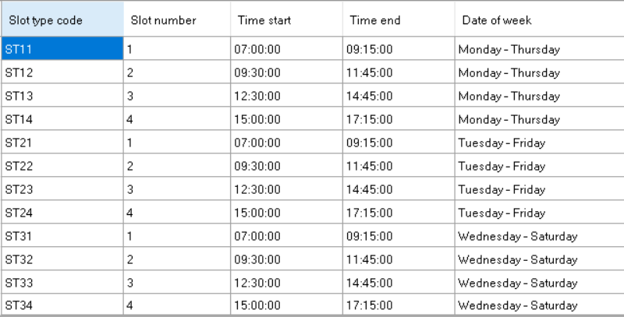

Figure . List slot types

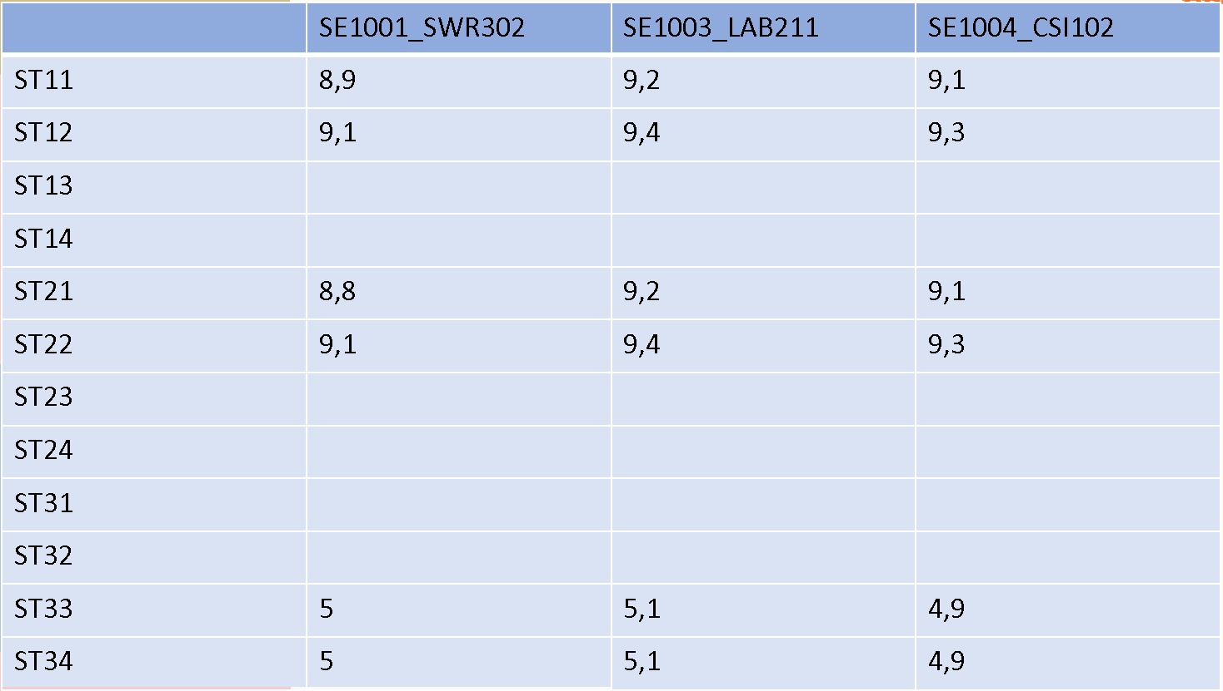

Figure . Lecturer 1 with 3 assigned courses and 12 slot types

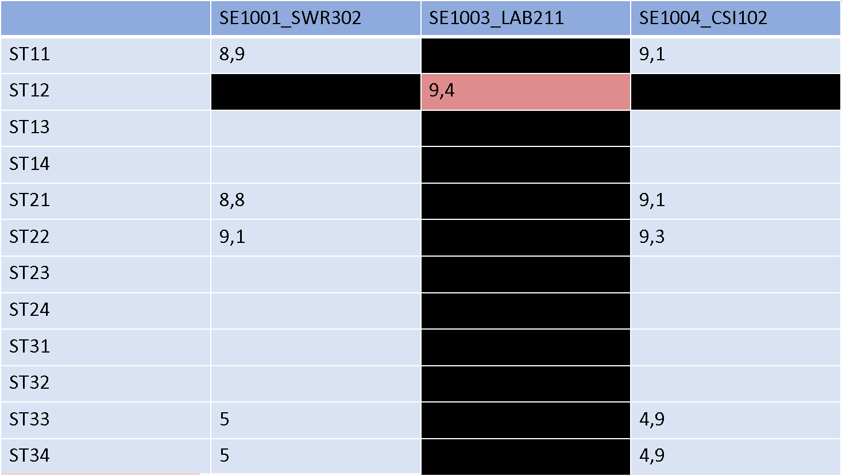

Figure . Choose the cell with the highest score, update the Pheromones matrix with the hard constraints

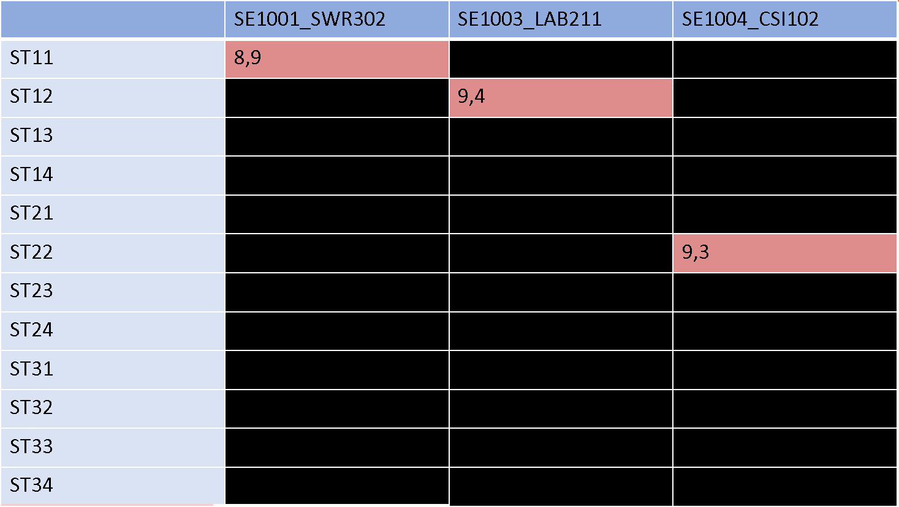

Figure . Repeat the steps until there are no more assignable slots

* Optimal score on each cell in pheromones matrix

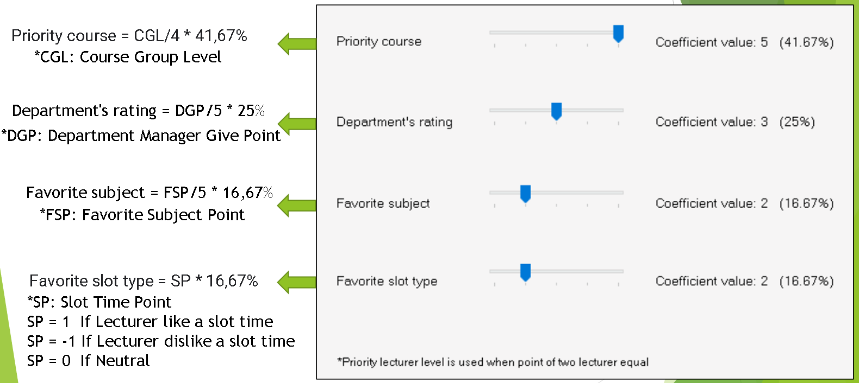

Figure . Optimal score

#### 6.2.2 Output

* Lecturer's schedule for the semester: Lecturer-Courses-Slot types
* Reference: <https://www.researchgate.net/publication/330159634_University_course_timetabling_model_using_ant_colony_optimization_algorithm_approach>

# IV. Software Design Description

## 1. System Design

### 1.1 Overall Architecture

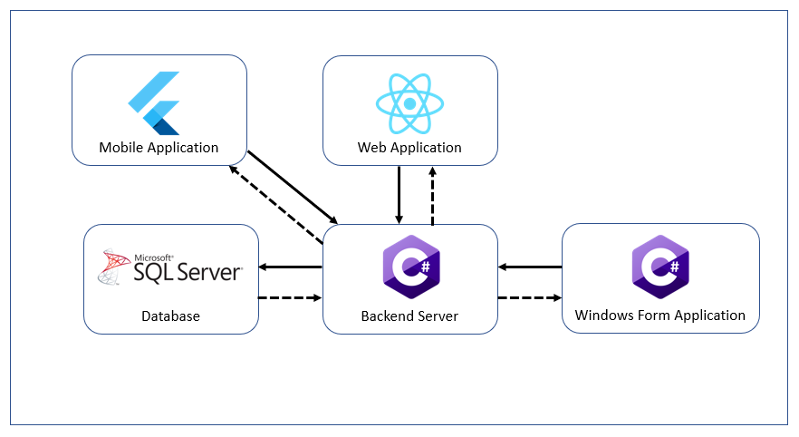

Figure . Overall Architecture

### 1.2 System Architecture

#### 1.2.1 Sever

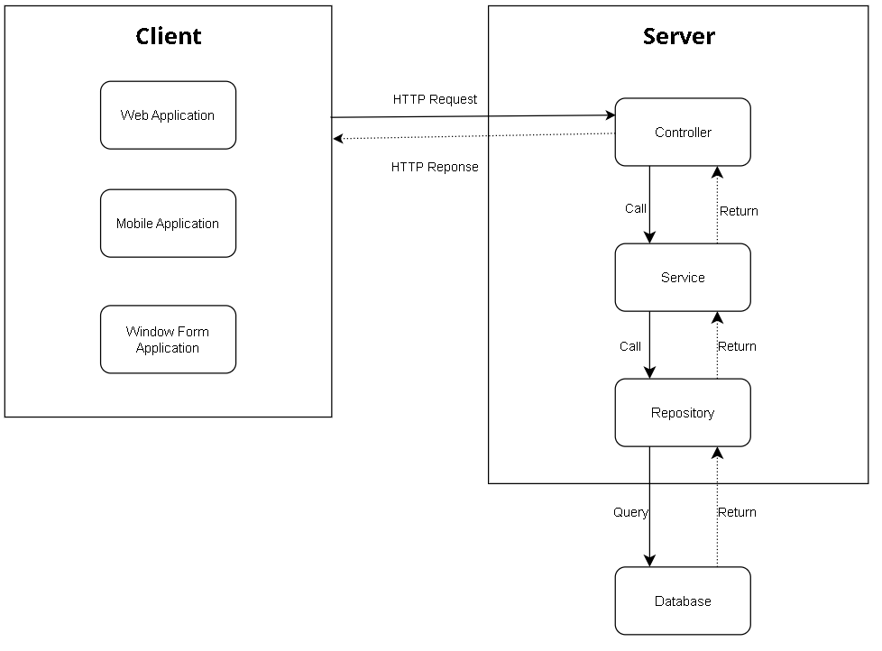

Figure . System Architecture - Server

#### 1.2.2 Web Application

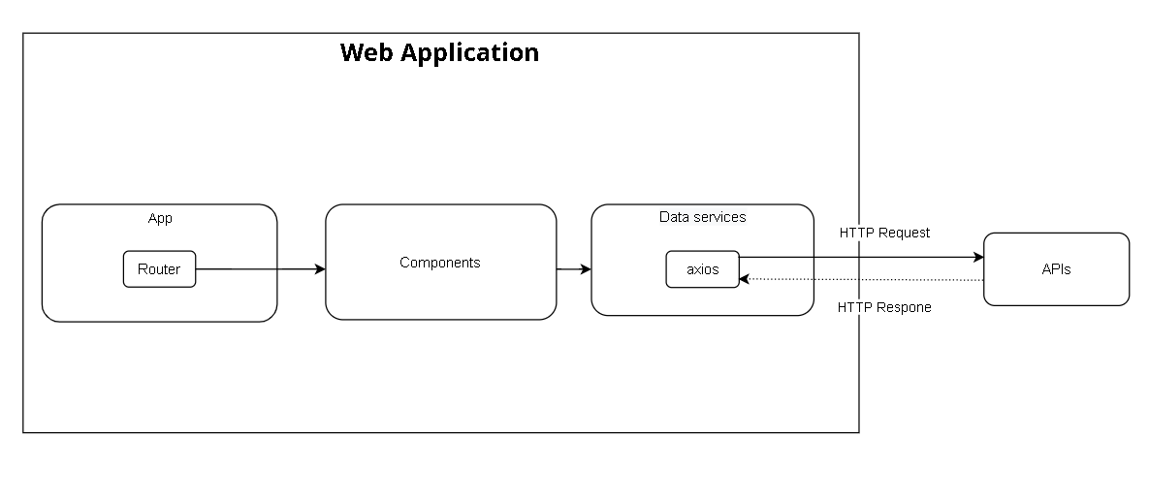

Figure . System Architecture - Web Application

#### 1.2.3 Windows Form Application

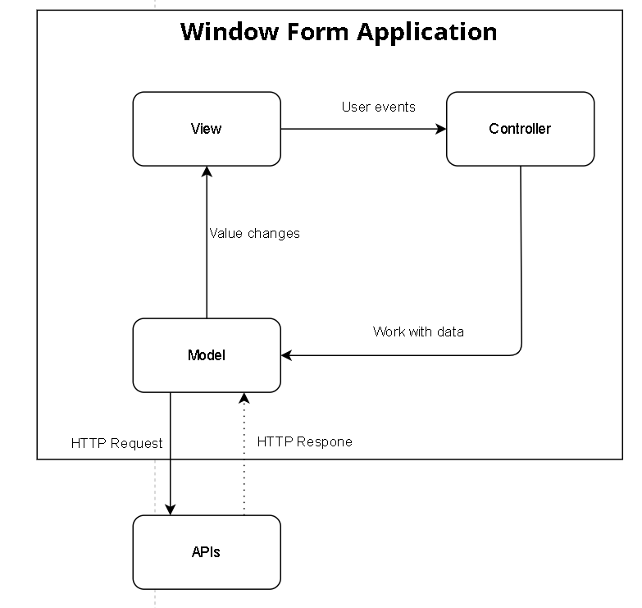

Figure . System Architecture - Windows Form Application

#### 1.2.4 Mobile Application

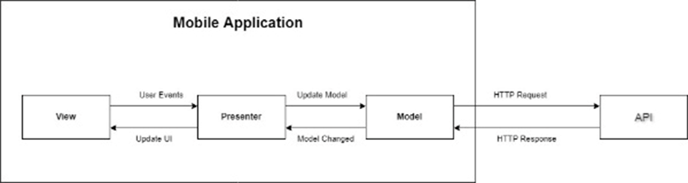

Figure . System Architecture - Mobile Application

Architecture of FLS Mobile Application is designed as:

* **Model:** Layer for storing data. It is responsible for handling the domain logic (real-world business rules) and communication with the database and network layers.
* **View:** UI (User Interface) layer. It provides the visualisation of the data and keeps a track of the user’s action to notify the Presenter.
* **Presenter:** Fetch the data from the model and apply the UI logic to decide what to display. It manages the state of the View and takes actions according to the user’s input notification from the View.

### 1.3 Package Diagram

#### 1.3.1 Back-end package diagram

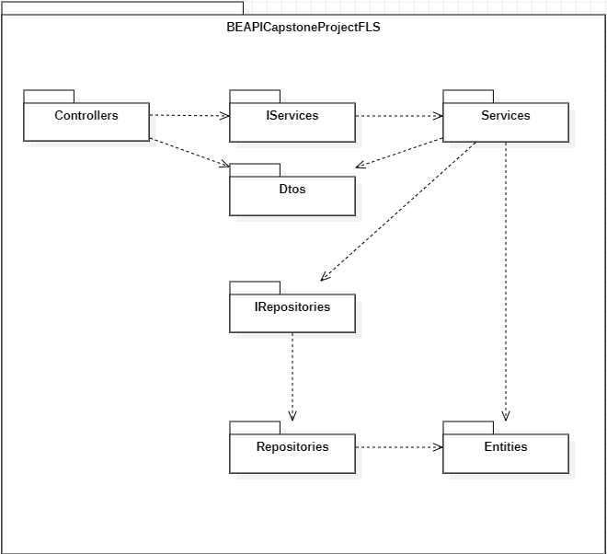

Figure . Package diagram - Back-end

***Package Descriptions***

|  |  |  |
| --- | --- | --- |
| **No** | **Package** | **Description** |
| 01 | BEAPICapstoneProjectFLS | The package contains the main source code of the project API. |
| 02 | Controllers | The package contains all controller classes. |
| 03 | IServices | The package contains all Service Interface classes. |
| 04 | Services | The package contains all Service classes. |
| 05 | Dtos | The package contains all Data Transfer Objects. |
| 06 | IRepositories | The package contains all Repository Interface classes. |
| 07 | Repositories | The package contains all Repository classes. |
| 08 | Entities | The package contains all Entity classes. |

Table . Package Descriptions - Back-end

#### 1.3.2 Front-end web package diagram

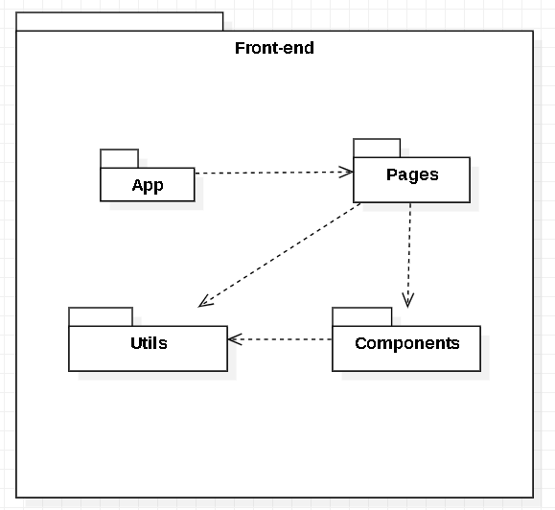

Figure . Package diagram - Front-end

|  |  |  |
| --- | --- | --- |
| **No** | **Package** | **Description** |
| 01 | App | The package contains router of the app. |
| 02 | Pages | The package contains layout of pages which are returned when the app goes routing. |
| 03 | Components | The package contains all components which build up the pages. |
| 04 | Utils | The package contains functions to format data getting form API, user-context, configure off calling API method and data in the app. |

Table . Package Descriptions - Front-end

#### 1.3.3 WinForms package diagram

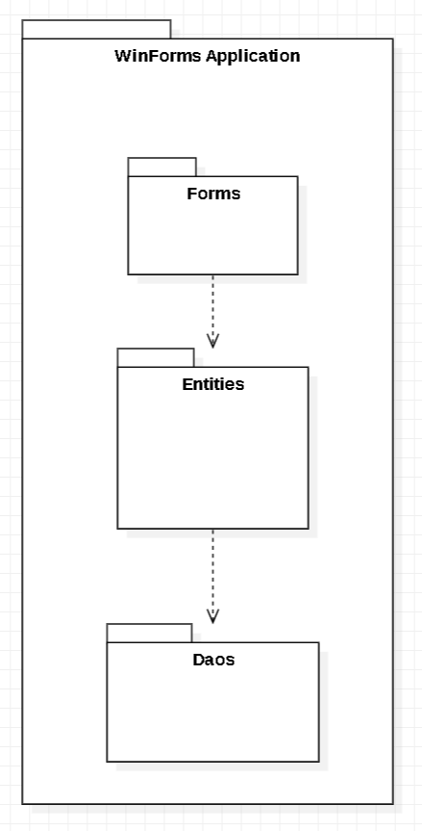

Figure . Package diagram - WinForms

|  |  |  |
| --- | --- | --- |
| **No** | **Package** | **Description** |
| 01 | Forms | The package contains all screens. |
| 02 | Entities | The package contains all Entity classes. |
| 03 | Daos | Package contains classes responsible for handling HTTP requests and returning responses with values. |

Table . Package Descriptions - WinForms

#### 1.3.4 Mobile package diagram

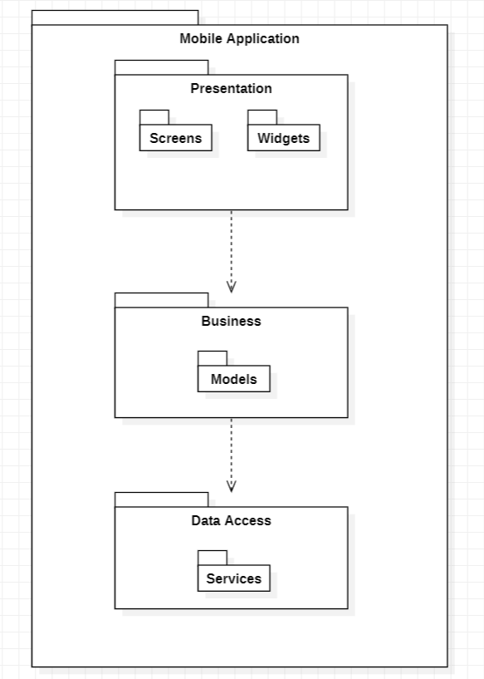

Figure . Package diagram - Mobile

|  |  |  |
| --- | --- | --- |
| **No** | **Package** | **Description** |
| 01 | Screens | Package contains classes responsible for rendering to the user interface. |
| 02 | Widgets | Package contains classes responsible for handling interface components. |
| 03 | Models | Package contains classes responsible for receiving data and converting data to objects. |
| 04 | Services | Package contains classes responsible for handling HTTP requests and returning responses with values. |

Table . Package Descriptions - Mobile

## 2. Database Design

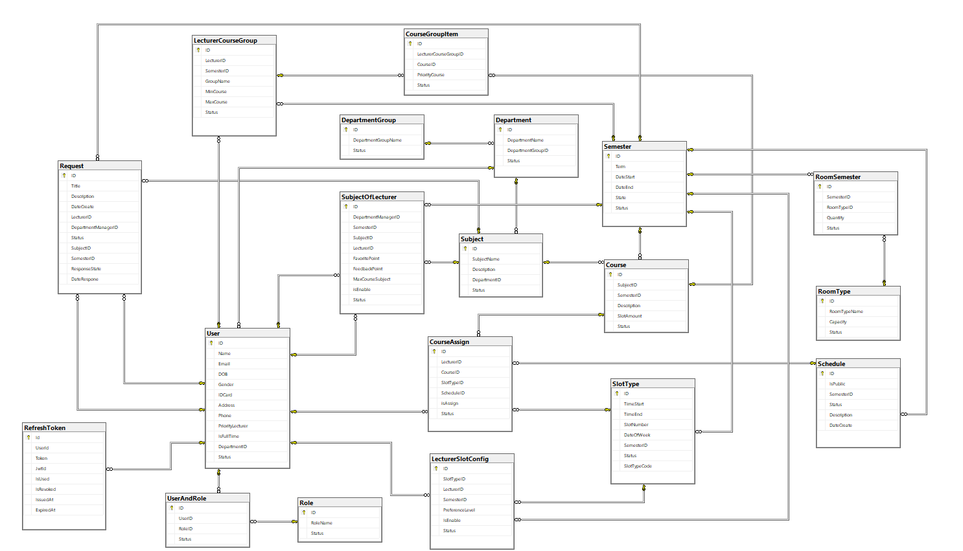

Figure . Database diagram

### 2.1 Table Descriptions

#### 2.1.1 User

|  |  |  |  |  |  |  |
| --- | --- | --- | --- | --- | --- | --- |
| **Field name** | **Type** | **Size** | **Unique** | **Not Null** | **PK/FK** | **Notes** |
| ID | varchar | 30 | X | X | PK | Identifier code of User |
| Name | nvarchar | 50 |  |  |  | Name of User |
| Email | varchar | 50 | X | X |  | Email of User |
| DOB | date |  |  |  |  | DOB of User |
| Gender | int |  |  |  |  | Gender of User |
| IDCard | char | 12 |  |  |  | ID Card of User |
| Address | nvarchar | 150 |  |  |  | Address of User |
| Phone | varchar | 11 |  |  |  | Phone of User |
| PriorityLecturer | int |  |  |  |  | The Priority of Lecturer |
| IsFullTime | int |  |  |  |  | Lecturer is full time or part time |
| DepartmentID | varchar | 30 |  |  |  | Department ID of Lecturer and Department Manager |
| Status | int |  |  | x |  | Status of User |

Table . Database design - User

#### 2.1.2 Course

|  |  |  |  |  |  |  |
| --- | --- | --- | --- | --- | --- | --- |
| **Field name** | **Type** | **Size** | **Unique** | **Not Null** | **PK/FK** | **Notes** |
| ID | varchar | 30 | X | X | PK | Identifier code of Course |
| SubjectID | varchar | 30 |  |  | FK | Identifier code of Subject |
| SemesterID | varchar | 30 |  |  | FK | Identifier code of Semester |
| Description | nvarchar | 300 |  |  |  | Description of Course |
| SlotAmount | int |  |  |  |  | SlotAmount of Course |
| Status | int |  |  | x |  | Status of Course |

Table . Database design - Course

#### 2.1.3 CourseAssign

|  |  |  |  |  |  |  |
| --- | --- | --- | --- | --- | --- | --- |
| **Field name** | **Type** | **Size** | **Unique** | **Not Null** | **PK/FK** | **Notes** |
| ID | varchar | 30 | X | X | PK | Identifier code of CourseAssign |
| LecturerID | varchar | 30 |  |  | FK | Identifier code of Lecturer |
| CourseID | varchar | 30 |  |  | FK | Identifier code of Course |
| isAssign | int |  |  |  |  | isAssign of CourseAssign |
| SlotTypeID | varchar | 30 |  |  | FK | Identifier code of SlotType |
| ScheduleID | varchar | 30 |  |  | FK | Identifier code of Schedule |
| Status | int |  |  | x |  | Status of CourseAssign |

Table . Database design - CourseAssign

#### 2.1.4 CourseGroupItem

|  |  |  |  |  |  |  |
| --- | --- | --- | --- | --- | --- | --- |
| **Field name** | **Type** | **Size** | **Unique** | **Not Null** | **PK/FK** | **Notes** |
| ID | varchar | 30 | X | X | PK | Identifier code of CourseGroupItem |
| LecturerCourseGroupID | varchar | 30 |  |  | FK | Identifier code of LecturerCourseGroup |
| CourseID | varchar | 30 |  |  | FK | Identifier code of Course |
| PriorityCourse | int |  |  |  |  | PriorityCourse of CourseGroupItem |
| Status | int |  |  | x |  | Status of CourseGroupItem |

Table . Database design - CourseGroupItem

#### 2.1.5 Department

|  |  |  |  |  |  |  |
| --- | --- | --- | --- | --- | --- | --- |
| **Field name** | **Type** | **Size** | **Unique** | **Not Null** | **PK/FK** | **Notes** |
| ID | varchar | 30 | X | X | PK | Identifier code of Department |
| DepartmentName | nvarchar | 100 |  |  |  | DepartmentName of Department |
| DepartmentGroupID | varchar | 30 |  |  | FK | Identifier code of DepartmentGroup |
| Status | int |  |  | x |  | Status of Department |

Table . Database design - Department

#### 2.1.6 DepartmentGroup

|  |  |  |  |  |  |  |
| --- | --- | --- | --- | --- | --- | --- |
| **Field name** | **Type** | **Size** | **Unique** | **Not Null** | **PK/FK** | **Notes** |
| ID | varchar | 30 | X | X | PK | Identifier code of DepartmentGroup |
| DepartmentGroupName | nvarchar | 100 |  |  |  | DepartmentGroupName of DepartmentGroup |
| Status | int |  |  | x |  | Status of DepartmentGroup |

Table . Database design - DepartmentGroup

#### 2.1.7 LecturerCourseGroup

|  |  |  |  |  |  |  |
| --- | --- | --- | --- | --- | --- | --- |
| **Field name** | **Type** | **Size** | **Unique** | **Not Null** | **PK/FK** | **Notes** |
| ID | varchar | 30 | X | X | PK | Identifier code of LecturerCourseGroup |
| LecturerID | varchar | 30 |  |  | FK | Identifier code of Lecturer |
| SemesterID | varchar | 30 |  |  | FK | Identifier code of Semester |
| GroupName | nvarchar | 150 |  |  |  | GroupName of LecturerCourseGroup |
| MinCourse | int |  |  |  |  | MinCourse of LecturerCourseGroup |
| MaxCourse | int |  |  |  |  | MaxCourse of LecturerCourseGroup |
| Status | int |  |  | x |  | Status of LecturerCourseGroup |

Table . Database design - LecturerCourseGroup

#### 2.1.8 LecturerSlotConfig

|  |  |  |  |  |  |  |
| --- | --- | --- | --- | --- | --- | --- |
| **Field name** | **Type** | **Size** | **Unique** | **Not Null** | **PK/FK** | **Notes** |
| ID | varchar | 30 | X | X | PK | Identifier code of LecturerSlotConfig |
| SlotTypeID | varchar | 30 |  |  | FK | Identifier code of SlotType |
| LecturerID | varchar | 30 |  |  | FK | Identifier code of Lecturer |
| SemesterID | varchar | 30 |  |  | FK | Identifier code of Semester |
| PreferenceLevel | int |  |  |  |  | PreferenceLevel of LecturerSlotConfig |
| IsEnable | int |  |  |  |  | IsEnable of LecturerSlotConfig |
| Status | int |  |  | x |  | Status of LecturerSlotConfig |

Table . Database design - LecturerSlotConfig

#### 2.1.9 Request

|  |  |  |  |  |  |  |
| --- | --- | --- | --- | --- | --- | --- |
| **Field name** | **Type** | **Size** | **Unique** | **Not Null** | **PK/FK** | **Notes** |
| ID | varchar | 30 | X | X | PK | Identifier code of Request |
| Title | nvarchar | 100 |  |  |  | Title of Request |
| Description | nvarchar | 150 |  |  |  | Description of Request |
| DateCreate | datetime |  |  |  |  | DateCreate of Request |
| LecturerID | varchar | 30 |  |  | FK | Identifier code of Lecturer |
| DepartmentManagerID | varchar | 30 |  |  | FK | Identifier code of DepartmentManager |
| SubjectID | varchar | 30 |  |  | FK | Identifier code of Subject |
| SemesterID | varchar | 30 |  |  | FK | Identifier code of Semester |
| DateResponse | datetime |  |  |  |  | DateResponse of Request |
| ResponseState | int |  |  |  |  | ResponseState of Request |
| Status | int |  |  | x |  | Status of Request |

Table . Database design - Request

#### 2.1.10 RoomSemester

|  |  |  |  |  |  |  |
| --- | --- | --- | --- | --- | --- | --- |
| **Field name** | **Type** | **Size** | **Unique** | **Not Null** | **PK/FK** | **Notes** |
| ID | varchar | 30 | X | X | PK | Identifier code of RoomSemester |
| SemesterID | varchar | 30 |  |  | FK | Identifier code of Semester |
| RoomTypeID | varchar | 30 |  |  | FK | Identifier code of RoomType |
| Quantity | int |  |  |  |  | Quantity of RoomSemester |
| Status | int |  |  | x |  | Status of RoomSemester |

Table . Database design - RoomSemester

#### 2.1.11 RoomType

|  |  |  |  |  |  |  |
| --- | --- | --- | --- | --- | --- | --- |
| **Field name** | **Type** | **Size** | **Unique** | **Not Null** | **PK/FK** | **Notes** |
| ID | varchar | 30 | X | X | PK | Identifier code of RoomType |
| RoomTypeName | nvarchar | 100 |  |  |  | RoomTypeName of RoomType |
| Capacity | int |  |  |  |  | Capacity of RoomType |
| Status | int |  |  | x |  | Status of RoomType |

Table . Database design - RoomType

#### 2.1.12 Schedule

|  |  |  |  |  |  |  |
| --- | --- | --- | --- | --- | --- | --- |
| **Field name** | **Type** | **Size** | **Unique** | **Not Null** | **PK/FK** | **Notes** |
| ID | varchar | 30 | X | X | PK | Identifier code of Schedule |
| IsPublic | int |  |  |  |  | IsPublic of Schedule |
| SemesterID | varchar | 30 |  |  | PK | Identifier code of Semester |
| Description | nvarchar | 1500 |  |  |  | Description of Schedule |
| DateCreate | datetime |  |  |  |  | DateCreate of Schedule |
| Status | int |  |  | x |  | Status of Schedule |

Table . Database design - Schedule

#### 2.1.13 Semester

|  |  |  |  |  |  |  |
| --- | --- | --- | --- | --- | --- | --- |
| **Field name** | **Type** | **Size** | **Unique** | **Not Null** | **PK/FK** | **Notes** |
| ID | varchar | 30 | X | X | PK | Identifier code of Semester |
| Term | nvarchar | 30 |  |  |  | Term of Semester |
| DateStart | date |  |  |  |  | DateStart of Semester |
| DateEnd | date |  |  |  |  | DateEnd of Semester |
| State | int |  |  |  |  | State of Semester |
| Status | int |  |  | x |  | Status of Semester |

Table . Database design - Semester

#### 2.1.14 SlotType

|  |  |  |  |  |  |  |
| --- | --- | --- | --- | --- | --- | --- |
| **Field name** | **Type** | **Size** | **Unique** | **Not Null** | **PK/FK** | **Notes** |
| ID | varchar | 30 | X | X | PK | Identifier code of SlotType |
| SlotTypeCode | varchar | 30 |  |  |  | SlotTypeCode of SlotType |
| TimeStart | time(0) |  |  |  |  | TimeStart of SlotType |
| TimeEnd | time(0) |  |  |  |  | TimeEnd of SlotType |
| SlotNumber | int |  |  |  |  | SlotNumber of SlotType |
| DateOfWeek | int |  |  |  |  | DateOfWeek of SlotType |
| SemesterID | varchar | 30 |  |  | FK | Identifier code of Semester |
| Status | int |  |  | x |  | Status of SlotType |

Table . Database design - SlotType

#### 2.1.15 Subject

|  |  |  |  |  |  |  |
| --- | --- | --- | --- | --- | --- | --- |
| **Field name** | **Type** | **Size** | **Unique** | **Not Null** | **PK/FK** | **Notes** |
| ID | varchar | 30 | X | X | PK | Identifier code of Subject |
| SubjectName | nvarchar | 100 |  |  |  | SubjectName of Subject |
| Description | nvarchar | 500 |  |  |  | Description of Subject |
| DepartmentID | varchar | 30 |  |  | FK | Identifier code of Department |
| Status | int |  |  | x |  | Status of Subject |

Table . Database design - Subject

#### 2.1.16 SubjectOfLecturer

|  |  |  |  |  |  |  |
| --- | --- | --- | --- | --- | --- | --- |
| **Field name** | **Type** | **Size** | **Unique** | **Not Null** | **PK/FK** | **Notes** |
| ID | varchar | 30 | X | X | PK | Identifier code of SubjectOfLecturer |
| DepartmentManagerID | varchar | 30 |  |  | FK | Identifier code of DepartmentManager |
| SemesterID | varchar | 30 |  |  | FK | Identifier code of Semester |
| SubjectID | varchar | 30 |  |  | FK | Identifier code of Subject |
| LecturerID | varchar | 30 |  |  | FK | Identifier code of Lecturer |
| FavoritePoint | int |  |  |  |  | FavoritePoint of SubjectOfLecturer |
| FeedbackPoint | int |  |  |  |  | FeedbackPoint of SubjectOfLecturer |
| MaxCourseSubject | int |  |  |  |  | MaxCourse of SubjectOfLecturer |
| isEnable | int |  |  |  |  | isEnable of SubjectOfLecturer |
| Status | int |  |  | x |  | Status of SubjectOfLecturer |

Table . Database design - SubjectOfLecturer

#### 2.1.17 UserAndRole

|  |  |  |  |  |  |  |
| --- | --- | --- | --- | --- | --- | --- |
| **Field name** | **Type** | **Size** | **Unique** | **Not Null** | **PK/FK** | **Notes** |
| ID | varchar | 30 | X | X | PK | Identifier code of UserAndRole |
| UserID | varchar | 30 |  |  | FK | ID of User |
| RoleID | varchar | 30 |  |  | FK | ID of Role |
| Status | int |  |  | x |  | Status of UserAndRole |

Table . Database design - UserAndRole

#### 2.1.18 Role

|  |  |  |  |  |  |  |
| --- | --- | --- | --- | --- | --- | --- |
| **Field name** | **Type** | **Size** | **Unique** | **Not Null** | **PK/FK** | **Notes** |
| ID | varchar | 30 | X | X | PK | Identifier code of Role |
| RoleName | nvarchar | 100 |  |  |  | Name of Role |
| Status | int |  |  | x |  | Status of Role |

Table . Database design - Role

#### 2.1.19 RefreshToken

|  |  |  |  |  |  |  |
| --- | --- | --- | --- | --- | --- | --- |
| **Field name** | **Type** | **Size** | **Unique** | **Not Null** | **PK/FK** | **Notes** |
| ID | varchar | 30 | X | X | PK | Identifier code of RefreshToken |
| UserID | varchar | 30 |  | x | FK | ID of User |
| Token | nvarchar | max |  |  |  | Token of Refresh Token |
| JwtID | nvarchar | max |  |  |  | JwtID of access token |
| IsUsed | int |  |  |  |  | IsUsed or not. |
| IsRevoked | int |  |  |  |  | IsRevoked or not. |
| IssuedAt | datetime2(7) |  |  | x |  | Creation time of RefreshToken |
| ExpiredAt | datetime2(7) |  |  | x |  | Expiration time of RefreshToken |

Table . Database design - RefreshToken

## 3. Detailed Design

### 3.1 Class Diagram

#### 3.1.1. Class Diagram

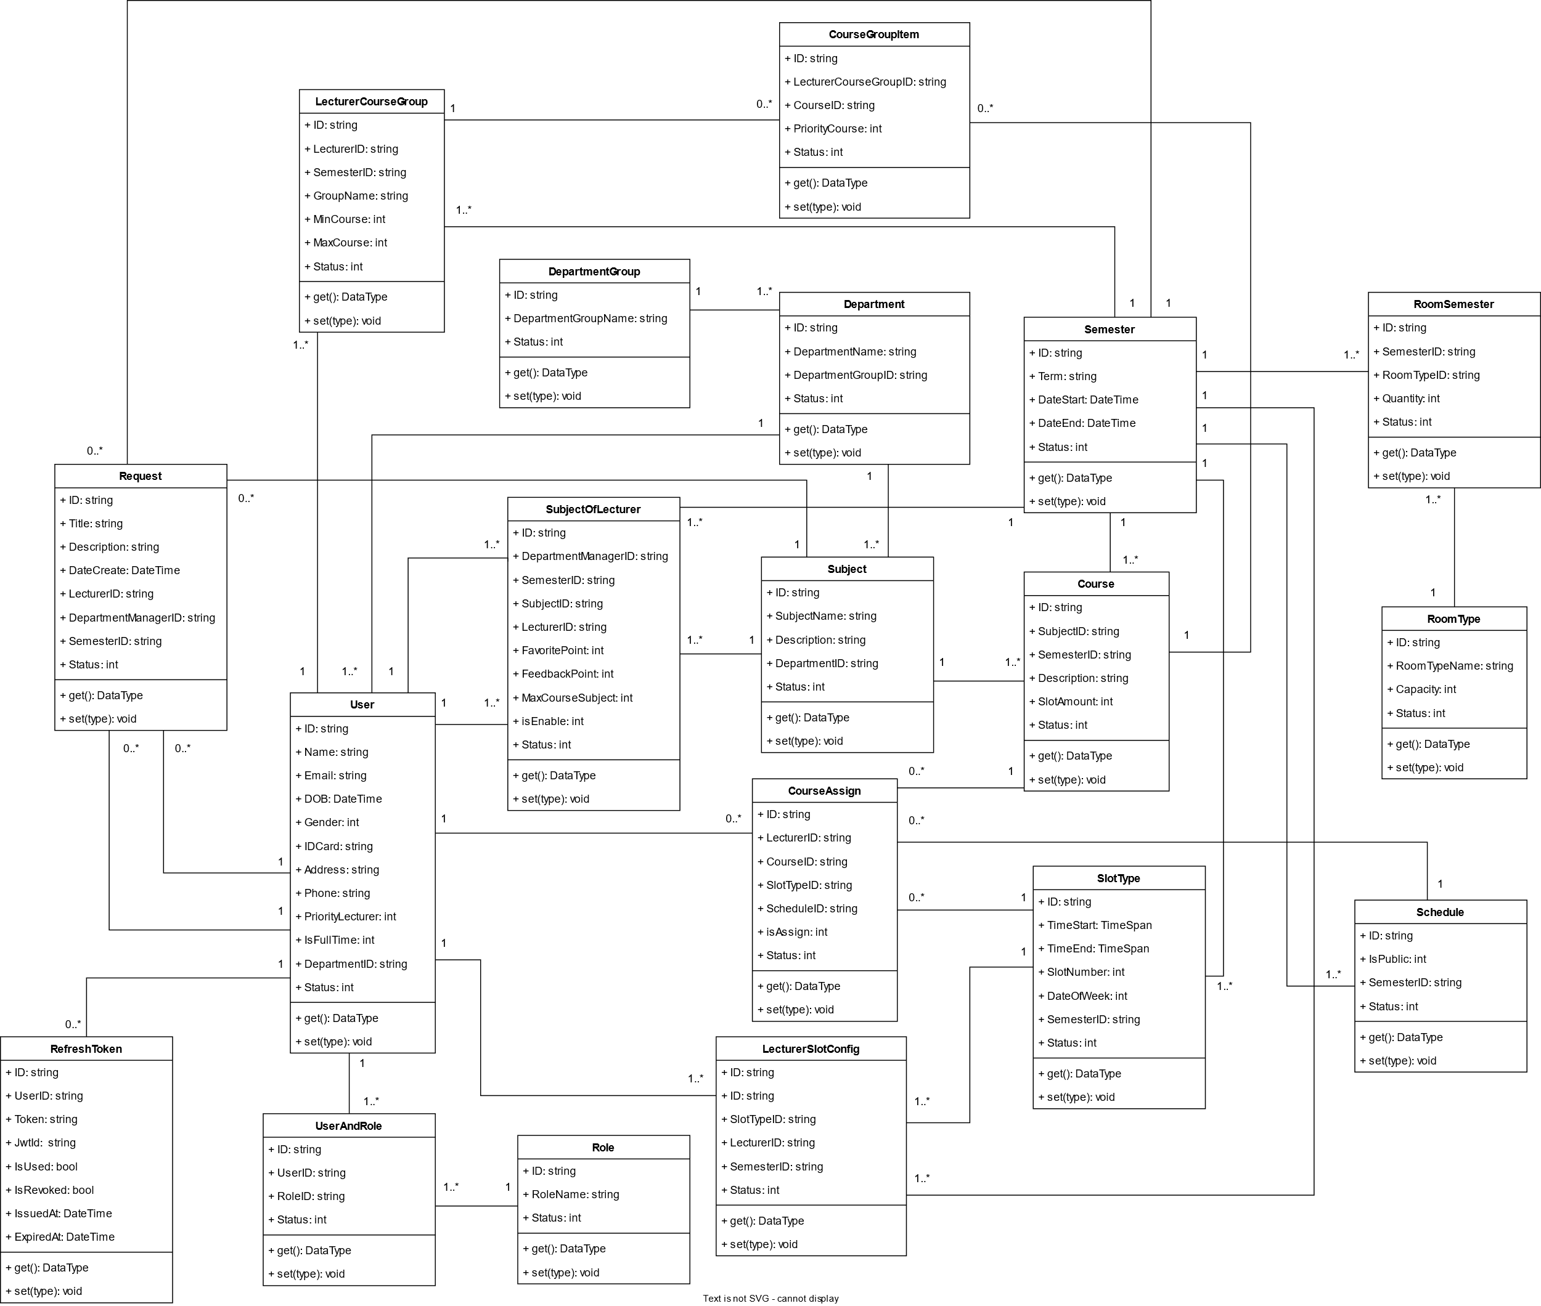

Figure . Class Diagram

#### 3.1.2. Class Specification

##### a. User

|  |  |  |  |  |
| --- | --- | --- | --- | --- |
| **No** | **Attribute** | **Type** | **Visibility** | **Description** |
| 1 | ID | string | private | Unique identifier of Admin |
| 2 | Name | string | private | Name of Admin |
| 3 | Email | string | private | Email of Admin |
| 4 | DOB | DateTime | private | Day of birth of Admin |
| 5 | Gender | int | private | Male or female. |
| 6 | IDCard | string | private | IDCard of Admin |
| 7 | Address | string | private | Address of Admin |
| 8 | Phone | string | private | Phone of Admin |
| 9 | PriorityLecturer | int | private | Indicate the lecturer's priority |
| 10 | IsFullTime | int | private | Is this CourseAssign full time or part time |
| 11 | DepartmentID | string | private | ID of Department |
| 12 | Status | int | private | Is this Admin active or disable. |

Table . Class Specification - User

|  |  |  |  |  |
| --- | --- | --- | --- | --- |
| **No** | **Method** | **Visibility** | **Return type** | **Description** |
| 01 | getter | public | Attribute type | Get attribute value. |
| 02 | setter | public | void | Set attribute value. |

Table . User Method

##### b. Course

|  |  |  |  |  |
| --- | --- | --- | --- | --- |
| **No** | **Attribute** | **Type** | **Visibility** | **Description** |
| 1 | ID | string | private | Unique identifier of Course |
| 2 | SubjectID | string | private | ID of subject |
| 3 | SemesterID | string | private | ID of semester |
| 4 | Description | string | private | Description of Course |
| 5 | SlotAmount | int | private | SlotAmount of Course |
| 6 | Status | int | private | Is this Course active or disable. |

Table . Class Specification - Course

|  |  |  |  |  |
| --- | --- | --- | --- | --- |
| **No** | **Method** | **Visibility** | **Return type** | **Description** |
| 01 | getter | public | Attribute type | Get attribute value. |
| 02 | setter | public | void | Set attribute value. |

Table . Course Method

##### c. CourseAssign

|  |  |  |  |  |
| --- | --- | --- | --- | --- |
| **No** | **Attribute** | **Type** | **Visibility** | **Description** |
| 1 | ID | string | private | Unique identifier of CourseAssign |
| 2 | LecturerID | string | private | ID of Lecturer |
| 3 | CourseID | string | private | ID of Course |
| 4 | SlotTypeID | string | private | ID of SlotType |
| 5 | ScheduleID | string | private | ID of Schedule |
| 6 | isAssign | int | private | Specify that the lecturer teaches this subject |
| 7 | Status | int | private | Is this CourseAssign active or disable. |

Table . Class Specification - CourseAssign

|  |  |  |  |  |
| --- | --- | --- | --- | --- |
| **No** | **Method** | **Visibility** | **Return type** | **Description** |
| 01 | getter | public | Attribute type | Get attribute value. |
| 02 | setter | public | void | Set attribute value. |

Table . CourseAssign Method

##### d. CourseGroupItem

|  |  |  |  |  |
| --- | --- | --- | --- | --- |
| **No** | **Attribute** | **Type** | **Visibility** | **Description** |
| 1 | ID | string | private | Unique identifier of CourseGroupItem |
| 2 | LecturerCourseGroupID | string | private | ID of LecturerCourseGroup |
| 3 | CourseID | string | private | ID of Course |
| 4 | PriorityCourse | int | private | Indicate the priority points of the group |
| 5 | Status | int | private | Is this CourseGroupItem active or disable. |

Table . Class Specification - CourseGroupItem

|  |  |  |  |  |
| --- | --- | --- | --- | --- |
| **No** | **Method** | **Visibility** | **Return type** | **Description** |
| 01 | getter | public | Attribute type | Get attribute value. |
| 02 | setter | public | void | Set attribute value. |

Table . CourseGroupItem Method

##### e. Department

|  |  |  |  |  |
| --- | --- | --- | --- | --- |
| **No** | **Attribute** | **Type** | **Visibility** | **Description** |
| 1 | ID | string | private | Unique identifier of Department |
| 2 | DepartmentName | string | private | Name of Department |
| 3 | DepartmentGroupID | string | private | ID of DepartmentGroup |
| 4 | Status | int | private | Is this Department active or disable. |

Table . Class Specification – Department

|  |  |  |  |  |
| --- | --- | --- | --- | --- |
| **No** | **Method** | **Visibility** | **Return type** | **Description** |
| 01 | getter | public | Attribute type | Get attribute value. |
| 02 | setter | public | void | Set attribute value. |

Table . Department Method

##### f. DepartmentGroup

|  |  |  |  |  |
| --- | --- | --- | --- | --- |
| No | Attribute | Type | Visibility | Description |
| 1 | ID | string | private | Unique identifier of DepartmentGroup |
| 2 | DepartmentGroupName | string | private | Name of DepartmentGroup |
| 3 | Status | int | private | Is this DepartmentGroup active or disable. |

Table . Class Specification – DepartmentGroup

|  |  |  |  |  |
| --- | --- | --- | --- | --- |
| **No** | **Method** | **Visibility** | **Return type** | **Description** |
| 01 | getter | public | Attribute type | Get attribute value. |
| 02 | setter | public | void | Set attribute value. |

Table . DepartmentGroup Method

##### g. LecturerCourseGroup

|  |  |  |  |  |
| --- | --- | --- | --- | --- |
| **No** | **Attribute** | **Type** | **Visibility** | **Description** |
| 1 | ID | string | private | Unique identifier of LecturerCourseGroup |
| 2 | LecturerID | string | private | ID of Lecturer |
| 3 | SemesterID | string | private | ID of Semester |
| 4 | GroupName | string | private | Name of Group |
| 5 | MinCourse | int | private | The minimum number of courses the instructor can teach |
| 6 | MaxCourse | int | private | The maximum number of courses an instructor can teach |
| 7 | Status | int | private | Is this LecturerCourseGroup active or disable. |

Table . Class Specification – LecturerCourseGroup

|  |  |  |  |  |
| --- | --- | --- | --- | --- |
| **No** | **Method** | **Visibility** | **Return type** | **Description** |
| 01 | getter | public | Attribute type | Get attribute value. |
| 02 | setter | public | void | Set attribute value. |

Table . LecturerCourseGroup Method

##### h. LecturerSlotConfig

|  |  |  |  |  |
| --- | --- | --- | --- | --- |
| **No** | **Attribute** | **Type** | **Visibility** | **Description** |
| 1 | ID | string | private | Unique identifier of LecturerSlotConfig |
| 2 | LecturerID | string | private | ID of Lecturer |
| 3 | SemesterID | string | private | ID of Semester |
| 4 | PreferenceLevel | int | private | The instructor's preference for that slot type |
| 5 | IsEnable | int | private | Allows interactive editing of slot type options or not at the state of the semester |
| 6 | Status | int | private | Is this LecturerSlotConfig active or disable |

Table . Class Specification – LecturerSlotConfig

|  |  |  |  |  |
| --- | --- | --- | --- | --- |
| **No** | **Method** | **Visibility** | **Return type** | **Description** |
| 01 | getter | public | Attribute type | Get attribute value. |
| 02 | setter | public | void | Set attribute value. |

Table . LecturerSlotConfig Method

##### i. Request

|  |  |  |  |  |
| --- | --- | --- | --- | --- |
| **No** | **Attribute** | **Type** | **Visibility** | **Description** |
| 1 | ID | string | private | Unique identifier of Request |
| 2 | Title | string | private | Title of Request |
| 3 | Description | string | private | Description of Request |
| 4 | DateCreate | DateTime | private | The creation date of Request |
| 5 | DateRespone | DateTime | private | The response date of Request |
| 6 | ResponseState | int | private | The Response State of Request |
| 7 | LecturerID | string | private | ID of Lecturer of Request |
| 8 | DepartmentManagerID | string | private | ID of DepartmentManager |
| 9 | SemesterID | string | private | ID of Semester |
| 10 | SubjectID | string | private | ID of Subject |
| 11 | Status | int | private | Is this Request active or disable. |

Table . Class Specification – Request

|  |  |  |  |  |
| --- | --- | --- | --- | --- |
| **No** | **Method** | **Visibility** | **Return type** | **Description** |
| 01 | getter | public | Attribute type | Get attribute value. |
| 02 | setter | public | void | Set attribute value. |

Table . Request Method

##### j. RoomSemester

|  |  |  |  |  |
| --- | --- | --- | --- | --- |
| **No** | **Attribute** | **Type** | **Visibility** | **Description** |
| 1 | ID | string | private | Unique identifier of RoomSemester |
| 2 | SemesterID | string | private | ID of Semester |
| 3 | RoomTypeID | string | private | ID of RoomType |
| 4 | Quantity | int | private | Identify the number of classrooms for a semester |
| 5 | Status | int | private | Is this RoomSemester active or disable. |

Table . Class Specification – RoomSemester

|  |  |  |  |  |
| --- | --- | --- | --- | --- |
| **No** | **Method** | **Visibility** | **Return type** | **Description** |
| 01 | getter | public | Attribute type | Get attribute value. |
| 02 | setter | public | void | Set attribute value. |

Table . RoomSemester Method

##### k. RoomType

|  |  |  |  |  |
| --- | --- | --- | --- | --- |
| **No** | **Attribute** | **Type** | **Visibility** | **Description** |
| 1 | ID | string | private | Unique identifier of RoomType |
| 2 | RoomTypeName | string | private | Name of roomType |
| 3 | Capacity | int | private | Capacity of the room |
| 4 | Status | int | private | Is this RoomType active or disable. |

Table . Class Specification - RoomType

|  |  |  |  |  |
| --- | --- | --- | --- | --- |
| **No** | **Method** | **Visibility** | **Return type** | **Description** |
| 01 | getter | public | Attribute type | Get attribute value. |
| 02 | setter | public | void | Set attribute value. |

Table . RoomType Method

##### l. Schedule

|  |  |  |  |  |
| --- | --- | --- | --- | --- |
| **No** | **Attribute** | **Type** | **Visibility** | **Description** |
| 1 | ID | string | private | Unique identifier of Schedule |
| 2 | IsPublic | int | private | Identify the official or draft class schedule |
| 3 | DateCreate | DateTime | private | The creation date of the calendar |
| 4 | Description | string | private | Description of Schedule |
| 5 | Status | int | private | Is this Schedule active or disable. |

Table . Class Specification – Schedule

|  |  |  |  |  |
| --- | --- | --- | --- | --- |
| **No** | **Method** | **Visibility** | **Return type** | **Description** |
| 01 | getter | public | Attribute type | Get attribute value. |
| 02 | setter | public | void | Set attribute value. |

Table . Schedule Method

##### m. Semester

|  |  |  |  |  |
| --- | --- | --- | --- | --- |
| **No** | **Attribute** | **Type** | **Visibility** | **Description** |
| 1 | ID | string | private | Unique identifier of Semester |
| 2 | Term | string | private | Name of Semester |
| 3 | DateStart | DateTime | private | DateStart of Semester |
| 4 | DateEnd | DateTime | private | DateEnd of Semester |
| 5 | State | int | private | State of Semester |
| 6 | Status | int | private | Is this Semester active or disable. |

Table . Class Specification – Semester

|  |  |  |  |  |
| --- | --- | --- | --- | --- |
| **No** | **Method** | **Visibility** | **Return type** | **Description** |
| 01 | getter | public | Attribute type | Get attribute value. |
| 02 | setter | public | void | Set attribute value. |

Table . Semester Method

##### n. SlotType

|  |  |  |  |  |
| --- | --- | --- | --- | --- |
| **No** | **Attribute** | **Type** | **Visibility** | **Description** |
| 1 | ID | string | private | Unique identifier of SlotType |
| 2 | SlotTypeCode | string | private | Code of SlotType |
| 3 | TimeStart | TimeSpan | private | TimeStart of SlotType |
| 4 | TimeEnd | TimeSpan | private | TimeEnd of SlotType |
| 5 | SlotNumber | int | private | SlotNumber of SlotType |
| 6 | DateOfWeek | int | private | Identify the days of the week of slotType |
| 7 | SemesterID | string | private | ID of Semester |
| 8 | Status | int | private | Is this SlotType active or disable. |

Table . Class Specification – SlotType

|  |  |  |  |  |
| --- | --- | --- | --- | --- |
| **No** | **Method** | **Visibility** | **Return type** | **Description** |
| 01 | getter | public | Attribute type | Get attribute value. |
| 02 | setter | public | void | Set attribute value. |

Table . SlotType Method

##### o. Subject

|  |  |  |  |  |
| --- | --- | --- | --- | --- |
| **No** | **Attribute** | **Type** | **Visibility** | **Description** |
| 1 | ID | string | private | Unique identifier of Subject |
| 2 | SubjectName | string | private | Name of Subject |
| 3 | Description | string | private | Description of Subject |
| 4 | DepartmentID | string | private | ID of Department |
| 5 | Status | int | private | Is this Subject active or disable. |

Table . Class Specification – Subject

|  |  |  |  |  |
| --- | --- | --- | --- | --- |
| **No** | **Method** | **Visibility** | **Return type** | **Description** |
| 01 | getter | public | Attribute type | Get attribute value. |
| 02 | setter | public | void | Set attribute value. |

Table . Subject Method

##### p. SubjectOfLecturer

|  |  |  |  |  |
| --- | --- | --- | --- | --- |
| **No** | **Attribute** | **Type** | **Visibility** | **Description** |
| 1 | ID | string | private | Unique identifier of SubjectOfLecturer |
| 2 | DepartmentManagerID | string | private | ID of DepartmentManager |
| 3 | SemesterID | string | private | ID of Semester |
| 4 | SubjectID | string | private | ID of Subject |
| 5 | LecturerID | string | private | ID of Lecturer |
| 6 | FavoritePoint | int | private | Identify the Lecturer's preference favourite point for the subject |
| 7 | FeedbackPoint | int | private | Identify the feedback point of department management evaluation for teachers for the subject. |
| 8 | MaxCourseSubject | int | private | Identify the maximum number of courses of a subject for the lecturer. |
| 9 | isEnable | int | private | Identify the lecturer will be able to teach that subject next term or not |
| 10 | Status | int | private | Is this SubjectOfLecturer active or disable. |

Table . Class Specification - SubjectOfLecturer

|  |  |  |  |  |
| --- | --- | --- | --- | --- |
| **No** | **Method** | **Visibility** | **Return type** | **Description** |
| 01 | getter | public | Attribute type | Get attribute value. |
| 02 | setter | public | void | Set attribute value. |

Table . SubjectOfLecturer Method

##### q. UserAndRole

|  |  |  |  |  |
| --- | --- | --- | --- | --- |
| **No** | **Attribute** | **Type** | **Visibility** | **Description** |
| 1 | ID | string | private | Unique identifier of UserAndRole |
| 2 | UserID | string | private | ID of User |
| 3 | RoleID | string | private | ID of Role |
| 4 | Status | int | private | Is this UserAndRole active or disable. |

Table . Class Specification- UserAndRole

|  |  |  |  |  |
| --- | --- | --- | --- | --- |
| **No** | **Method** | **Visibility** | **Return type** | **Description** |
| 01 | getter | public | Attribute type | Get attribute value. |
| 02 | setter | public | void | Set attribute value. |

Table . UserAndRole Method

##### r. Role

|  |  |  |  |  |
| --- | --- | --- | --- | --- |
| **No** | **Attribute** | **Type** | **Visibility** | **Description** |
| 1 | ID | string | private | Unique identifier of Role |
| 2 | RoleName | string | private | Name of Role |
| 5 | Status | int | private | Is this Role active or disable. |

Table . Class Specification- Role

|  |  |  |  |  |
| --- | --- | --- | --- | --- |
| **No** | **Method** | **Visibility** | **Return type** | **Description** |
| 01 | getter | public | Attribute type | Get attribute value. |
| 02 | setter | public | void | Set attribute value. |

Table . Role Method

##### s. RefreshToken

|  |  |  |  |  |
| --- | --- | --- | --- | --- |
| **No** | **Attribute** | **Type** | **Visibility** | **Description** |
| 1 | ID | string | private | Unique identifier of SubjectOfLecturer |
| 2 | UserID | string | private | ID of User |
| 3 | Token | string | private | Token to Refresh Token |
| 4 | JwtID | string | private | JwtID of access token |
| 5 | IsUsed | int | private | Is this UserAndRole IsUsed or not. |
| 6 | IsRevoked | int | private | Is this UserAndRole IsRevoked or not. |
| 7 | IssuedAt | datetime | private | Creation time of RefreshToken |
| 8 | ExpiredAt | datetime | private | Expiration time of RefreshToken |

Table . Class Specification- RefreshToken

|  |  |  |  |  |
| --- | --- | --- | --- | --- |
| **No** | **Method** | **Visibility** | **Return type** | **Description** |
| 01 | getter | public | Attribute type | Get attribute value. |
| 02 | setter | public | void | Set attribute value. |

Table . RefreshToken Method

### 3.2 Sequence Diagrams

#### 3.2.1 <Member> Login

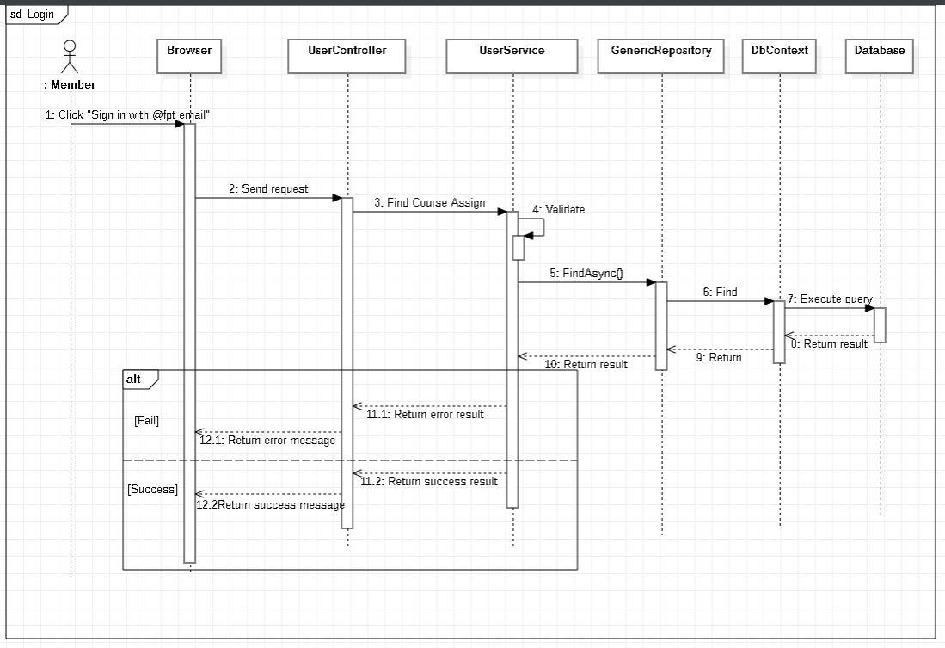

Figure . Sequence Diagram - Member Login

#### 3.2.2 <Admin> View all semesters

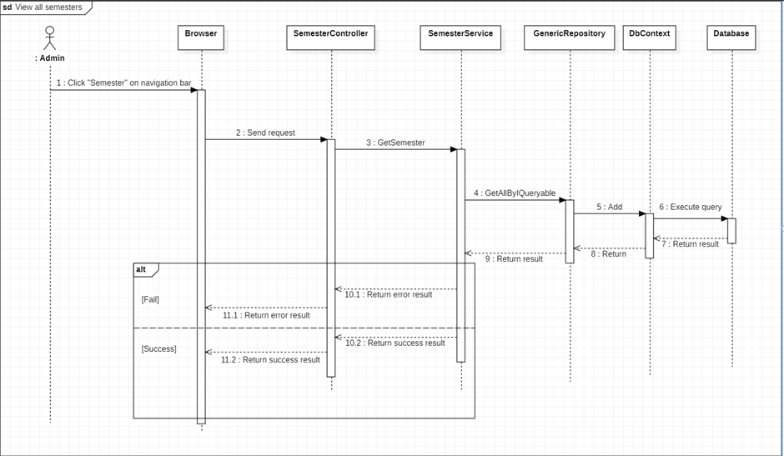

Figure . Sequence Diagram - Admin View all semesters

#### 3.2.3 <Admin> View semester detail

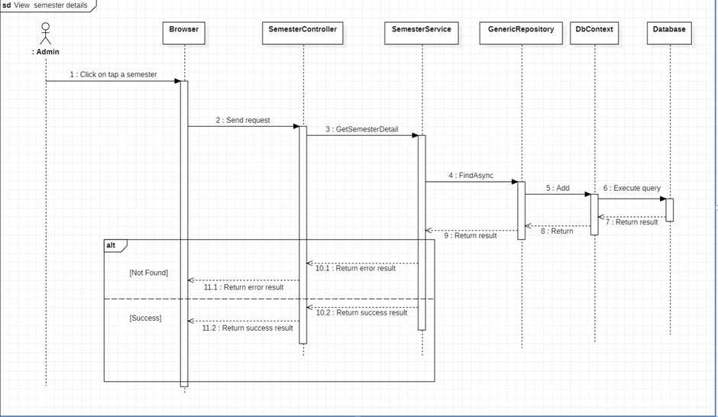

Figure . Sequence Diagram - Admin View semester detail

#### 3.2.4 <Admin> Create semester

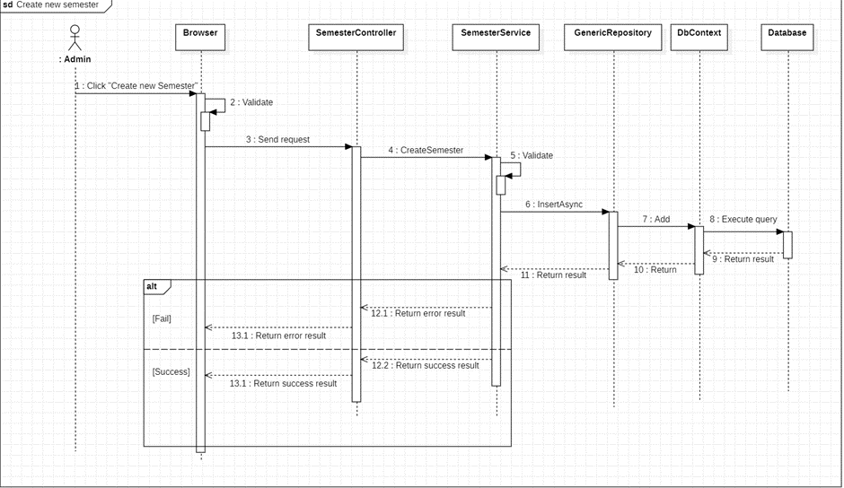

Figure . Sequence Diagram - Admin Create semester

#### 3.2.5 <Admin> Edit semester

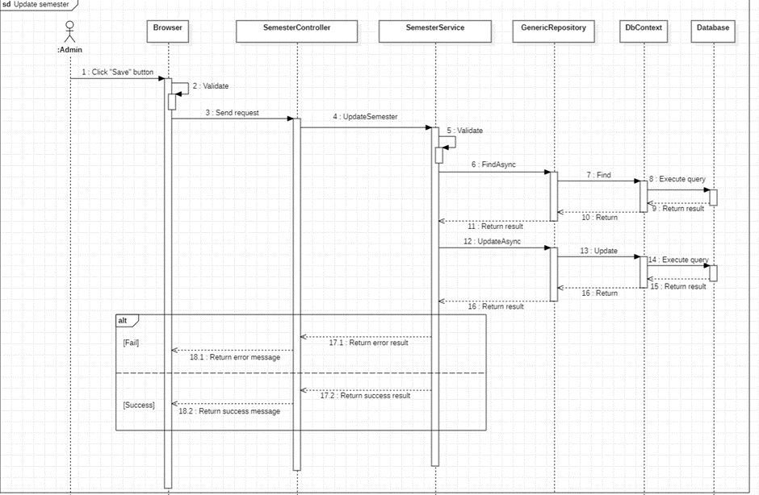

Figure . Sequence Diagram - Admin Edit semester

#### 3.2.6 <Admin> Delete semester

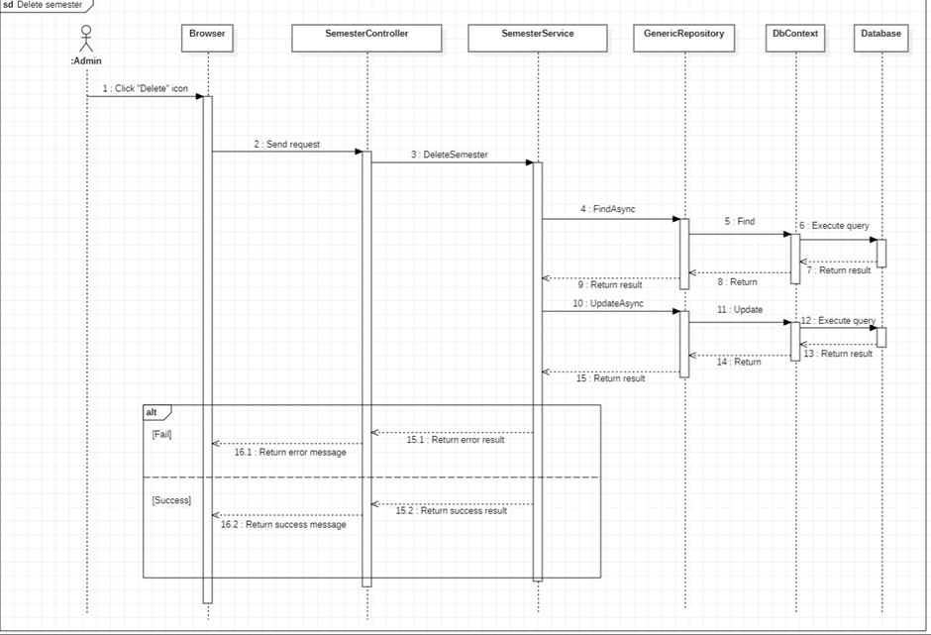

Figure . Sequence Diagram - Admin Delete semester

#### 3.2.7 <Admin> Import semester course list

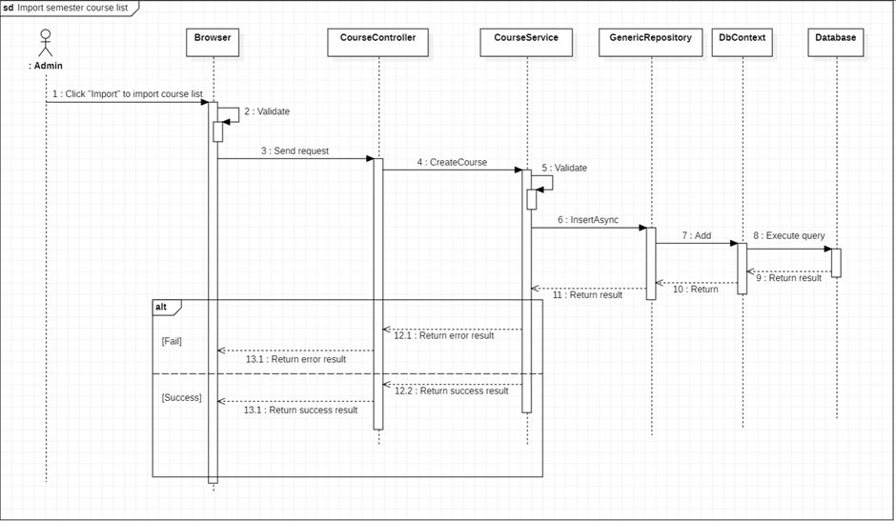

Figure . Sequence Diagram - Admin Import semester course list

#### 3.2.8 <Admin> Create course

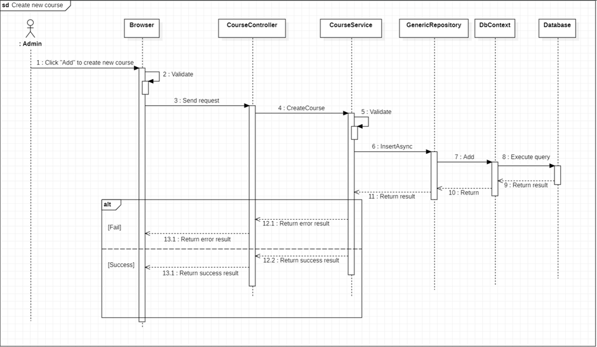

Figure . Sequence Diagram - Create course

#### 3.2.9 <Admin> Update course

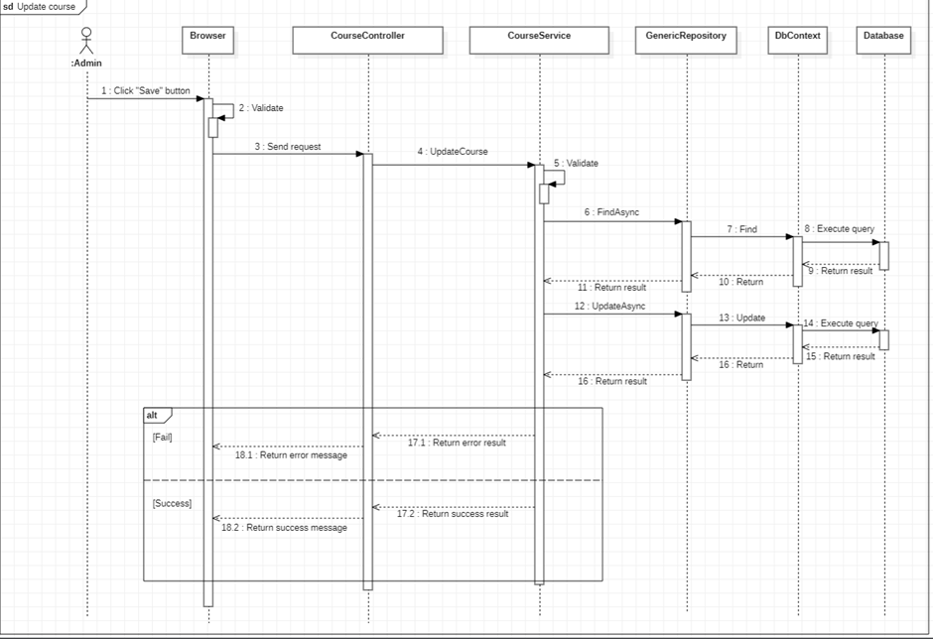

Figure . Sequence Diagram - Update course

#### 3.2.10 <Admin> Delete course

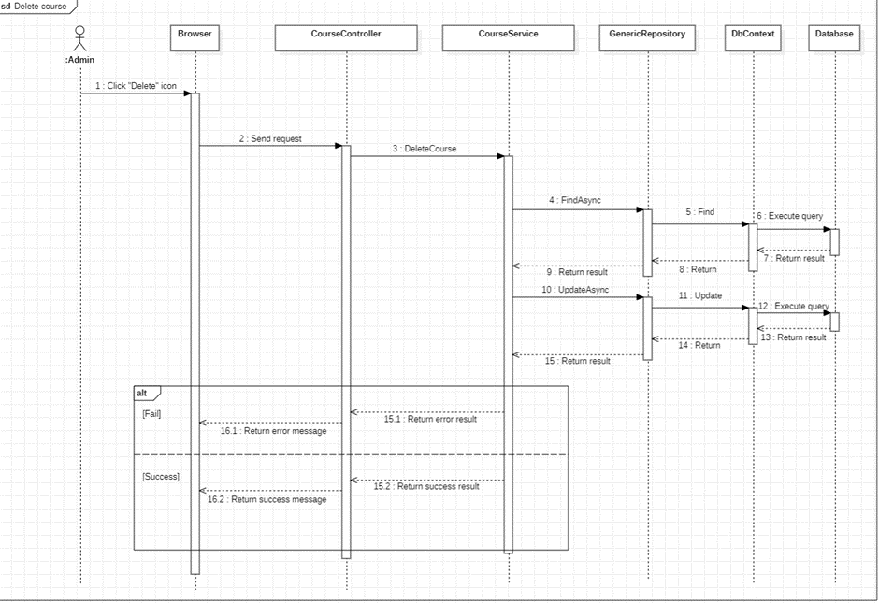

Figure . Sequence Diagram - Admin Delete course

#### 3.2.11 <Admin> View all courses

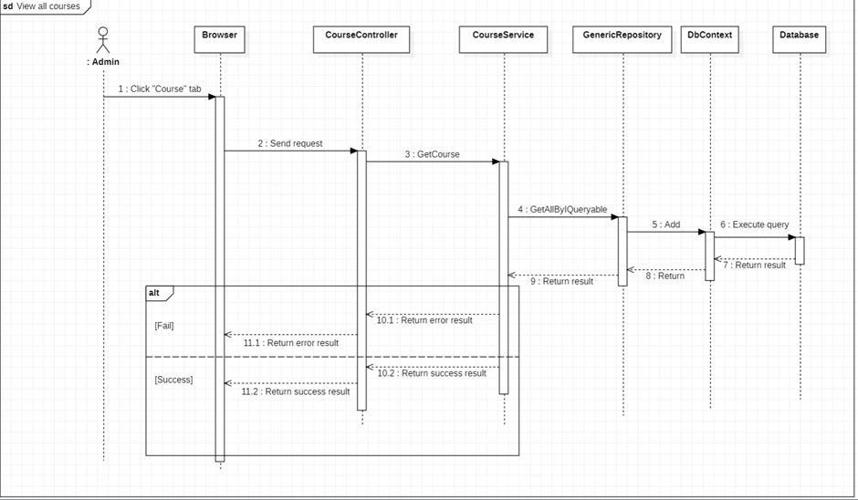

Figure . Sequence Diagram - Admin View all courses

#### 3.2.12 <Admin> View all slot type in semester

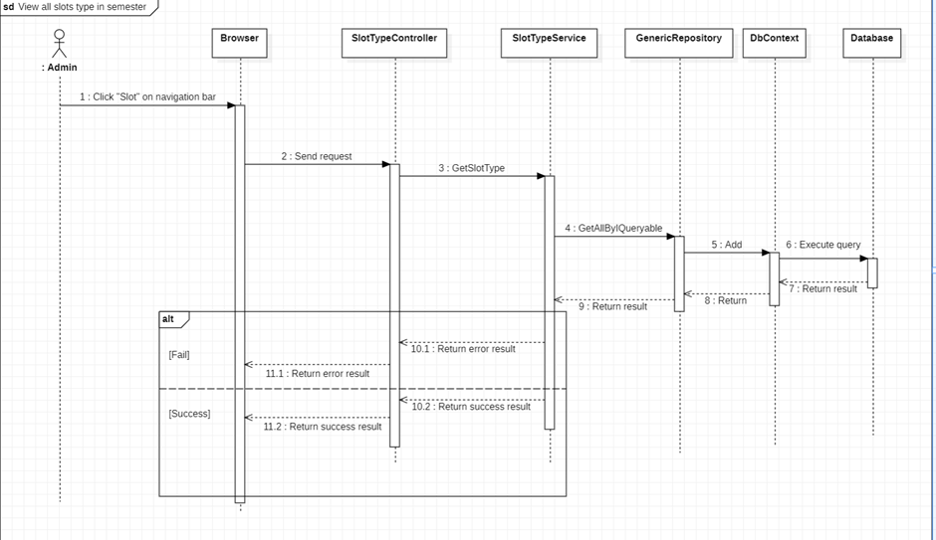

Figure . Sequence Diagram - Admin View all slot type in semester

#### 3.2.13 <Admin> View all lecturers

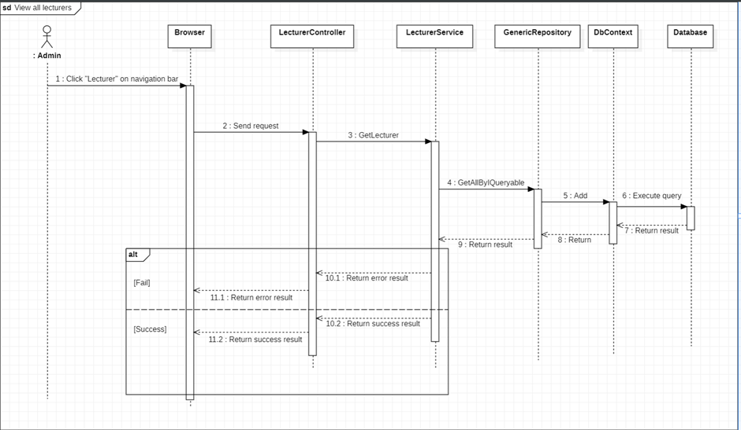

Figure . Sequence Diagram - Admin View all lecturers

#### 3.2.14 <Admin> View lecturer detail

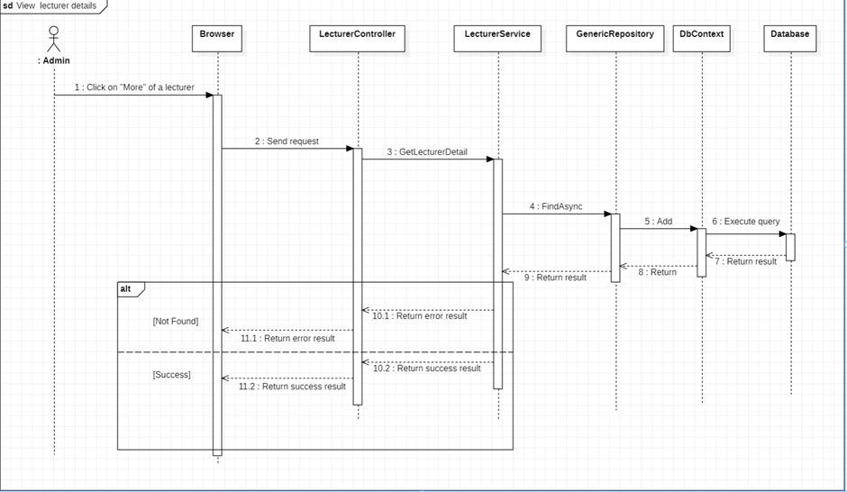

Figure . Sequence Diagram - Admin View lecturer detail

#### 3.2.15 <Admin> View all schedule of lecturers in semester

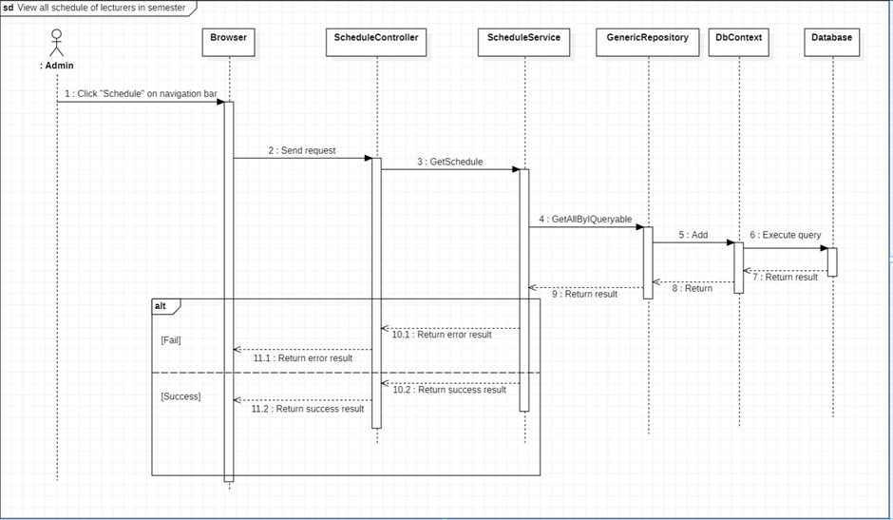

Figure . Sequence Diagram - Admin View all schedule of lecturers in semester

#### 3.2.16 <Admin> Create department

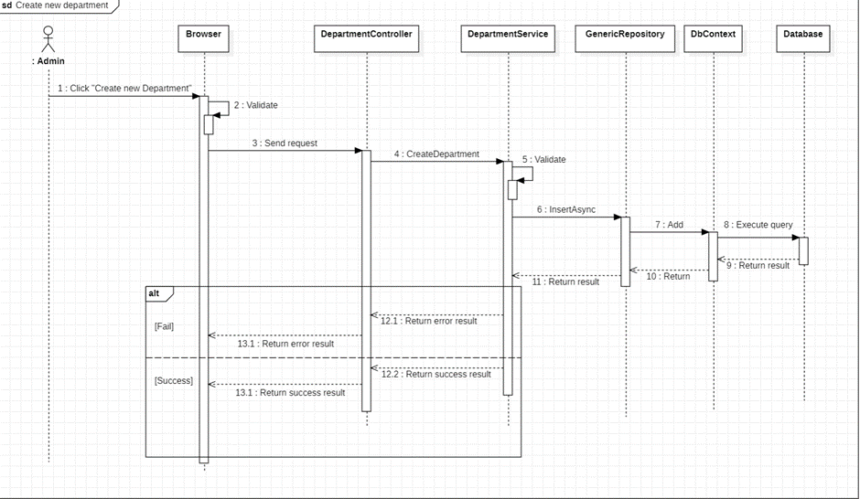

Figure . Sequence Diagram - Admin Create department

#### 3.2.17 <Admin> Update department

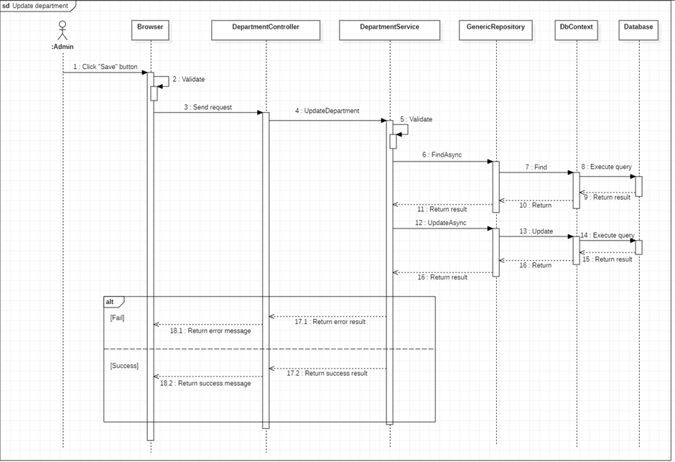

Figure . Sequence Diagram - Admin Update department

#### 3.2.18 <Admin> Delete department

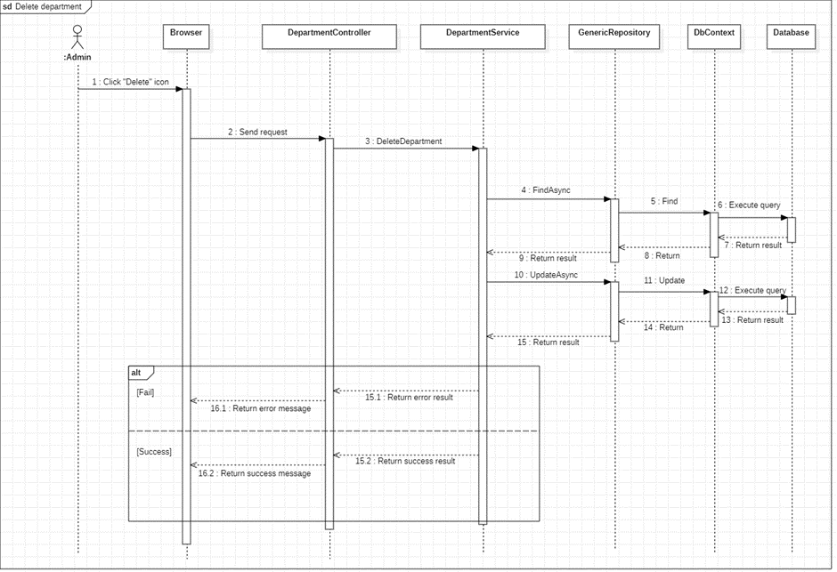

Figure . Sequence Diagram - Admin Delete department

#### 3.2.19 <Admin> View all departments

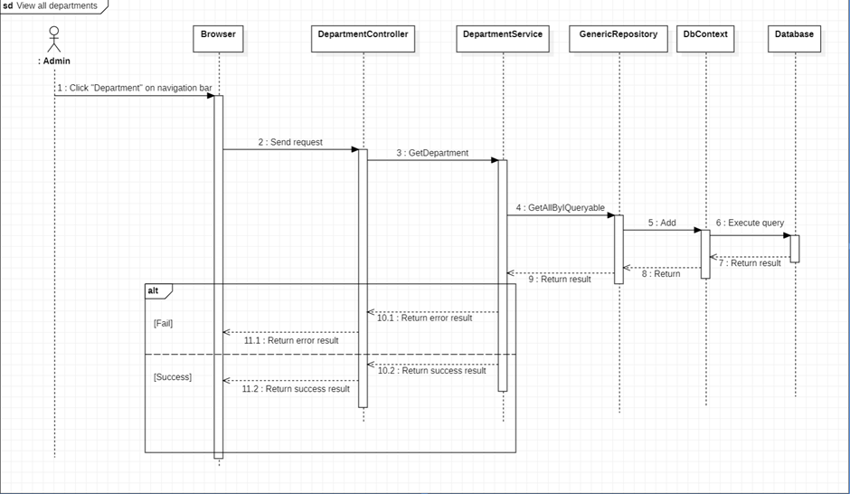

Figure . Sequence Diagram - Admin all departments

#### 3.2.20 <Admin> Create subject

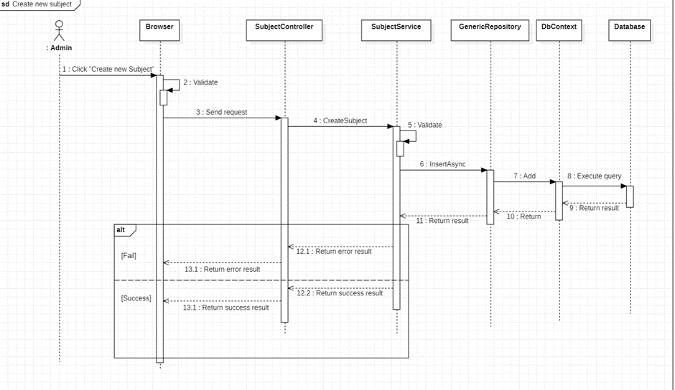

Figure . Sequence Diagram - Admin Create subject

#### 3.2.21 <Admin> Update subject

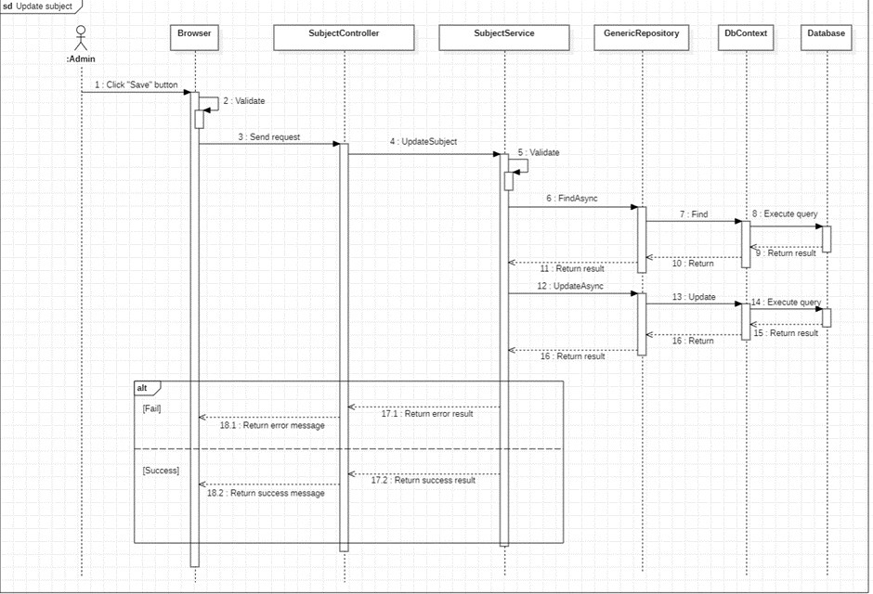

Figure . Sequence Diagram - Admin Update subject

#### 3.2.22 <Admin> Delete subject

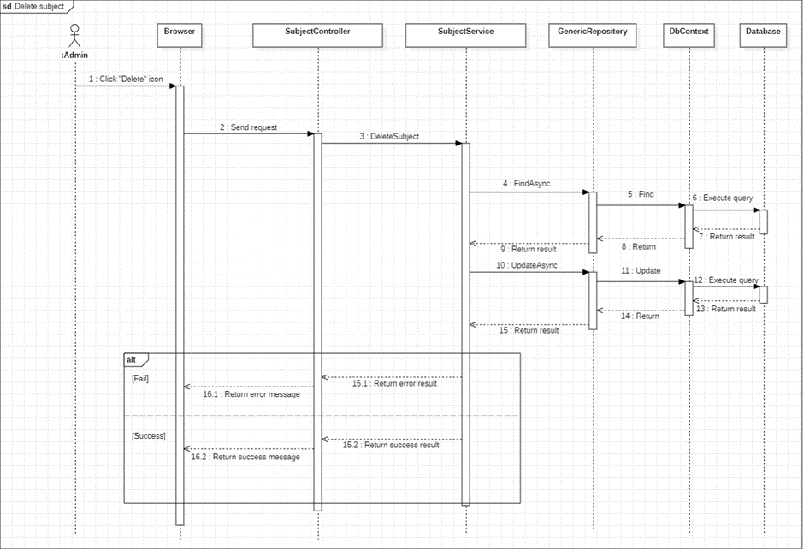

Figure . Sequence Diagram - Admin Delete subject

#### 2.2.23 <Admin> View all subjects

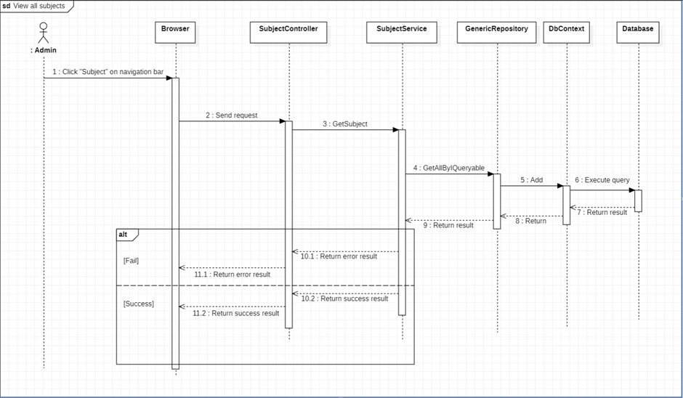

Figure . Sequence Diagram - Admin View all subjects

#### 3.2.24 <Department manager> View all assigned courses in semester

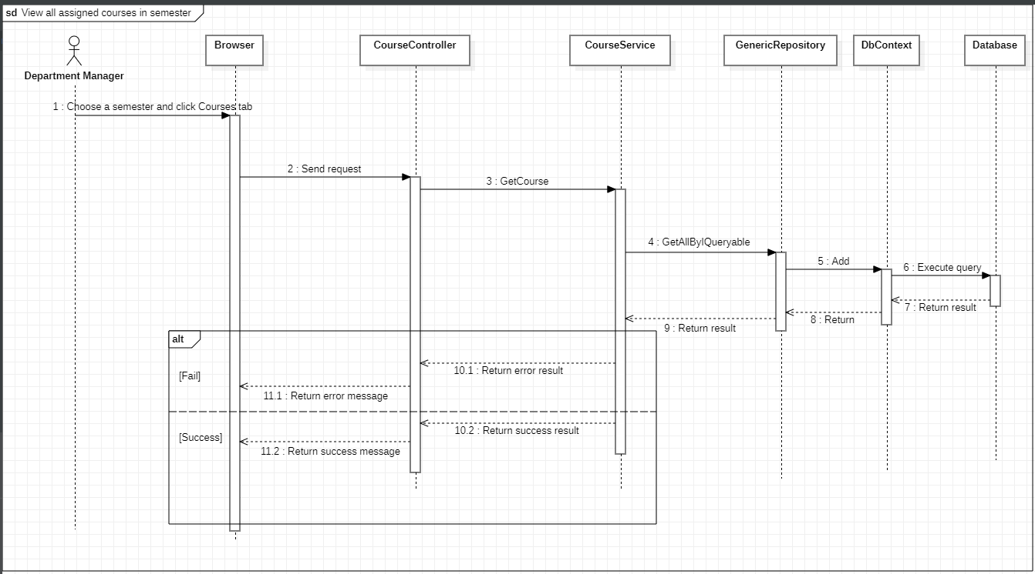

Figure . Sequence Diagram - Admin View all assigned courses in semester

#### 3.2.25 <Department manager> Assign courses for lecturers

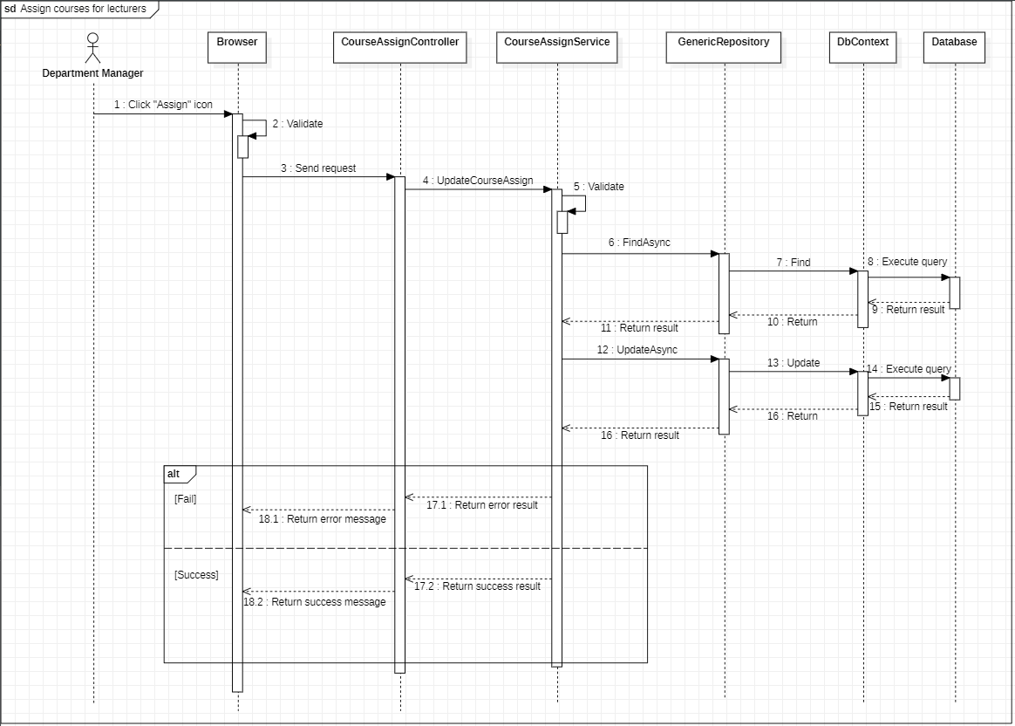

Figure . Sequence Diagram - Admin Assign courses for lecturers

#### 3.2.26 <Department manager> Disable courses assign for lecturer

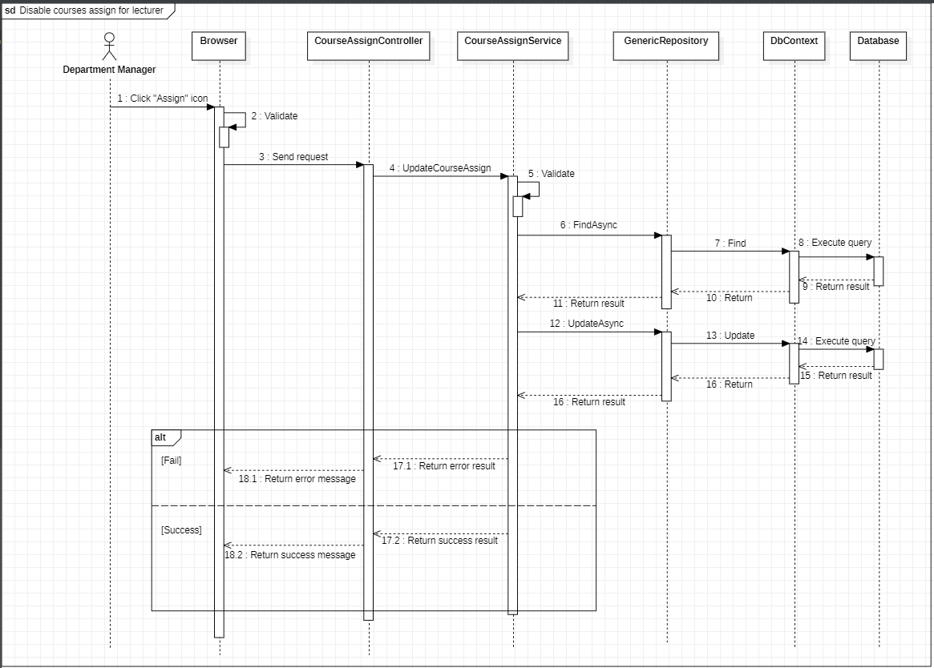

Figure . Sequence Diagram - Department manager Disable courses assign for lecturer

#### 3.2.27 <Department manager> Add priority courses for lecturers

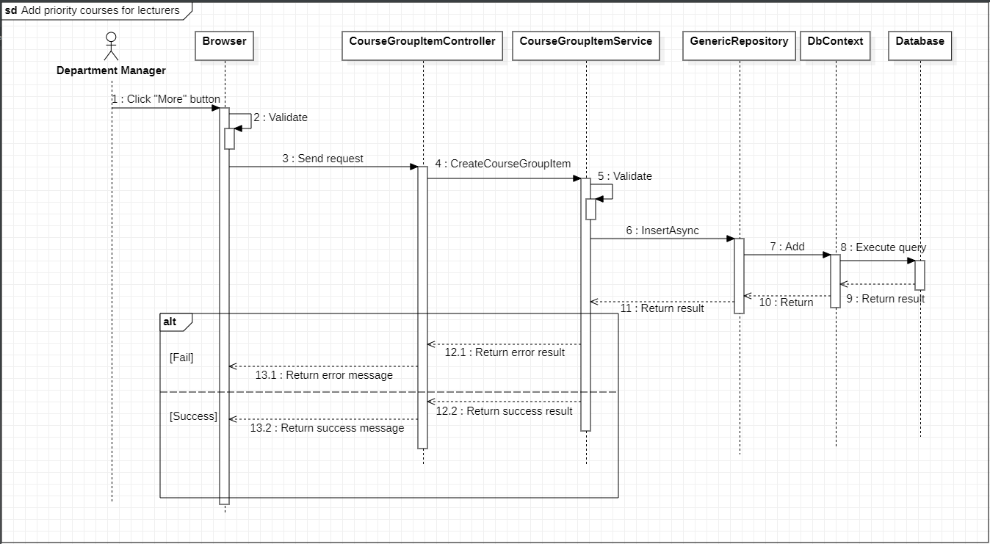

Figure . Sequence Diagram - Department manager Add priority courses for lecturers

#### 3.2.28 <Department manager> Assess subject evaluation points for lecturers with subjects

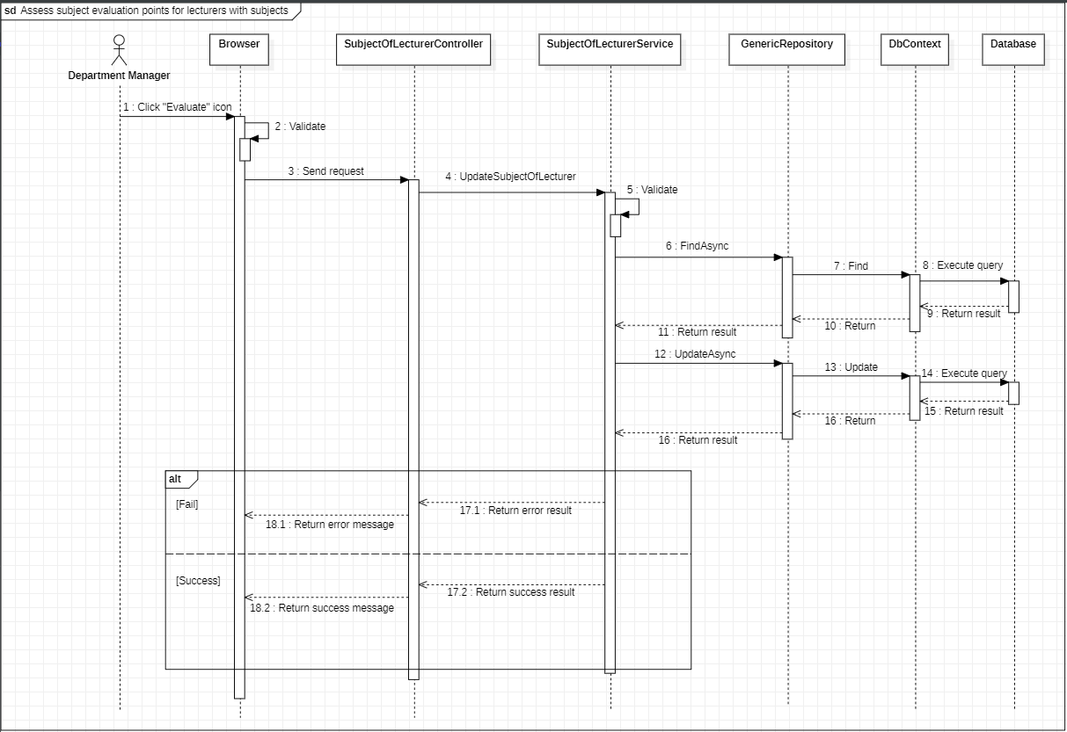

Figure . Sequence Diagram - Department manager Assess subject evaluation points for lecturers with subjects

#### 3.2.29 <Department manager> Disable subjects of lecturer

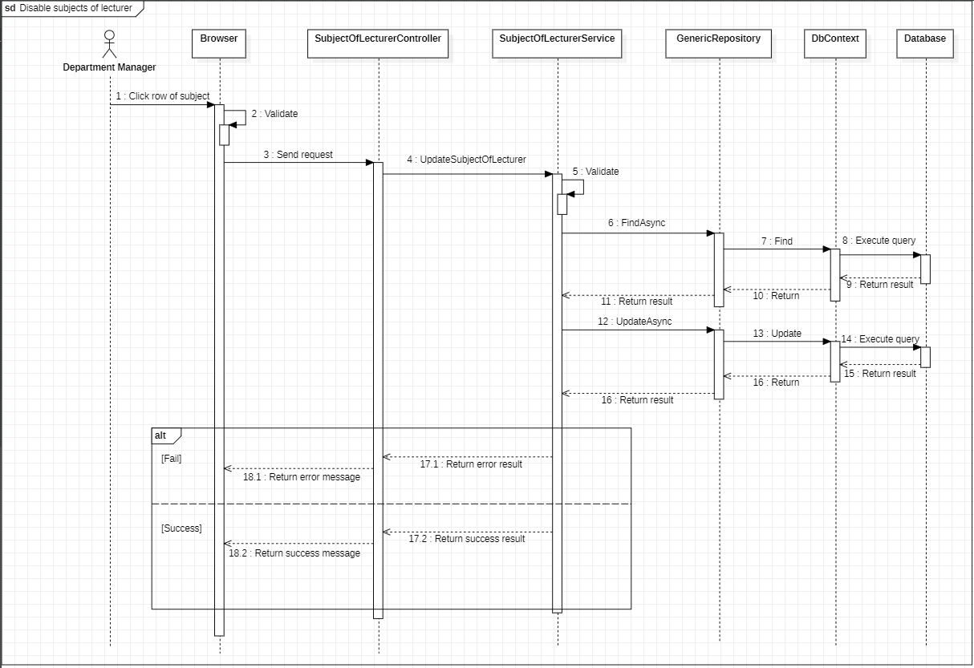

Figure . Sequence Diagram - Department manager Disable subjects of lecturer

#### 3.2.30 <Department manager> Disable slots of lecturer

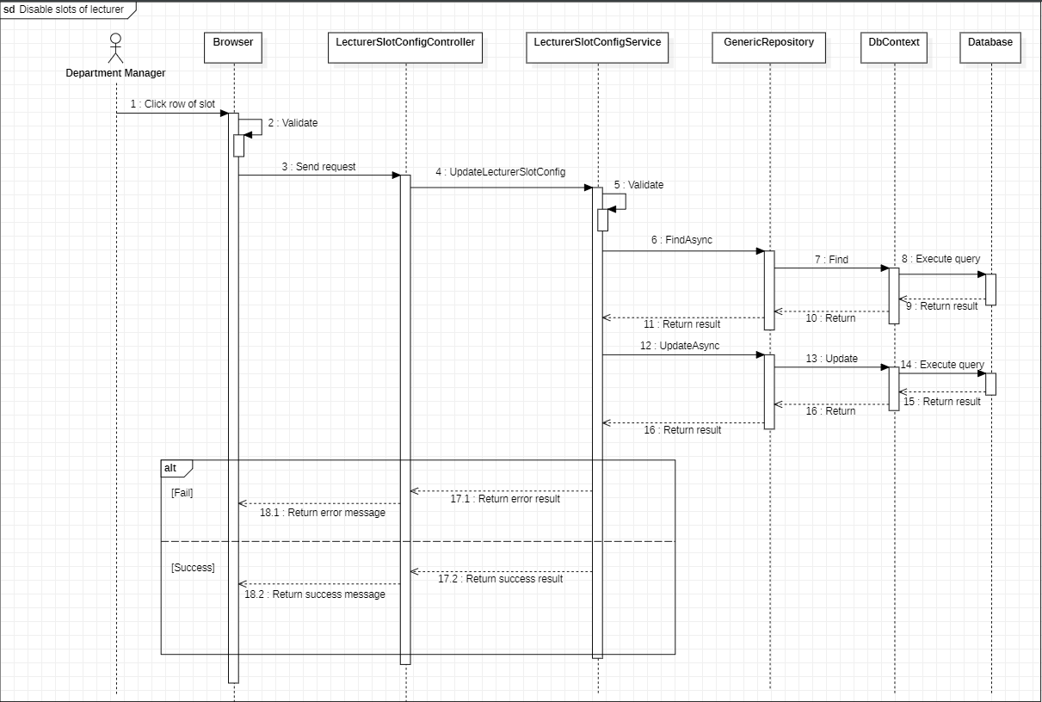

Figure . Sequence Diagram - Department manager Disable slots of lecturer

#### 3.2.31 <Department manager> Update min max courses number in semester of lecturer

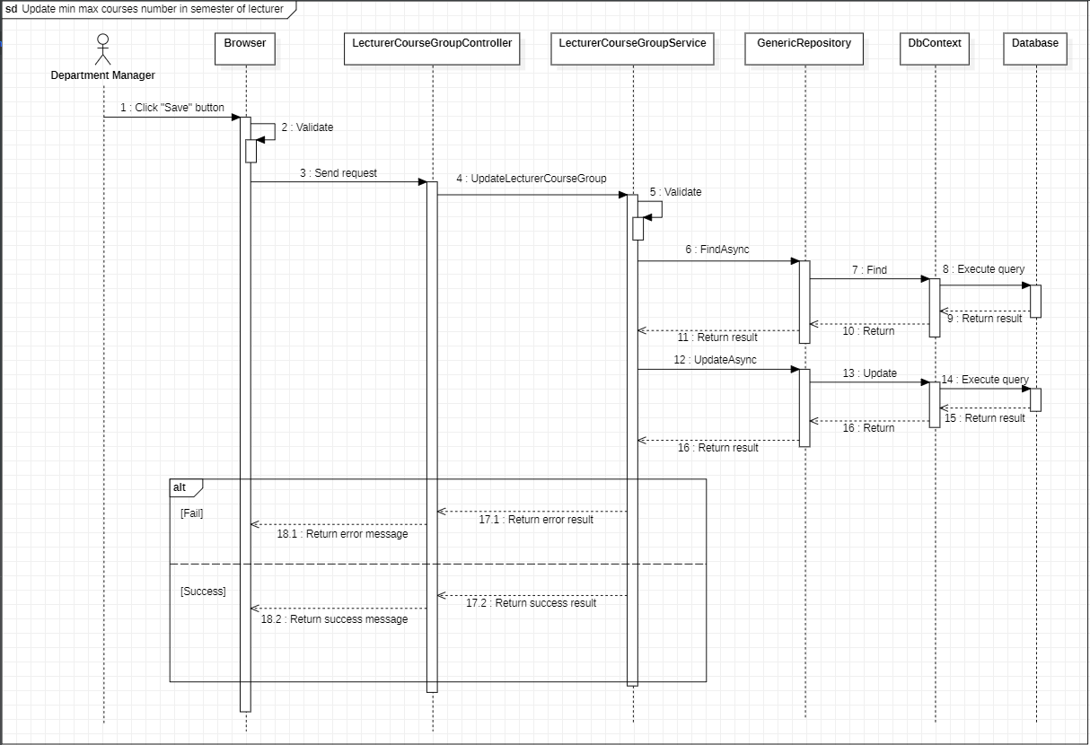

Figure . Sequence Diagram - Department manager Update min max courses number in semester of lecturer

#### 3.2.32 <Department manager> View all request from lecturers in semester

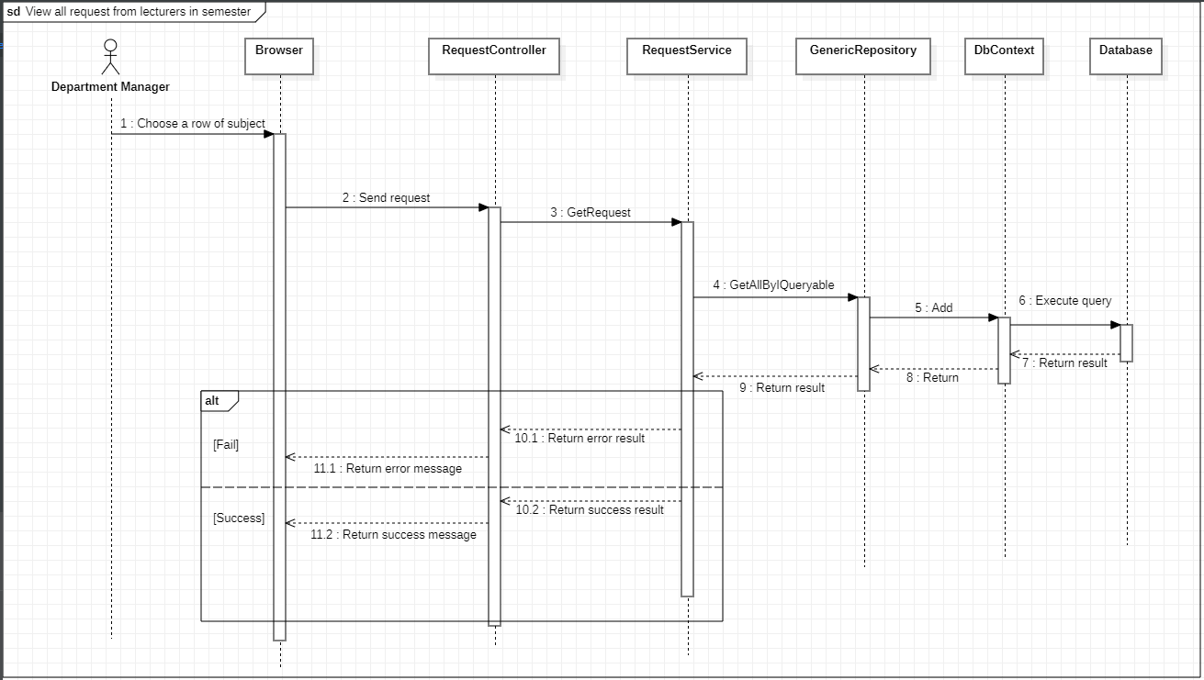

Figure . Sequence Diagram - Department manager View all request from lecturers in semester

#### 3.2.33 <Department manager> Response requests from lecturers

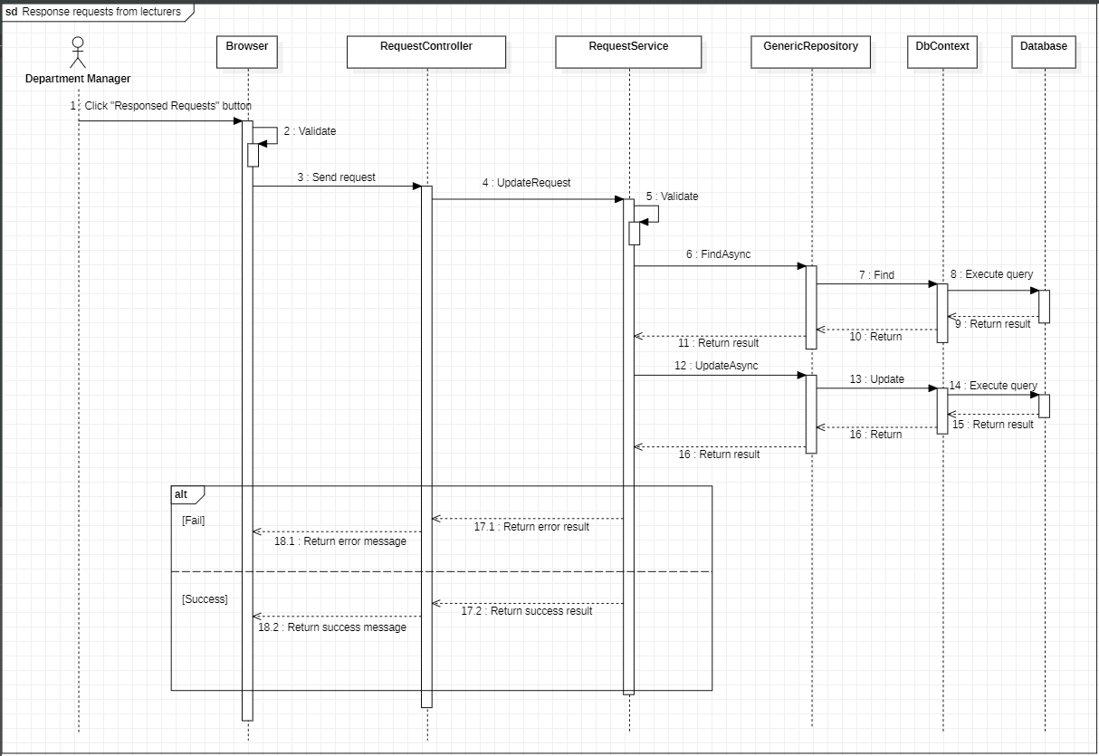

Figure . Sequence Diagram - Department manager Response requests from lecturers

#### 3.2.34 <Department Manager>Swap assigned courses in schedule of a lecturer

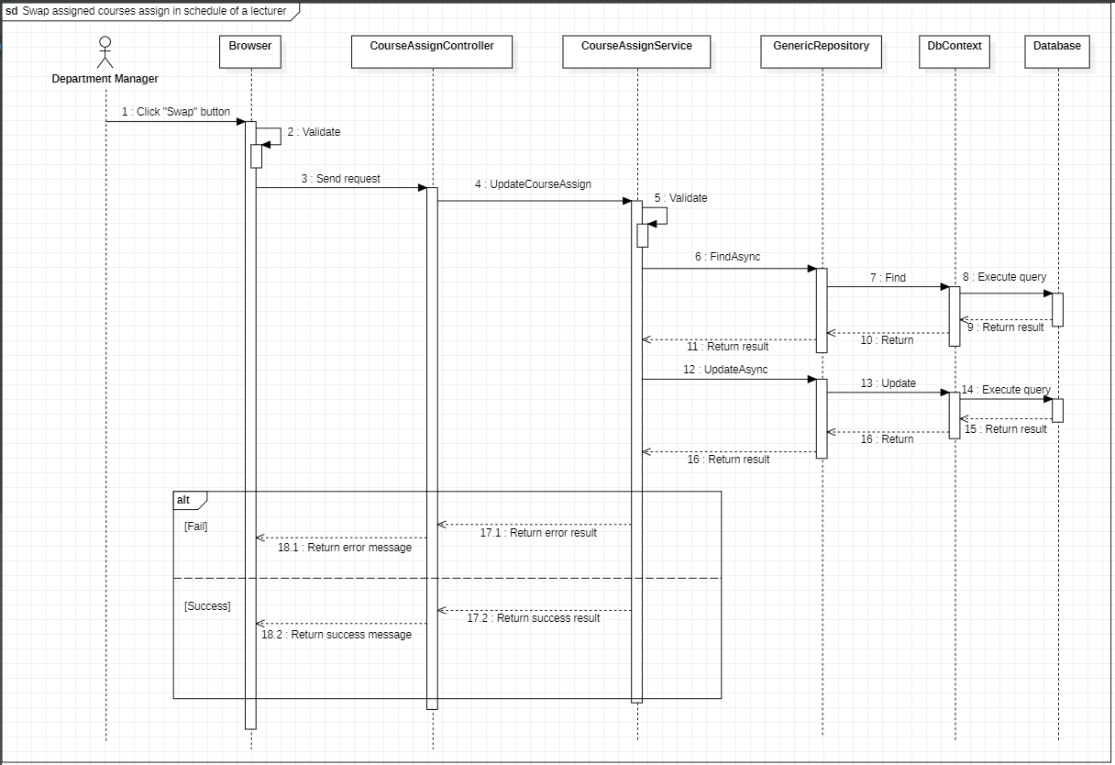

Figure . Sequence Diagram - Department manager Swap assigned courses in schedule of a lecturer

#### 3.2.35 <Department manager> Swap assigned courses in schedule between lecturers

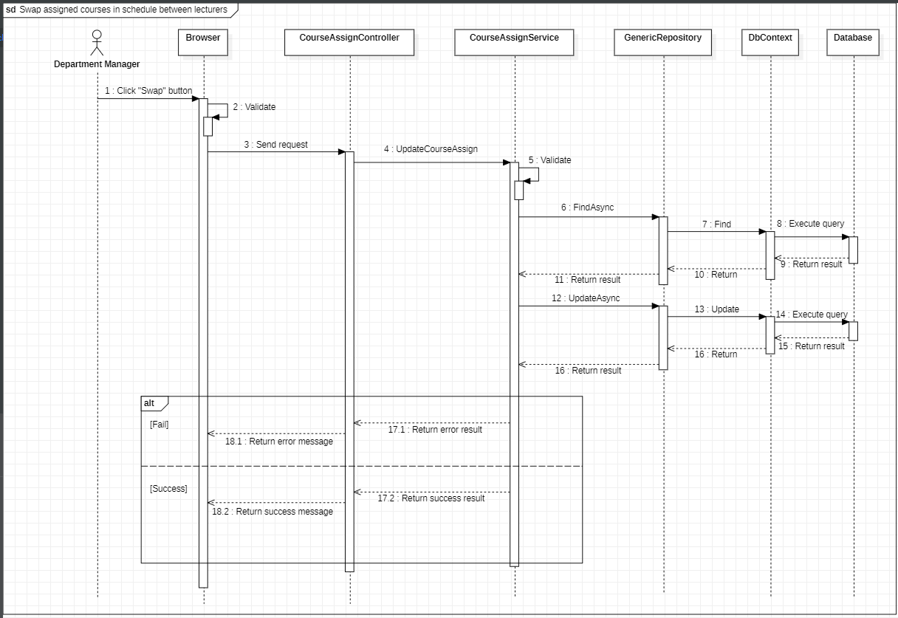

Figure . Sequence Diagram - Department manager Swap assigned courses in schedule between lecturers

#### 3.2.36 <Lecturer> View all semesters

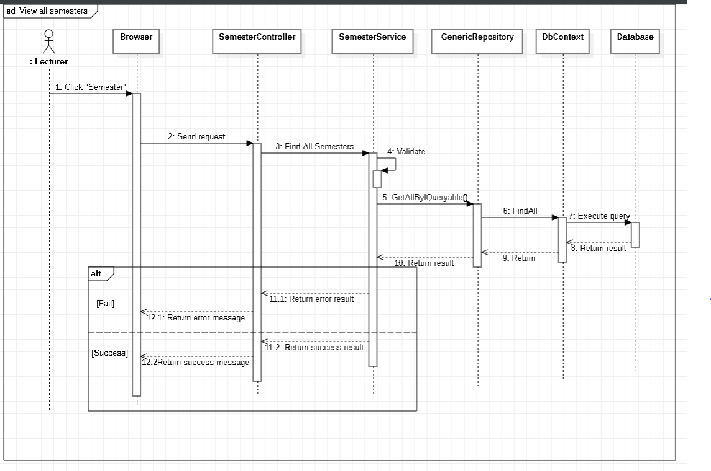

Figure . Sequence Diagram - Lecturer View all semesters

#### 3.2.37 <Lecturer> View schedule in semester

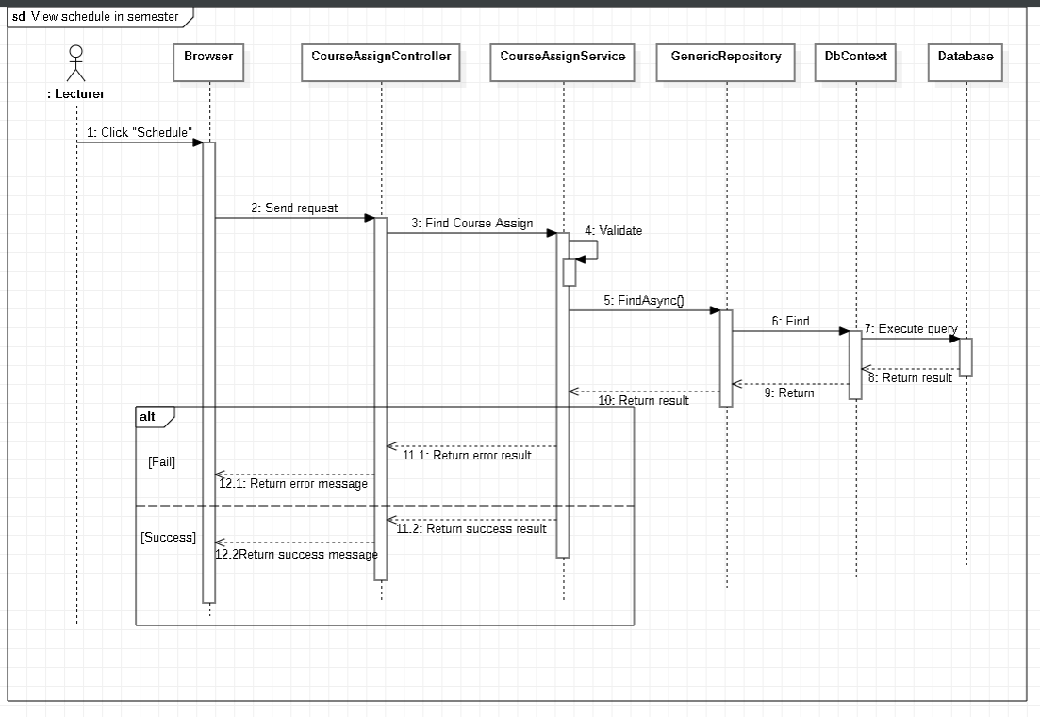

Figure . Sequence Diagram - Lecturer View schedule in semester

#### 3.2.38 <Lecturer> Rate grades for his/her assigned subjects in the department

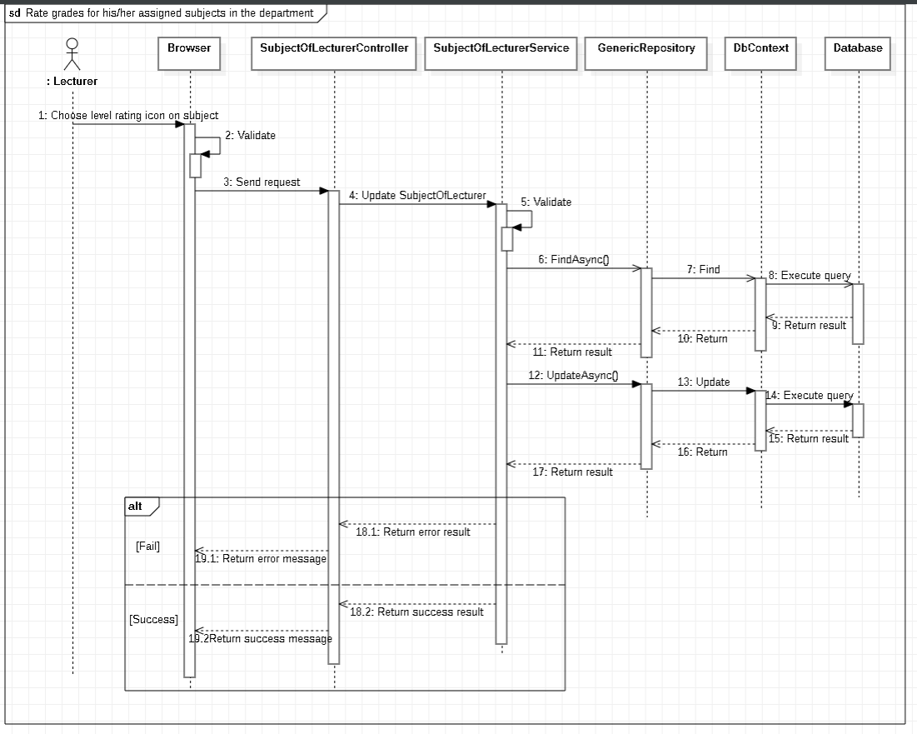

Figure . Sequence Diagram - Lecturer Rate grades for his/her assigned subjects in the department

#### 3.2.39 <Lecturer> Rate favourite slots time

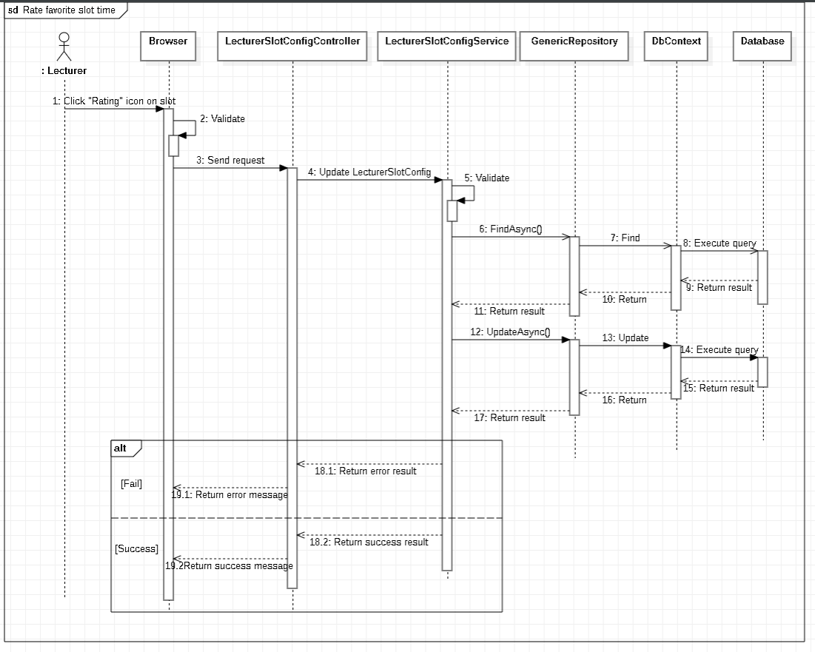

Figure . Sequence Diagram - Lecturer Rate favourite slots time

#### 3.2.40 <Lecturer> Send requests to teach more subjects out the department

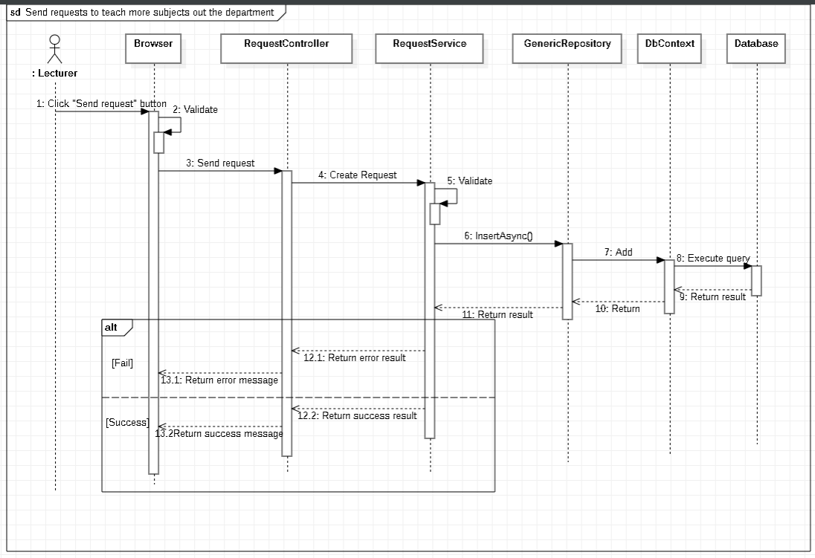

Figure . Sequence Diagrams - Lecturer Send requests to teach more subjects out the department

### 3.3 Activity Diagrams

#### 3.3.1 <Member> Login

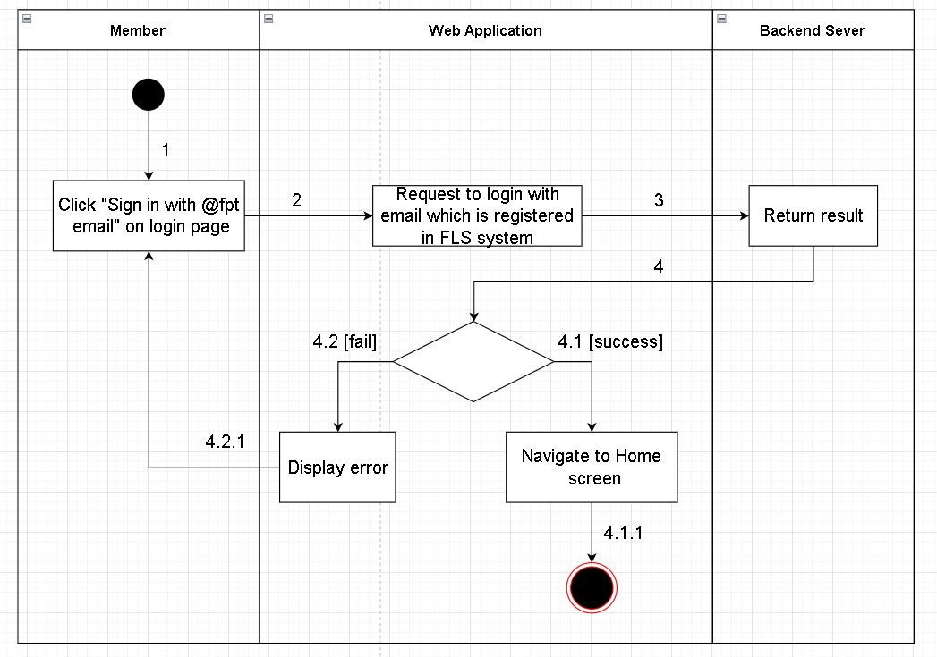

Figure . Activity Diagrams - Member Login

#### 3.3.2 <Member> View profile

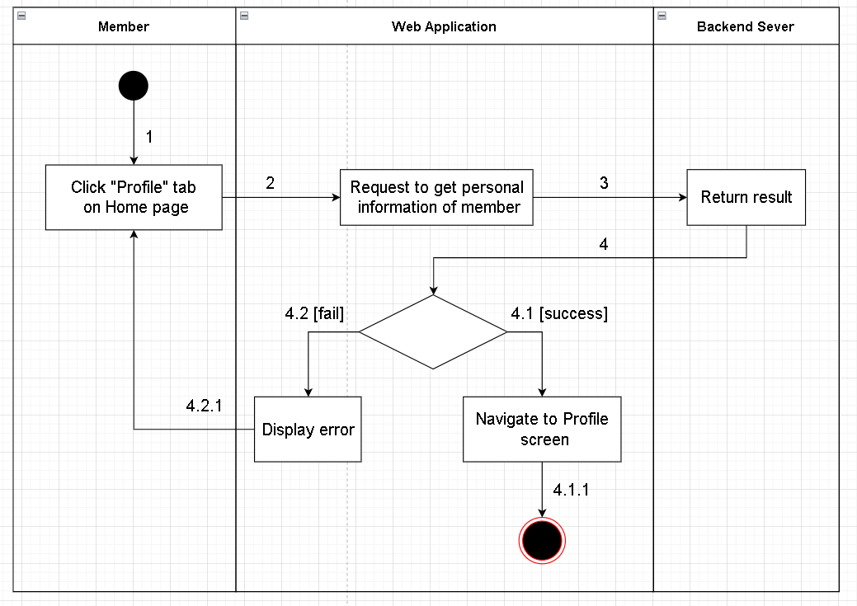

Figure . Activity Diagrams - Member View profile

#### 3.3.3 <Member> Update personal profile

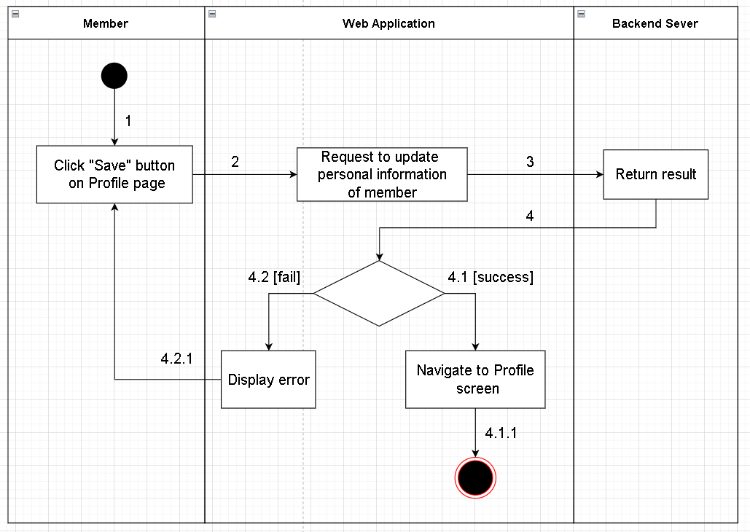

Figure . Activity Diagrams - Member Update personal profile

#### 3.3.4 <Admin> View all list semesters

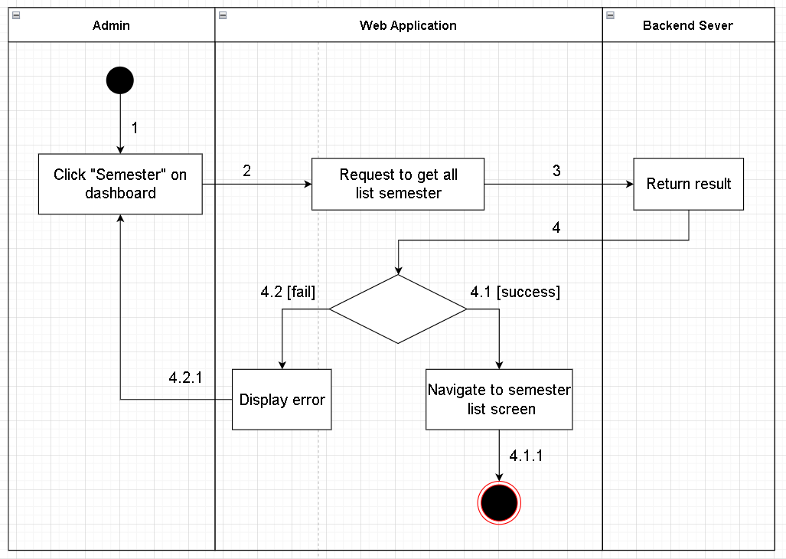

Figure . Activity Diagrams - Admin View all list semesters

#### 3.3.5 <Admin> Create semester

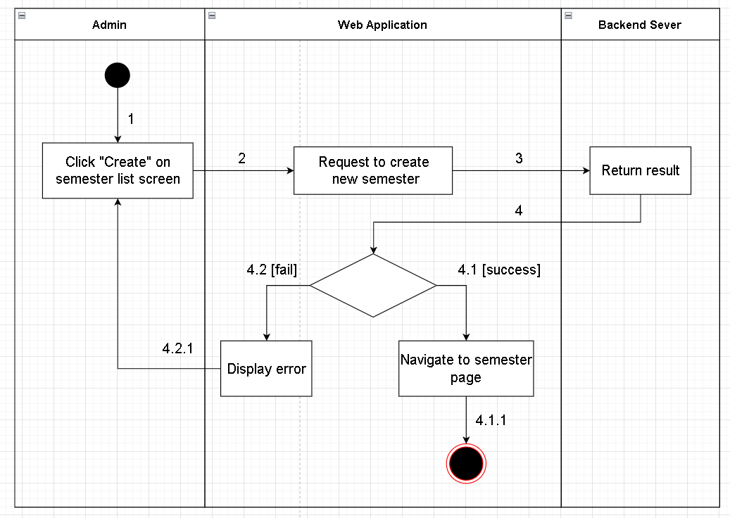

Figure . Activity Diagrams - Admin Create semester

#### 3.3.6 <Admin> Import data courses list

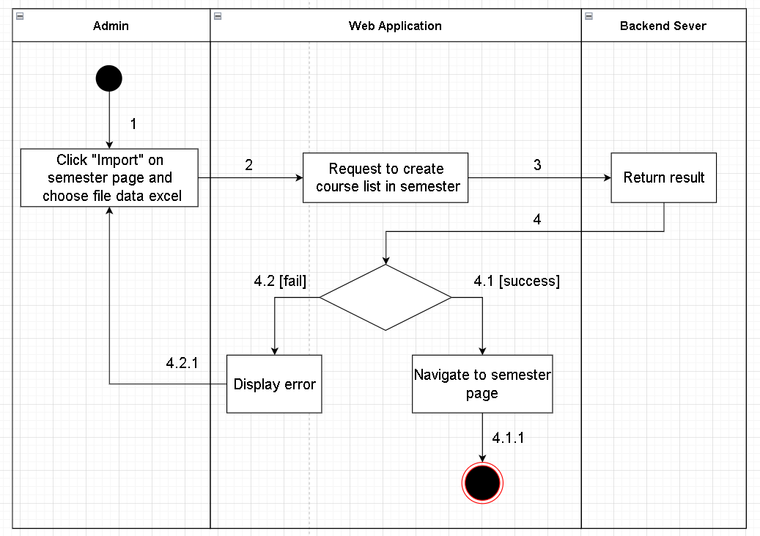

Figure . Activity Diagrams - Admin Import data courses list

#### 3.3.7 <Admin> Update state of semester

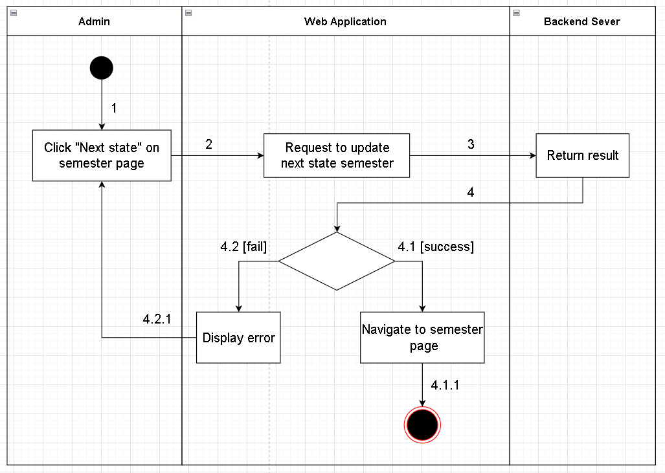

Figure . Activity Diagrams - Admin Update state of semester

#### 3.3.8 <Admin> Delete semester

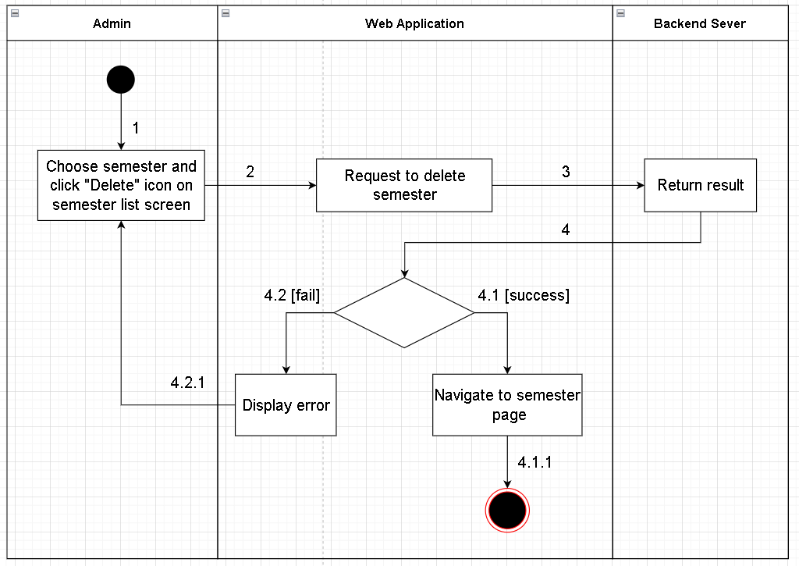

Figure . Activity Diagrams - Admin Delete semester

#### 3.3.9 <Admin> Generate schedule

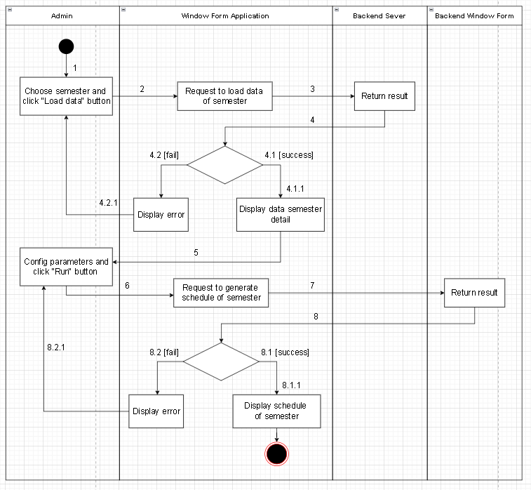

Figure . Activity Diagrams - Admin Generate schedule

#### 3.3.10 <Department manager> Assign courses for lecturers

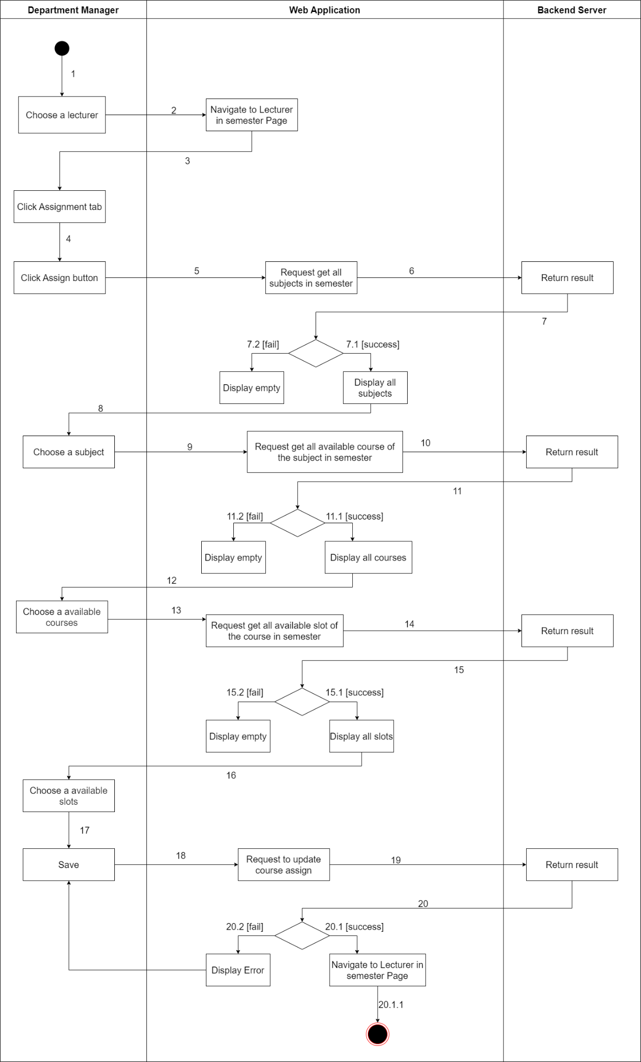

Figure . Activity Diagrams - Department Manager Assign courses for lecturers

#### 3.3.11 <Department manager> Add priority courses for lecturers

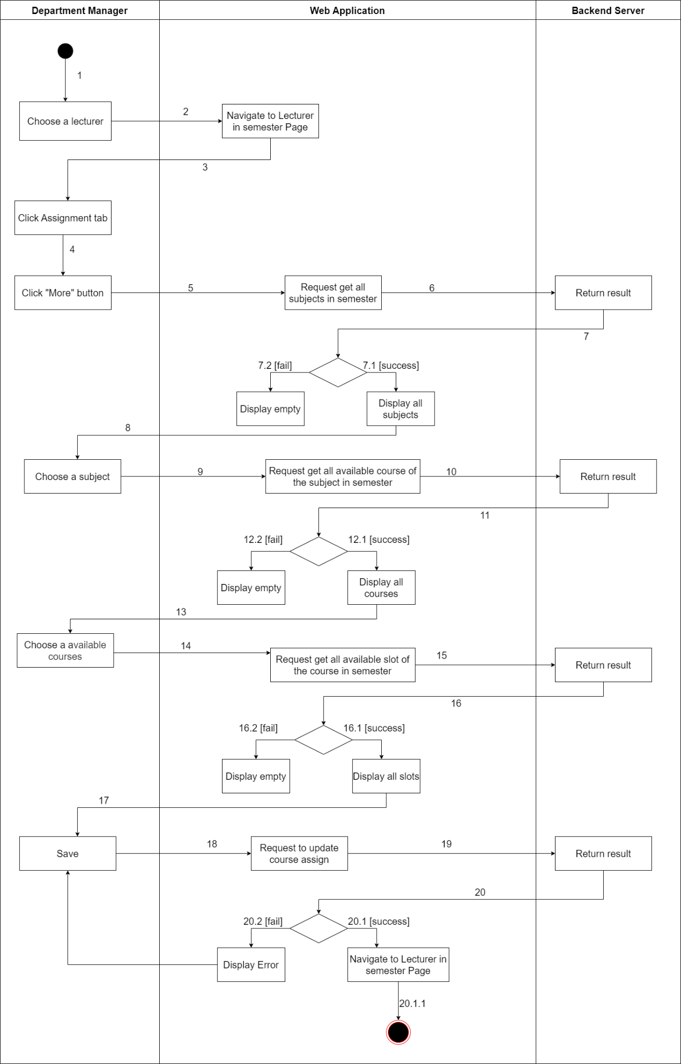

Figure . Activity Diagrams - Department Manager Add priority courses for lecturers

#### 3.3.12 <Department manager> View all request from lecturers in semester

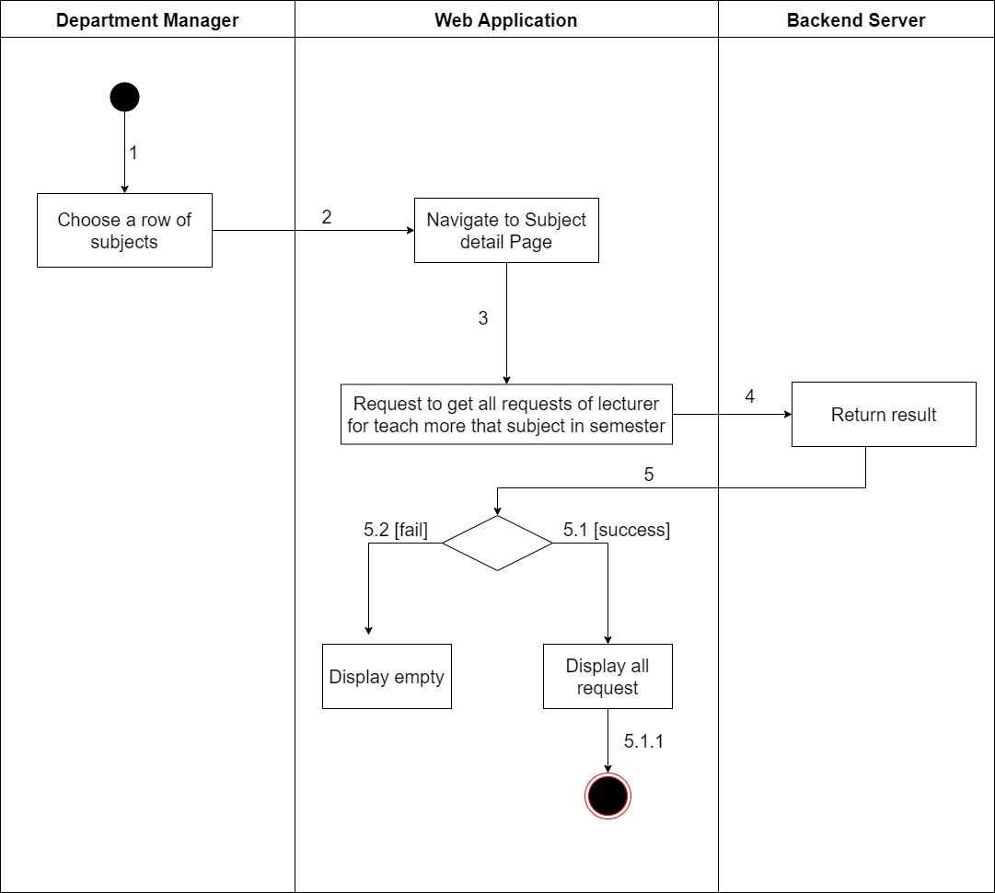

Figure . Activity Diagrams - Department Manager View all request from lecturers in semester

#### 3.3.13 <Department manager>Response requests from lecturers

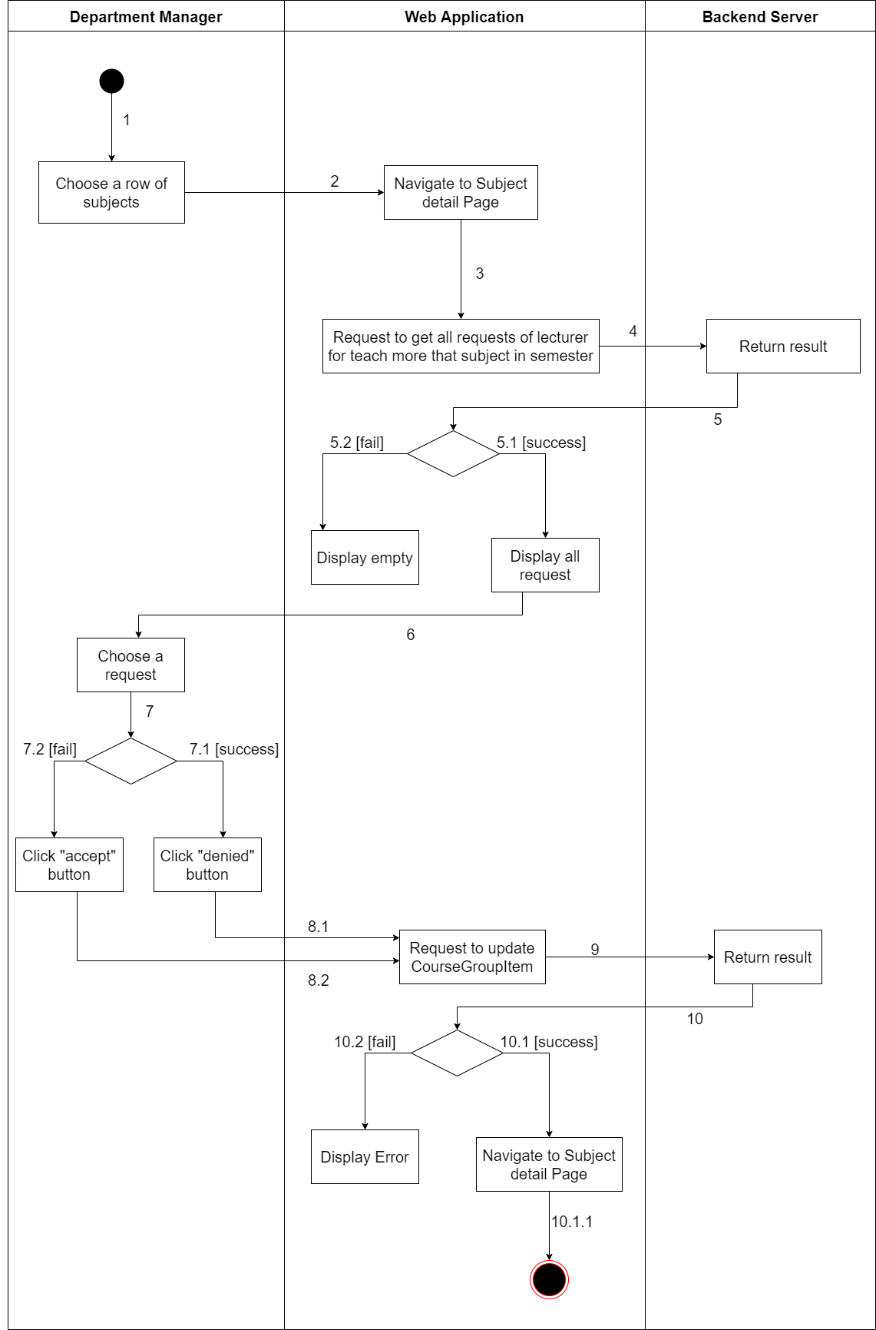

Figure . Activity Diagrams - Department Manager Response requests from lecturers

#### 3.3.14 <Department manager>Swap assigned courses in schedule of a lecturer

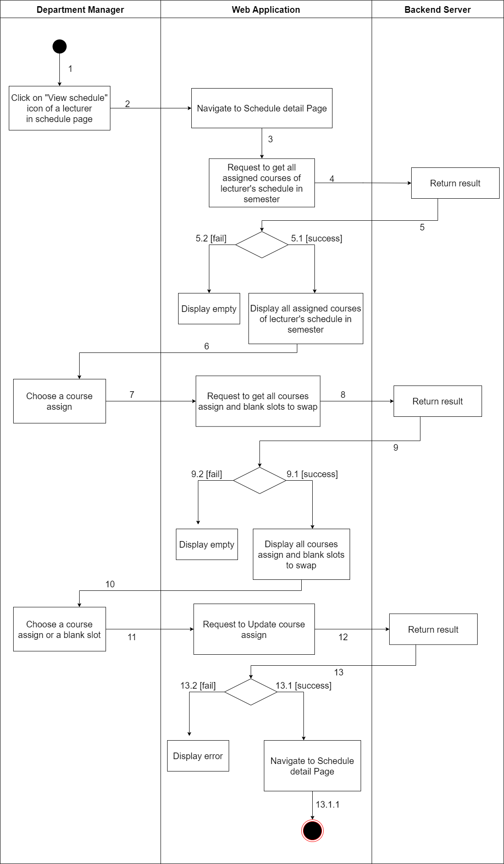

Figure . Activity Diagrams - Department Manager Swap assigned courses in schedule of a lecturer

#### 3.3.15 <Department manager>Swap assigned courses in schedule between lecturers

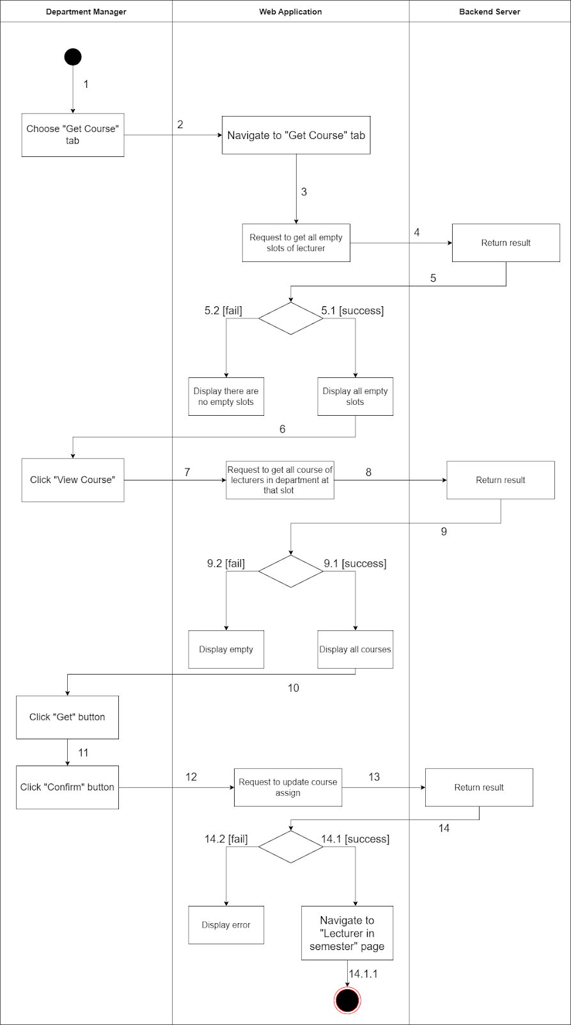

Figure . Activity Diagrams - Department Manager Swap assigned courses in schedule between lecturers

#### 3.3.16 <Lecturer>Send requests to teach more subjects out the department

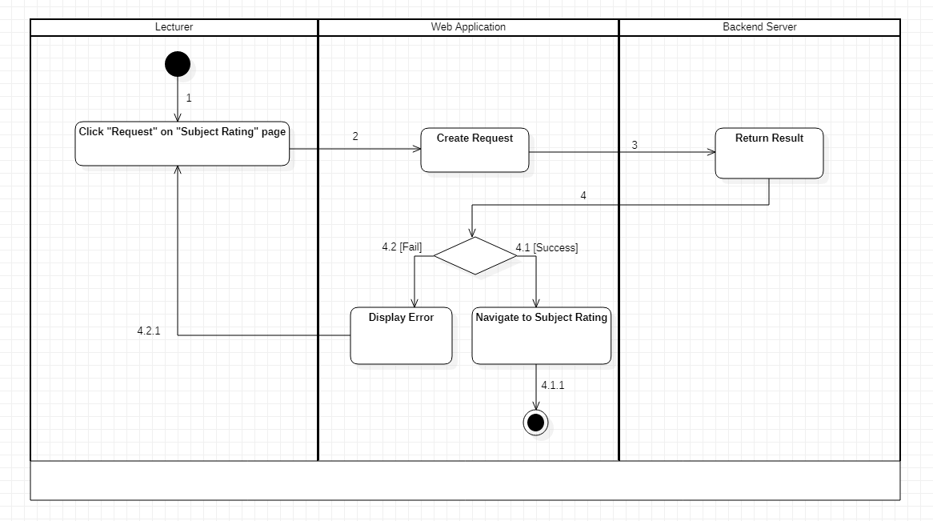

Figure . Activity Diagrams - Lecturer Send requests to teach more subjects out the department

3.3.17 <Lecturer>Rate Reference Slot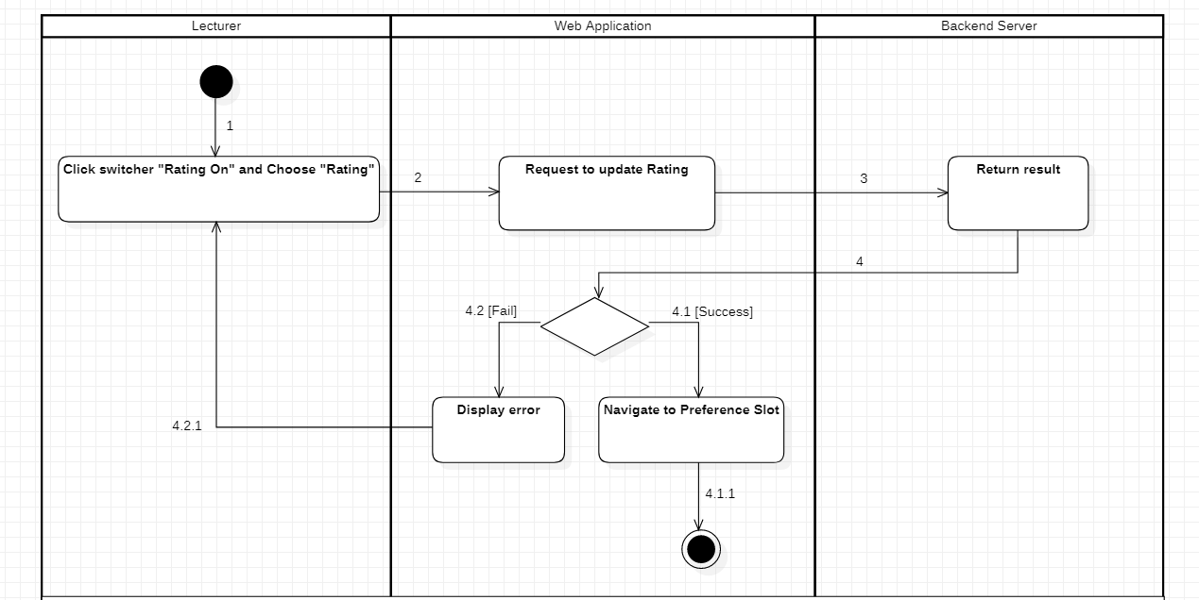

Figure . Activity Diagrams - Lecturer Rate Reference Slot

#### 3.3.18 <Lecturer>Rate grades for his/her subjects in the department

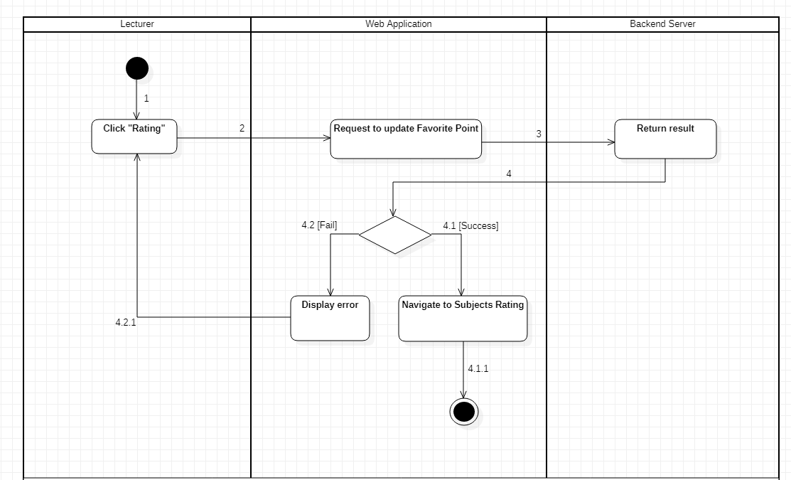

Figure . Activity Diagrams - Lecturer Rate grades for his/her subjects in the department

#### 3.3.19 <Lecturer>View Schedule in semester on Mobile Application

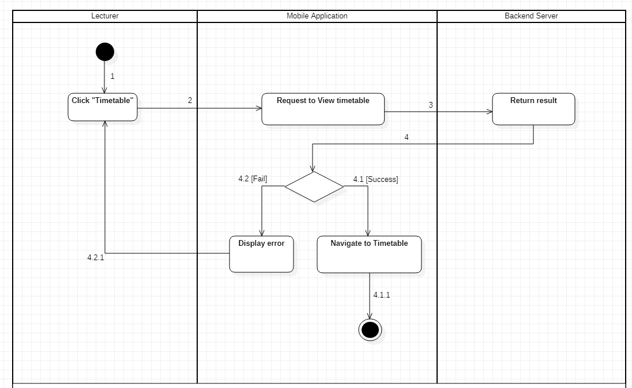

Figure . Activity Diagrams - Lecturer View schedule in semester on Mobile Application

#### 3.3.20 <Lecturer>View all assigned courses in semester

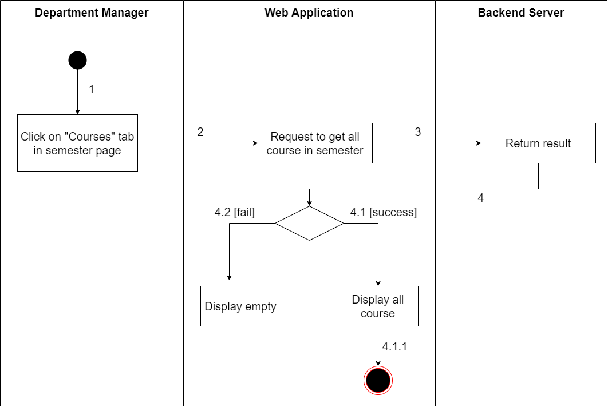

Figure . Activity Diagrams - Lecturer View all assigned courses in semester

### 3.4 State Machine Diagram

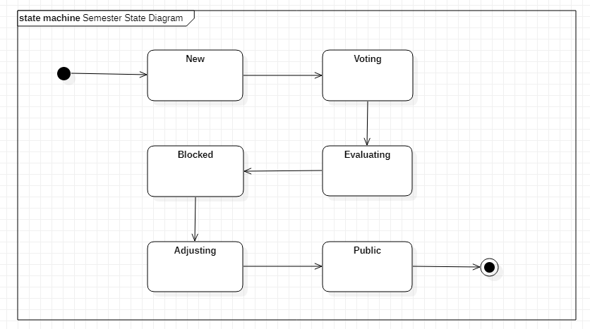

Figure . State Machine Diagram

#### 3.4.1 State Machine Diagram Description:

|  |  |  |
| --- | --- | --- |
| **No** | **State** | **Description** |
| 01 | New | In this state, a semester will be created with adding courses, adding department or import file courses. |
| 02 | Voting | In this state, Lecturer will give favourite subject point (Subject rating) and choose preference slots and request teachable subject to Department Manager. |
| 03 | Evaluating | In this state, Lecturer cannot rate favourite subjects, preference slot and request to Manager, Manager will assign courses, use subject evaluation, preference slots, course number features. |
| 04 | Blocked | In this state, Admin will block semester, all features of Department Manager and Lecturer will be disable. Admin will use WinForms app to generate schedule. |
| 05 | Adjusting | In this state, the Department Manager and Lecturer can see the schedule. With a Lecturer, they can just view the schedule. With the Department Manager, they can swap courses of a Lecturer, fill more courses to Lecturers who have free slots, and fill more courses for Lecturer who do not have enough courses to teach from other Lecturer with min max course rules. |
| 06 | Public | In this state, all schedules will be public. Nothing features can be used in this state. |

Table . State Machine Diagram Description

# V. Software Testing Documentation

## 1. Scope of Testing

### 1.1 Test model

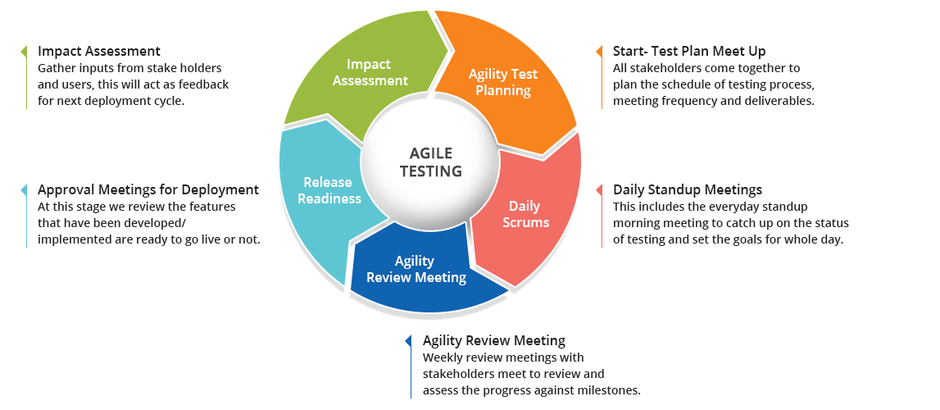

Figure . Agile Testing

* Since the FLS project team uses the Scrum workflow, Agile testing approach is suitable for changing requirements with each cycle being a completely new test phase, allows the testing team to spot bugs easily and prevent the development team to repeat a bug type too many times.
* Additionally, Agile testing is well-suited for small and medium-sized software development projects.

### 1.2 Scope

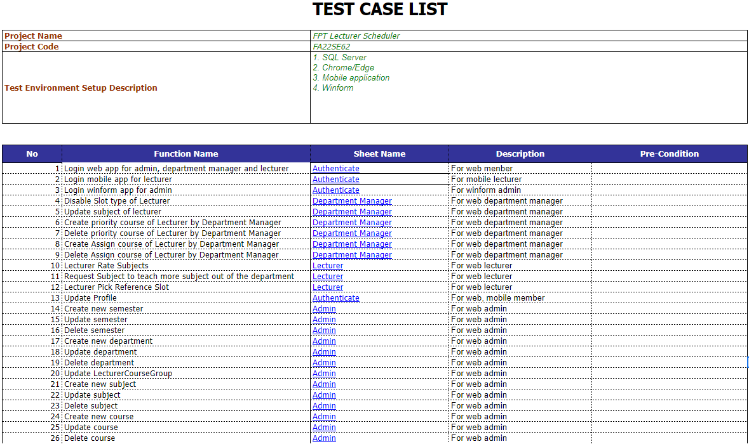

Figure . Test case list

## 2. Test Strategy

### 2.1 Testing Types

**a. Function testing**

Perform individually testing to verify the functionalities of major features under specific conditions.

The detailed descriptions of each test case will be described in Report5_Test Case Document.xlsx

**b. User interface testing**

Perform testing on UI controls to verify if they work properly according to their desired functionalities.

Further descriptions of each test case will be described in Report5_Test Case Document.xlsx

**c. API testing**

Perform testing for RESTful APIs implemented for web application and mobile application.

Perform testing on Postman using HTTP methods: GET, POST, PUT, DELETE to check responses from FLS server.

### 2.2 Test Levels

**a. Unit testing**

This is the smallest testing level of the system or application. This level helps to test each part of the software by separating it. It checks that components are fulfilling functionalities or not. At this level, the developer tests manually to ensure that the code meets the requirements.

**b. Integration testing**

This checks the data flow from one module to other modules. This kind of testing is performed by the developer and tester.

**c. System testing**

System testing tests the FLS system as a whole and validates the functionalities and verifies if the system meets the end–to–end specifications and requirements.

**d. Acceptance testing**

The final testing stage before the system is ready for delivery. Acceptance testing is performed by user or customer.

## 3. Test Plan

### 3.1 Human Resources

|  |  |  |
| --- | --- | --- |
| **Worker/Doer** | **Role** | **Specific Responsibilities/Comments** |
| Vũ Minh Đăng | Leader | Unit Test, System Test |
| Hồng Đại Dương | Member | Unit Test, Integration Test, System Test |
| Trần Tuấn Minh | Member | Unit Test, Integration Test, System Test |
| Đỗ Thế Dương | Member | Unit Test, Integration Test, System Test |
| Nguyễn Quốc Bảo | Member | Unit Test, System Test |

Table . Human Resources

### 3.2 Test Environment

|  |  |  |
| --- | --- | --- |
| **Purpose** | **Tool** | **Provider** |
| View logs of web application | Chrome DevTools | Chrome |
| Test case management | Microsoft Excel | Microsoft |
| UI for Unit test and Integration test | Postman | Postman |
| Backend IDE | Visual studio | Microsoft |
| Web application IDE | Visual Studio Code | Microsoft |
| WinForms application IDE | Visual Studio Code | Microsoft |
| Mobile application IDE | Visual Studio Code | Microsoft |
| Execution hardware | Testing is implemented on computers with the following specifications:  · CPU: Intel i5  · RAM: ≥ 4GB  · Storage device: HDD or SSD | Any providers |
| Communication | Online meeting,  Messenger | Google Meet,  Facebook |

Table . Test Environment

### 3.3 Test Milestones

|  |  |  |
| --- | --- | --- |
| **Milestone Task** | **Start Date** | **End Date** |
| Create Test Plan | 02/11/2022 | 02/11/2022 |
| Create test case list | 03/11/2022 | 05/11/2022 |
| Write unit test case list | 06/11/2022 | 07/11/2022 |
| Create unit tests | 08/11/2022 | 10/11/2022 |
| Create integration test | 11/11/2022 | 12/11/2022 |
| Create system test cases | 19/11/2022 | 20/11/2022 |
| Doing test | 21/11/2022 | 29/11/2022 |
| Reports for testing | 30/11/2022 | 30/11/2022 |

Table . Test Milestones

## 4. Test Cases

The detailed test case document will be described at this link: [Report5_Test Case Document](https://docs.google.com/spreadsheets/d/1rZiGCsWeYYfDsm2AHSVwzIeb4abFyn9J/edit?usp=sharing&ouid=114242891490030950955&rtpof=true&sd=true)

## 5. Test Reports

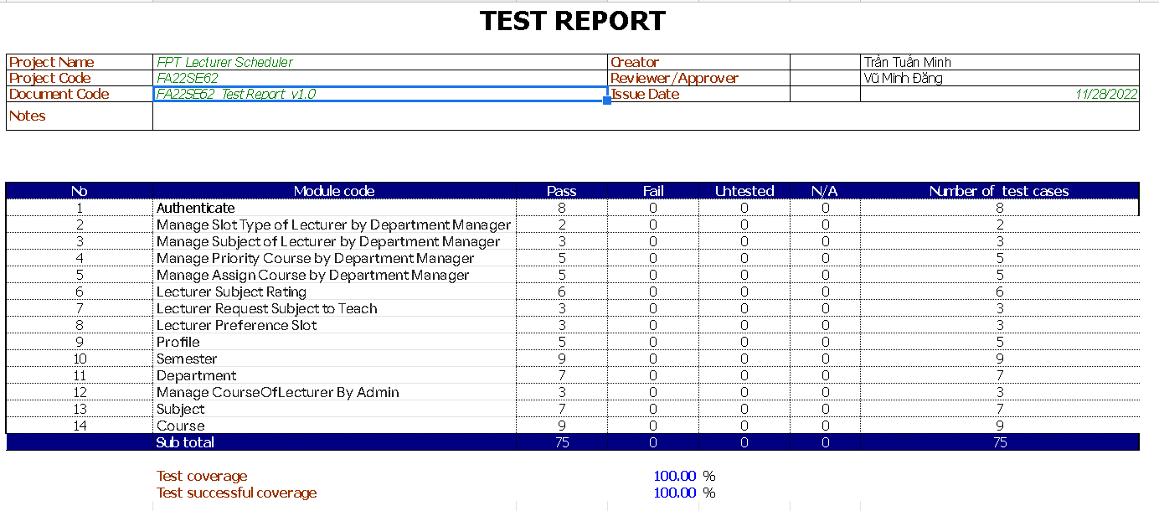

Figure . Test Reports

# VI. Release Package & User Guides

## 1. Deliverable Package

### 1.1 Source codes & documents

|  |  |  |
| --- | --- | --- |
| **No** | **Items** | **Sub-Items** |
| **Code packages** | | |
| 1 | FLS_BE_API.rar |  |
| 2 | FLS_BE_WinForm.rar |  |
| 3 | FLS_FE_Web.rar |  |
| 4 | FLS_FE_Mobile.apk |  |
| **Databases** | | |
| 1 | Script | FLSCapstoneProjectDB.sql |
| **Document** | | |
| 1 | Final Project Report | Report7_Final Project Report.docx |

Table . Source code & documents

### 1.2 Known Issues, Limitations & Restrictions

The language is only English. Not support Vietnamese

The mobile application only supports Android OS.

Manual SDKs and runtimes installation.

## 2. Installation Guides

### 2.1 System Requirements

#### 2.1.1 Module mobile system requirements:

* OS: Android 7.0 or higher.
* Network: Internet access capability.
* Hardware configurations:

|  |  |  |  |
| --- | --- | --- | --- |
| **Type** | **Component** | **Minimum** | **Recommend** |
| Mobile Phone | OS | Android 7 | Android 12 |
| Mobile Phone | Network | Wi-Fi, 3G and 4G | Wi-Fi, 4G and 5G |
| Mobile Phone | RAM | 2GB | >= 4GB |

Table . System Requirements- Hardware Requirements for Mobile

#### 2.1.2 Module computer API and Web application system requirements:

* OS: Windows 10 and SQL Server 2014 or above.
* Network: LAN, Internet access capability.
* Hardware configuration:

|  |  |  |  |
| --- | --- | --- | --- |
| **Type** | **Component** | **Minimum** | **Recommend** |
| Computer | OS | Windows 10 64 bit | Windows 10, 11 64 bit |
| Computer | Network | Wi-Fi, LAN | Wi-Fi, LAN |
| Computer | RAM | 4GB | >= 8GB |

Table . System Requirements- Hardware Requirements For PC

### 2.2 Setup file

* FLS_FE_Web.rar: FLSweb application for admin, lecturer, department manager.
* FLS_BE_API.rar: FLS API back-end setup.
* FLS_BE_WinForm.rar: FLS WinForms application for admin.
* FLS_FE_Mobile.apk: FLS mobile setup. FLS mobile application for lecturer.
* FLSCapstoneProjectDB.sql: Database for FLS system.

### 2.3 Installation Instruction

* Setup Database:
* Download and install SQL Server 2014
* Run SQL Server:
* Open FLSCapstoneProjectDB.sql and execute the script.
* Setup local backend API
* Download and install Visual Studio 2019
* Extract file FLS_BE_API.rar and open with Visual Studio
* Open file appsettings.json and edit ConnectionStrings



Figure . Set up local backend API

* Run project FLS Schedule with Visual Studio

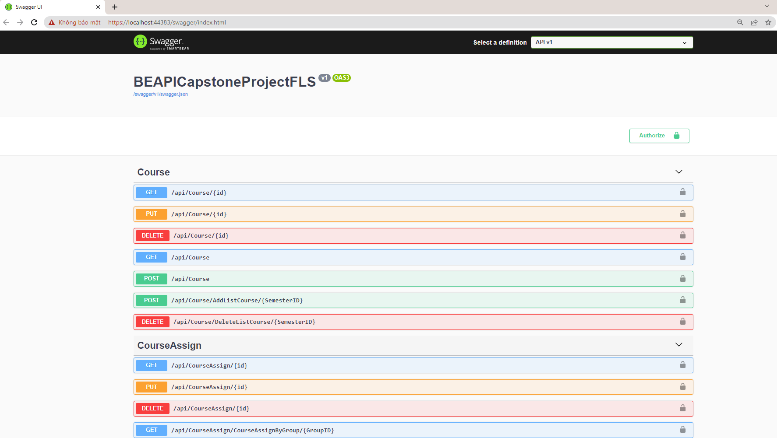

Figure . Swagger API

* Setup Web:
* User open the browser
* User paste this link to URL:[**https://flscapstone.netlify.app/**](https://flscapstone.netlify.app/)
* Setup WinForms:
* Extract file FLS_BE_WinForm.rar and run file FLS_BE_WinForm.exe
* Go to FLSCapstone-Scheduler\WindowsFormsApp\WindowsFormsApp\bin\Debug
* Run file WindowsFormsApp.exe

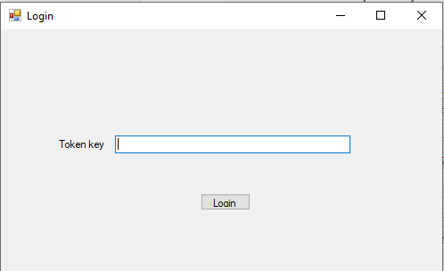

Figure . Login WinForms Application

* **Setup mobile:**
* Download file FLS_FE_Mobile.apk
* Open file FLS_FE_Mobile.apk
* Press “Install” to install the mobile application to the mobile device.

## 3. User Manual

### 3.1 Terms and definitions

* Mobile device: Android mobile device.
* Mobile app: the app for lecturers to use to view schedules.
* Web app: the app for administrators to manage systems, app for department managers to manage departments.

### 3.2 System Requirements

#### 3.2.1 Hardware Requirements

* **For PC:**

|  |  |  |
| --- | --- | --- |
| **PC** | **Minimum Requirements** | **Recommended** |
| Internet Connection | Cable, Wi-Fi (4 Mbps) | Cable, Wi-Fi (8 Mbps) |
| Operating System | Windows 7 | Windows 10 |
| Computer Processor | Intel® Core i3 1.4GHz | Intel® Core i5 2.50GHz |
| Computer Memory | 1GB RAM | 2GB RAM or more |
| Web Browser | Chromes (v69 or higher) | Chrome latest stable version |

Table . User Manual - Hardware Requirements For PC

* **For Android Devices:**

|  |  |
| --- | --- |
| **Operating system** | Android 6.0 or higher |
| **Processor** | Intel Atom® Processor Z2520 1.2 GHz, or faster processor |
| **Storage** | Between 850 MB and 1.2 GB, depending on the language version |
| **RAM** | Minimum of 1 GB, 2 GB is recommended |
| **Hard Disk** | 2 GB of available hard-disk space for installation |

Table . User Manual- Hardware Requirements for Android Devices

#### 3.2.2 Software Requirements

|  |  |  |
| --- | --- | --- |
| **Software** | **Name / Version** | **Description** |
| Operation System | Windows 7, Windows 10 | Operating system and platform for development |
| Web browser | Chrome 69 or above | For web app |
| Android System | Android 6.0 or higher | For mobile app |

Table . User Manual - Software Requirements For PC

### 3.3 Application Usage

#### 3.3.1 Web Application

##### a. <Member> Login

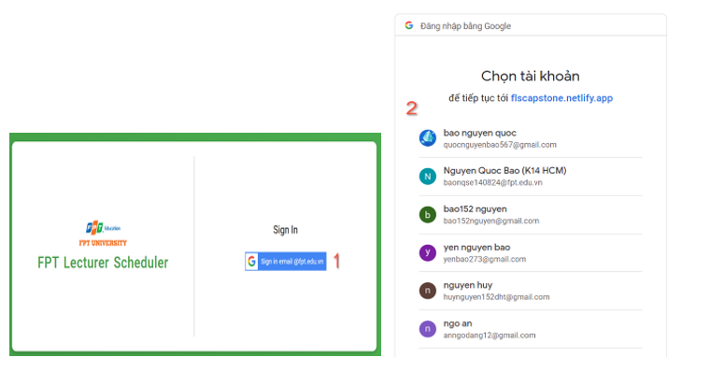

Figure . Login

|  |  |
| --- | --- |
| No. | Description |
| 1 | Click on the “Sign in email @fpt.vn” button to login the system. |
| 2 | Choose the google account that the lecturer is provided to login the system |

Table . Brief Description - Login

##### b. <Member> Profile

***b1. <Member> View Profile***

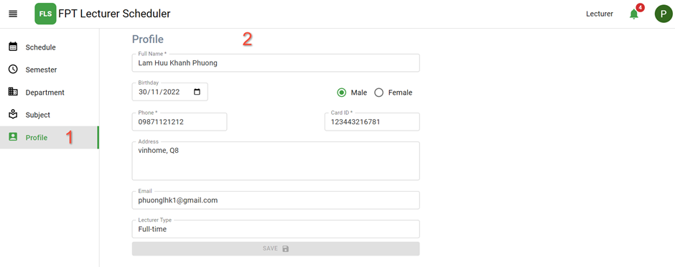

Figure . View Profile

|  |  |
| --- | --- |
| No. | Description |
| 1 | Click on the “Profile” on the navigation bar to view the profile. |
| 2 | Form shows the information of the lecturer. |

Table . Brief Description- View Profile

***b2. <Member> Update Profile***

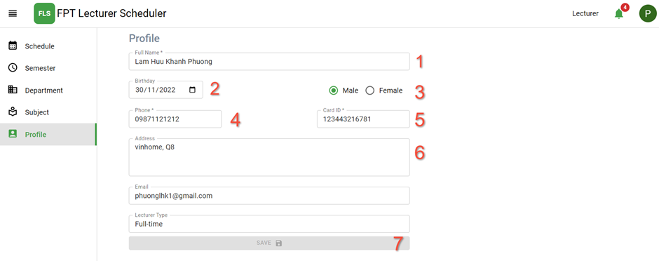

Figure . Update Profile

|  |  |
| --- | --- |
| No. | Description |
| 1 | Input in the field: “Full Name” to update full name. |
| 2 | Choose in the date picker: “Birthday” to update birthday. |
| 3 | Choose radio buttons to update gender |
| 4 | Input in the field: “Phone” to update phone number. |
| 5 | Input in the field: “Card ID” to update card id. |
| 6 | Input in the field: “Address” to update address. |
| 7 | Click on the “Save” button to update your profile. |

Table . Brief Description- Update Profile

##### c. <Admin> View Home

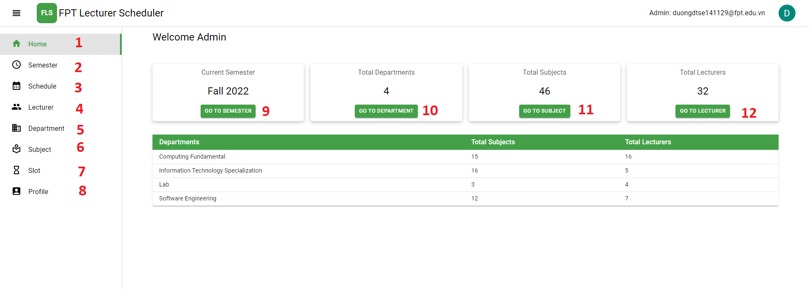

Figure . View Home

|  |  |
| --- | --- |
| No. | Description |
| 1 | Click on the “Home” tab to navigate to the Home page. |
| 2 | Click on the “Semester” tab to navigate to the Semester page. |
| 3 | Click on the “Schedule” tab to navigate to the Home page. |
| 4 | Click on the “Lecturer” tab to navigate to the Home page. |
| 5 | Click on the “Department” tab to navigate to the Home page. |
| 6 | Click on the “Subject” tab to navigate to the Home page. |
| 7 | Click on the “Slot” tab to navigate to the Home page. |
| 8 | Click on the “Profile” tab to navigate to the Home page. |
| 9 | Click on the “Go to semester” button to navigate to the Home page. |
| 10 | Click on the “Go to department” button to navigate to the Department page. |
| 11 | Click on the “Go to subject” button to navigate to the Subject page. |
| 12 | Click on the “Go to lecturer” button to navigate to the Lecturer page. |

Table . Brief Description- Admin Function

##### d. <Admin> Manage semester

***d1. <Admin> Create Semester***

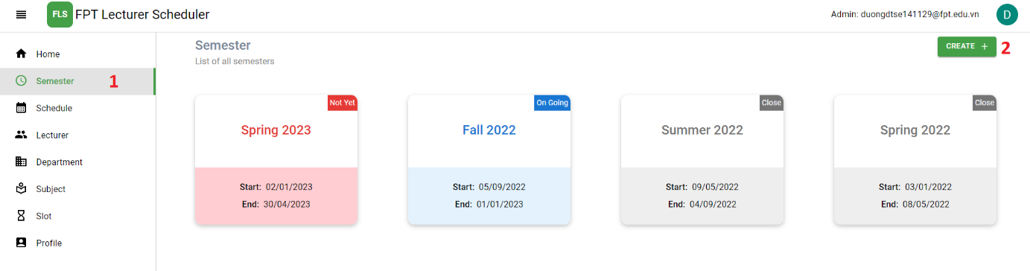

Figure . View semester

|  |  |
| --- | --- |
| No. | Description |
| 1 | Click on the “Semester” tab to navigate to the Semester page. |
| 2 | Click on the “Create” button to navigate to create a new semester. |

Table . Brief Description- View Semester

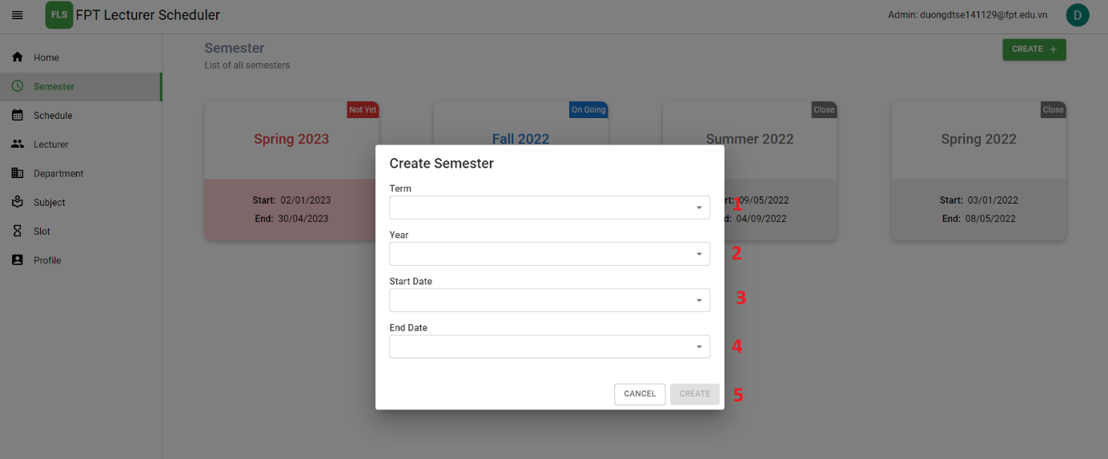

Figure . Create semester

| No. | Description |
| --- | --- |
| 1 | Input in the field: “Term” for the name of the semester. |
| 2 | Input in the field: “Year” for the year of the semester. |
| 3 | Choose start date for the start date of the semester. |
| 4 | Choose end date for the end date of the semester. |
| 5 | Click on the “Create” button to create new semester and navigate semester page. |

Table . Brief Description- Create Semester

***d2. <Admin> Delete semester***

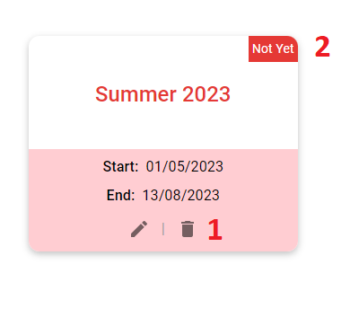

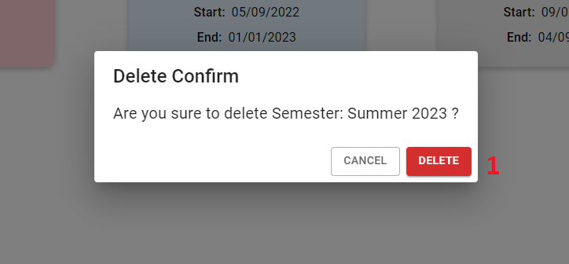

Figure . Delete semester

|  |  |
| --- | --- |
| No. | Description |
| 1 | Click on the “Delete” icon to delete semester. |
| 2 | Only the semester in the status not yet can delete it |
| 3 | Click on the “Delete” button to delete semester. |

Table . Brief Description- Delete Semester

***d3 <Admin> Update semester***

* Update start date vs end date

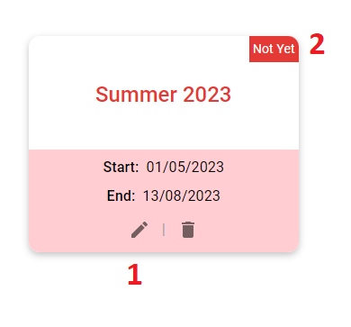

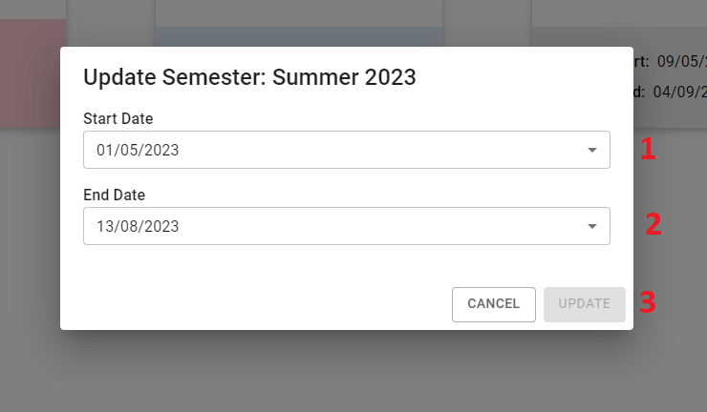

Figure . Edit semester

|  |  |
| --- | --- |
| No. | Description |
| 1 | Click on the “Edit” icon to update new semester. |
| 2 | Only the semester in the status not yet can update start date vs end date of semester |
| 3 | Choose start date for the start date of the semester. |
| 4 | Choose end date for the end date of the semester. |
| 5 | Click on the “Update” button to update semester. |

Table . Brief Description- Update Semester

* Update state of semester

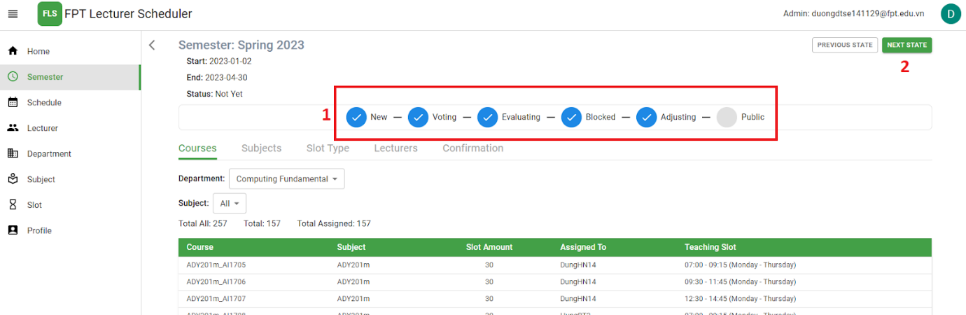

Figure . State of Semester

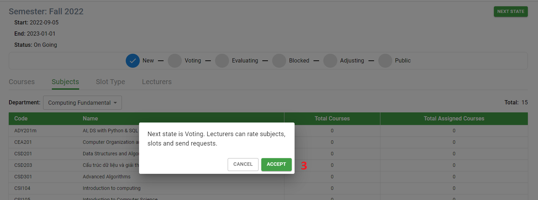

Figure . Update state of Semester

|  |  |
| --- | --- |
| No. | Description |
| 1 | View current state of semester |
| 2 | Click on the “Next state” button to update state of semester. |
| 3 | Click on the “ACCEPT” button to confirm. |

Table . Brief Description - Update state of Semester

##### e. <Admin> Manage course

***e1. <Admin>*** View course

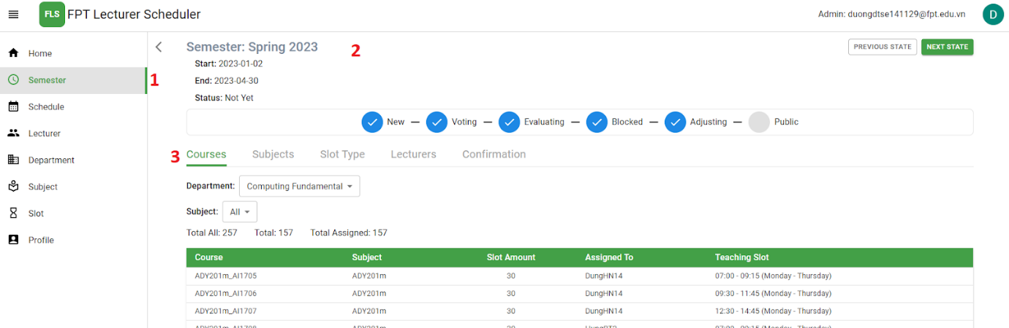

Figure . View Course

|  |  |
| --- | --- |
| No. | Description |
| 1 | Click on the “Semester” tab to navigate to the Semester page. |
| 2 | Choose the semester to navigate to the semester detail page. |
| 3 | Choose the “Course” tab to navigate to the course page. |

Table . Brief Description - Update state of Semester

***e2. <Admin> Create course***

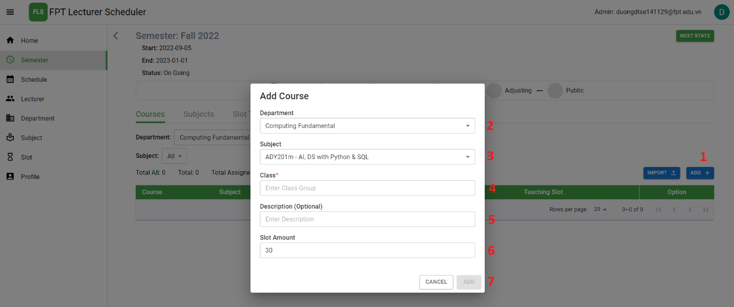

Figure . Create Course

|  |  |
| --- | --- |
| No. | Description |
| 1 | Click on the “Add” button to create new course. |
| 2 | Choose department |
| 3 | Choose subject |
| 4 | Input in the field: “Class” |
| 5 | Input in the field: “Description” |
| 6 | Input in the field: “Slot Amount” |
| 7 | Click on the “Add” button to create new course. |

Table . Brief Description- Create course

***e3. <Admin> Import course***

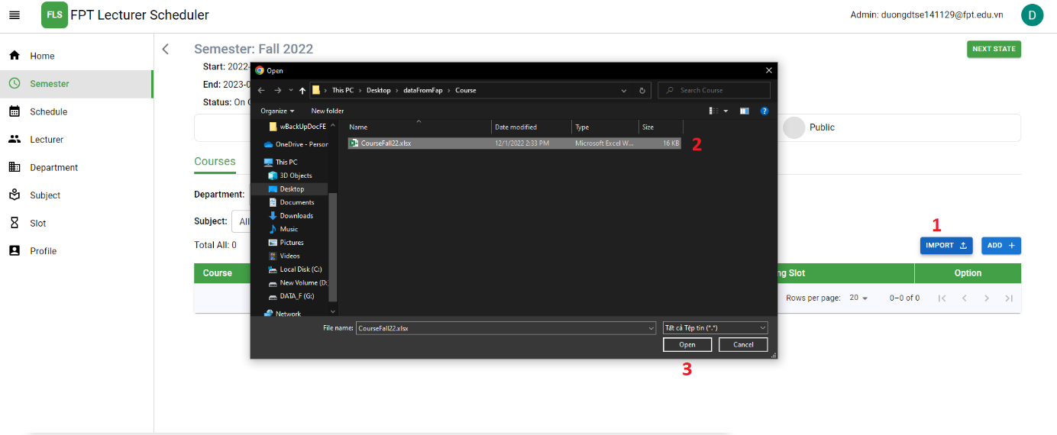

Figure . Choose file to import Course

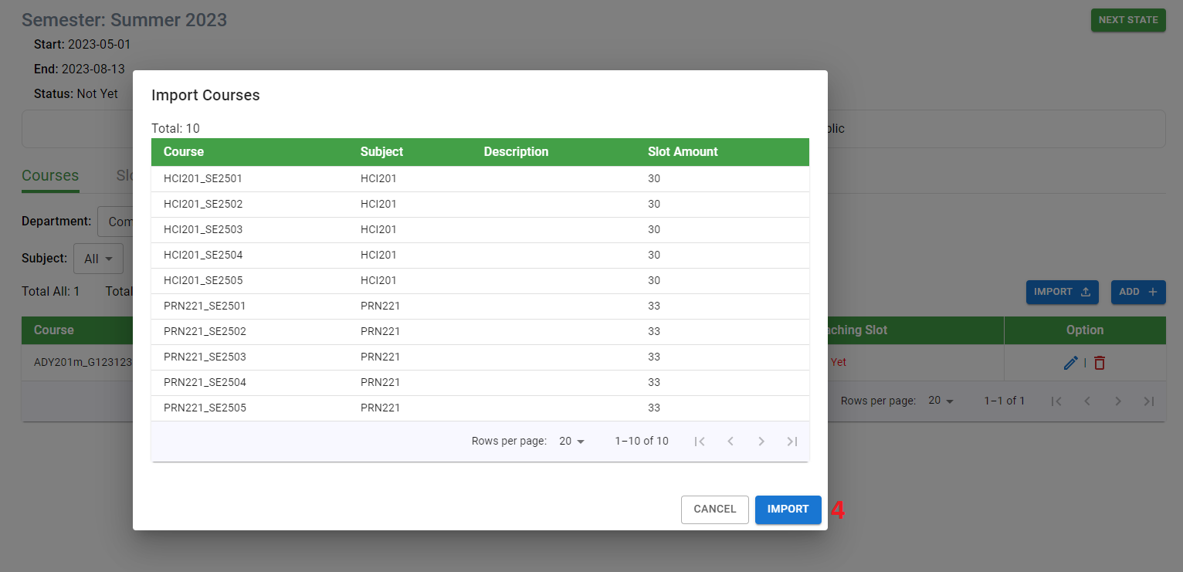

Figure . Import Course

|  |  |
| --- | --- |
| No. | Description |
| 1 | Click on the “Import” button to import courses. |
| 2 | Choose the file. |
| 3 | Click on the “Open” button. |
| 4 | Click on the “Import” button import courses. |

Table . Brief Description- Import course

***e4. <Admin> Update course***

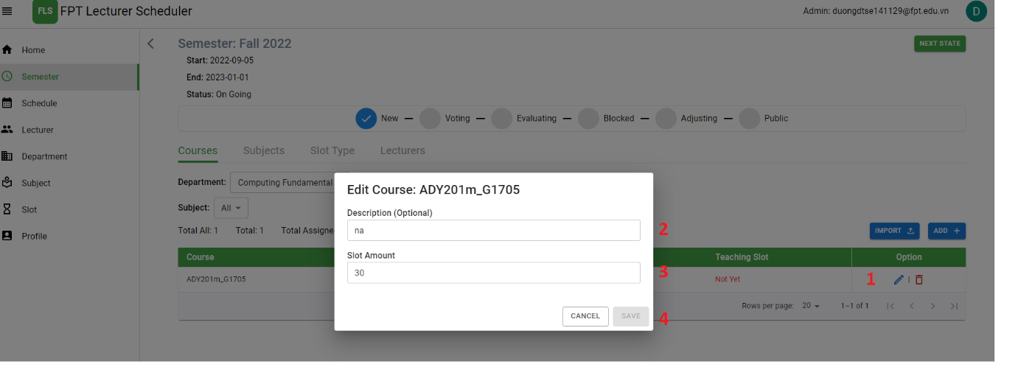

Figure . Update Course

|  |  |
| --- | --- |
| No. | Description |
| 1 | Click on the “Edit” icon to update courses. |
| 2 | Input in the field: “Description” |
| 3 | Input in the field: “Slot amount” |
| 4 | Click on the “Save” button import courses. |

Table . Brief Description- Update course

***e5. <Admin> Delete course***

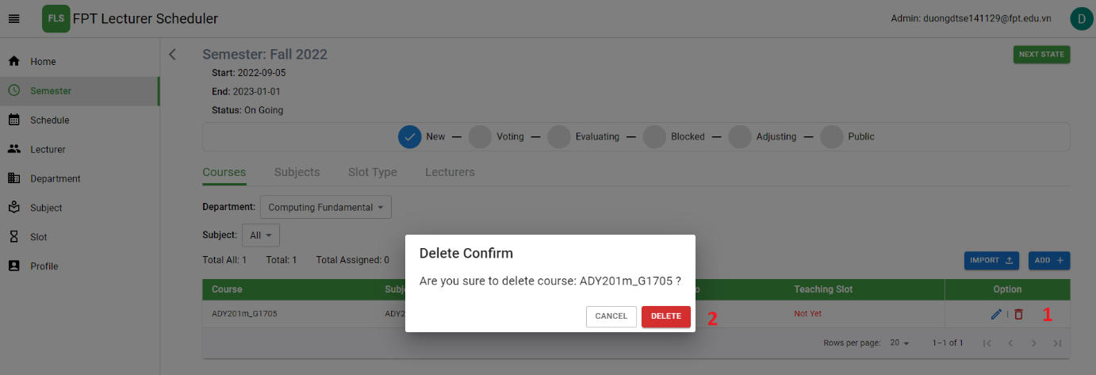

Figure . Delete course

|  |  |
| --- | --- |
| No. | Description |
| 1 | Click on the “Delete” icon to delete course. |
| 2 | Click on the “Delete” button to delete course |

Table . Brief Description- Delete course

##### f. <Admin> Manage schedule of lecturer

***f1. <Admin>*** View schedule

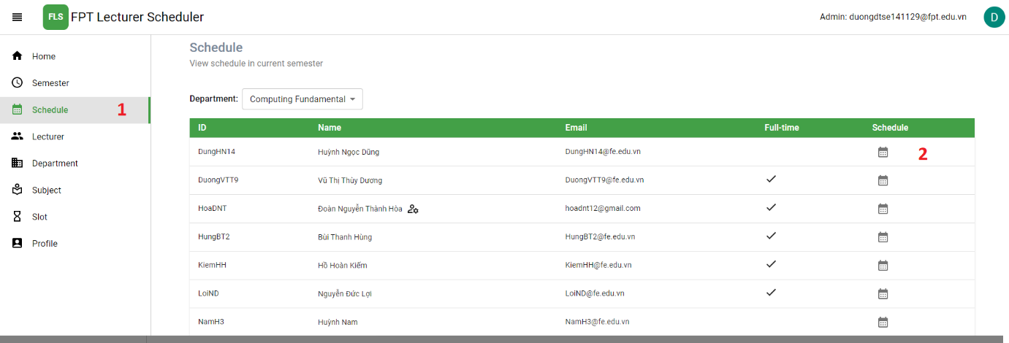

Figure . View Schedule

|  |  |
| --- | --- |
| No. | Description |
| 1 | Click on the “Schedule” tab to navigate to the Schedule page. |
| 2 | Click on the “Schedule” icon to navigate to the detail schedule page of lecturer. |

Table . Brief Description- View Schedule

***f2. <Admin>*** View schedule detail of lecturer



Figure . View Schedule Detail of Lecturer

##### g. <Admin> Manage Lecturer

***g1. <Admin>*** View lecturer

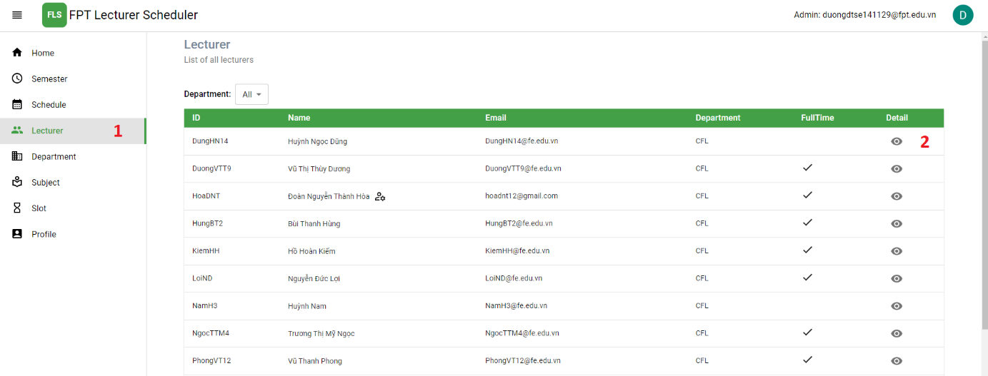

Figure . View Lecturer

|  |  |
| --- | --- |
| No. | Description |
| 1 | Click on the “Lecturer” tab to navigate to the Lecturer page. |
| 2 | Click on the “Detail” icon to navigate to the lecturer’s information page. |

Table . Brief Description- View Lecturer

***g2. <Admin> View detail information of lecturer***

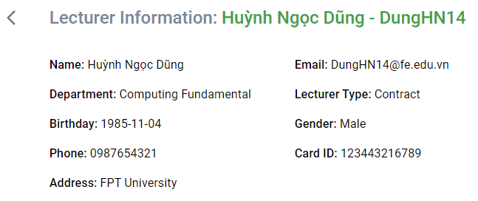

Figure . View Lecturer Detail

##### h. <Admin> Manage department

***h1. <Admin>*** View department

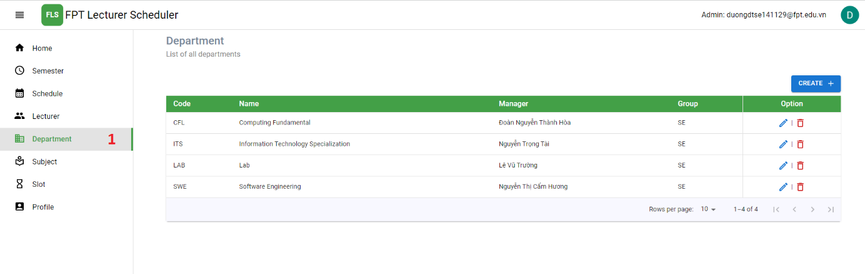

Figure . View Department

|  |  |
| --- | --- |
| No. | Description |
| 1 | Click on the “Department” tab to navigate to the Department page. |

Table . Brief Description- View Department

***h2. <Admin>*** Create department

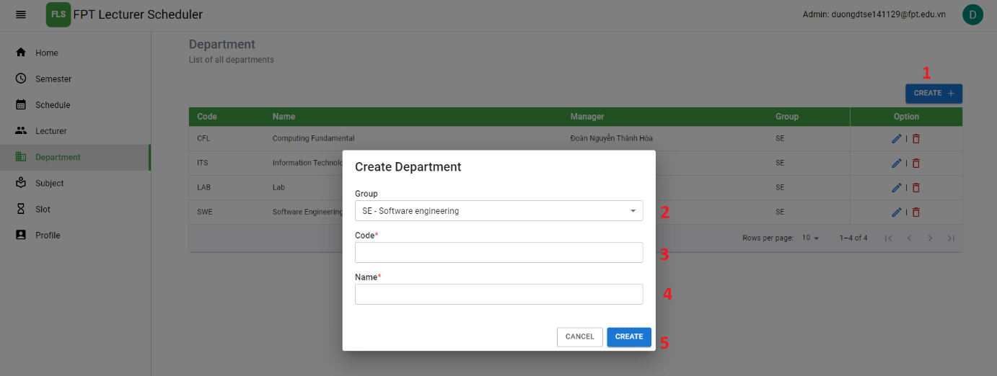

Figure . Create Department

| No. | Description |
| --- | --- |
| 1 | Click on the “Create” button to show “Create department” pop up. |
| 2 | Choose group for the department group of the department. |
| 3 | Input in the field: “Code” for the ID of the department. |
| 4 | Input in the field: “Name” for the department name of the department. |
| 5 | Click on the “Create” button to create new department and navigate department page. |

Table . Brief Description- Create Department

***h3. <Admin>*** Update department

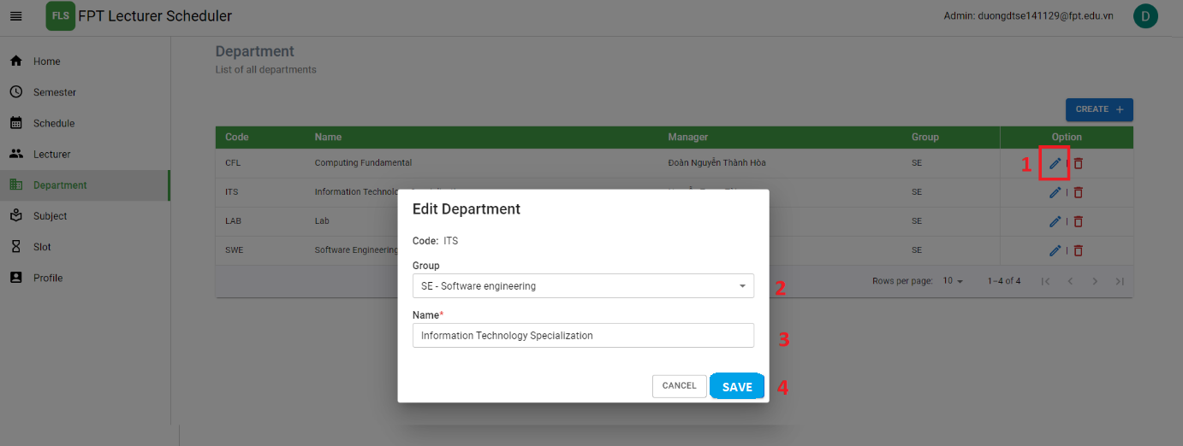

Figure . Update Department

| No. | Description |
| --- | --- |
| 1 | Click on the “Edit” icon to show “Edit department” pop up. |
| 2 | Choose group for the department group of the department. |
| 3 | Input in the field: “Name” for the department name of the department. |
| 4 | Click on the “Save” button to update department and navigate department page. |

Table . Brief Description- Update Department

***h4. <Admin>*** Delete department

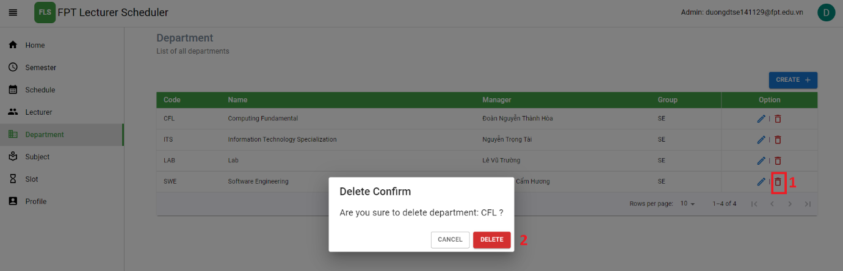

Figure . Delete Department

|  |  |
| --- | --- |
| No. | Description |
| 1 | Click on the “Delete” icon to delete department. |
| 2 | Click on the “Delete” button to delete department. |

Table . Brief Description- Delete Department

##### i. <Admin> Manage subject

***i1. <Admin>*** View subject

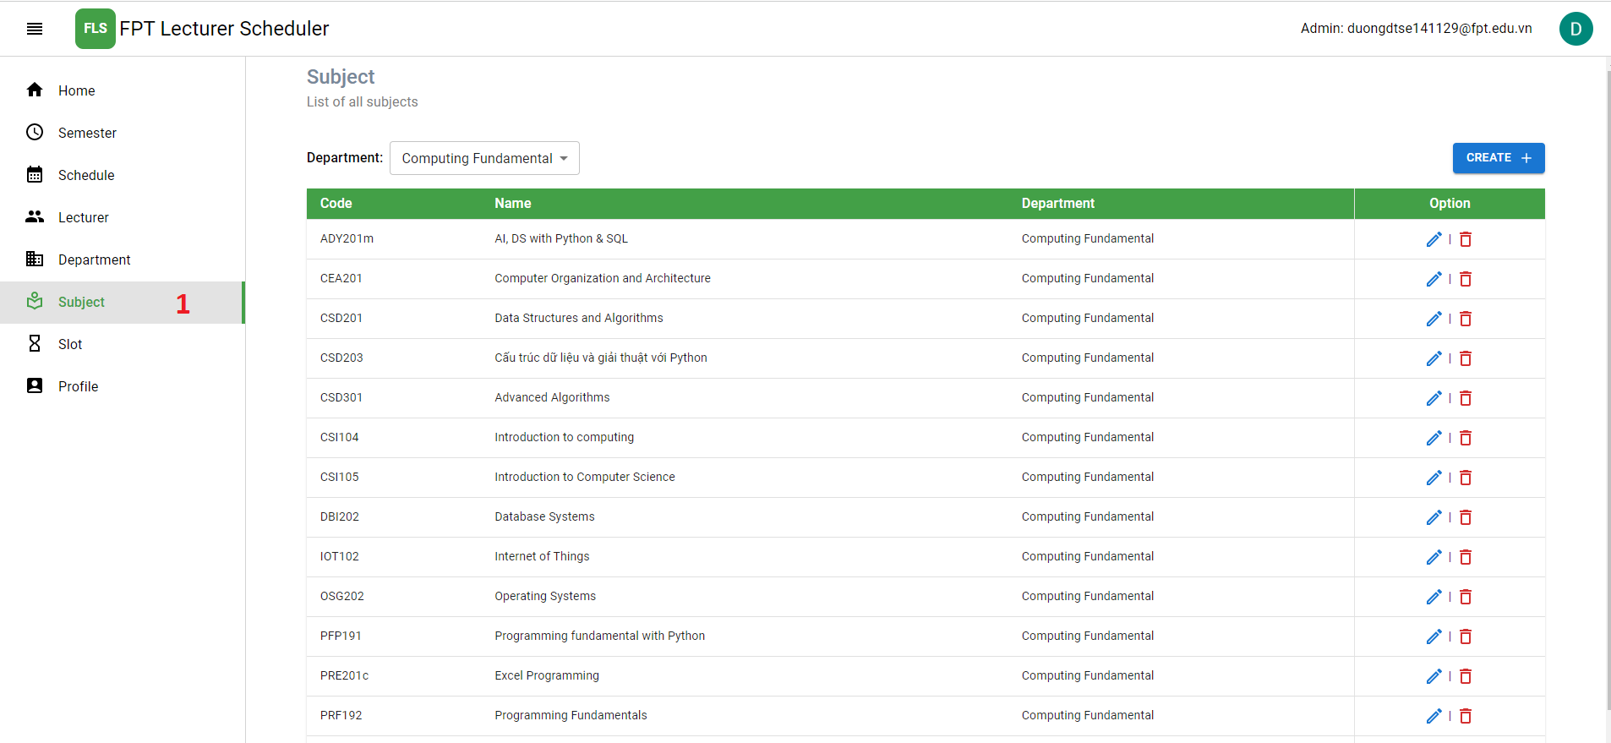

Figure . View Subject

|  |  |
| --- | --- |
| No. | Description |
| 1 | Click on the “Subject” tab to navigate to the Subject page. |

Table . Brief Description- View Subject

***i2. <Admin> Create subject***

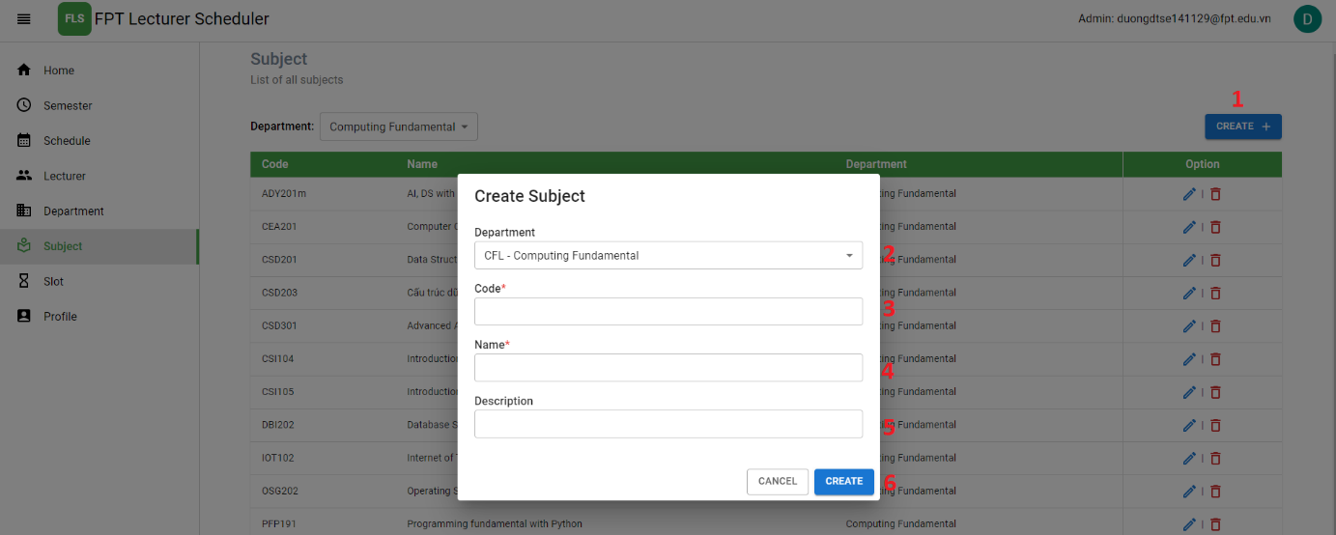

Figure . Create Subject

| No. | Description |
| --- | --- |
| 1 | Click on the “Create” button to show “Create subject” pop up. |
| 2 | Choose department for the department of the subject. |
| 3 | Input in the field: “Code” for the ID of the subject. |
| 4 | Input in the field: “Name” for the subject name of the subject. |
| 5 | Input in the field: “Description” for the description of the subject. |
| 6 | Click on the “Create” button to create new subject and navigate subject page. |

Table . Brief Description- Create Subject

***i3. <Admin> Update subject***

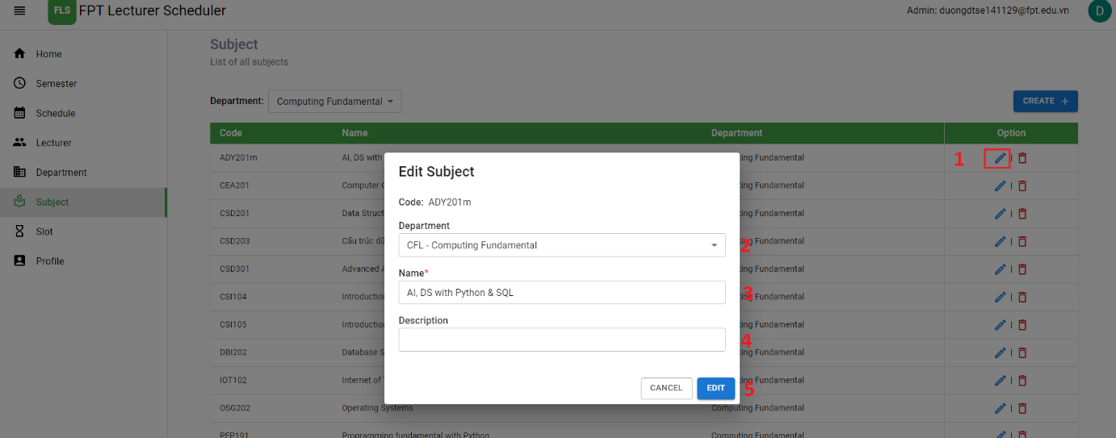

Figure . Update Subject

| No. | Description |
| --- | --- |
| 1 | Click on the “Edit” icon to show “Edit subject” pop up. |
| 2 | Choose department for the department of the subject. |
| 3 | Input in the field: “Name” for the subject name of the subject. |
| 4 | Input in the field: “Description” for the description of the subject. |
| 5 | Click on the “Edit” button to edit subject and navigate subject page. |

Table . Brief Description- Update Subject

***i4. <Admin> Delete subject***

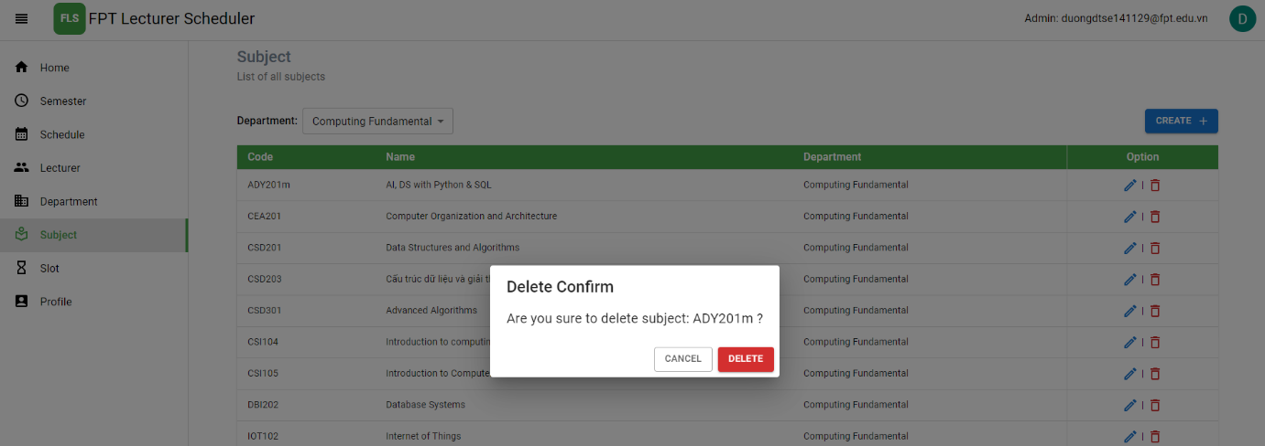

Figure . Delete Subject

|  |  |
| --- | --- |
| No. | Description |
| 1 | Click on the “Delete” icon to delete subject. |
| 2 | Click on the “Delete” button to delete subject. |

Table . Brief Description- Delete Subject

##### j. <Admin> Manage slot

***j1. <Admin>*** View Slot

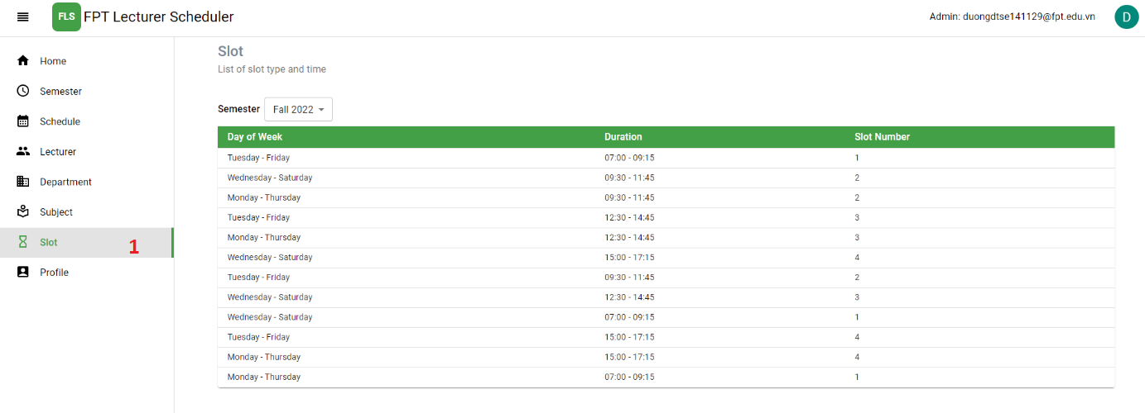

Figure . View Slot

|  |  |
| --- | --- |
| No. | Description |
| 1 | Click on the “Slot” tab to navigate to the Slot page. |

Table . Brief Description- View Slot

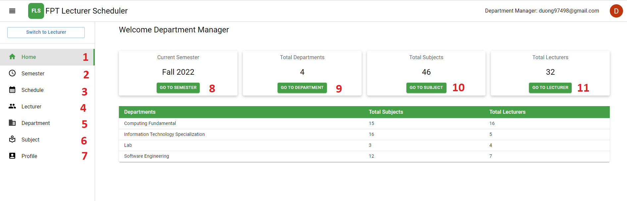

Figure . View Home of Department Manager

|  |  |
| --- | --- |
| No. | Description |
| 1 | Click on the “Home” tab to navigate to the Home page. |
| 2 | Click on the “Semester” tab to navigate to the Semester page. |
| 3 | Click on the “Schedule” tab to navigate to the Home page. |
| 4 | Click on the “Lecturer” tab to navigate to the Home page. |
| 5 | Click on the “Department” tab to navigate to the Home page. |
| 6 | Click on the “Subject” tab to navigate to the Home page. |
| 7 | Click on the “Profile” tab to navigate to the Home page. |
| 8 | Click on the “Go to semester” button to navigate to the Home page. |
| 9 | Click on the “Go to department” button to navigate to the Department page. |
| 10 | Click on the “Go to subject” button to navigate to the Subject page. |
| 11 | Click on the “Go to lecturer” button to navigate to the Lecturer page. |

Table . Brief Description-View Home of Department Manager

##### k. <Department Manager> Manage course assign

***k1. <Department Manager>*** Assign course for lecturer in Department Manager’s department

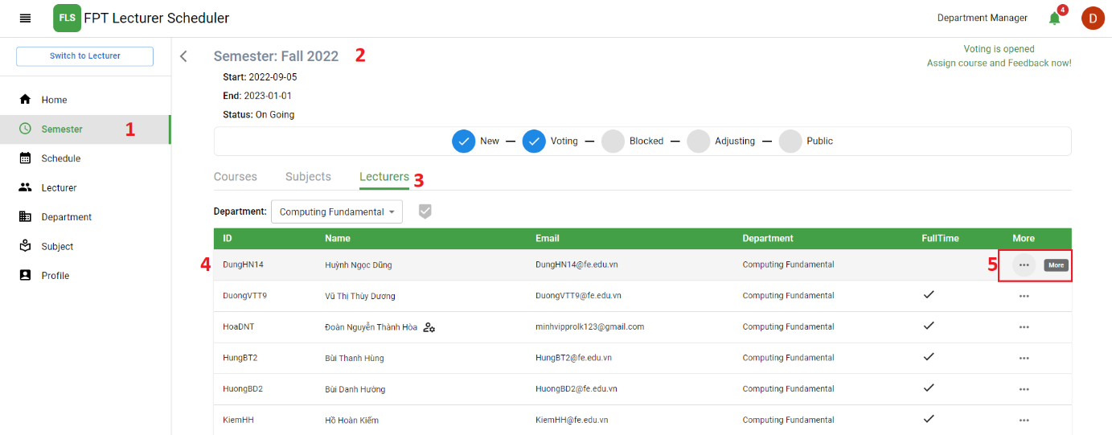

Figure . View Lecturer to assign course

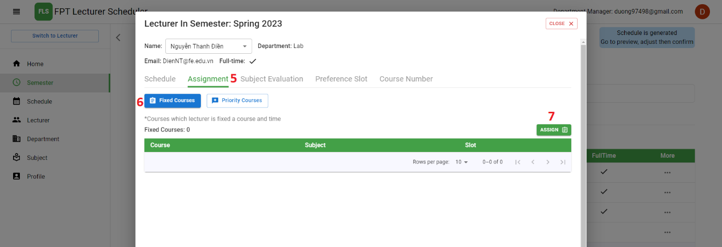

Figure . View Assign Course

|  |  |
| --- | --- |
| No. | Description |
| 1 | Click on the “Semester” tab to navigate to the Semester page. |
| 2 | Choose the semester to navigate to the semester detail page. |
| 3 | Choose the “lecturer” tab to navigate to the lecturer tab in semester page. |
| 4 | Click on the “Detail” icon to navigate to the Lecture in semester page. |
| 5 | Choose the “Assignment” tab. |
| 6 | Choose the “Fixed courses” button to navigate to fixed courses page. |
| 7 | Click on the “Assign” button to show assign course pop up. |

Table . Brief Description- View Assign course

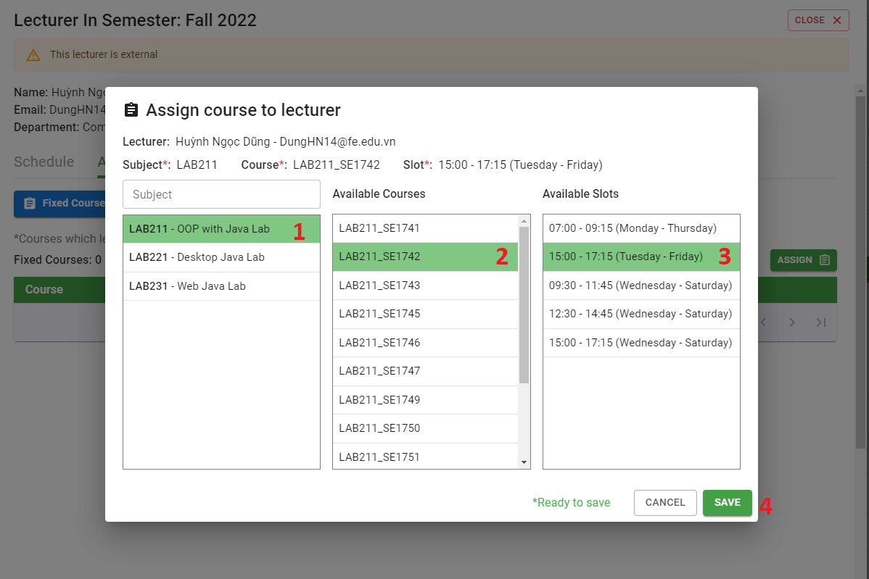

Figure . Assign course

|  |  |
| --- | --- |
| No. | Description |
| 1 | Choose the subject to list all course of this subject. |
| 2 | Choose the course. |
| 3 | Choose the slot. |
| 4 | Click on the “Save” icon to assign course for lecturer. |

Table . Brief Description- Assign course

##### l. <Department Manager> Manage course group item

***l1. <Department Manager> Add courses to the priority group for lecturer in the department***

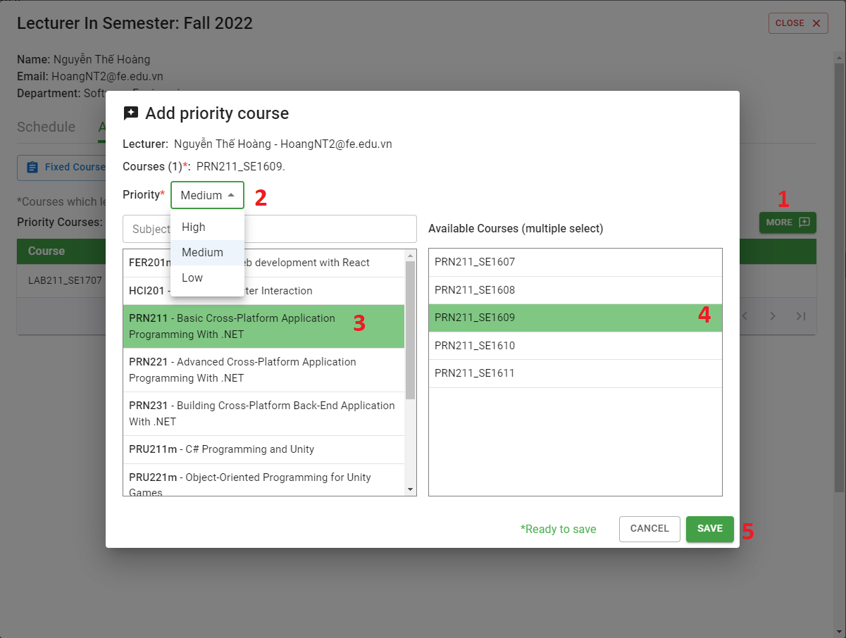

Figure . Add Priority Course in Department

|  |  |
| --- | --- |
| No. | Description |
| 1 | Click on the “More” button to show Add priority course pop up. |
| 2 | Choose the priority of the priority group. |
| 3 | Choose the subject. |
| 4 | Choose courses. |
| 5 | Click on the “Save” icon to add courses to the priority group for lecturer in the department. |

Table . Brief Description- Add Priority Course in Department

***l2. <Department Manager> Add courses to the priority group for lecturer out the department***

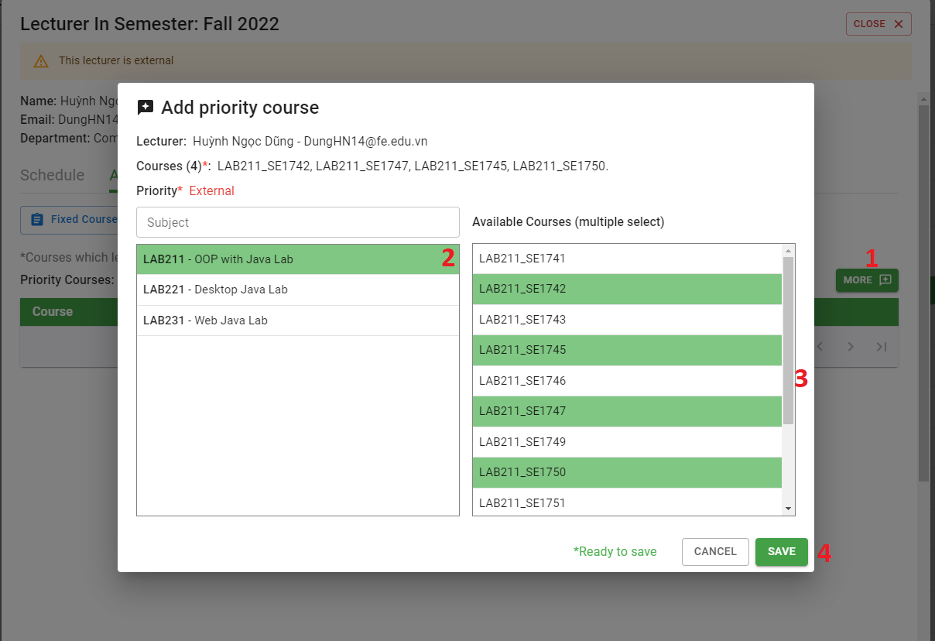

Figure . Add Priority Course Out Department

|  |  |
| --- | --- |
| No. | Description |
| 1 | Click on the “More” button to show Add priority course pop up. |
| 2 | Choose the subject. |
| 3 | Choose courses. |
| 4 | Click on the “Save” button to add courses to the priority group for lecturer in the department. |

Table . Brief Description- Add Priority Course Out Department

***l3. <Department Manager> Delete course group item***

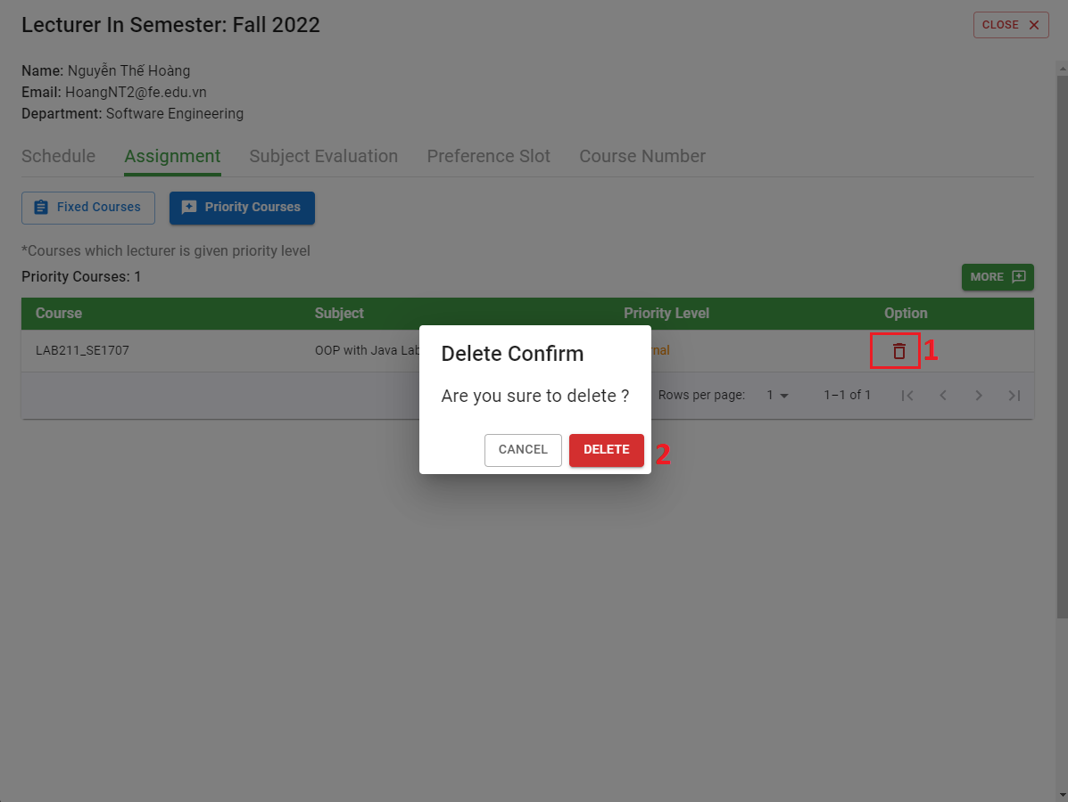

Figure . Delete Course Group Item

|  |  |
| --- | --- |
| No. | Description |
| 1 | Click on the “Delete” icon. |
| 2 | Click on the “Save” button to delete priority courses for lecturer. |

Table . Brief Description- Delete Course Group Item

##### m. <Department Manager> Manage request

***m1. View request to teach more subjects out of department from lecturer.***

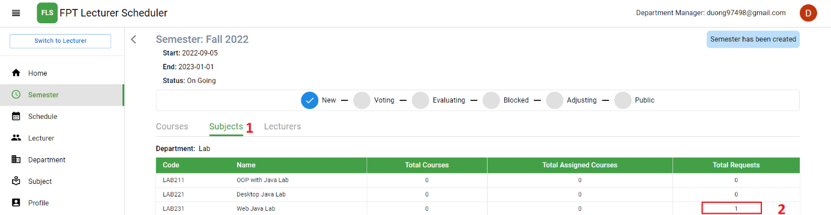

Figure . Manager Request

|  |  |
| --- | --- |
| No. | Description |
| 1 | Click on the “Subject” tab. |
| 2 | Click on the row of subject to navigate to the Subject detail page. |

Table . Brief Description- Manager Request

***m2. <Department Manager> Response the request from lecturer***

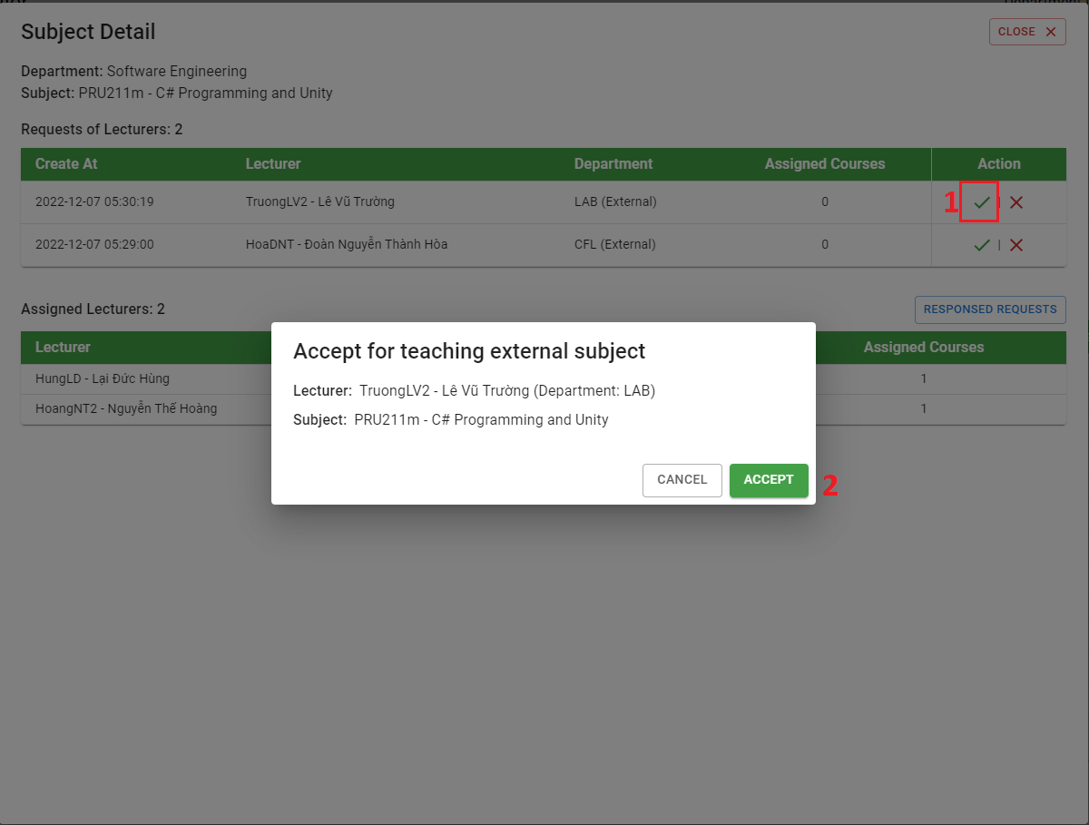

Figure . Response Request

|  |  |
| --- | --- |
| No. | Description |
| 1 | Click on the “Accept” or “Denied” icon. |
| 2 | Click on the “Accept” button to navigate to the Subject detail page |

Table . Brief Description- Response Request

***m3. <Department Manager> View response requests***

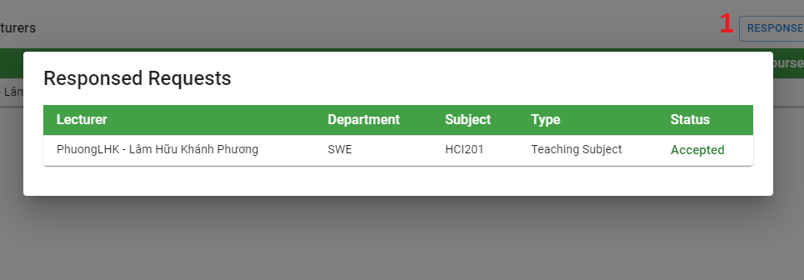

Figure . View Response Request

|  |  |
| --- | --- |
| No. | Description |
| 1 | Click on the “Response requests” button to show Response requests pop up. |

Table . Brief Description- View Response Request

##### n. <Department Manager> Edit min max course of lecturer

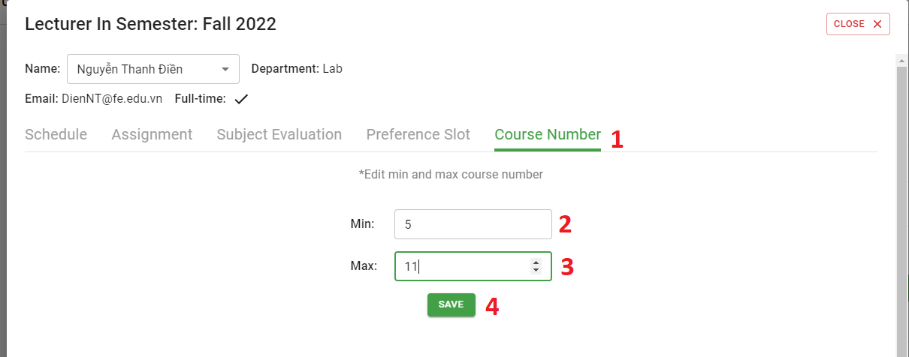

Figure . Edit Min Max Course of Lecturer

|  |  |
| --- | --- |
| No. | Description |
| 1 | Click on the “Course number” tab. |
| 2 | Input in the field: “Min” for the max course of the lecturer. |
| 3 | Input in the field: “Max” for the min course of the lecturer. |
| 4 | Click on the “Save” button to edit min max course of lecturer |

Table . Brief Description- Edit Min Max Course of Lecturer

##### o. <Department Manager> Manage subject of lecturer

***o1. <Department Manager>*** View subject of lecturer

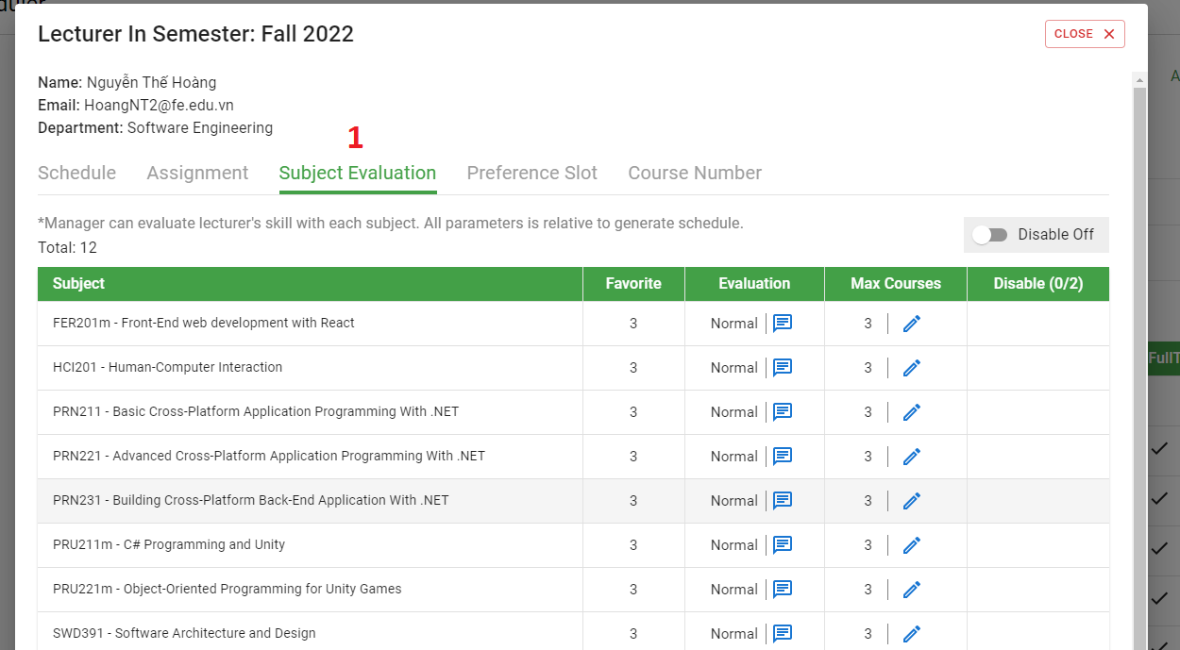

Figure . View Subject of Lecturer

|  |  |
| --- | --- |
| No. | Description |
| 1 | Click on the “Subject Evaluation” tab. |

Table . Brief Description- View Subject of Lecturer

***o2. <Department Manager> Update evaluation point of subject for lecturer***

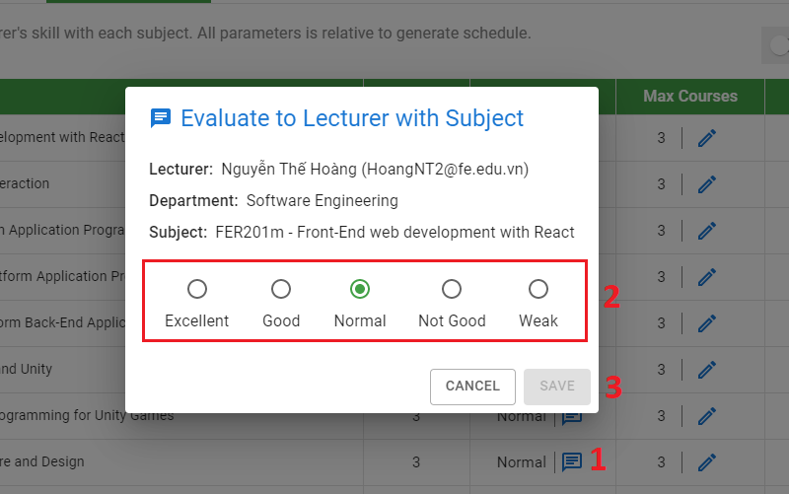

Figure . Update Evaluation Point of Subject

|  |  |
| --- | --- |
| No. | Description |
| 1 | Click on the “Evaluate” icon navigate to the Evaluate pop up. |
| 2 | Choose the radio button. |
| 3 | Click on the “Save” button to evaluate point of subject for lecturer. |

Table . Brief Description- Update Evaluation Point of Subject

***o3. <Department Manager> Update the maximum number of subjects that the lecturer can teach.***

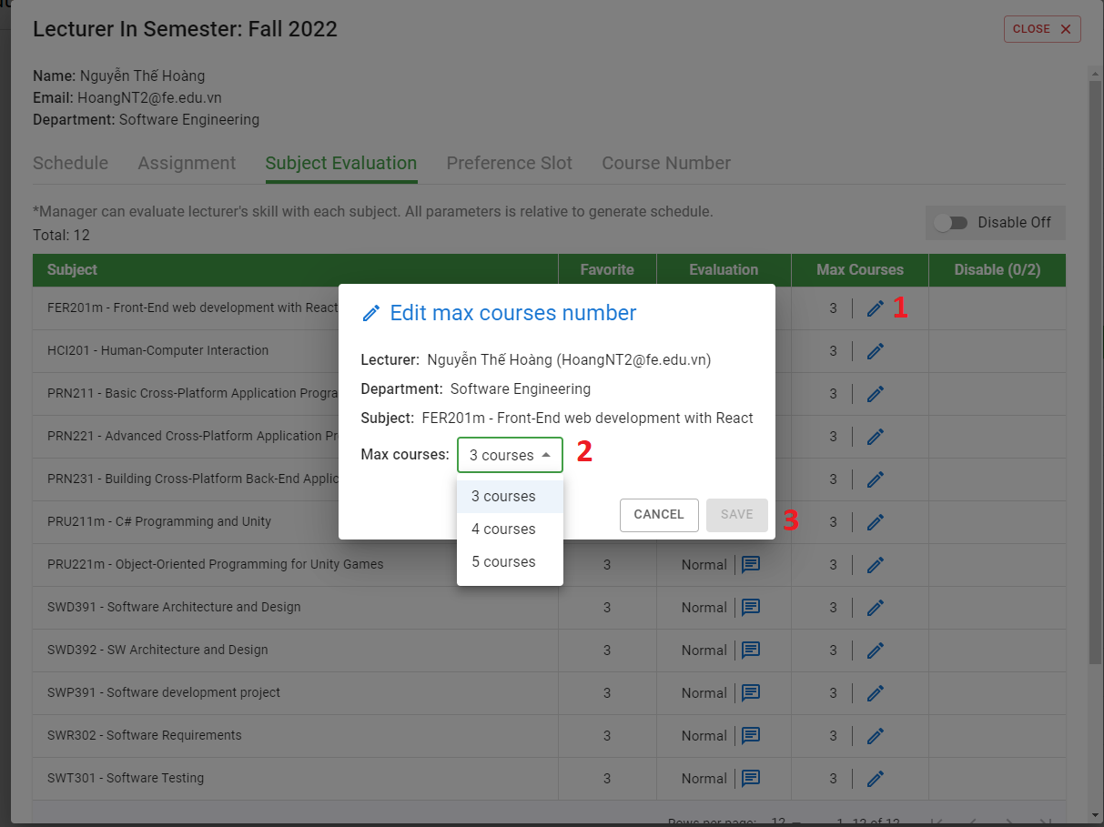

Figure . Update The Maximum Number of Subject

|  |  |
| --- | --- |
| No. | Description |
| 1 | Click on the “Edit” icon navigate to the Edit max courses number pop up. |
| 2 | Choose the max courses. |
| 3 | Click on the “Save” button to update max number of course of the subject that the lecturer can teach. |

Table . Brief Description- Update the Maximum Number of Subject

***o4. <Department Manager> Disable teachers from teaching that subject.***

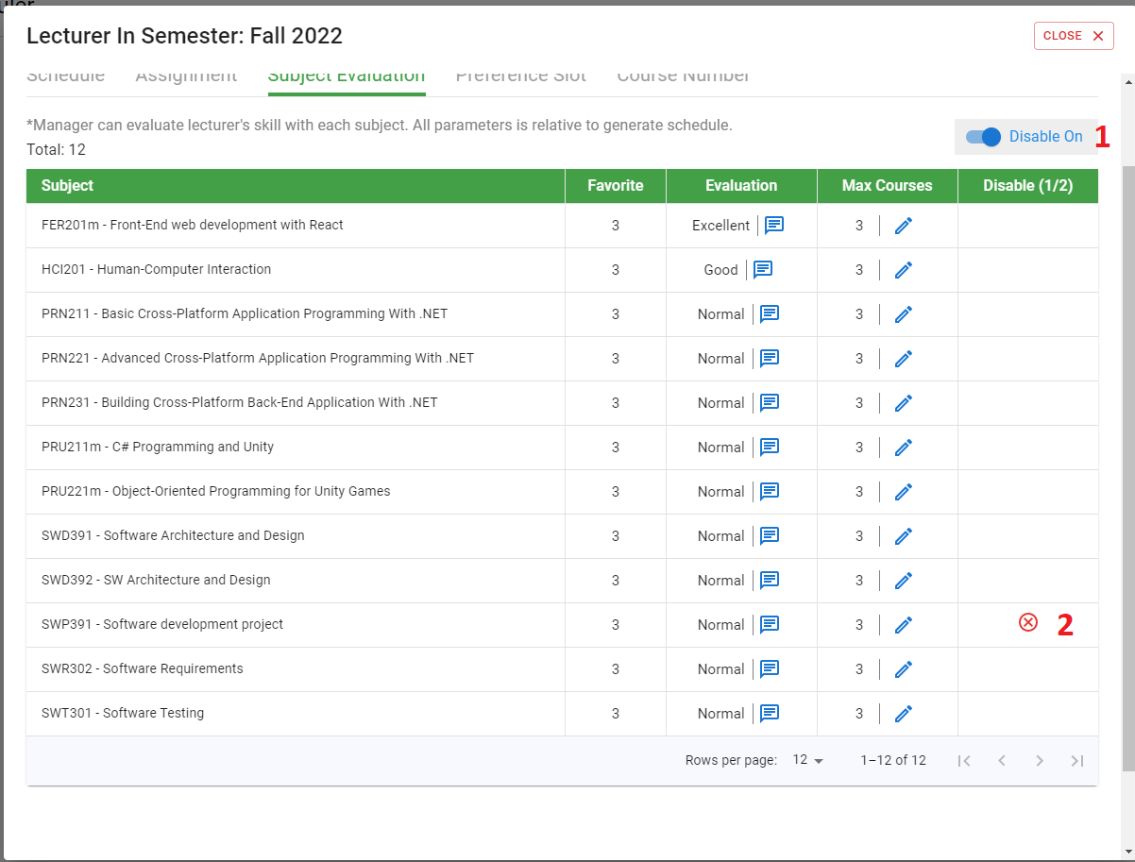

Figure . Disable Teachers from Teaching That Subject

##### p. <Department Manager> Manage lecturer Slot Config

***p1. <Department Manager> Disable slot of lecturer***

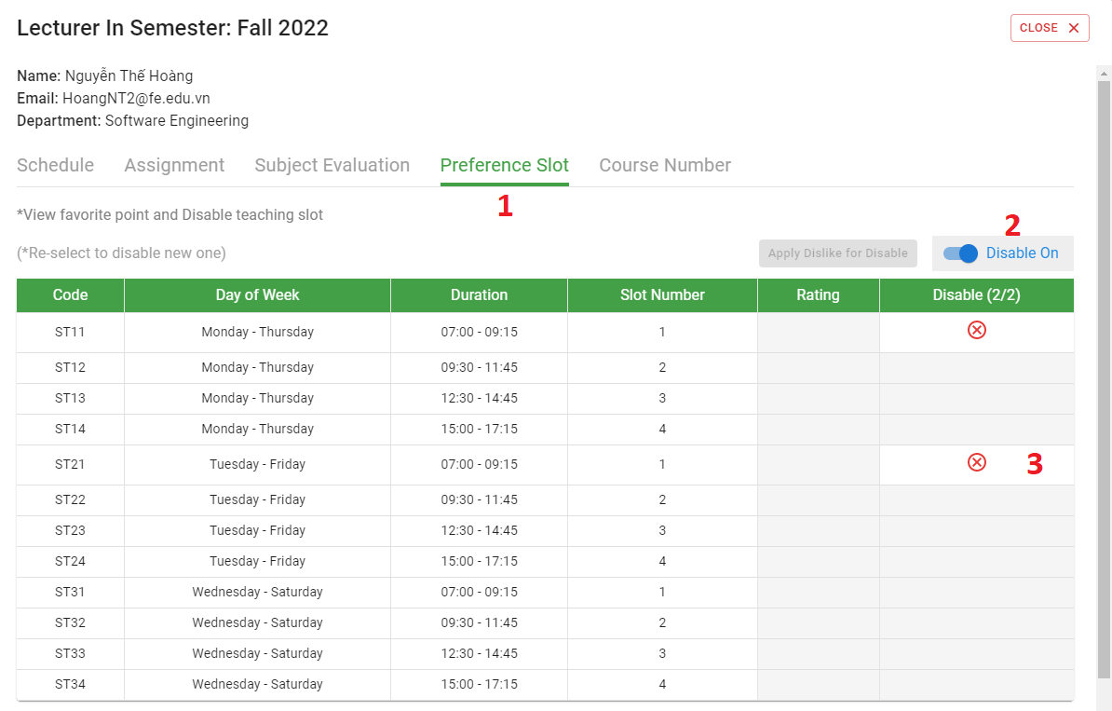

Figure . Manager Lecturer Slot Config

|  |  |
| --- | --- |
| No. | Description |
| 1 | Click on the “Preference slot” tab. |
| 2 | Click on the “Disable” switcher |
| 3 | Choose the row slot to disable slots of the lecturer. |

Table . Brief Description- Manager Lecturer Slot Config

##### **q. <Department Manager> Manage swap course assign**

***q1. <Department Manager> Swap assigned courses in schedule of a lecturer***

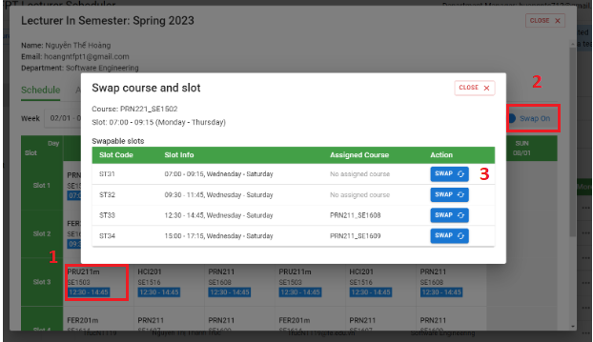

Figure . Department Manager Swap assigned courses in schedule of a lecturer

|  |  |
| --- | --- |
| No. | Description |
| 1 | Choose a course assign of the lecturer |
| 2 | Click on the “Swap on” switcher |
| 3 | Click “Swap” button to swap assigned courses in the schedule of a lecturer. |

Table . Brief Description - Department Manager Swap assigned courses in schedule of a lecturer

***q2. <Department Manager> Swap assigned courses in schedule between lecturers***

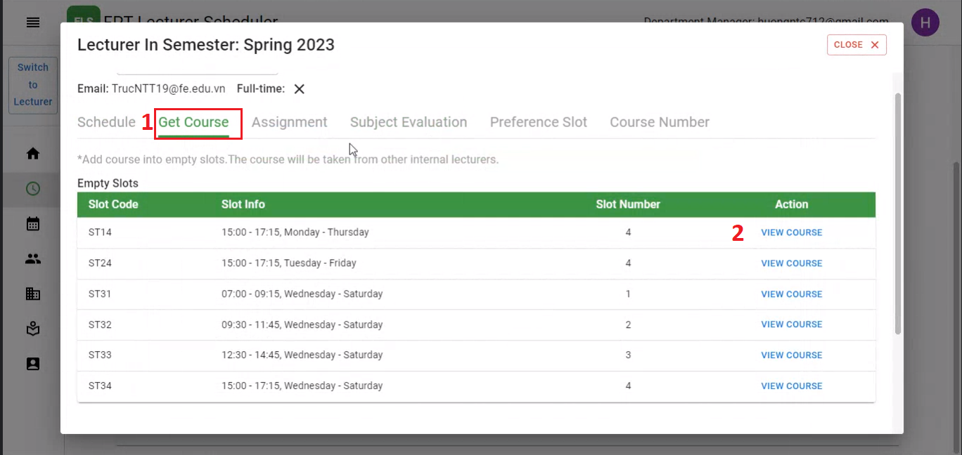

Figure . Department Manager Get list empty slots

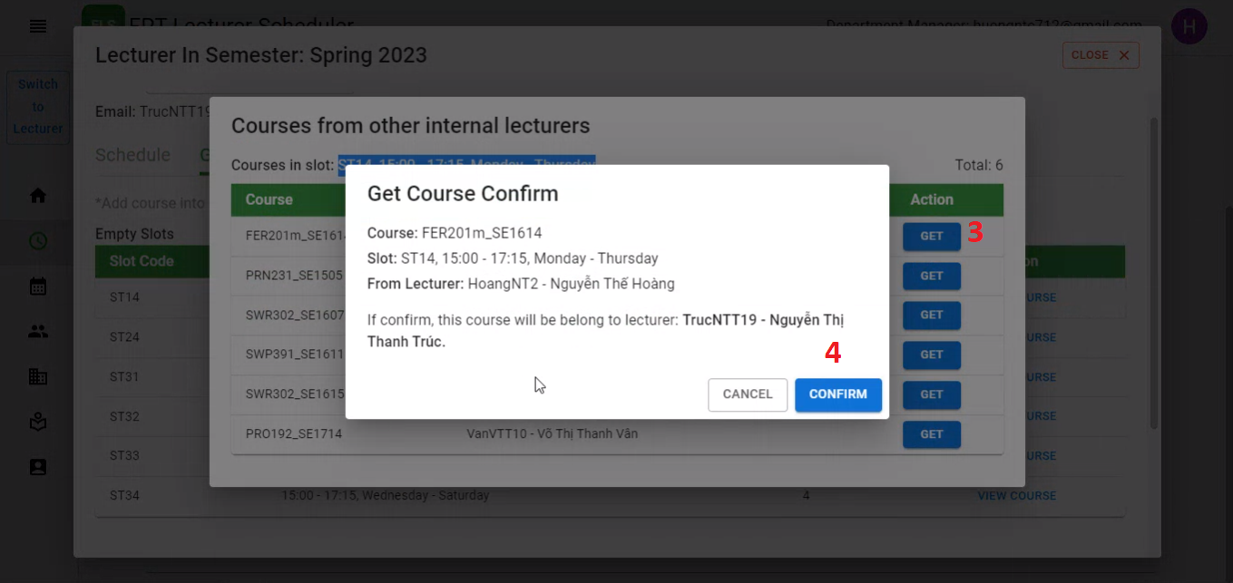

Figure . Department Manager Swap assigned courses in schedule between lecturers

|  |  |
| --- | --- |
| No. | Description |
| 1 | Click on the “Get course” tab to get all empty slots. |
| 2 | Click on the “View Course” to choose slot to assign course |
| 3 | Click “Get” button to view all courses of lecturers in the department at that slot |
| 4 | Click “Confirm” button to get that course assigned. |

Table . Brief Description - Department Manager Swap assigned courses in schedule between lecturers

##### r. <Lecturer> View Scheduler

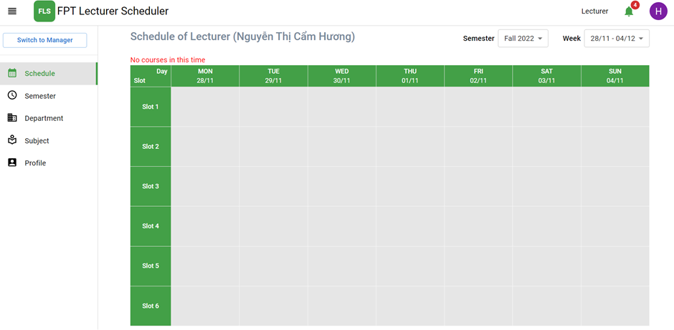

Figure . View Schedule

|  |  |
| --- | --- |
| No. | Description |
| 1 | Click on the “Schedule” on the navigation bar to view the schedule. |
| 2 | Choose in the selection: “Semester” to choose the semester |
| 3 | Choose in the selection: “Week” to choose the week |
| 4 | Table shows the information of the scheduler. |

Table . Brief Description- View Schedule

##### s. <Lecturer> Manage Semester

***s1. <Lecturer>* View Semester**

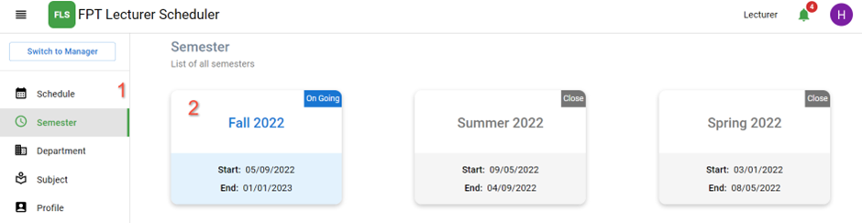

Figure . View Semester

|  |  |
| --- | --- |
| No. | Description |
| 1 | Click on the “Semester” on the navigation bar to view the semester. |
| 2 | Click on a semester card to view semester details. |

Table . Brief Description- View Semester

***s2. <Lecturer>* View Detail Semester**

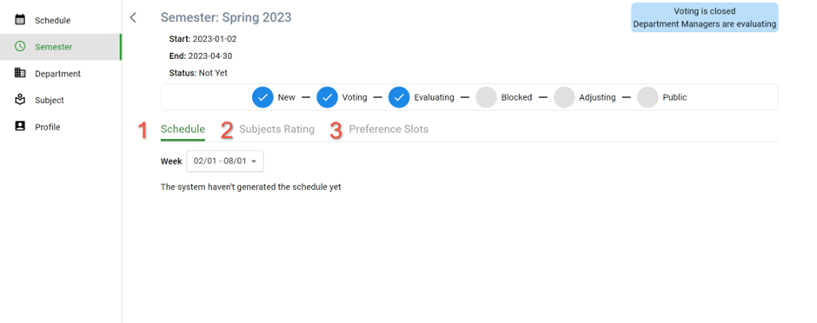

Figure . View Semester Details

|  |  |
| --- | --- |
| No. | Description |
| 1 | Click on the “Schedule” tab to view the schedule in the semester. |
| 2 | Click on the “Subject Rating” tab to rate subjects in the semester. |
| 3 | Click on the “Preference Slots” tab to preference slots in the semester. |

Table . Brief Description- View Semester Details

##### t. <Lecturer> View Schedule

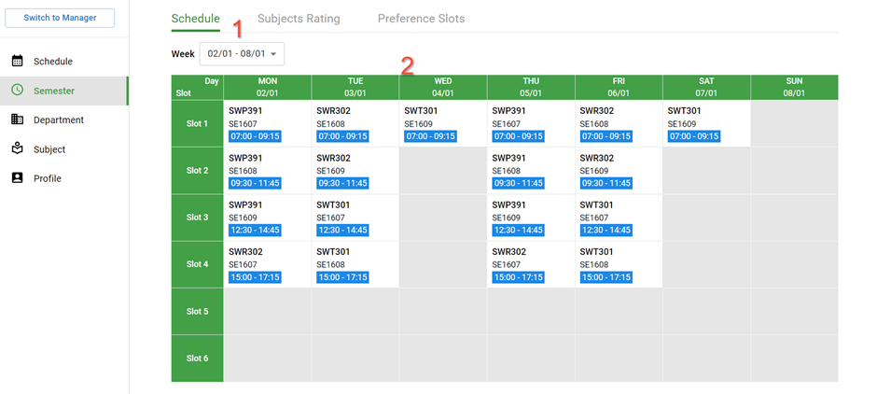

Figure . View Schedule

|  |  |
| --- | --- |
| No. | Description |
| 1 | Choose in the selection: “Week” to choose the schedule |
| 2 | Table shows the information of the scheduler. |

Table . Brief Description- View Schedule

##### u. <Lecturer> View Subjects Rating

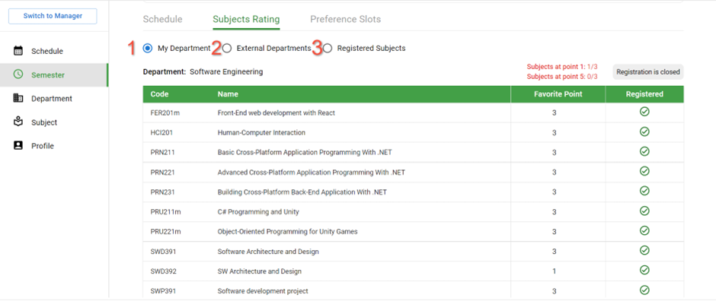

Figure . View Rating favourite Subjects

|  |  |
| --- | --- |
| No. | Description |
| 1 | Click on the “My Department” radio button to rate subjects in the department. |
| 2 | Click on the “External Department” radio button to send a request to register to teach more subjects external to the department. |
| 3 | Click on the “Registered Subject” radio button to view registered subjects in the semester. |

Table . Brief Description- View Subject Rating

##### *v. <Lecturer>* Rating favourite subjects

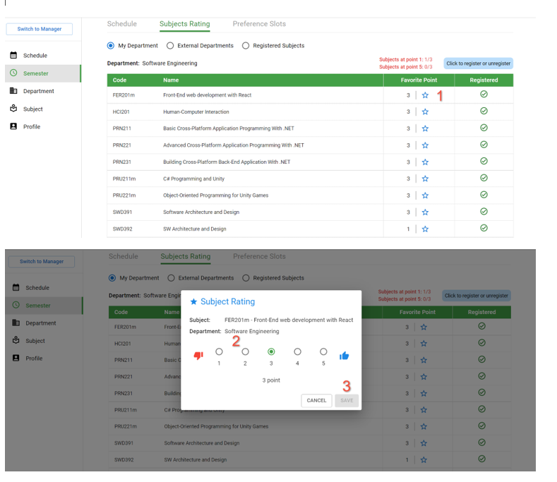

Figure . Rating favourite Subjects

|  |  |
| --- | --- |
| No. | Description |
| 1 | Click on the “Star” icon to rate subjects in the department. |
| 2 | Click on the “Point” radio button to choose point to rate subject. |
| 3 | Click on the “Save” button to save |

Table . Brief Description- Rating favourite Subjects

##### *w. <Lecturer>* Send Request to teach more subjects out the department

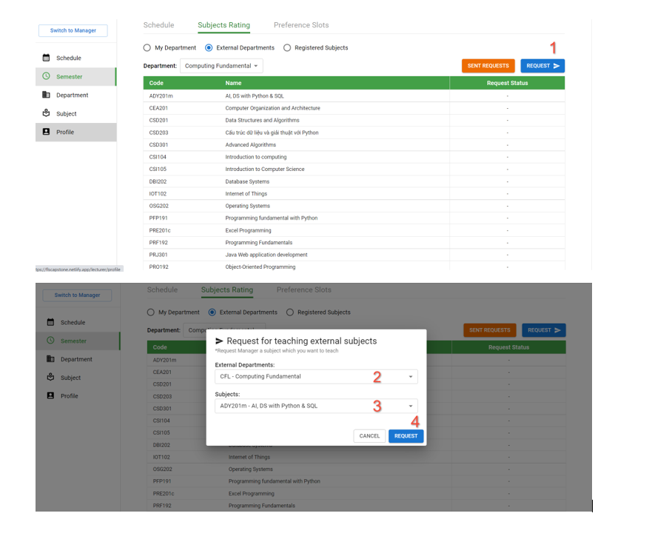

Figure . Send Request

|  |  |
| --- | --- |
| No. | Description |
| 1 | Click on the “Request” button to send request |
| 2 | Choose in the selection: “Department” to choose the department |
| 3 | Choose in the selection: “Subject” to choose the subject |
| 4 | Click on the “REQUEST” button to send request |

Table . Brief Description- Send Request

##### *x. <Lecturer>* View Requests

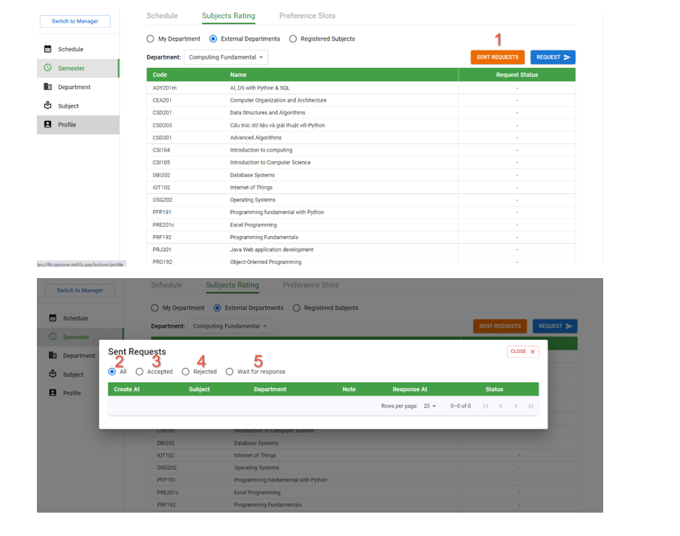

Figure . View Requests

|  |  |
| --- | --- |
| No. | Description |
| 1 | Click on the “Sent Requests” button to view requests |
| 2 | Click on the “All” radio button to view all requests. |
| 3 | Click on the “Accepted” radio button to view accepted requests. |
| 4 | Click on the “Rejected” radio button to view rejected requests. |
| 5 | Click on the “Waiting response” radio button to view waiting requests. |

Table . Brief Description- View Requests

##### y. <Lecturer> Preference slots

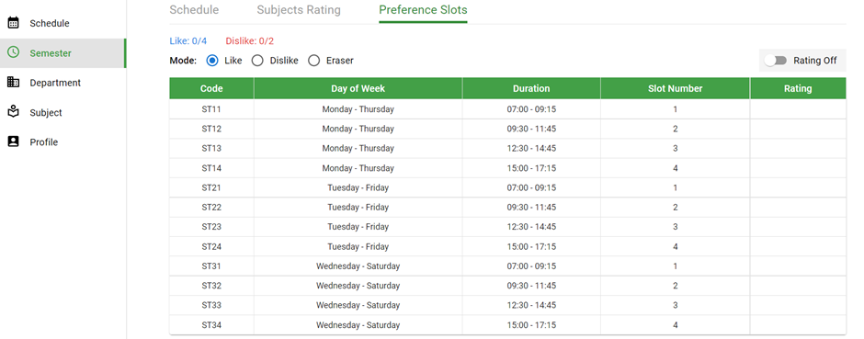

Figure . Preference Slots

|  |  |
| --- | --- |
| No. | Description |
| 1 | Click on the “Preference Slots” tab to preference slots |
| 2 | Click on the “Rating Off” switcher to change to “Rating On” |
| 3 | Click on the “Radio like” or “Radio dislike” or “Radio Eraser” button to choose level favourite. |
| 4 | Click on the row at “Rating” column in table to preference slots |

Table . Brief Description- Preference Slots

##### z. <Lecturer> View Department

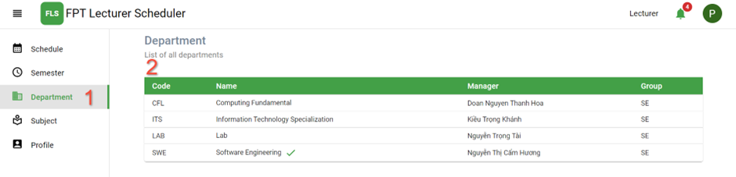

Figure . View Department

|  |  |
| --- | --- |
| No. | Description |
| 1 | Click on the “Department” on the navigation bar to view the department. |
| 2 | Table shows the information of the department. |

Table . Brief Description- View Department

##### A <Lecturer> View Subject

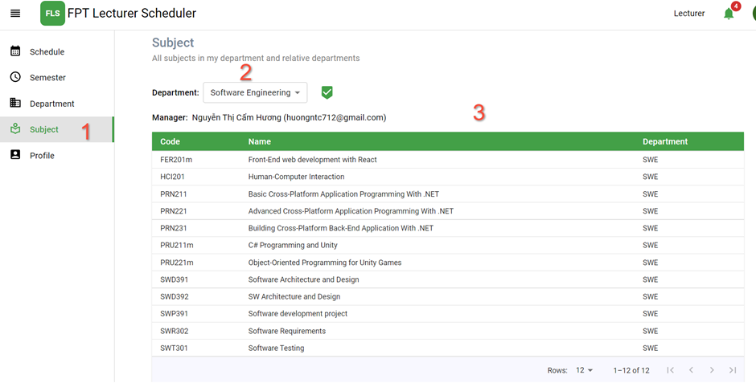

Figure . View Subject

|  |  |
| --- | --- |
| No. | Description |
| 1 | Click on the “Subject” on the navigation bar to view the department. |
| 2 | Choose in the selection: “Department” to choose the department |
| 3 | Table shows the list of subjects in this department. |

Table . Brief Description- View Subject

#### 3.3.2 Mobile Application

##### a. <Lecturer> Login

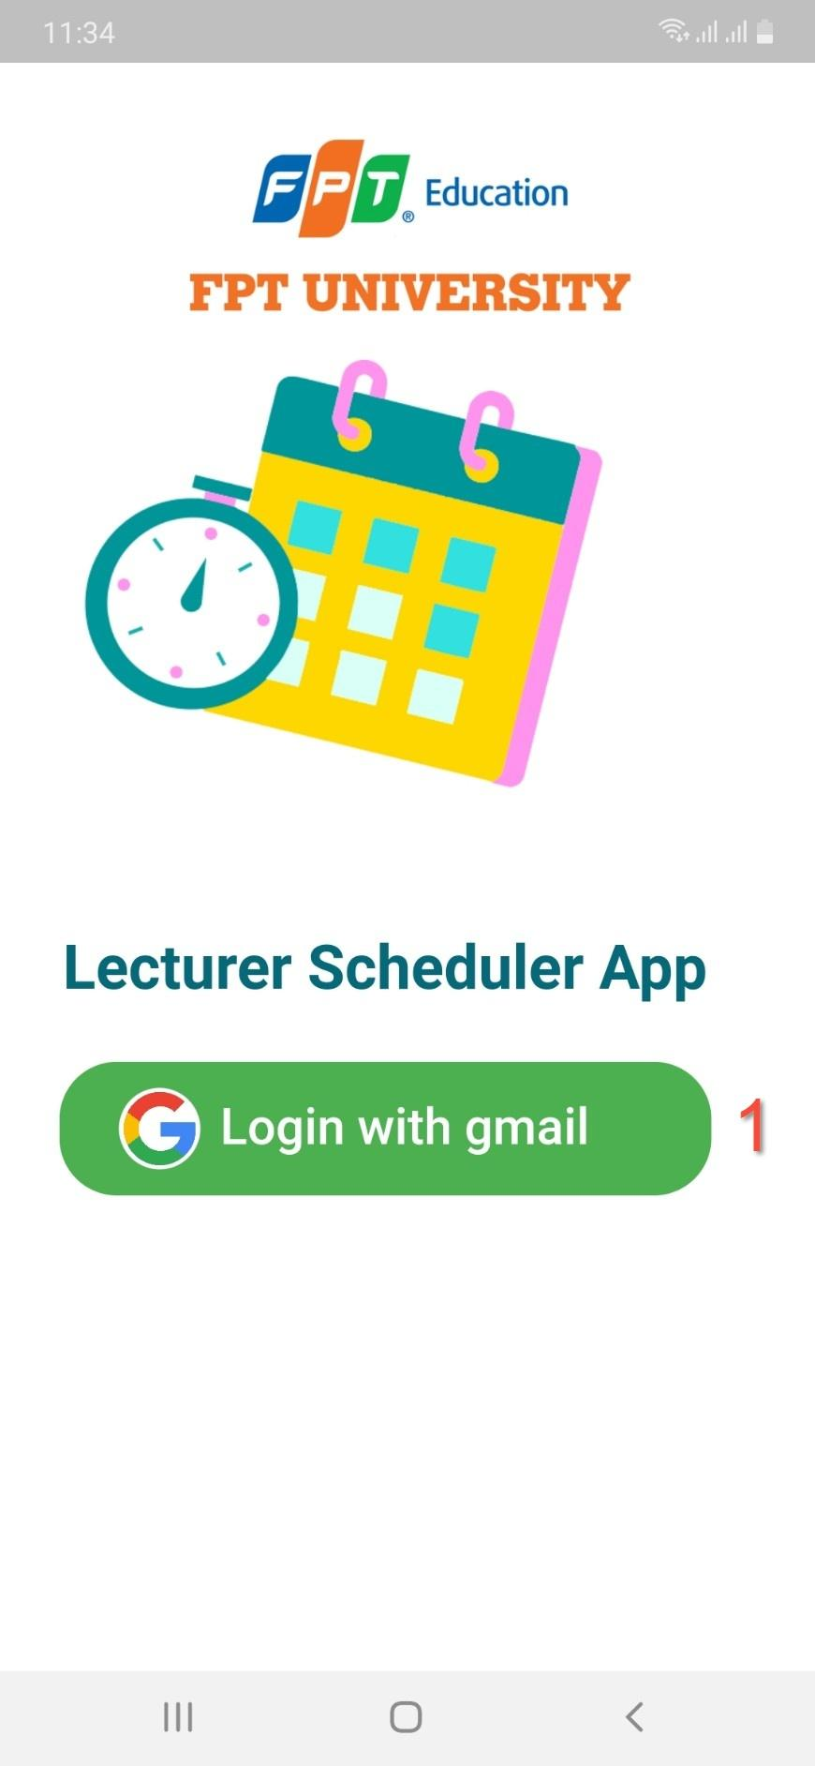 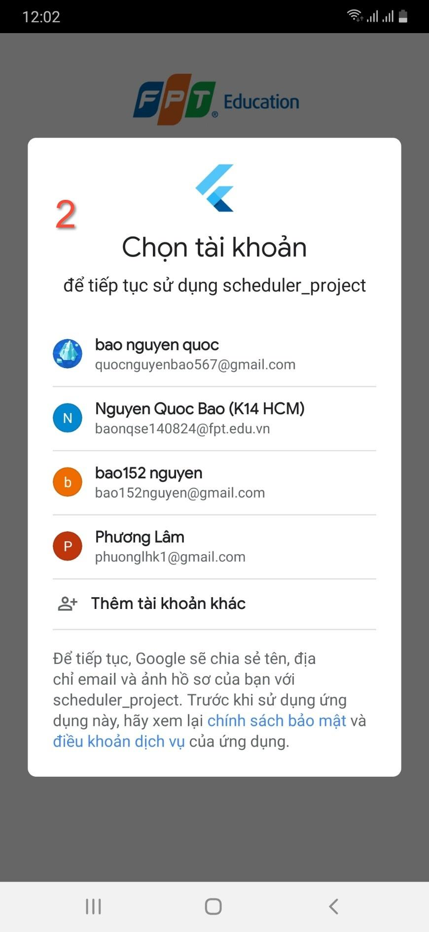

Figure . Login

|  |  |
| --- | --- |
| No. | Description |
| 1 | Click on the “Login with email” button to login the system. |
| 2 | Choose the google account that the lecturer is provided. |

Table . Brief Description- Login

##### b. <Lecturer> View Scheduler

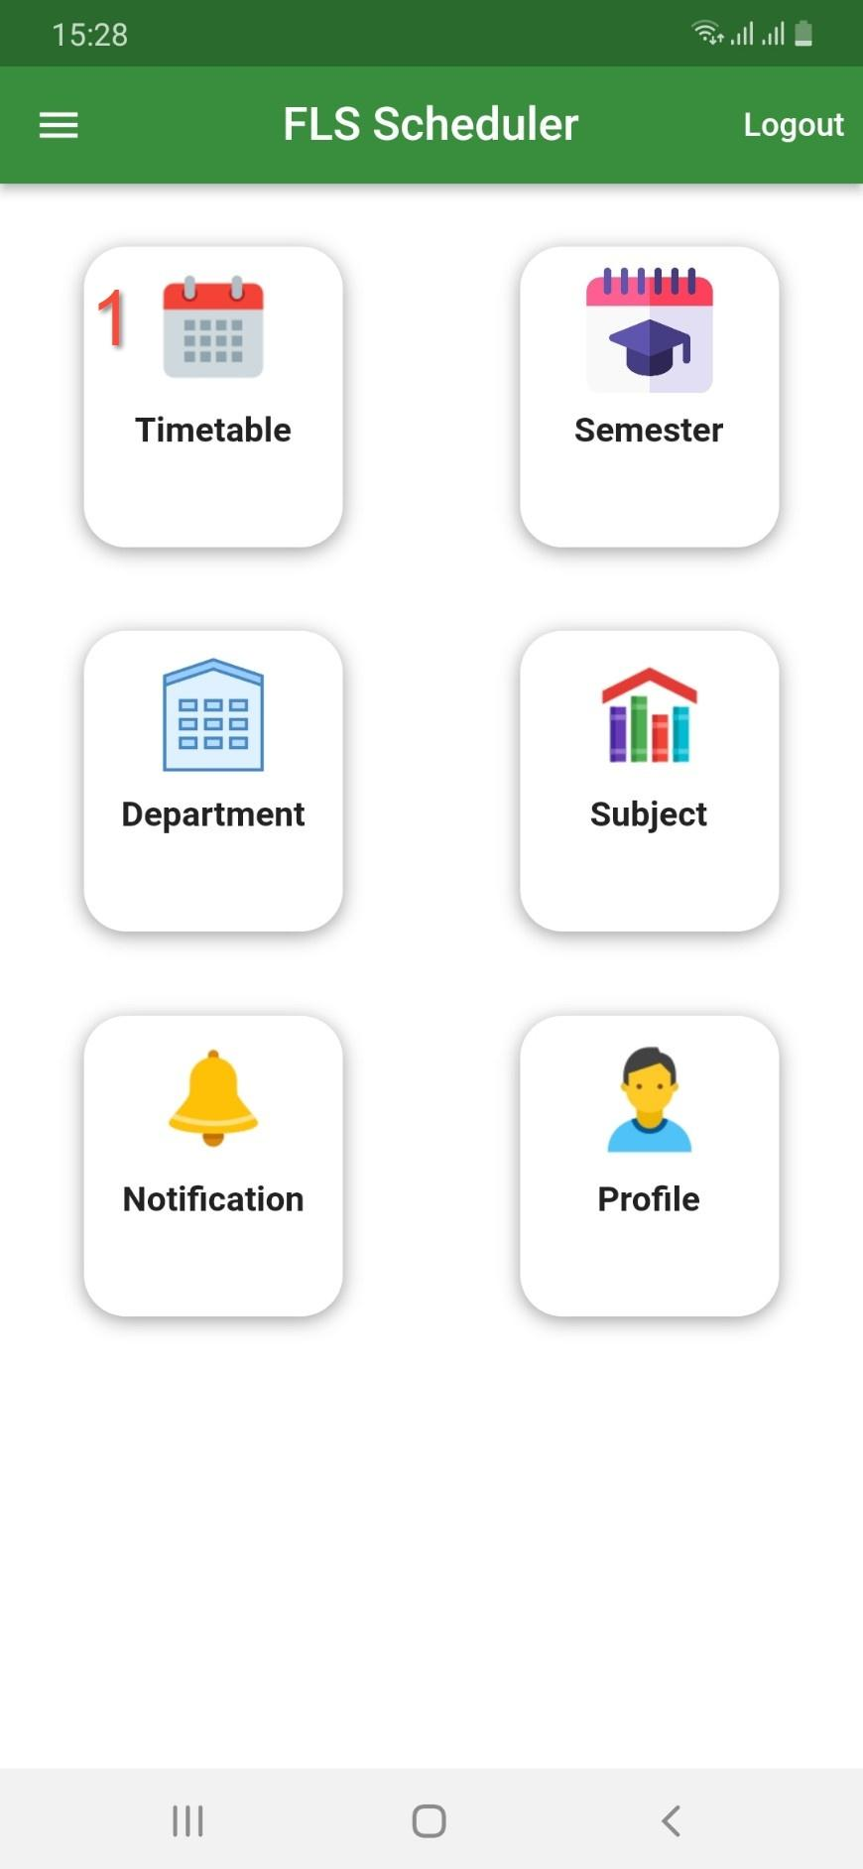 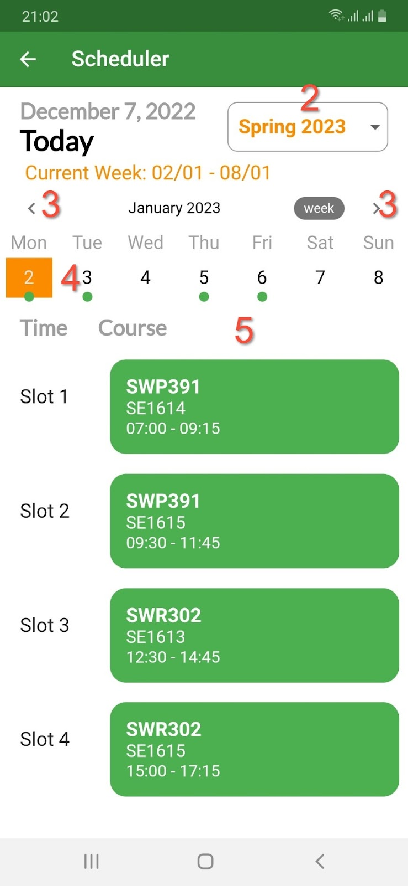

Figure . View Schedule

|  |  |
| --- | --- |
| No. | Description |
| 1 | Click on the “Timetable” card to view the scheduler. |
| 2 | Choose “semester” in dropdown list |
| 3 | Click on the “arrow left” icon or “arrow right” icon to choose week |
| 4 | Click on the “day” text to choose day |
| 5 | List view shows information about the scheduler on this day |

Table . Brief Description- View Schedule

##### c. <Lecturer> Manager Semester

***c1. <Lecturer>* View Semester**

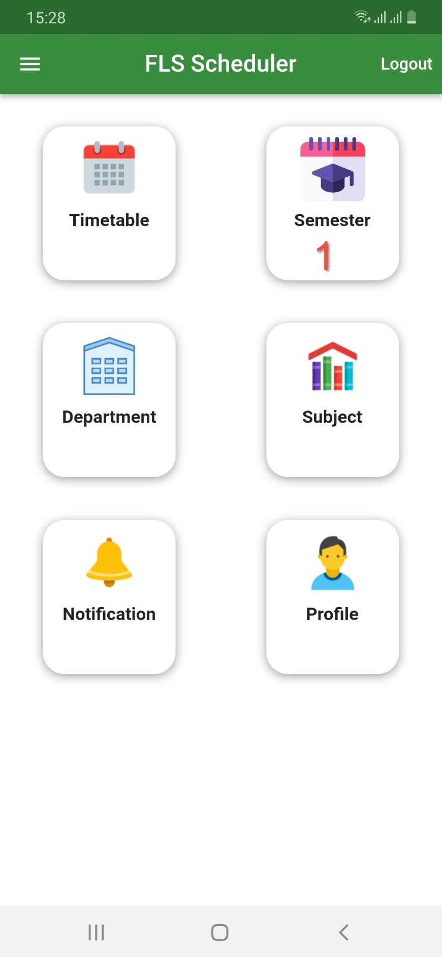 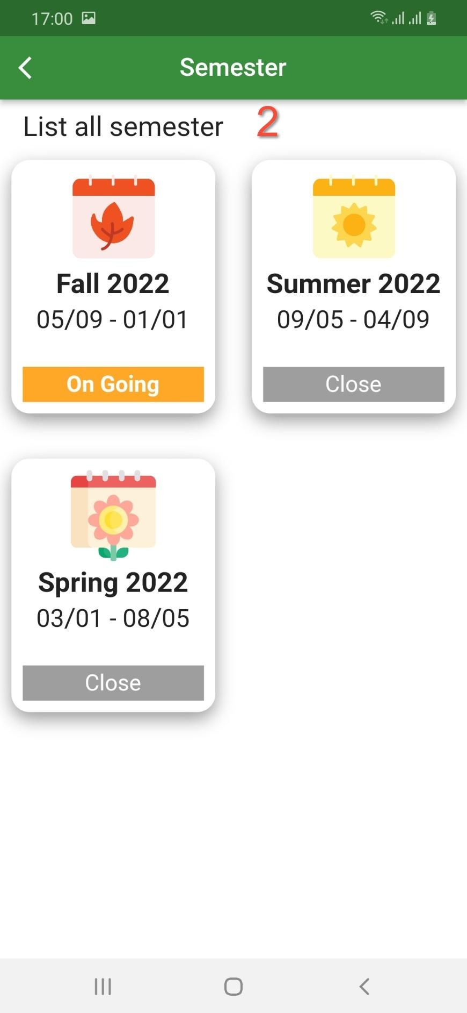

Figure . View Semester

|  |  |
| --- | --- |
| No. | Description |
| 1 | Click on the “Semester” card to view the semester. |
| 2 | List view shows information about semester |

Table . Brief Description- View Semester

***c2. <Lecturer>* View Detail Semester**

 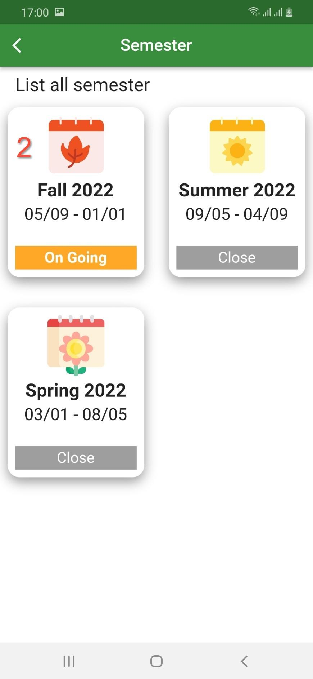

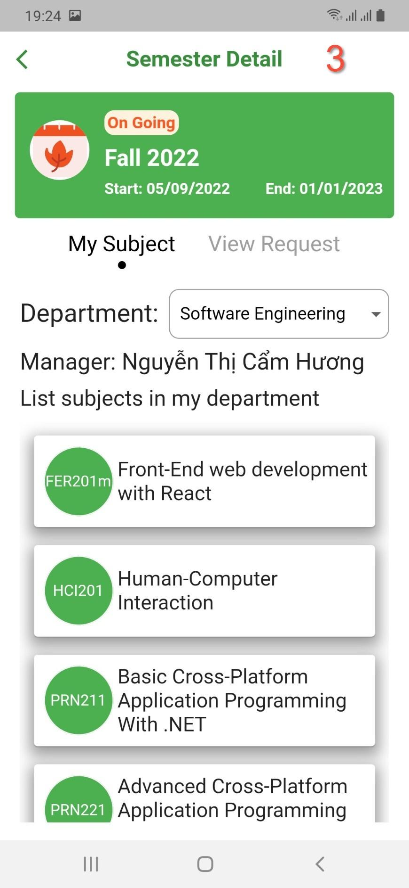

Figure . View Semester Detail

|  |  |
| --- | --- |
| No. | Description |
| 1 | Click on the “Semester” card to view the semester. |
| 2 | Click on the “Semester” card to view the detail semester |
| 3 | Detail semester shows on the screen |

Table . Brief Description- View Semester Detail

***c3. <Lecturer>* View Registered Subjects**

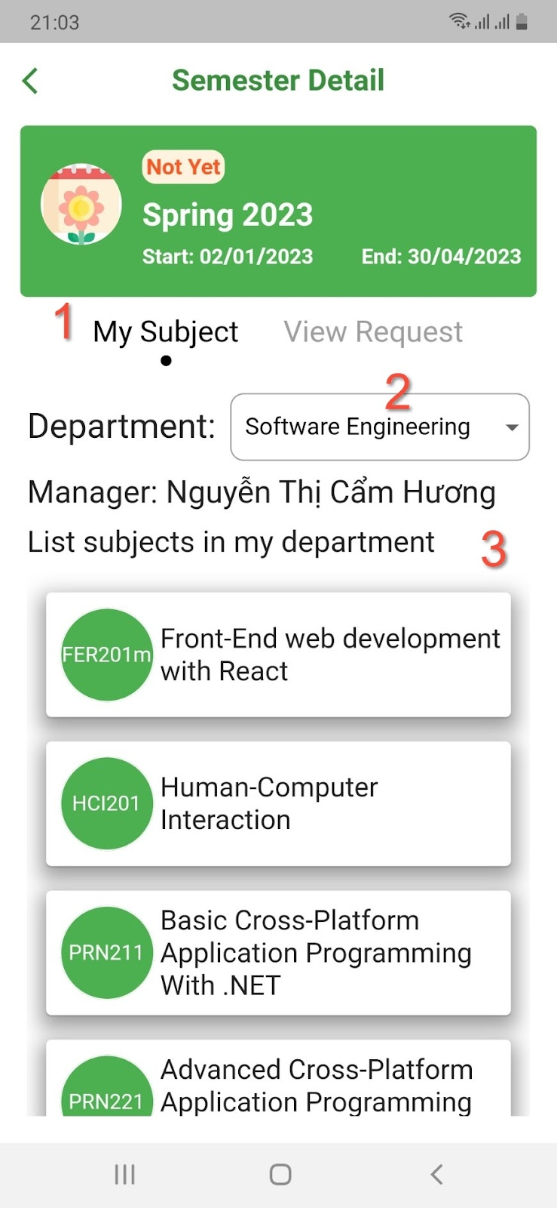

Figure . View Registered Subjects

|  |  |
| --- | --- |
| No. | Description |
| 1 | Click on the “My Subject” tab to view registered subjects |
| 2 | Choose “Department” in dropdown list |
| 3 | List view shows information about subject in this department |

Table . Brief Description- View Registered Subjects

***c4. <Lecturer>* View Requests**

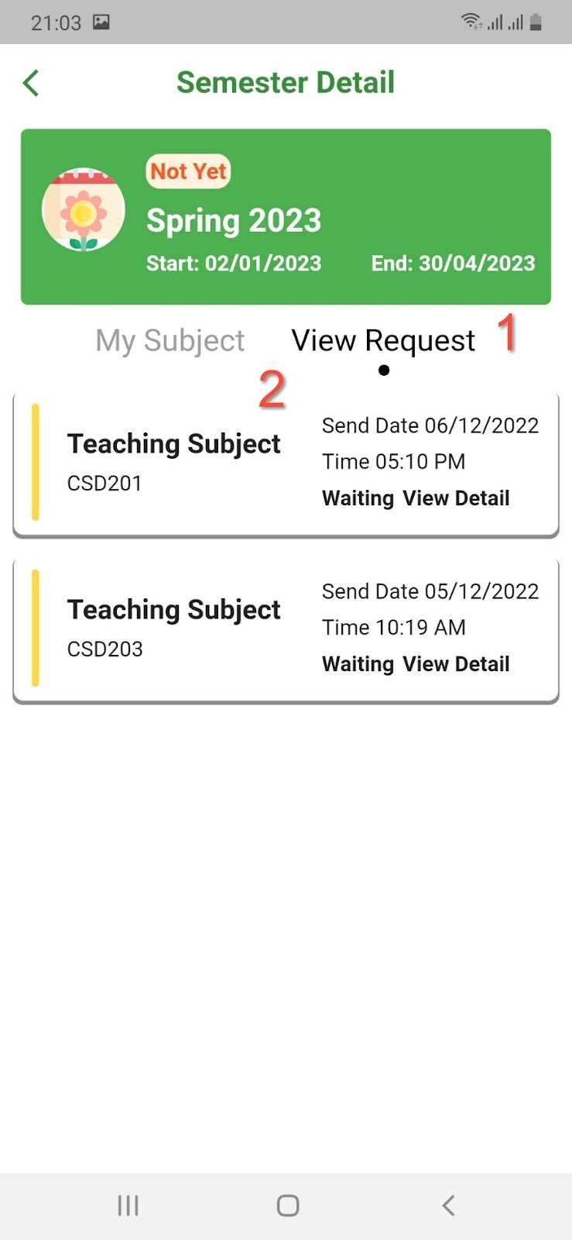

Figure . View Requests

|  |  |
| --- | --- |
| No. | Description |
| 1 | Click on the “View Request” tab to view requests |
| 2 | List view shows information about request |

Table . Brief Description- View Request

##### d. <Lecturer> View Department

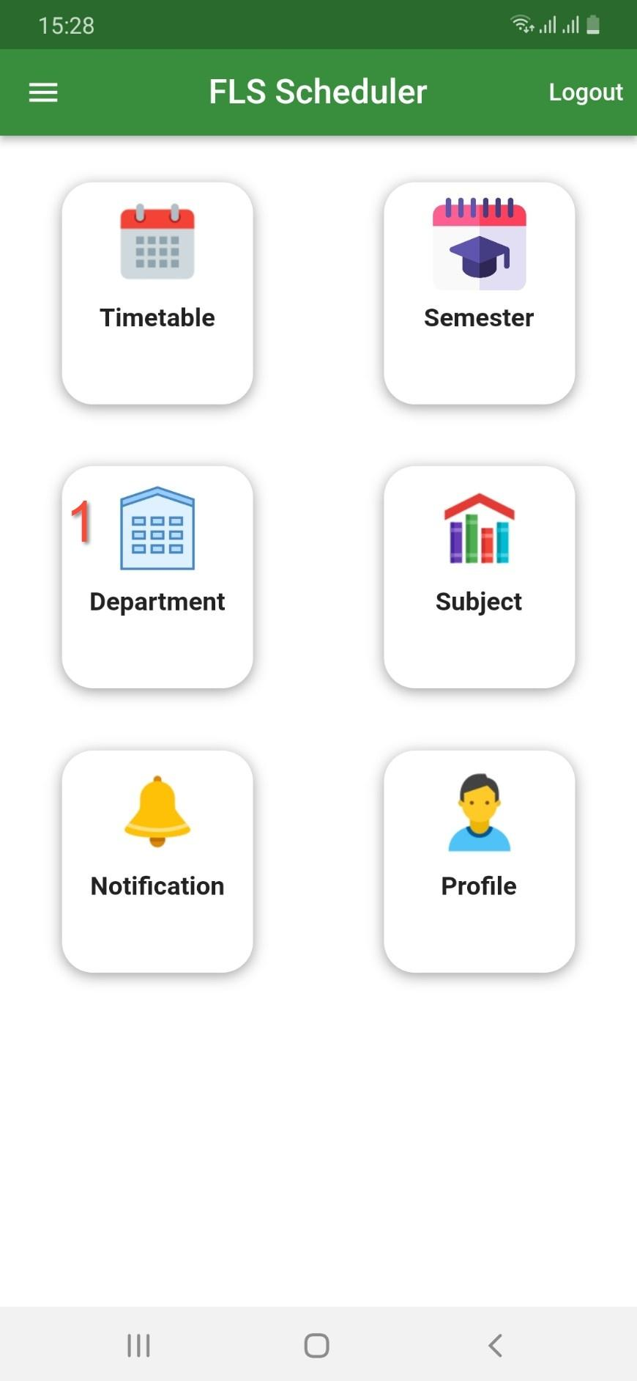 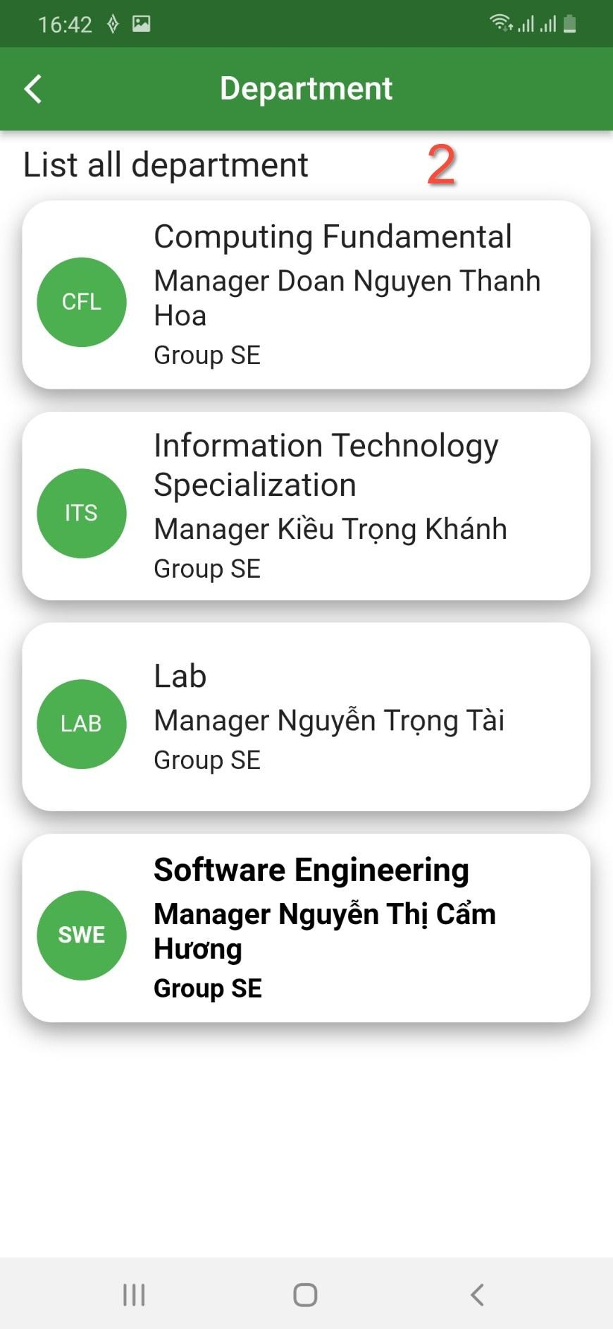

Figure . View Department

|  |  |
| --- | --- |
| No. | Description |
| 1 | Click on the “Department” card to view the department. |
| 2 | List view shows information about the department. |

Table . Brief Description- View Department

##### e. <Lecturer> View Subject

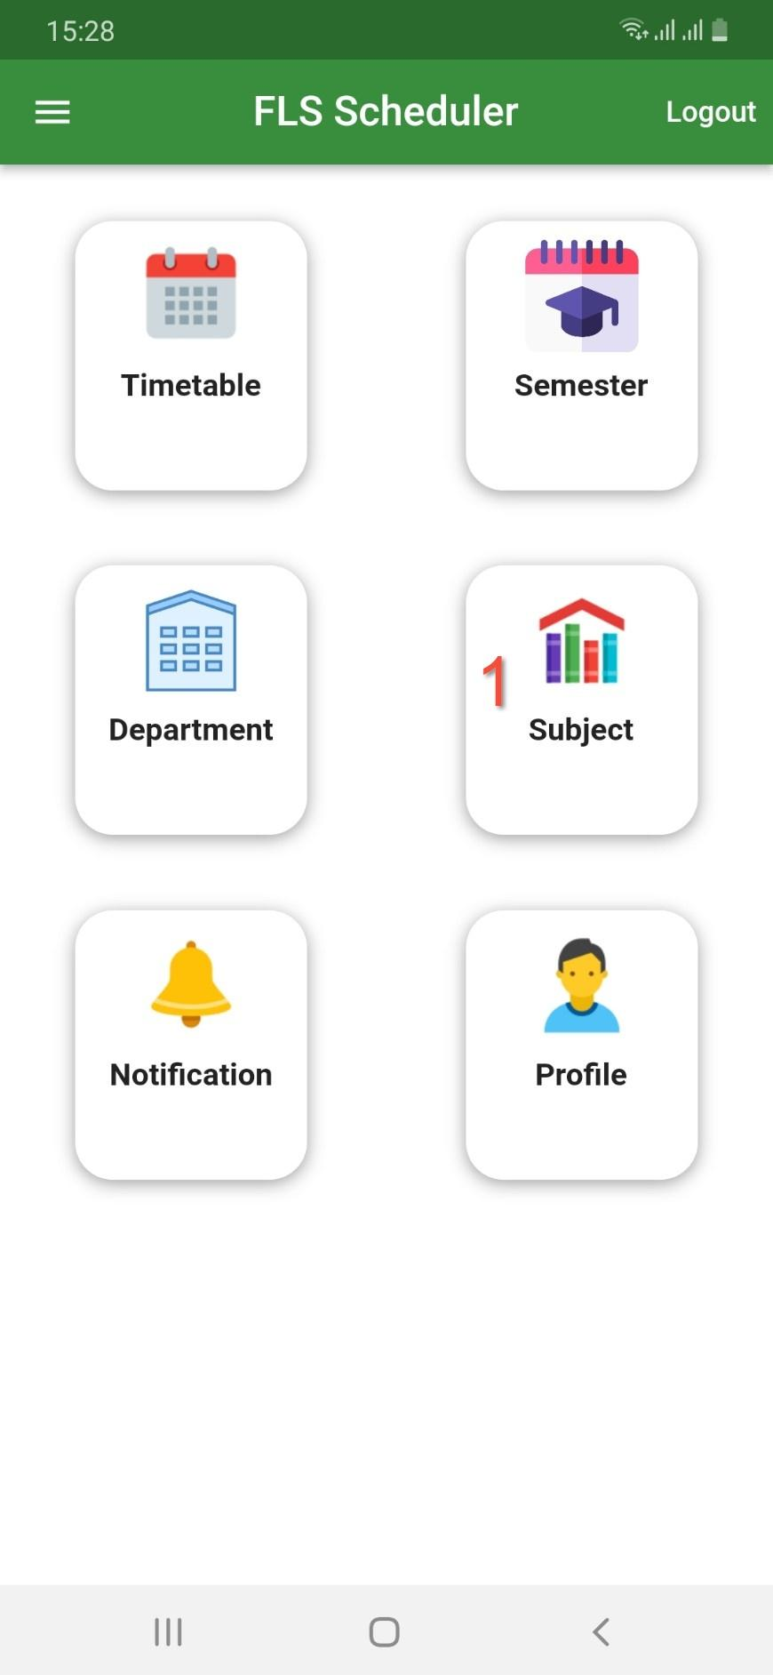 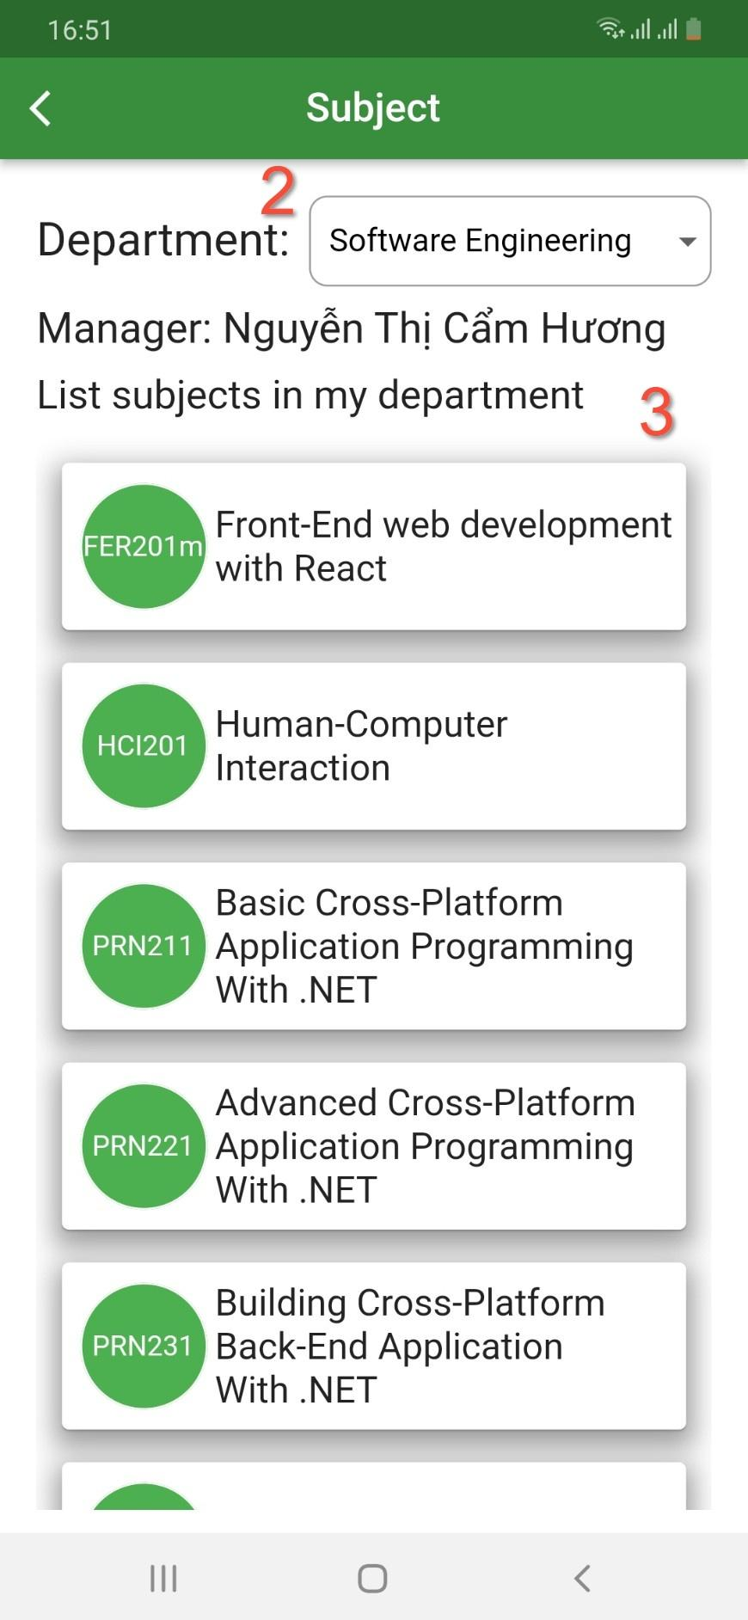

Figure . View Subject

|  |  |
| --- | --- |
| No. | Description |
| 1 | Click on the “Subject” card to view the department. |
| 2 | Choose “Department” in dropdown list |
| 3 | List view shows information about subject in this department |

Table . Brief Description- View Subject

##### f. <Lecturer> Profile

***f.1<Lecturer>* View profile**

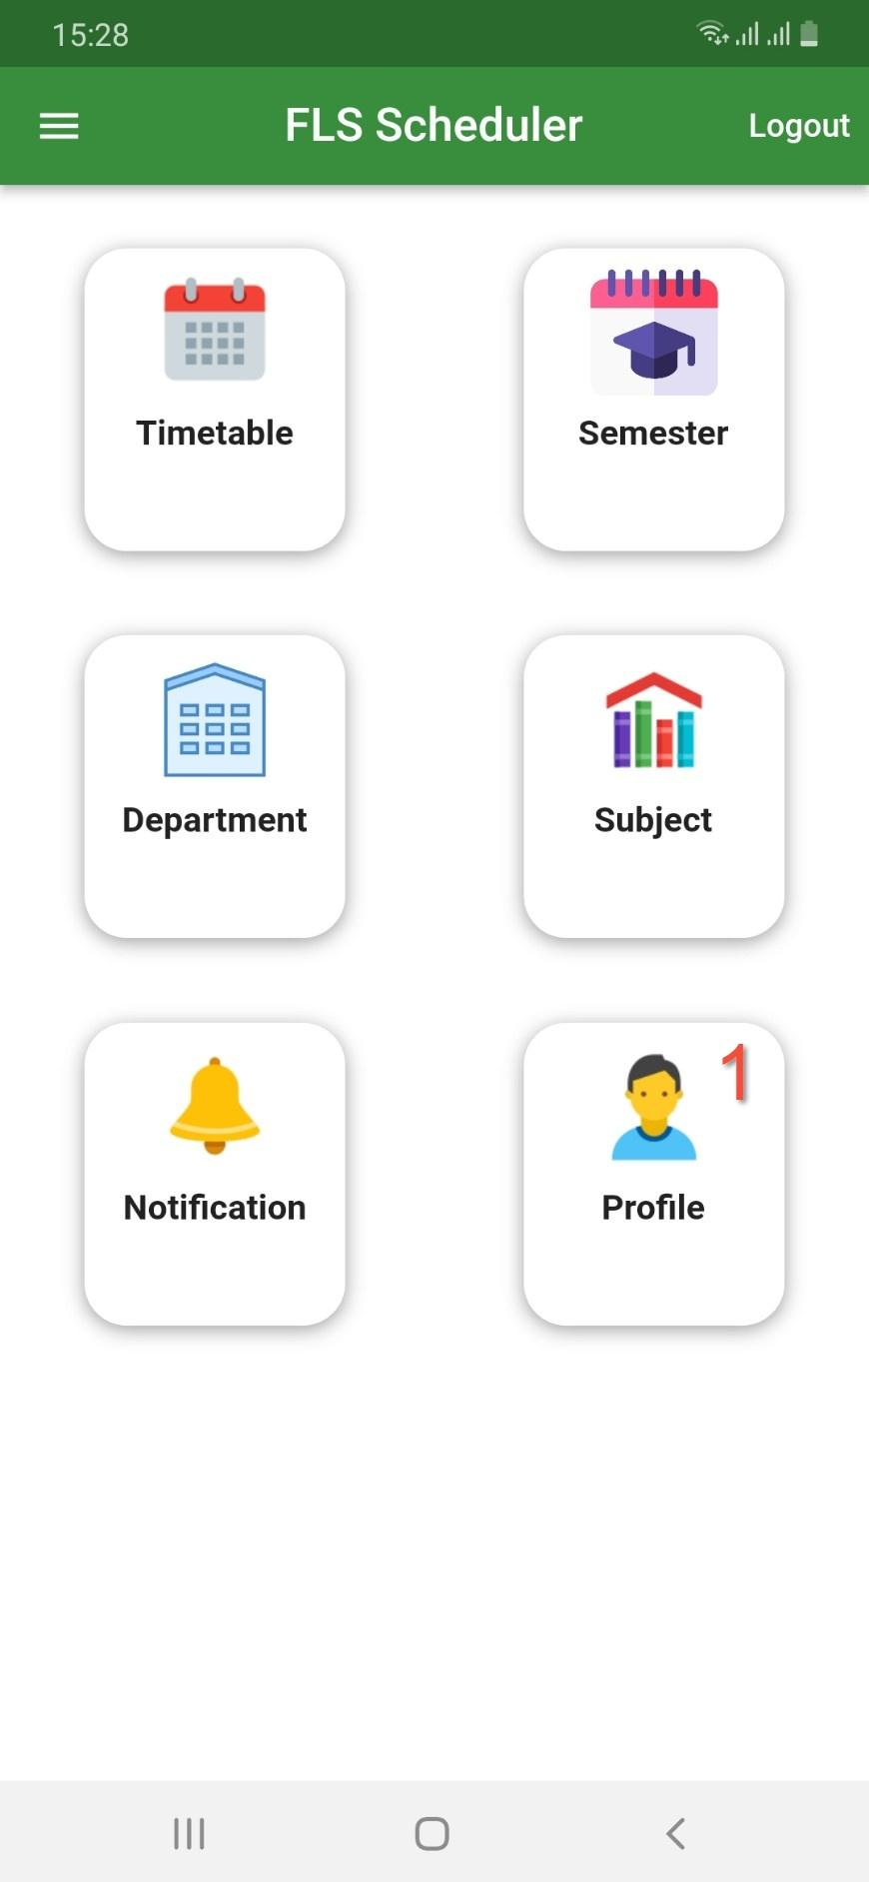 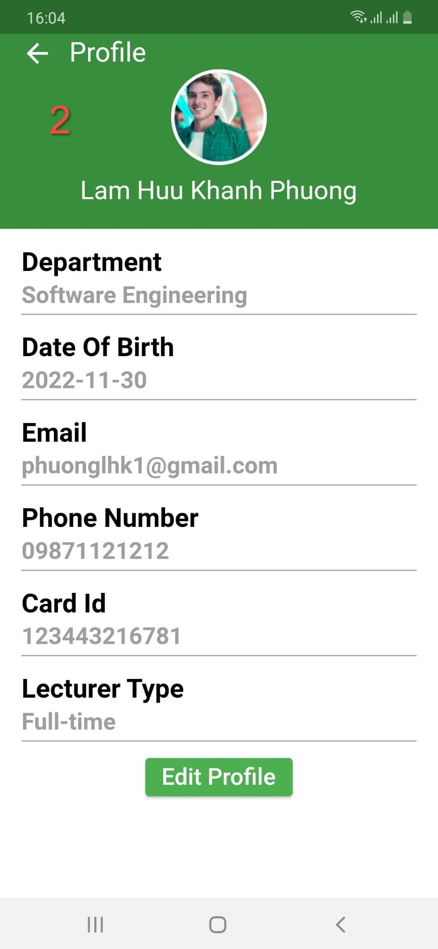

Figure . View Profile

|  |  |
| --- | --- |
| No. | Description |
| 1 | Click on the “Profile” card to view the profile. |
| 2 | Form shows information about the lecturer. |

Table . Brief Description- View Profile

***f.2<Lecturer>* Update Profile**

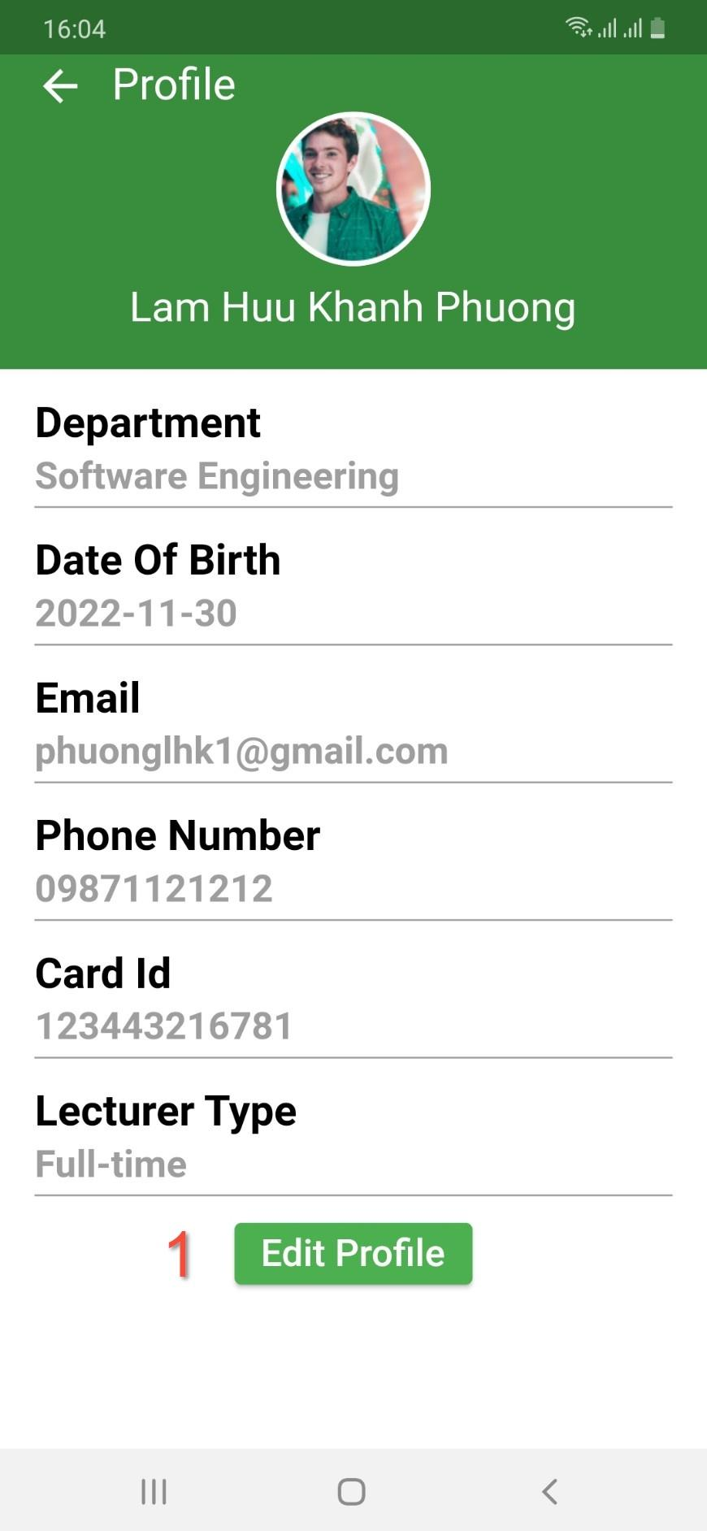 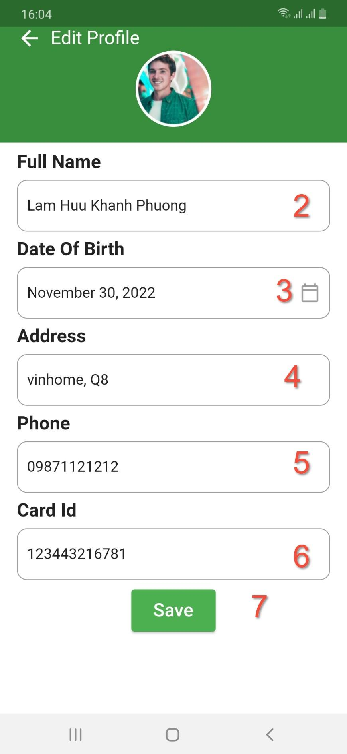

Figure . Update Profile

|  |  |
| --- | --- |
| No. | Description |
| 1 | Click on the “Edit Profile” button to edit profile. |
| 2 | Input in the field: “Full Name” to update full name. |
| 3 | Choose in the date picker: “Date of Birth” to choose date of birth. |
| 4 | Input in the field: “Address” to update address. |
| 5 | Input in the field: “Phone” to phone number. |
| 6 | Input in the field: “Card Id” to update card id. |
| 7 | Click on the “Save” button to update your profile. |

Table . Brief Description- Update Profile

#### 3.3.3 <Admin> Windows Form Application

##### a. <Admin> Login

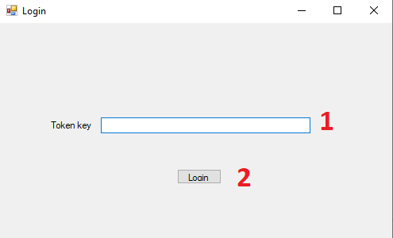

Figure . Admin login WinForms

| No. | Description |
| --- | --- |
| 1 | Input in the field: “Token key” |
| 2 | Click on the “Login” button to navigate the Schedule form page. |

Table . Brief Description- Admin login WinForms

##### b. <Admin> Generate schedule

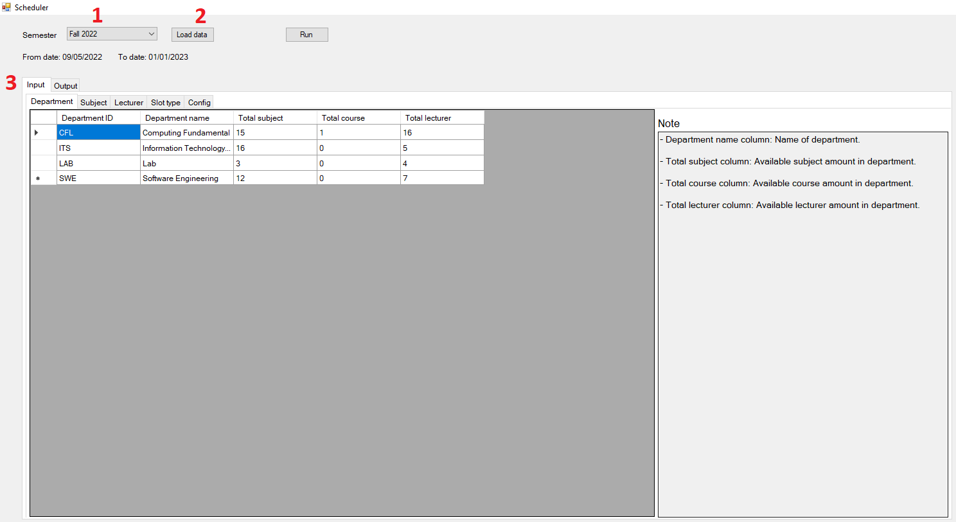

Figure . Admin load data in semester

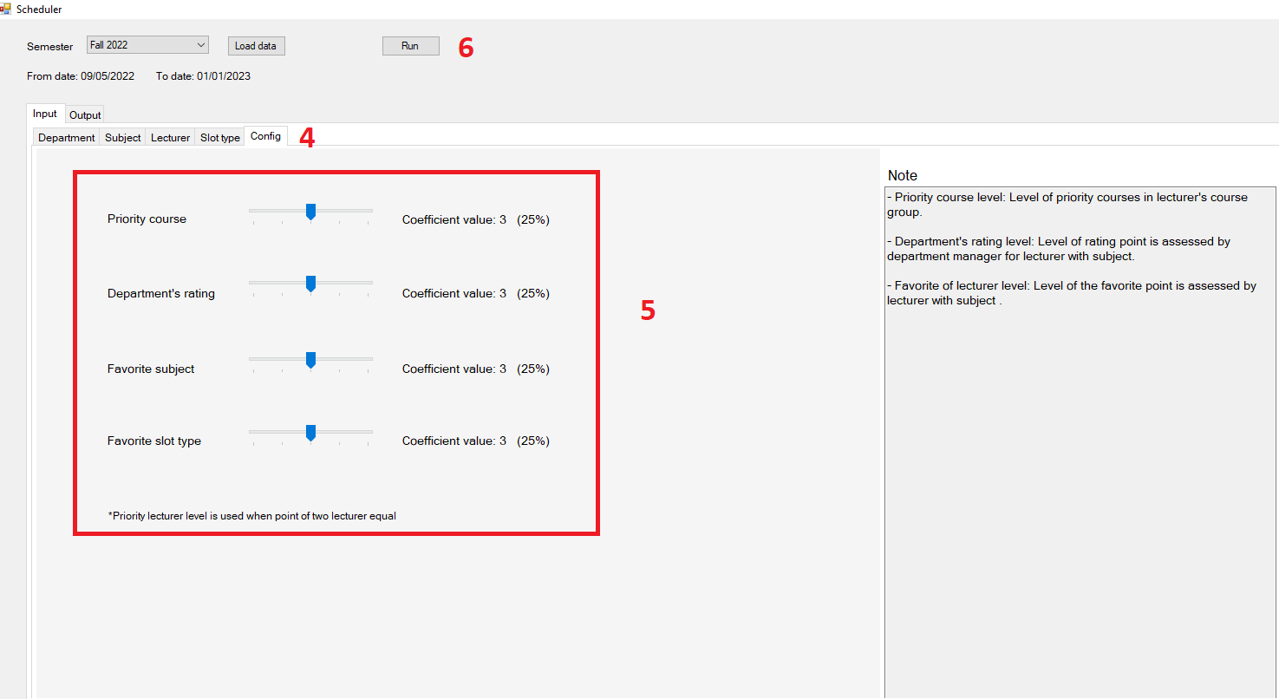

Figure . Admin configures the coefficients

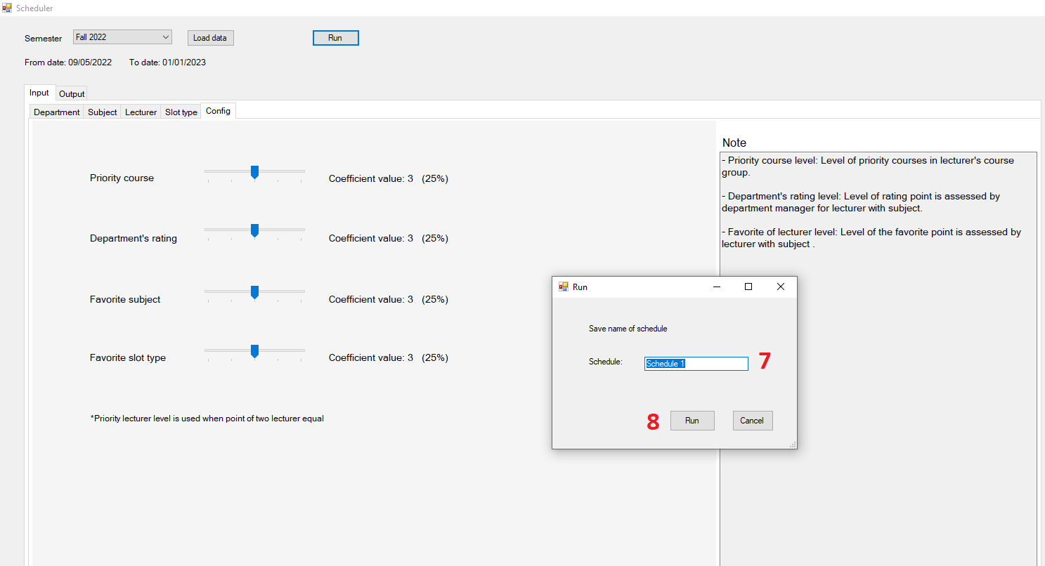

Figure . Admin name the schedule

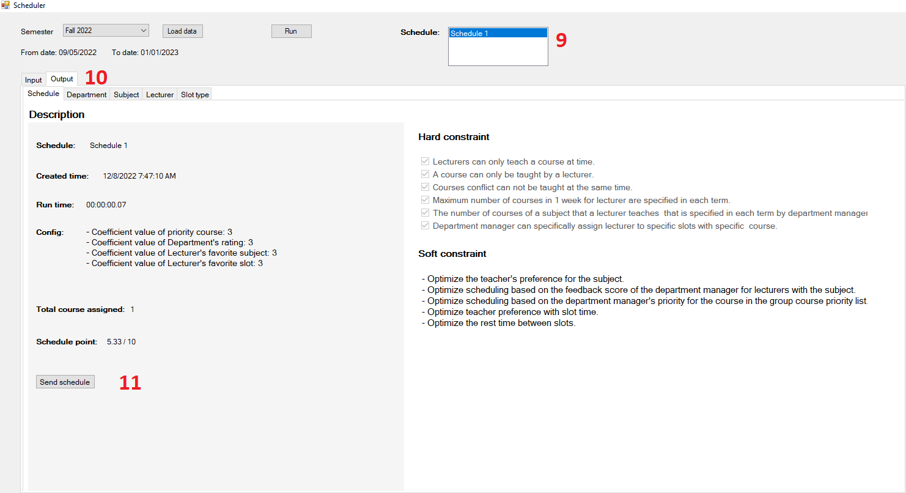

Figure . Admin send the schedule to the server

| No. | Description |
| --- | --- |
| 1 | Choose a semester to generate schedule |
| 2 | Click on the “Load data” button to get all data. |
| 3 | Click on the “Input” tab to view all data. |
| 4 | Click on the “Config” tab to navigate config page. |
| 5 | Edit to configure the coefficients. |
| 6 | Click “Run” to generate schedule |
| 7 | In to the field “schedule” to name the schedule |
| 8 | Click “Run” button to generate schedule |
| 9 | Choose a schedule |
| 10 | Click on the “output” tab to view all data of schedule. |
| 11 | Click “Send schedule” button to push the schedule to the server |

Table . Admin generates schedule

# VII. Appendix

## 1. References

* **ASP.Net Core Web API:** [**https://dotnet.microsoft.com/en-us/apps/aspnet/apis**](https://dotnet.microsoft.com/en-us/apps/aspnet/apis)
* **ReactJS:** [**https://reactjs.org/**](https://reactjs.org/)
* **Flutter:** [**https://docs.flutter.dev/**](https://docs.flutter.dev/) **,** [**https://pub.dev/**](https://pub.dev/)
* **.NET Desktop Guide for Windows Forms:** [**https://learn.microsoft.com/vi-vn/dotnet/desktop/winforms/?view=netframeworkdesktop-4.8**](https://learn.microsoft.com/vi-vn/dotnet/desktop/winforms/?view=netframeworkdesktop-4.8)
* **Scrum:** [**https://www.scrum.org/resources/scrum-framework-poster**](https://www.scrum.org/resources/scrum-framework-poster)